LORETO HIGH SCHOOL-LIMURU
Kenya Certificate of Secondary Education
231/1- BIOLOGY –PAPER 1
(Theory)
Nov. 2021-2 hours
Name................................................................Adm number.....................

Candidates Signature........................................Date..................................

Instructions to candidates
(a)Write your name and admission number in the spaces provides above.
(b)Sign and write the date of examination in the spaces provided above.
(c) This section has a total number of 28 questions
(d)Answer all the questions in the space provided.
(e)This paper consist 10 printed pages
(f)Candidates should check the question paper to ascertain that all pages are printed as indicated and no questions are missing
(g)Candidates should answer all the questions in English.

FOR EXAMINERS USE ONLY
1 | 2 | 3 | 4 | 5 | 6 | 7 | 8 | 9 | 10 | 11 | 12 | 13 | 14

15 | 16 | 17 | 18 | 19 | 20 | 21 | 22 | 23 | 24 | 25 | 26 | 27 | 28

STUDENTS SCORE: TOTAL MARKS: 80 MARKS
1. Define the following terms:
(a)Phylogeny (1mark)
The evolutionary relationships between organisms
(b)Ontogeny (1mark)
Developmental history of living organism
2. Differentiate between a test cross and a back cross (2marks)
A test cross is a cross carried out to determine an unknown genotype by crossing an individual showing the dominant phenotype with a recessive individual for that trait.
Back cross is a cross in which an individual is crossed with one of its parents or individuals that is genetically identical to the parent.
3. State two roles of Golgi apparatus. (2marks)
Synthesis of lysosomes
Packaging and transportation of glycoproteins
4. The diagram below represents a living organism. Study it and answer the questions that follows.
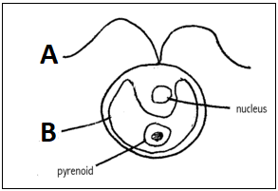
- (i)State the kingdom in which the organism belongs
(1mark)
Protoctista/Protista P must be capital letter

(ii) Give a reason for your answer. (1mark)
Presence of flagellum for locomotion
Unicellular
(b) Name the structure labeled A and state its function, (1mark)
Flugellum for locomotion

5. State the role of each of the following in the mammalian respiratory system:
(a) Surfactant fluid (1mark)
To prevent collapsing of alveolus during exhalation
(b) Epiglottis (1 mark)
Epiglottis — used as a valve/flap between the larynx and the oesophagus to permit air to enter the air-way to the lungs and food particles to pass into the gut;
6. Why is it necessary for blood from the gut to pass through the liver before joining general circulation? (2 marks)
To regulate sugar levels in blood
TO oxidise excess glucose
7. The diagram below represents a type of response in an organism use it to answer the question that follows:
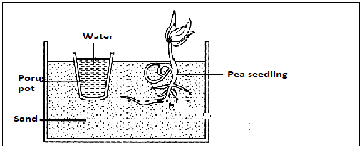
(a)State the type of response represented above (1mark)
Positive hydrotropism
(b)What is the importance of the response to living organism (1mark)
Enables plant to obtain/ uptake water and dissolved mineral salts

8. Identical twins were separated after birth and were then raised in different environments. One in Kenya and the other in U.S.A. They rejoined after 18 years and they looked slightly different.
(i)Name the type of variation the twins exhibited (1mark)
Continuous variation
(ii)Give two observable differences likely to be noted between the twins (2marks)
- Skin colour
-Height
-Body weight (size)
9. The diagram below indicates a type of response in a given animal
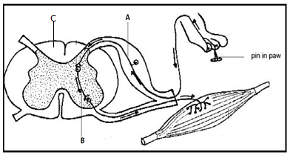
(a)Name the part labelled
A- Sensory neurone (1mark)
(b) In the space provided below give the letter(s) that represents the part of the reflex arc that consists mainly of axons of sensory and motor neurons. (1mark)
Part C
(c) State the role of part labeled B. (1mark)
Relay impulses between sensory and motor neuron.
10. Explain why a pregnant woman excretes less urea compared to a woman who is non- pregnant. (2marks)
Amino acids are used in the formation of foetal tissues; thus has less excess to be eliminated

11. The diagram below indicates an eye defect use it to answer the question that follows:
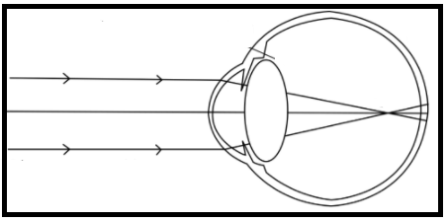
(a)Name the eye defect using the diagram given above (1mark)
Shortsightedness/Myopia√
(b)Draw a diagram that indicates how the defect can be collected (2marks)
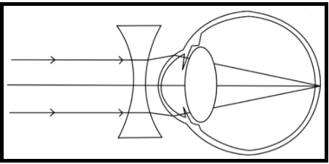
12. What is the significance of the following process during meiosis 1.
(a)Shortening of the spindle fibres during Anaphase I
(1mark)
Makes it possible for homologous chromosomes/ homologues to be separated so that each daughter cell receives only one member of the pair of homologous chromosomes/ homologues;
Accept: Pairs homologous chromosomes/ homologues prior to their separation/ segregation to
opposite ends of the cell in late anaphase;
Reject: To allow crossing over to take place
(b)Chiasmata formation (1mark)
Enables non-sister chromatids to exchange genetic information resulting in formation of new gene combinations;

13. The figure below shows an apparatus at the start of an experiment to investigate the digestion of an emulsion of fat droplets in water by enzyme A
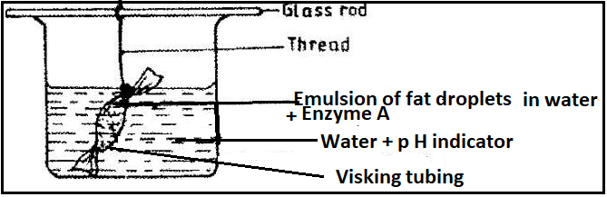
When the pH of the solution is 7 the colour of the pH indicator is green, blue when the pH is above 7 and red when below 7. The apparatus is kept at 40 degrees Celsius for 20 minutes during which time the indicator changes from green to red.

(a)Describe how the products of fat digestion enter a person’s transport system
(2marks)
They are absorbed in the into lacteal vessels which then transport them to the lymphatic system
(b)State the identity of enzyme A (1mark)
Lipase
(c)Describe the process that led to the change in p H (2marks)
Lipase enzyme digests the fat to produce fatty acids and glycerol hence lowering the pH below 7 leading to the color change from green to red
14. (a)Distinguish between parthenocarpy and parthogenesis. (2marks)
Parthenocarpy
Parthogenesis is a type of a sexual reproduction that occurs when eggs are produced without being fertilized such as black and green aphids.
(b) State the role of juvenile hormone in insect metamorphosis. (1mark)
This leads to formation of larval cuticle making moulting not to go beyond the larval stage.

15. Explain how industrial melanism can be used to provide evidence for evolution (3marks)
Currently there is two species of peppered moth from same ancestry
White moth was well comforaged by lichen on barks of trees prior to industrial evolution
After industrialization when soot was deposited on backs of tree, white moth was easily detected by birds which are predators
Due to predation pressure, mutation occurred leading into darker melanic form resulting into new variety
Nature selected white moth while industrialial regions selected very darker moths

16. What is the causative agent of the following conditions?
(a)Amoebic dysentery (1mark)
Entamoeba histolytica
(b)Candidiasis (1mark)
Candida albican
Or Candida tropicalis
Or Candida krusei
17. The diagram below shows a section through the human ovary. Study it and answer the questions that Follows:
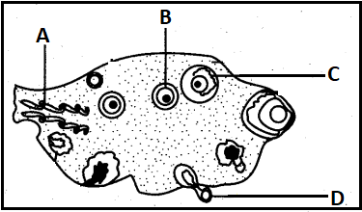
(a)Name the parts labelled A and B
A: Blood vessel (1mark)
B: Secondary Follicle (1mark)
C: Antrum (1mark)
(b)Explain how the part labelled D is adapted to its function (2marks)

Oval in shape to facilitate faster wafting
Haploid nucleus to control all activities of the cell
18. Most of carbon (Iv) oxide is transports from tissues to lungs within red blood cells and not blood plasma explain? (2marks
Faster loading and offloading of carbon (IV) oxide due to presence of carbonic anhydrase
The p H of the blood is not altered as hydrogen ions readily combines with haemoglobin
19. What is the significance of the counter current flow system in the loop of Henle? (2marks)
In ascending limb of Henle there is selective reabsorption of sodium chloride ions which increases osmotic potential which increases more permeability of water by osmosis while in distal convoluted tubule there is active reabsorption of water
20. The diagram below shows parts of the human skeleton. Study it and answer the questions that follow.
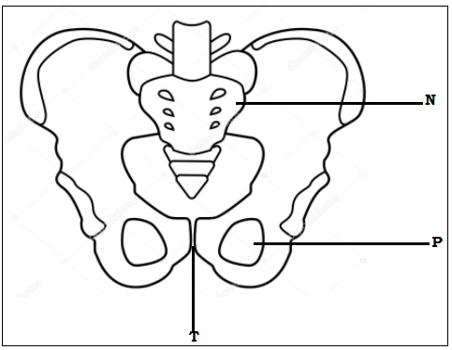
- Name the part labeled N and P (2marks)
N- Sacrum

P-Obturator foramen
- State the role the part marked T. (1mark)
Flexible and enlarges during birth to allow for expulsion of the foetus.

- In a mammal bone is usually made of many small fused bones. How many such bones constitute structure N of this mammal (1mark)

5
21. Examine the drawings of organisms shown below. Using features that are clearly visible, construct dichotomous key that can be used to distinguish them (4marks)
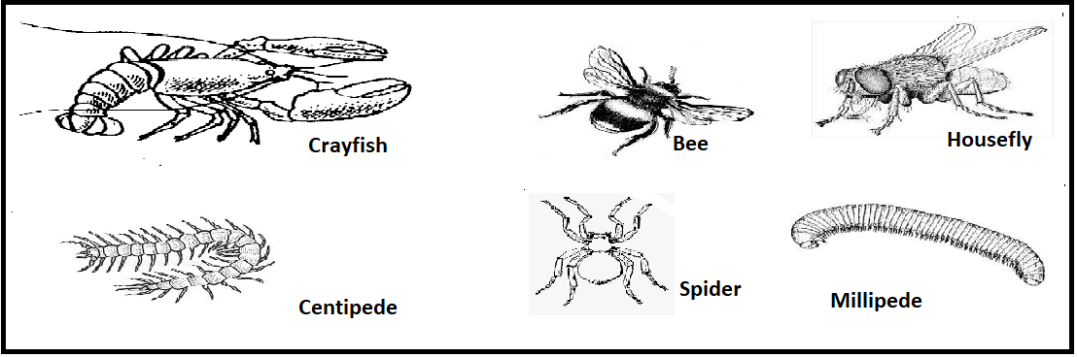
1(a)Animal with wings................................................................go to 2
(b)Animal without wings............................................................go to 3
2(a)With one pair of wings.......................................................Housefly
(b)With two pairs of wings............................................................Bee
3(a)With four pairs of walking legs..............................................go to4
(b)With more than four pairs of walking legs.............................go to 5
4(a)With antennae....................................................................Crayfish
(b)Without antennae..................................................................Spider
5(a)One pair of legs in each body segment.............................Centipede
(b)Two pairs of legs in each body segment............................Millipede
22.Explain any two processes by through which plants excrete their waste products from their bodies (2marks)
Diffusion: enables plants to get rid of carbon (IV) oxide and oxygen
Guttation/ exudation is a process by which plants remove waste products like excess water, salts etc
Transpiration is the process by which plants get rid of excess water in form of water vapour
Deposition and consequent leaf; flower or fruit fall is used by plants to get rid of alkaloids such as nicotine, caffeine, cocaine, pyrethrins and tannins.
23. G A C A G U A C represents the base sequence of a segment of nucleic acid.
(a)Which nucleic acid does the above segment represent? (1mark)
RNA
(b)Give a reason for your answer in (a) above (1mark)
Has organic base uracil
(c)Write down the complementary base sequence of the strand (1mark)
C T G T C A T G
24. State two differences between Krebs cycle and Glycolysis. (2marks)
Krebs cycle occurs in matrix of mitochondrion while glycolysis occurs in the cytoplasm
25. The images shown below were taken from a given experiment whose objective was to determine germination using given seed that was subjected into various suitable conditions. Use the images given below to answer the questions that follows:
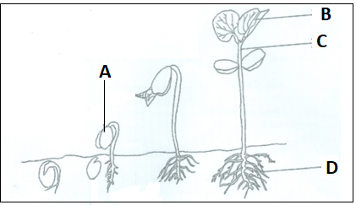
(a)Name the parts labelled C (1mark)
Epicotyl

(b)What is the function of the part labelled D (1mark)
Anchors plant firmly to soil and used for absorption of water and dissolved mineral salts from the soil
(c)Name the type of germination above (1mark)
Epigeal
(d)Explain how the part labelled A is carried above the soil level (2marks)
The bent like hypocotyl which straightens√ out/ elongates carrying the cotyledons upward.√

26.An elephant weighing 2000Kg requires 3000kJ per gram body weight while a rat weighing 100g requires 5000kJ per gram body weight. Explain
(2marks)
A rat has larger surface area to volume ratio than an elephant hence loses more heat energy faster than an elephant which has smaller surface area to volume ratio which loses lesser energy compared to the rat.

27. Explain the fate of excess glucose in humans (2marks)
Insulin stimulates liver cells to convert excess glucose into glycogen. Insulin also stimulates uptake of glucose into muscle cells where it undergoes respiratory breakdown to release energy or conversion of excess glucose to glucose. If glucose is still in excess it is taken up by adipose tissue cells and converted into fats for storage through the influence of insulin
28. The figure below shows the change in the population of herbivores after new animals were introduced into a new isolated habitat with abundant vegetation and no natural enemies.
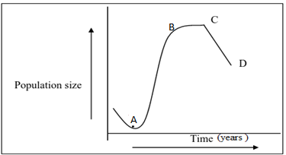
- Account for the change in population between point A and B (2marks)
There is an increase in the population of herbivores because they are become well adapted to the prevailing environmental conditions, Birth rate is higher than death rate, no competition for resources and space etc..
- Explain one factor that maybe responsible for the change in population between point C and D. (2marks)
Disease epidemics, floods, Sudden change in Weather conditions e.g. drought, competition etc.
- What term is used to describe the change in population between point C and D. (1mark)
Population crash.

