**Name……………………………………............................. Index number …………..…**

**Class……………….. Adm no…………….…….Candidate’s signature ………………….**

**School ……………………………………………..**

233/1

**CHEMISTRY**

Paper 1

**THEORY**

December 2021

**2 Hours**

**SUKELLEMO JOINT MOCK EXAM**

Kenya Certificate of Secondary Education

**CHEMISTRY**

Paper 1

**THEORY**

**Instruction to Candidates**

* Write your name, index number class and admission number in the spaces provided
* Sign and write the date of examination in the spaces provided.
* Answer **all** the questions in the spaces provided.
* Mathematical tables and silent electronic calculators may be used.
* All working **must** be clearly shown where necessary.
* **This paper consists of 15 printed pages**
* **Candidates should check the question paper to ascertain that all the pages are printed as indicated and no questions are missing.**
* **Candidates should answer the questions in English.**

**For Examiner’s Use Only**

|  |  |  |
| --- | --- | --- |
| **Questions** | **Maximum Score** | **Candidates Score** |
| 1-31 | 80 |  |

**1**. What name is given to the different forms of an element in the same physical state? (1mark)

….……………………………………………………………………………………….….……

**2.** Element **J** whose atomic number is 31 has two isotopes. The table below shows the mass numbers and the relative abundance for each isotope.

|  |  |
| --- | --- |
| Mass | Relative abundance % |
| 69 | 60.4 |
| 71 | 39.6 |

1. Determine the number of neutrons in the isotope with mass number 69 (1mark)

………………………………………………………………………………………………………………………………………………………………………………………………………………

1. Calculate the relative atomic mass of element J (2marks)

….………………………………………………………………………………………………...………………………………………………………………………………………………………………………………………………………………………………………………………………………………………………………………………………………………………………………………………………………………………………………………………………………………...

**3.** When excess chlorine gas is bubbled through dilute sodium hydroxide solution the resulting solution act as a bleaching agent.

1. Write an equation for the reaction between chlorine and sodium hydroxide solution.  (1mark)

………………………………………………………………………………………………………

1. Explain how the resulting solution act as a bleaching agent (1mark)

………………………………………………………………………………………………………………………………………………………………………………………………………………………………………………………………………………………………………………………

1. Other than bleaching state one use of chlorine  (1mark)

………………………………………………………………………………………………………………………………………………………………………………………………………………

**4.** Crystals of lead (II) nitrate and potassium iodide were placed on opposite ends of a petri dish with water as shown below.

Potassium iodide crystal

Lead (II) nitrate crystal

(i) State the observation that would be made after some time (1mark)

…………………………………………………………………………………………………….

(ii) On the diagram above indicate with an **X** the likely position of the observation made in (i) above. (Pb = 207 , I = 127) (1mark)

(iii) Explain your observation in (ii) above. (1mark)

………………………………………………………………………………………………………………………………………………………………………………………………………………………………………………………………………………………………………………………

**5.** The table below gives some information about elements represented by letters B,C,D and E. Study the information and answer the questions that follow.

|  |  |  |
| --- | --- | --- |
| Element | Atomic radii(nm) | Melting point oC |
| B | 0.152 | 180 |
| C | 0.186 | 98 |
| D | 0.231 | 64 |
| E | 0.244 | 39 |

1. Would these elements form part of a group or a period? Explain. (1mark)

………………………………………………………………………………………………………………………………………………………………………………………………………………………………………………………………………………………………………………………

1. Explain the trend in the melting point of the elements. (1mark)

………………………………………………………………………………………………………………………………………………………………………………………………………………………………………………………………………………………………………………………

**6.** When an aqueous solution of barium chloride was added to an aqueous sodium salt **W**, a white precipitate was formed. On addition of dilute hydrochloric acid the white precipitate dissolved and a gas was evolved.

(i) Give **two** possible identities of **W** (1mark)

………………………………………………………………………………………………………………………………………………………………………………………………………………

(ii) What type of reaction takes place when Sulphur is reacted with concentrated sulphuric(VI) acid. (1mark)

………………………………………………………………………………………………………

(iii) What property of concentrated sulphuric (VI) acid enables it to be used as used as a drying agent (1mark)

………………………………………………………………………………………………………………………………………………………………………………………………………………

**7.** In an experiment 10.6g of a mixture of anhydrous sodium carbonate and sodium chloride were dissolved in water to make 100cm3 of solution.25cm3 of this solution required 20.0cm3 of 0.1M hydrochloric acid for complete neutralization. Calculate the percentage of sodium chloride in the mixture.( R.A.M; Na = 23 , O = 16 , H = 1 ) (3marks)

………………………………………………………………………………………………………………………………………………………………………………………………………………………………………………………………………………………………………………………………………………………………………………………………………………………………………………………………………………………………………………………………………………………………………………………………………………………………………………………………………………………………………………………………………………………

………………………………………………………………………………………………………………………………………………………………………………………………………………

**8**. Give the name of a suitable method that can be used to extract potassium from its ore. Explain your

answer (1mark)

………………………………………………………………………………………………………..

……….………………………………………………………………………………………….….

**9.** The diagram below shows the apparatus used by a student to collect dry hydrogen chloride gas



Gas generator

1. Explain why even with the correct chemicals in the gas generator the student failed to collect hydrogen chloride gas. (1mark)

…………………………………………………………………………………………………………………………………………………………………………………………………………………………………………………………………………………………………………………………………………………………………………………….……………………

1. Which gas could be dried and collected using this arrangement? (1mark)

………………………………………………………………………………………………………

1. Write an equation for the reaction that produces hydrogen chloride gas in the laboratory (1mark)

………………………………………………………………………………………………………………………………………………………………………………………………………………

1. An element **R** has a boiling point of 4830 oC and burns in air to form an acidic gas.

Suggest a likely structure for element **R**. Explain your answer (2marks)

……………………………………………………………………………………………………….

….……………………………………………………………………………………………………

….……………………………………………………………………………………………………

**11.** 3.79g of metal **M** were deposited when a molten salt of M was electrolysed by passing a current of 0.6A for 90 minutes.

(Relative atomic mass of M = 226, 1 Faraday = 96500 Coulombs)

(a) Calculate the amount of electricity in Coulombs;

(i) Used to deposit 3.79g of metal M (1mark)

………………………………………………………………………………………………………………………………………………………………………………………………………………………………………………………………………………………………………………………

(ii) Needed to deposit one mole ofM (1mark)

………………………………………………………………………………………………………………………………………………………………………………………………………………………………………………………………………………………………………………………

(b) Deduce the charge on the ions of M (1mark)

………………………………………………………………………………………………………………………………………………………………………………………………………………………………………………………………………………………………………………………

**12.** Lead is extracted from an ore called galena

1. What is the formula of galena?  (1mark)

………………………………………………………………………………………………………

1. State the role of the following in extraction of lead.
2. Scrap iron (1mark)

………………………………………………………………………………………………………

………………………………………………………………………………………………………

(ii) Limestone (1mark)

………………………………………………………………………………………………………………………………………………………………………………………………………………

**13.** The equations below represent two processes that take place without change in temperature

I  H2O(s) H2O(l)

II CdCl2(s) Cd2+(l) + 2Cl-(l)

(i) Explain why although heat is required for each of the processes to take place, the temperature remains constant in both cases (1mark)

………………………………………………………………………………………………………………………………………………………………………………………………………………………………………………………………………………………………………………………

(ii) Which of the two processes has a higher enthalpy change ΔH Give a reason? (3marks)

………………………………………………………………………………………………………………………………………………………………………………………………………………………………………………………………………………………………………………………………………………………………………………………………………………………………………………………………………………………………………………………………………………………………………………………………………………………………………………………………………………………………………………………………………………………………………………………………………………………………………………………………

**14.** Describe how you can distinguish between dilute sulphuric (VI) acid and ethanoic acid.

(2marks)

……………………………………………………………………………………………………………………………………………………………………………………………………………………………………………………………………………………………………………………….....................................................................................................................

**15.** (i) An isotope **F** has a half- life of 2.5 hours. What percentage of a given mass of the isotope would be left after 10.0 hours? (2marks)

………………………………………………………………………………………………………………………………………………………………………………………………………………………………………………………………………………………………………………………………………………………………………………………………………………………………

(ii) Radioactive Polonium 216 dacays as shown below.

Po

208

82

216

84

Pb + m α + n β

216

Po

84

82

208

Determine the values of **m** and **n** (2marks)

m ………………………………………………………………………………………..……

n …………………………………………………………………………………………..….

………………………………………………………………………………………………

**16.** Alkanol is one of the homologous series of organic compounds

(a) Give the name and structural formula of the fourth member of this series

(i) name; ………………………………………………………………………… (1mark)

(ii) structural formula (1mark)

…………………………………………………………………………………………………..…………………………………………………………………………………………………………………………………………………………………………………………………………………

(b) Write an equation for the complete combustion of the fourth member of this series (1mark)

………………………………………………………………………………………………………………………………………………………………………………………………………………

**17.** (a)What is vulcanization of rubber (1mark)

………………………………………………………………………………………………………………………………………………………………………………………………………………(b)Sulphur(IV)oxide gas is oxidised catalytically to sulphur(VI) Oxide gas in the contact process as shown below

2SO2 (g) + O2 (g) 2SO3 (g) ΔH = -197kJ

Explain how the following conditions will affect the yield of Sulphur (VI) oxide

(i) Increase in temperature (1mark)

………………………………………………………………………………………………………………………………………………………………………………………………………………

(ii) Increase in pressure (1mark)

………………………………………………………………………………………………………………………………………………………………………………………………………………

**18**.(i) A compound **Y** reacts with bromine to form another compound whose formula is

H Br

| |

CH3CH2 ­__ C ­__ C __ CH3

| |

Br H

Give the formula and name of compound Y (2marks)

……………………………………………………………………………………………………………………………………………………………………………………………………………………………………………………………………………………………………..…………….…………………………………………………………………………………………………….…..

(ii)Name the compound formed when ethanol is reacted with propanoic acid in presence of a few drops of concentrated sulphuric (VI) acid (1mark)

………………………………………………………………………………………………………

**19.** (i)When soap is added to hard water, lather does not form immediately but eventually forms on addition of more soap. Explain using an equation (1mark)

………………………………………………………………………………………………………

….……………………………………………………………………………………………...……

(ii) State **two** methods that can be used to remove both types of water hardness (1mark)

………………………………………………………………………………………………………………………………………………………………………………………………………………

**20.** Methane in natural gas is used for preparing hydrogen for the Haber process. When methane is heated with steam, carbon II oxide and hydrogen are formed.

(i)Write an equation for this reaction (1mark)

………………………………………………………………………………………………………………………………………………………………………………………………………………

Using the bond energies given below

|  |  |
| --- | --- |
| Bond | Bond Energies kJmol-1 |
| H­­­­__H | 436 |
| H__O | 463 |
| C__H | 412 |
| C __ O | 995 |

(ii) Calculate the enthalpy change for the reaction in (i) above  (2marks)

………………………………………………………………………………………………………………………………………………………………………………………………………………………………………………………………………………………………………………………………………………………………………………………………………………………………………………………………………………………………………………………………………………………………………………………………………………………………………………………………………………………………………………………………………………………

**21.** Starting with **50 cm3** of **2M** sodium hydroxide describe how crystals of sodium sulphate can be prepared in the laboratory. (3marks)

…………………………………………………………………………………………………………………………………………………………………………………………………………………………………………………………………………………………………………………………………………………………………………………………………………………………………………………………………………………………………………………………………………………………………………………………………………………………………………………………………………………………………………………………………………………………........................................................................................................................................................

**22.** When carbon (IV) oxide is bubbled through lime water a white precipitate is formed. This precipitate dissolves when excess carbon (IV) oxide is bubbled.

(i) Name the white precipitate (1mark)

………………………………………………………………………………………………………

(ii) Write an equation for the reaction that occurs when the white precipitate dissolves (1mark)

……………………………………………………………………………………………………………………………………………………………………………………………………………....

(iii) State **one** use of carbon (IV) oxide and state the property of the gas which the use depends (1mark)

………………………………………………………………………………………………………………………………………………………………………………………………………………

1. Hydrogen peroxide decomposes in presence of manganese (IV) oxide to give oxygen gas

(i)Draw a labelled diagram to show how the volume of oxygen gas can be measured.  (1mark)

………………………………………………………………………………………………………………………………………………………………………………………………………………………………………………………………………………………………………………………………………………………………………………………………………………………………………………………………………………………………………………………………………………………………………………………………………………………………………………

(ii) Explain how an increase in temperature affects the rate of a chemical reaction.  (2marks)

……………………………………………………………………………………………………………………………………………………………………………………………………………………………………………………………………………………………………………………………………………………………………………………………………………………………………………………………………………………………………………………………………….

**24**.(a)Name the solvent that is used to extract oil from groundnuts  (1mark)

………………………………………………………………………………………………………

(b) Study the information in the table below and answer the question that follow

|  |  |
| --- | --- |
| Liquid | Boiling point oC |
| Water | 100 |
| Ethanoic acid | 118 |

Suggest with an explanation the most suitable method of separating a mixture of ethanoic acid and water (1mark)

……………………………………………………………………………………………………………………………………………………………………………………………………………..

**25.** A candle was burnt in air as shown below by a form one student. She made some observations as the burning progresses.

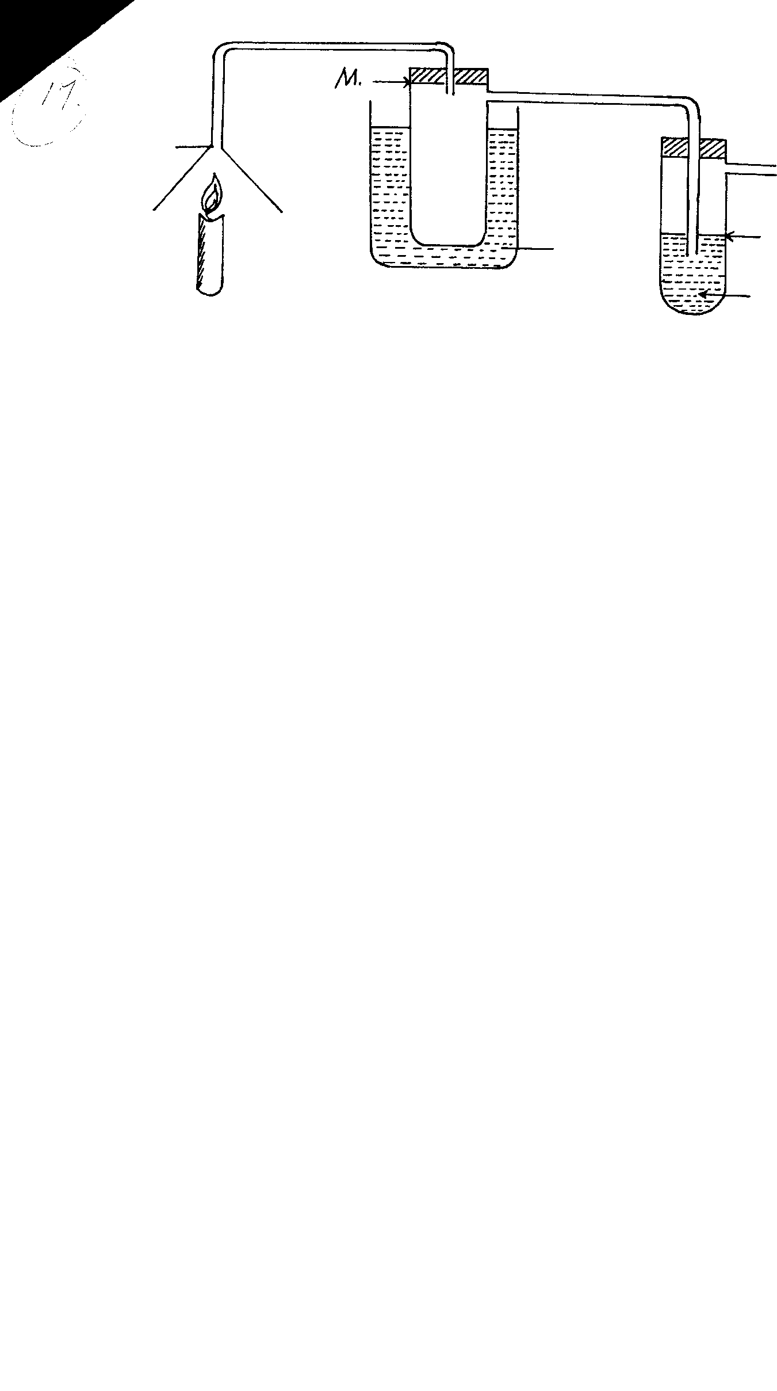

Ice- cold mixture

N

Calcium hydroxide

M

Inverted funnel

candle

Ice cold water

To pump or aspirator

Aqueous sodium hydroxide

(a) Identify the substance that form in tube **M** (1mark)

………………………………………………………………………………………………………

(b) What observation would be made in tube **N**. Explain your answer.  (1mark)

………………………………………………………………………………………………………………………………………………………………………………………………………………

**26.** A piece of phosphorus was burnt in excess air and the product obtained was shaken with a small amount of hot water to make a solution.

(i)Write an equation for the burning of phosphorus in excess air. (1mark)

…………………………………………………………………………………………………………

………………………………………………………………………………………………………..

(ii)State the observation that would be made when both red and blue litmus papers are dipped into the

resulting solution (1mark)

………………………………………………………………………………………………………..

……………………………………………………………………………………………………….

**27.** The set- up below was used to study one of the chemical properties of ammonia. Study it and answer the questions that follow.

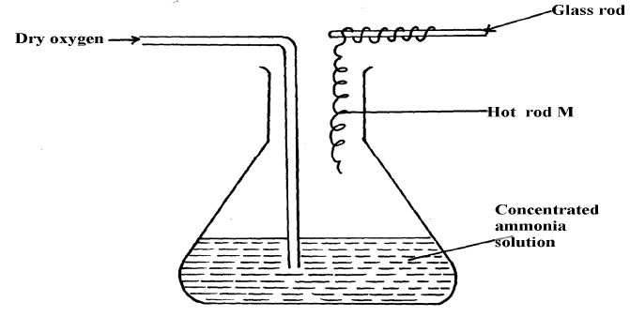

1. Identify metal M (1mark)

………………………………………………………………………………………………….…….

1. State **two** observations that would be made during the experiment above (1mark)

……………………………………………………………………………………………………..

……………………………………………………………………………………………………….

1. Write an equation for the reaction that occurs. (1mark)

………………………………………………………………………………………………………..

**28.** (a) What is an acid- base indicator. (1mark)

……………………………………………………………………………………………………….

………………………………………………………………………………………………………..

………………………………………………………………………………………………………..

(b) Give one example of a commercial acid – base indicator and the colour of the indicator in a basic solution (1mark)

|  |  |
| --- | --- |
| Indicator | Colour in basic solution |
|  |  |

**29.** In a paper chromatography experiment to determine the presence of substances A B, C and D in a mixture M the results shown below were obtained

P

P

Q

R

S

T

M

A

B

C

D

(a) Identify line P. ………………………………………………………………………… (1mark)

(b)What substances are present in mixture M. (1mark)

………………………………………………………………………………………………………………………………………………………………………………………………………………

**30**. Use the standard electrode potential given below to answer the questions that follow

Cu2+(aq) + 2e Cu(s)  Eɵ = + 0.34

I2(aq) + 2e 2I-(aq)  Eɵ = + 0.54

Calculate the e.m.f of the cell made by combining the two half cells above (1mark)

……………………………………………………………………………………………………………………………………………………………………………………………………………..

…………………………………………………………………………………………………….

…………………………………………………………………………………………………….

**31**. Below is a diagram used by a student to investigate zinc / copper electrochemical cell

**V**

Copper electrode

Zinc electrode

1M solution X

1M solution Y

Porous pot

(i) What could solutions X and Y be (1mark)

………………………………………………………………………………………………………………………………………………………………………………………………………………

(ii) On the diagram above show the direction of flow of electrons. (1mark)

(iii) Write an equation for the reaction that occurs at the anode. (1mark)

………………………………………………………………………………………………………

………………………………………………………………………………………………………

**THIS IS THE LAST PRINTED PAGE**