JOINT MOCK EXAMINATION
312/2
GEOGRAPHY
Paper 2
Nov./Dec. 2021
2¾ hours

Instructions to candidates
(a) This paper has two sections; A and B.
(b) Answer all the questions in section A.
(c) Answer question 6 and any other two questions from section B.
(d) Answers must be written in the answer booklet provided.
(e) This paper consists of 6 printed pages.
(f) Candidates should check the question paper to ascertain that all the pages are printed as
indicated and that no questions are missing.

Joint Mock Examination, 2021 Turn over
SECTION A
Answer all the questions in this section.
1. (a) (i) Define Geography. (2 mark)
(ii) Name two branches of Geography (2 marks)
(b) State two reasons why it is important to study Geography. (2 marks)
2. (a) Name two breeds of dairy cattle reared in Kenya. (2 marks)
(b) State two factors which favour dairy farming in Denmark. (2 marks)
3. (a) State two physical factors which influence the location of settlements. (2 marks)
4. The diagram below shows shaft mining.
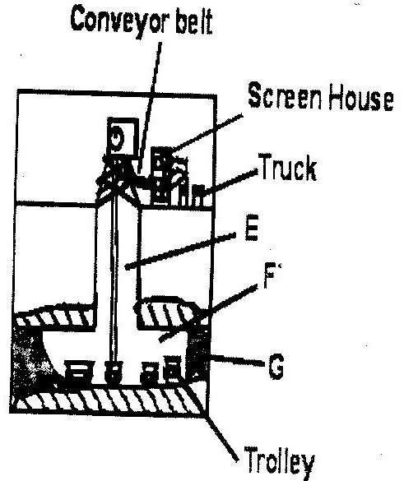

(i) Name the parts marked E, F and G. (3marks)
(ii) State two problems associated with shaft mining. (2marks)
(b) State two factors which influence the occurrence of minerals. (2 marks)

Joint Mock Examination, 2021 Turn over
5. (a) (i) Define the term eco-tourism. (2 marks)

(ii) Name two tourist attraction found in the Rift valley province of Kenya. (2 marks)

(c) Give two reasons why domestic tourism is being encouraged in Kenya. (2 marks)
SECTION B
Answer questions 6 and any other two questions in this section.
6. Study the table below that shows crop production in Kenya between 1978 and 1982 and
answer question (a).
CROP/YEAR | 1978 | 1979 | 1980 | 1981 | 1982
Coffee | 1000 | 990 | 870 | 850 | 840
Tea | 750 | 700 | 650 | 700 | 600
Pyrethrum | 300 | 250 | 350 | 400 | 450
Cotton | 500 | 450 | 550 | 600 | 350
Others | 550 | 300 | 300 | 350 | 300
Crop production in 000’ kilograms
(a) (i) Draw a divided bar 15cm long to represent the crop production in Kenya in 1978.
(8 marks)
(ii) Calculate the percentage decrease in tea production between 1978 and 1979. (2 marks)
(b) (i) Name two research stations that produce maize in Kenya. (2 marks)
(ii) Name two common pests that attack maize in Kenya. (2 marks)
(c) Describe how the following conditions influence the growing of maize;
Topography (3 marks)
Soils (3 marks)
(d) Describe the processing of maize in Kenya. (5 marks)

Joint Mock Examination, 2021 Turn over
7. (a) (i) What is Agroforestry? (1 mark)
(ii) Give four reasons why afforestation is being encouraged in Kenya. (4 marks)
(b) (i) List two factors that determine the distribution of forests in Kenya. (2 marks)
(ii) Give two economic uses of mangrove forests. (2 marks)
(c) (i) Compare forestry in Canada and Kenya under the following sub – headings.
Tree harvesting. (2 marks)
Transportation of logs. (2 marks)
(d) Explain three problems that affect forestry in Canada. (6 marks)
(e) You are supposed to carry out a field study on Agroforestry in the area around your
school.
(i) State three reasons why it would be necessary to visit the area before the day of the
study. (3 marks)
(ii) Give three significance of agroforestry you are likely to identify during the study.
(3 marks)

8. (a) (i) A part from draining swamps, state two other methods used in reclaiming land in
Kenya. (2 marks)
(ii) State three benefits that resulted from reclamation of the Yala swamp. (3 marks)
(b) (i) Draw a map of Kenya; (2 marks)
(ii) On the map drawn, locate the following;
Perkerra irrigation scheme (1 mark)
Mwea Tebere irrigation scheme (1 mark)
River Tana (1 mark)
(c) Describe the stages in the reclamation of land from the sea in the Netherlands. (7 marks)
(d) Explain four benefits of land reclamation in the Netherlands. (8 marks)

Joint Mock Examination, 2021 Turn over

9. The map below shows some major fishing grounds in the world. Use it to answer question (a)
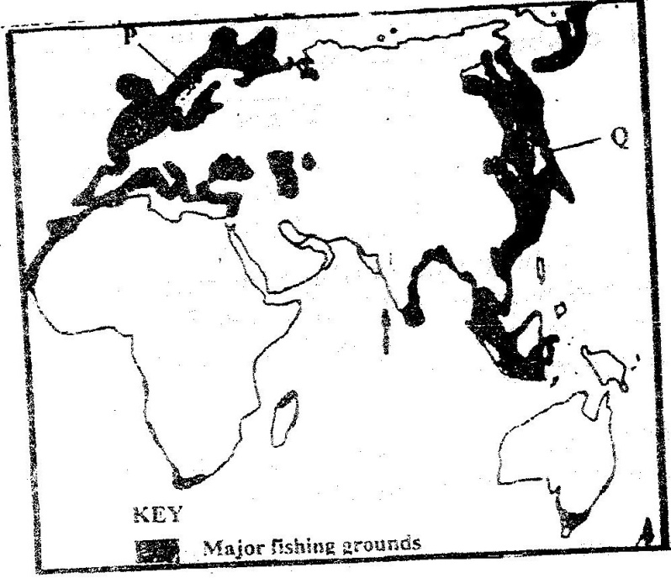

(a) (i) Name the countries marked P and Q. (2 marks)

(ii) Name one types of fish caught along the west coast of country Q. (1 mark)

(iii) Name two methods of fishing used in the shaded areas. (2 marks)

(iv) Explain three conditions that favour fishing in the shaded coastal waters. (6 marks)

(b) Explain four ways in which marine fisheries in Kenya can be conserved. (8 marks)

(c) Explain three problems experienced by fishermen while fishing in Lake Victoria.
(6 marks)

©2021
Joint Mock Examination, 2021 Turn over

10. (a) Define the following terms;
overpopulation (1 mark)
optimum population (1 mark)
(b) How does Kenya’s population differ from that of Sweden? (4 marks)
(c) The population pyramid below represents the population structure of a country.
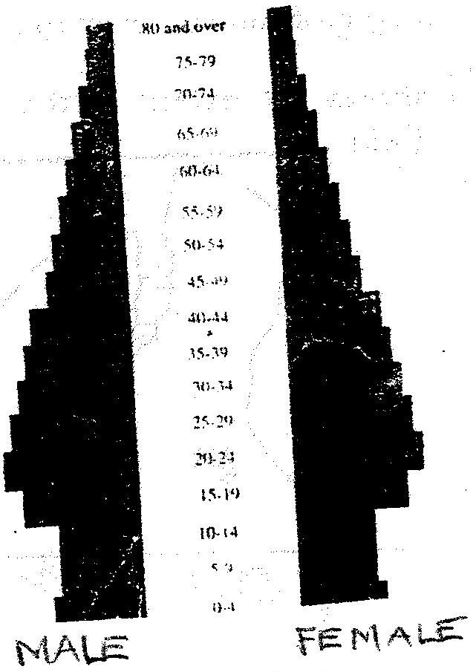

Describe the characteristics of the population as represented by the pyramid. (4 marks)
(d) Explain four factors that influence population distribution in Kenya. (4 marks)
(e) (i) A part from rural – rural migration, list three other types of migrations in Kenya.
(3 marks)
(ii) Explain four causes of rural – rural migration in Kenya. (8 marks)

THIS IS THE LAST PRINTED PAGE

