NAME......................................................................... ADM.............................
GATITU MIXED SECONDARY SCHOOL
AGRICULTURE FORM 1 CAT 2 2013

1. State two roles of humus in the soil that are beneficial to crops 2mks

2. Outline five activities that may be undertaken in organic farming 5mks

3. List four effects of temperature on crop growth 4mks

4. State four ways by which wind affects the growth of crops 4mks

5. Name two factors related to light that affect crop production and distribution in Kenya 2mks

6. Describe the environmental conditions that may lead to low crop yields 4mks

7. List three environmental factors that affect crop distribution in Kenya 3mks

8. State one physical characteristic used in classifying soil 1mk

9. Outline four advantages of organic farming 4mks

10. The diagrams below show an experiment carried out by a form 1 class. Study them carefully and
Answer questions that follow:
E
D
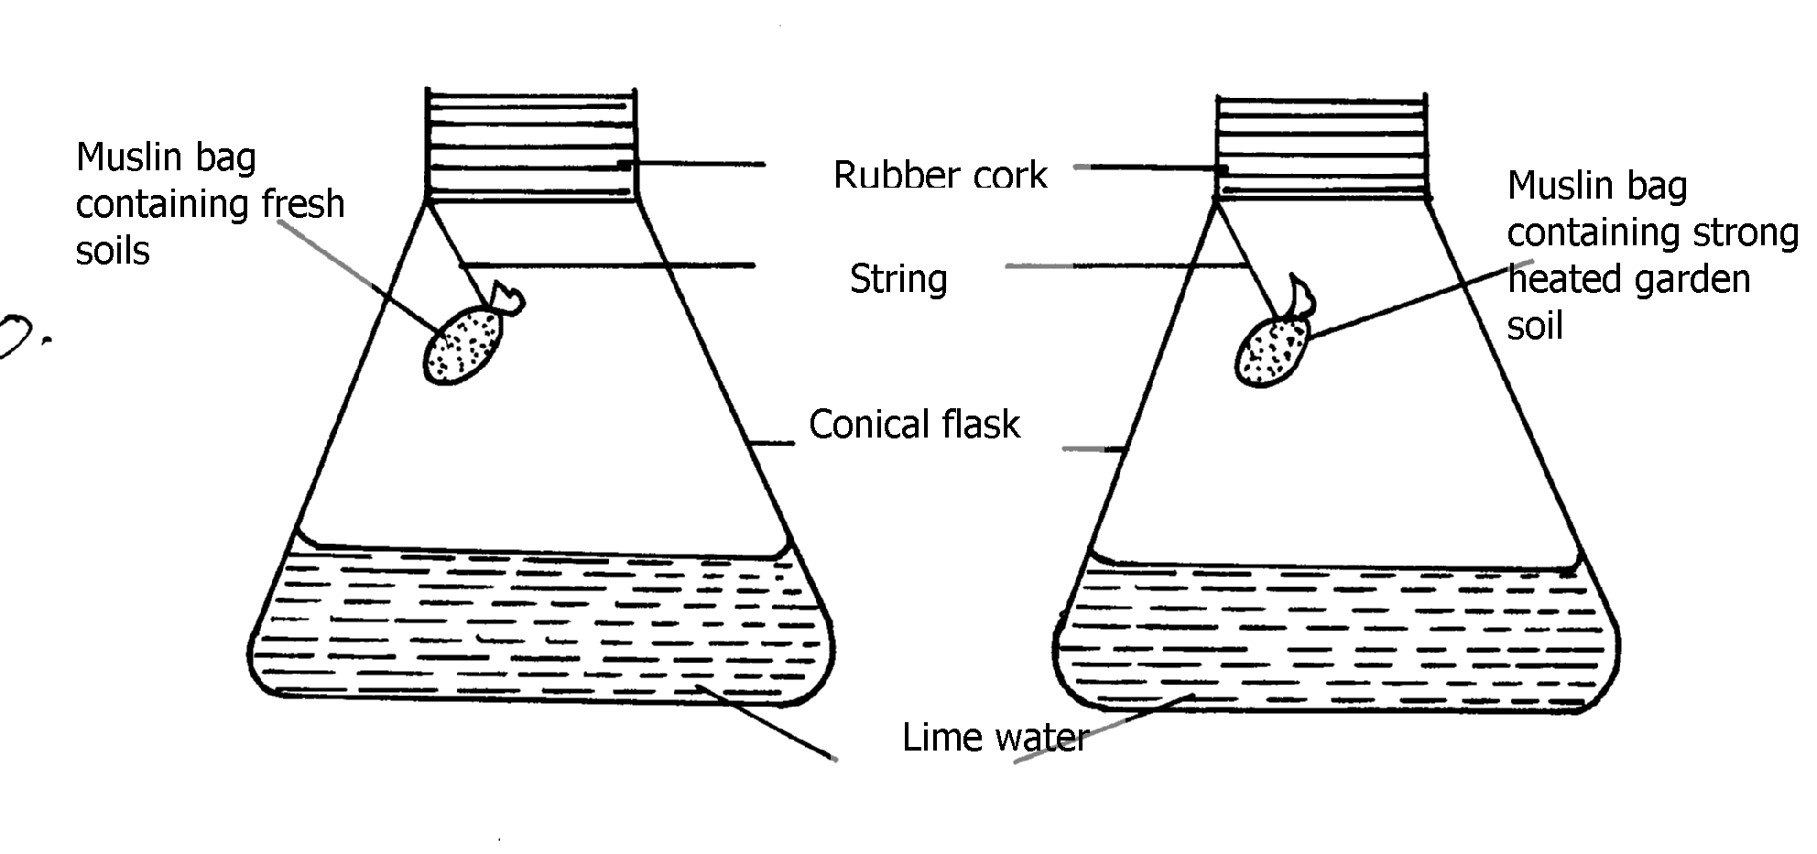

(a) What was the aim of the experiment? 1mk

(b) What was the observation that form 1 students made at the end of the experiment in
Flasks D and E? 2mks

11. What are the three aspects of light that are important to a farmer? 3mks

12. Study the diagram below and answer the questions that follow
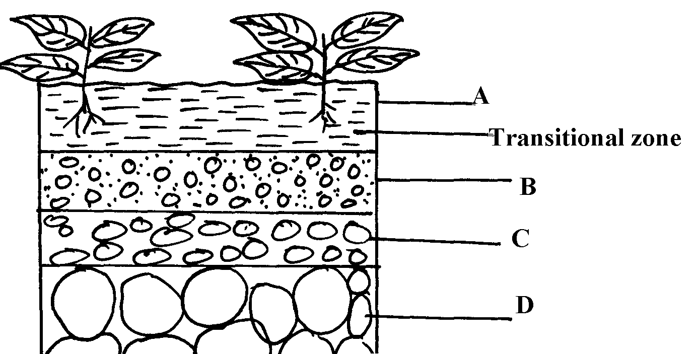

a) State merits of horizon A 3mks

b) State distinct features of horizon B 3mks

c) What does the term transition zone refer to in soil profile 2mks

i) Name horizon C and state its importance 2mks

13. Outline two ways temperature affects crop production 2mks

14. Mention four ways of modifying soil temperature in crop production 4mks

15. List four environmental factors that affect crop production in Kenya 4mks

16. Give four factors that influence soil formation 4mks

17. Name any three agents of biological weathering 3mks

