NAME: …………………………………………..…………………………. DATE: ……………………
SCHOOL…………………………………………………………………….……..ADM NO:.…………….... CANDIDATE’S SIGNATURE: …………..…

443
AGRICULTURE
FORM ONE
TIME: 2 HOURS
THIRD TRIAL 2017

Kenya Certificate of Secondary Education

INSTRUCTIONS TO CANDIDATES
- Write your name and admission number in the spaces provided above.
- Answer ALL the questions in the spaces provided.

FOR EXAMINERS USE ONLY
QUESTIONS | MAXIMUM SCORE | CANDIDATES SCORE
1 – 19 | 70

QUESTIONS
- State three biotic factors that affect aquaculture (3 mks)
…………………………………………………………………………………………………………………………………………………………………….
…………………………………………………………………………………………………………………………………………………………………….
…………………………………………………………………………………………………………………………………………………………………….
- Give four beneficial of soil micro organism to crops (4 mks)
…………………………………………………………………………………………………………………………………………………………………….
…………………………………………………………………………………………………………………………………………………………………….
…………………………………………………………………………………………………………………………………………………………………….
…………………………………………………………………………………………………………………………………………………………………….
- Outline four ways in which high temperature affects agricultural production in Kenya (4 mks)
…………………………………………………………………………………………………………………………………………………………………….
…………………………………………………………………………………………………………………………………………………………………….
…………………………………………………………………………………………………………………………………………………………………….
…………………………………………………………………………………………………………………………………………………………………….

- Distinguish between soil structure and soil texture (2 mks)
…………………………………………………………………………………………………………………………………………………………………….
…………………………………………………………………………………………………………………………………………………………………….
…………………………………………………………………………………………………………………………………………………………………….
- Name two mechanical ways of separating soil particles according to size during soil analysis (2 mks)
…………………………………………………………………………………………………………………………………………………………………….
…………………………………………………………………………………………………………………………………………………………………….

- Name two processes of rock weathering other than biological weathering (2 mks)
……………………………………………………………………………………………………………………………………………………………….
……………………………………………………………………………………………………………………………………………………………….
- List two aspects of biological rock weathering (2 mks)
……………………………………………………………………………………………………………………………………………………………….
……………………………………………………………………………………………………………………………………………………………….

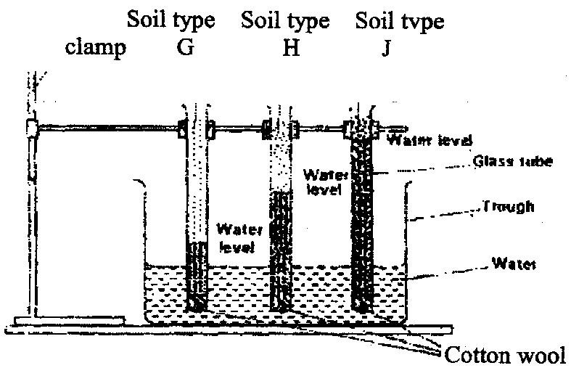
- The diagram below shows an experiment set up using soil types G, H and J and observations made after 24 hours. Study the diagram and answer the questions that follow.

- What is the experiment represented above designed to study (1 mk)
……………………………………………………………………………………………………………………………………………………………….

- Name the three soil types G, H and J. (3 mks)
……………………………………………………………………………………………………………………………………………………………….
……………………………………………………………………………………………………………………………………………………………….
……………………………………………………………………………………………………………………………………………………………….

- What is the characteristic texture of soil types G and J (2 mks)
……………………………………………………………………………………………………………………………………………………………….
……………………………………………………………………………………………………………………………………………………………….

- State how a farmer would improve the structure of soil type G. (1 mk)
……………………………………………………………………………………………………………………………………………………………….

- State three beneficial of good soil structure (3 mks)
…………………………………………………………………………………………………………………………………………………………………….
…………………………………………………………………………………………………………………………………………………………………….
…………………………………………………………………………………………………………………………………………………………………….

- List four environmental structure that affect crop distribution in Kenya (4 mks)
…………………………………………………………………………………………………………………………………………………………………….
…………………………………………………………………………………………………………………………………………………………………….
…………………………………………………………………………………………………………………………………………………………………….
…………………………………………………………………………………………………………………………………………………………………….

- Give three reasons why soil is important to crops (3 mks)
…………………………………………………………………………………………………………………………………………………………………….
…………………………………………………………………………………………………………………………………………………………………….
…………………………………………………………………………………………………………………………………………………………………….

- Give four conditions that favour shifting cultivation (4 mks)
…………………………………………………………………………………………………………………………………………………………………….
…………………………………………………………………………………………………………………………………………………………………….
…………………………………………………………………………………………………………………………………………………………………….
…………………………………………………………………………………………………………………………………………………………………….

- Name four soil constituents (4 mks)
…………………………………………………………………………………………………………………………………………………………………….
…………………………………………………………………………………………………………………………………………………………………….
…………………………………………………………………………………………………………………………………………………………………….
…………………………………………………………………………………………………………………………………………………………………….

- Define the term soil profile (1 mk)
……………………………………………………………………………………………………………………………………………………………….
……………………………………………………………………………………………………………………………………………………………….
- What is a transitional zone as applied is soil profile (1 mk)
……………………………………………………………………………………………………………………………………………………………….
……………………………………………………………………………………………………………………………………………………………….
- Give two characteristics of sub soil as a zone of soil profile (2 mks)
……………………………………………………………………………………………………………………………………………………………….
……………………………………………………………………………………………………………………………………………………………….
- Outline four importance of ranching in arid and semi arid areas (4 mks)
…………………………………………………………………………………………………………………………………………………………………….
…………………………………………………………………………………………………………………………………………………………………….
…………………………………………………………………………………………………………………………………………………………………….
…………………………………………………………………………………………………………………………………………………………………….

- Differentiate between agricultural engineering and agricultural economics (2 mks)
…………………………………………………………………………………………………………………………………………………………………….
…………………………………………………………………………………………………………………………………………………………………….
…………………………………………………………………………………………………………………………………………………………………….
…………………………………………………………………………………………………………………………………………………………………….
- In each of the above give one positive significance to an agricultural production (2 mks)
…………………………………………………………………………………………………………………………………………………………………….
…………………………………………………………………………………………………………………………………………………………………….
…………………………………………………………………………………………………………………………………………………………………….
…………………………………………………………………………………………………………………………………………………………………….
- Give four advantages of mixed farming (4 mks)
…………………………………………………………………………………………………………………………………………………………………….
…………………………………………………………………………………………………………………………………………………………………….
…………………………………………………………………………………………………………………………………………………………………….
…………………………………………………………………………………………………………………………………………………………………….
- List three factors that contribute to soil formation (3 mks)
…………………………………………………………………………………………………………………………………………………………………….
…………………………………………………………………………………………………………………………………………………………………….
…………………………………………………………………………………………………………………………………………………………………….
- Outline three ways level of education influences agricultural development in Kenya (3 mks)
…………………………………………………………………………………………………………………………………………………………………….
…………………………………………………………………………………………………………………………………………………………………….
…………………………………………………………………………………………………………………………………………………………………….
- Give four examples of livestock production as a branch of agriculture practiced in Kenya (4 mks)
…………………………………………………………………………………………………………………………………………………………………….
…………………………………………………………………………………………………………………………………………………………………….
…………………………………………………………………………………………………………………………………………………………………….
…………………………………………………………………………………………………………………………………………………………………….
END OF PRINTED PAGE

