NAME………………………………………………………….ADM NO………………………
SCHOOL…………………………………………………….. DATE……………………………
SIGN…………………………….

BIOLOGY
COMBINED PAPER
(Theory)
JULY/AUGUST 2016
TIME: 2 HOURS

TOP EVALUATION EXAMINATIONS 2016
FORM 1 PAPER

INSTRUCTIONS TO CANDIDATES
- Write your name and admission number in the spaces provided above
- Sign and write the date of examination in the spaces provided above
- Answer all questions
- Answers must be written in the spaces provided in the question paper
- This question paper has 8 printed pages.
- Students should check the question paper to ascertain that all the pages are printed as indicated and that not questions are missing
- Students should answer the questions in English.

FOR EXAMINER’S USE ONLY
Question | Maximum score | Student’s Score
1-12 | 80

1.List and explain four branches of biology. (4marks)
……………………………………………………………………………………………………………………………………………………………………………………………………………………………………………………………………………………………………………………………………………………………………………………………………………………………………………………………………………………………………………………………………………………………………………………………………………………………………………………………………………………………………………………………………………………………………………….
2. Name three careers that study of Biology enables one to enter. (3marks)
……………………………………………………………………………………………………………………………………………………………………………………………………………………………………………………………………………………………………………………………………………………………………………………………………………………………………………………………………………………………………..
3. Discuss two characteristics of living things. (4 marks)
……………………………………………………………………………………………………………………………………………………………………………………………………………………………………………………………………………………………………………………………………………………………………………………………………………………………………………………………………………………………………………………………………………………………………………………………………………………………………………………………………………………………………………………………………………………………………………….
4. Identify each of the following materials and state its use. (6marks)

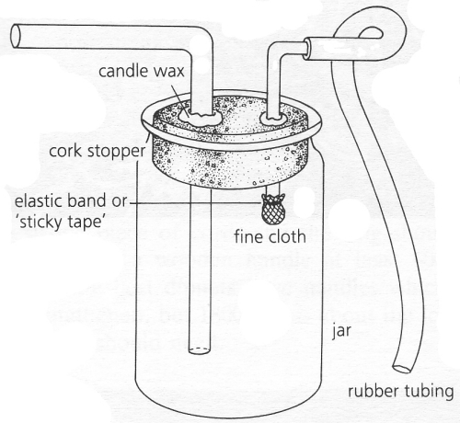
Name:……………………………………………………………………………………………………..
Use:…………………………………………………………………………………………………………………………………………………………………………………………………………………………

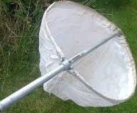

Name:………………………………………………………………………………………………………..

Use:…………………………………………………………………………………………………………..
Name: ……………………………………………………………………………………………………………..
Use:………………………………………………………………………………………………………….

5. State the differences between plants and animals. (3 marks)
……………………………………………………………………………………………………………………………………………………………………………………………………………………………………………………………………………………………………………………………………………………………………………………………………………………………………………………………………………………………………………………………………………………………………………………………………………………………………………………………………………………………………………………………………………………………………………….

6. (a) Define: (2 marks)
- Classification.
……………………………………………………………………………………………………………………………………………………………………………………………………………..
- Taxonomy
……………………………………………………………………………………………………………………………………………………………………………………………………………………………………………………………………………………………………………………………………
(b) Outline the steps followed in using a magnifying lens to observe specimen. (2 marks)
………………………………………………………………………………………………………………………………………………………………………………………………………………………………………………………………………………………………………………………………………………………………………………………
(c) Give two reasons for classification. (2 marks)
………………………………………………………………………………………………………………………………………………………………………………………………………………………………………………………………………………………………………………………………………………………………………………………

7. (a) Identify the kingdom each of the following belong. (3 marks)

i) Moulds – …………………………………………………………………………………………………………..
ii) Protozoa – ……………………………………………………………………………………………………
iii) maize …………………………………………………………………………………………

(b) List any three external features of a plant. (3 marks)
………………………………………………………………………………………………………………………………………………………………………………………………………………………………………………………………………………………………………………………………………………………………………………………

8.(a) Below is a part of a microscope. Use it to answer the questions that follow.

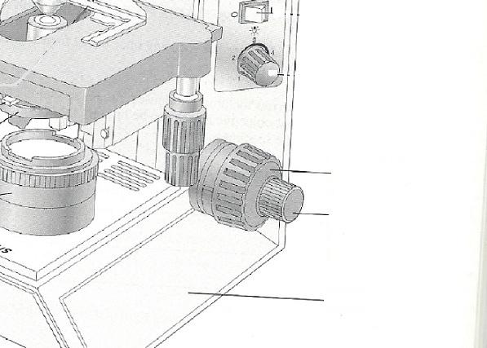
- On the diagram,label the three parts. (3 marks)
- Give the function of each of the three parts labeled. (3 marks)
………………………………………………………………………………………………………………………………………………………………………………………………………………………………………………………………………………………………………………………………………………………………………………………………………………………………………………………………………………………………………………………………………………………………………………………………………………………………………………………………………………………………………………………………………………………………………………
(b) Describe the steps followed when using a microscope. (4 marks)
………………………………………………………………………………………………………………………………………………………………………………………………………………………………………………………………………………………………………………………………………………………………………………………………………………………………………………………………………………………………………………………………………………………………………………………………………………………………………………………………………………………………………………………………………………………………………………

(c) Give the ways of caring for a microscope. (2 marks)
………………………………………………………………………………………………………………………………………………………………………………………………………………………………………………………………………………………………………………………………………………

9. Below is plant cell Structure as Seen Through the Electron Microscope. Use it to answer questions that follow.

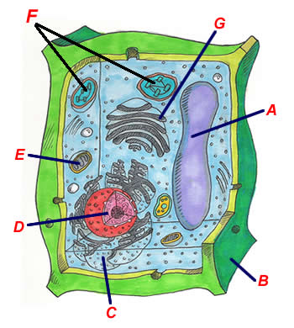

- Name the part labeled: (4 marks)
- A ………………………………………………………………………………………
- B ………………………………………………………………………………………
- C …………………………………………………………………………………….
- D …………………………………………………………………………………….

- Give the function(s) of:
- F (1 mark)
…………………………………………………………………………………………………………………………………………………………………………………………………………………..
- G (2 marks)
………………………………………………………………………………………………………………………………………………………………………………………………………………………………………………..
- Explain the adaptation of part E to its function. (2 marks)
………………………………………………………………………………………………………………………………………………………………………………………………………………………………………………..
- Name the organelle: (3 marks)
- That controls the movement of substances into and out of the cell.
…………………………………………………………………………………………………
- Which is a jelly-like substance in which chemical processes are carried out.
…………………………………………………………………………………………………
- That consist of protein and ribonucleic acid (RNA).
………………………………………………………………………………………………..
- Identify three organelles found in both plant and animal cell. (3 marks)
. ……………………………………………………………………………………………………………………………………………………………………………………………………………………………………………………………………………………………..………………………………………………………………………..

10. State the: (2 marks)
(a) Advantage the Electron Microscope has over the light microscope.
………………………………………………………………………………………………………………………………………………………………………………………………………………………………………………..
(b) Advantage the light microscope has over the Electron Microscope.
………………………………………………………………………………………………………………………………………………………………………………………………………………………………………………..

11. Give four differences between animal cell and plant cell. (4 marks)
………………………………………………………………………………………………………………………………………………………………………………………………………………………………………………..……………………………………………………………………………………………………………………………………………………………………………………………………………………………………………….………………………………………………………………………………………………………………………………………………………………………………………………………………………………………………..
12. The diagram shows a typical experiment using Visking tubing and sucrose solution to demonstrate a certain process:
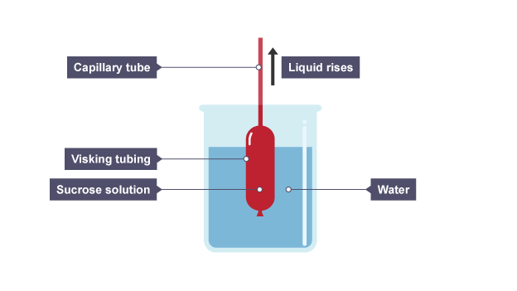
(a)State the purpose of the experiment above. (1 mark)
………………………………………………………………………………………………………………………………………………………………………………………………………………………………
(b) Give two conditions necessary for the process above to occur. (2 marks)
…………………………………………………………………………………………………………………………………………………………………………………………………………………………………………………………
(c) Give ways in which you will make this test fair and accurate by. (3 marks)
………………………………………………………………………………………………………………………………………………………………………………………………………………………………………………………………………………………………………………………………………………………………………………………………………………………………………………………………..
(d) Give the observation when the set up was left for 12 hours. (1 mark)
…………………………………………………………………………………………………………………………………………………………………………………………………………………………………………………………
- Account for (d) above. (2 marks) ………………………………………………………………………………………………………………………………………………………………………………………………………………………………………………………………………………………………………………………………………………………………………………

(g) Explain two factors affecting the the process under investigation above. (4 marks)
………………………………………………………………………………………………………………………………………………………………………………………………………………………………………………………………………………………………………………………………………………………………………………………………………………………………………………………………………………………………………………………………………………………………………………………………………………………………………………………………………………………………………………………………………………………………………………
- Define the following terms: (2 marks)
- Hypertonic solution
……………………………………………………………………………………………………………………………………………………………………………………………………………………………………………………
- Isotonic solution
…………………………………………………………………………………………………………………………………………………………………………………………………………………………………………………………

