Name ………………………………………………………………
GATITU MIXED SECONDARY SCHOOL
BIOLOGY FORM 1 END OF TERM 2 2013 EXAM
- What is a cell? 2mks

- Name 3 cell structures that can only be seen under
- Light microscope 3mks

- Electron microscope 3mks

- If the nucleus of a cell is removed , what would happen to that cell and why 3mks

- Define the following 3mks
- A tissue

- An organ

- An organ system

- What is cell specialization 2mks

- What is the name of a scientist who studies cells 1mk

- Name the cell organelle which
- Form ribosomes

- Transports lipids 2mks

- The diagram below is that of a palisade cell. Name the structures labeled A,B and c 3mks
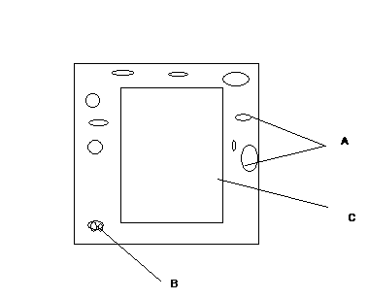
Name the structures labeled A,B and c 3mks

- The diagram below represents a certain cell organelle

- Identify the above cell organelle 1mk

- Name part labeled X 1mk

- State the function of the above cell organelle 1mk

- Compare the structure of plant and animal cells 5mks

- A drawing of 5 cm in length, was made of a beetle whose actual length was 1 cm. calculate the magnification of the drawing. 2mks

- What are the functions of
- Connective tissue

- Epidermal tissue

- Parenchyma tissue 6mks

- Define the term species 2mks

