GATITU DAY MIXED SECONDARY SCHOOL
BIOLOGY FORM 1
END OF TERM 2 2012 EVALUATION EXAM
- State two branches of Biology and define each. (2mks)

2. A motor vehicle is to move and break down fuel to carbon (IV) oxide as water yet it is not classified as a living thing. List other characteristics of living things that are not shown by a motor vehicle. (3mks)

3. Write equations for the following processes: (6mks)
a. Photosynthesis

b. Photolysis

c. Carbon (IV) oxide fixation

4. a) Draw and label the structure of the chloroplast (5mks)

b) Where does photolysis take place (1mk)
c) Where does carbon dioxide fixation take place (1mk)

5) State and briefly describe the four factors that affect the rate of photosynthesis (8mks)

6.Define the following terminologies
a) Nutrition (2mks)

b) Heterotrophism (2mks)

c) Autotrophism (2mks)

7. The figure below shows the external structures of a plant leaf. (3mks)

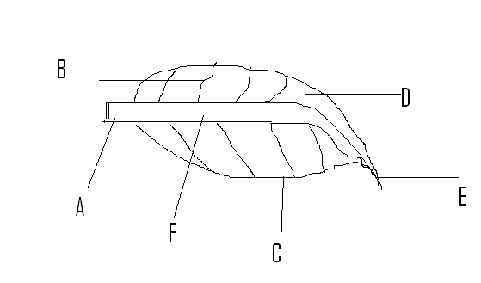
8. What is cell physiology? (2mks)

9. List 3 types of carbohydrates (3mks)

10. Give 3 properties of monosaccharides (3mks)

11. Name 3 examples of monosaccharides (3mks)

12. Explain the following terms. (4mks)
a) active transport.

b) Plasmolysis

13. Give 3 properties of a cell membrane (3mks)

14. What are the functions of: (3mks)
a) a sweep net

b) Pooter

c) pair of forceps

15. Outline two types of disaccharides and 2 types of polysaccharides. (4mks)

16. Explain how a plant leaf is adapted to its functions (10mks)

