**Name:**.................................................................................... **Index No.:**............................

**Class………………………**

**Candidate’s Signature**: .........................

**Date**: ...................................

**232/3**

**PHYSICS**

**Paper 3**

**PRACTICAL**

**TERM 1, 2018**

**Time: 2¼ hours**

**POST EVALUATION EXAMINATION**

**FORM FOUR END TERM EXAMINATION**

**PHYSICS**

**Paper 3**

**Instructions to Candidates**

* *Write your name and index number in the spaces provided above.*
* *Sign and write the date of the examination paper.*
* *Answer* ***ALL*** *the questions in the spaces provided in the question paper.*
* *ALL working* ***MUST*** *be clearly shown where necessary.*
* *Mathematical tables and silent electronic calculators may be used.*
* *Candidates should check the paper to ascertain that all the pages are printed as indicated and that no questions are missing.*
* *Take density of water 1g/cm3.*

1.  ***You are provided with:***

* A resistance wire mounted on millimeter scale
* Two dry cells in a cell holder
* A voltmeter
* Four connecting wires, one with a crocodile clip at one end

***Proceed as follows:-***

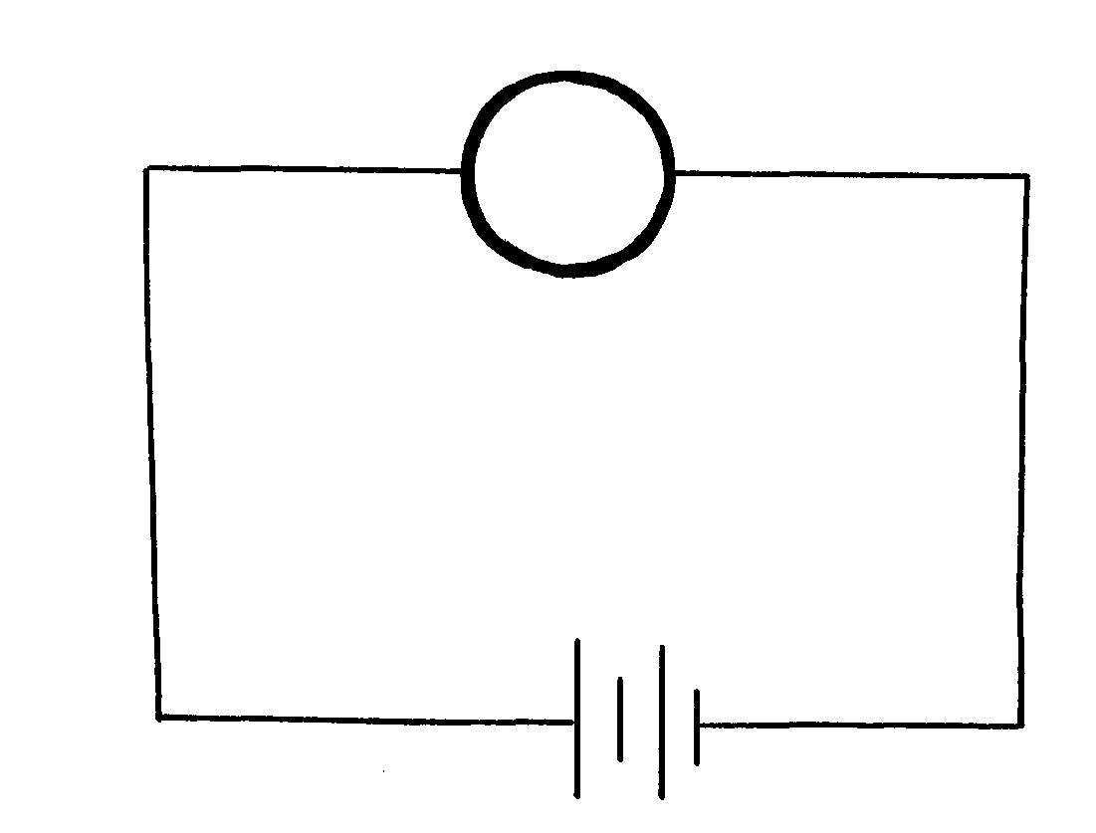(a) Set up the circuit as in the figure below and determine the total electromotive force E, of the cells.

V

Electromotive force E, of the cells……………….………………………..…..Volts. 1 Mark

(b) Set up the circuit shown in the figure below, connect the wire with clip on the mounted wire at a length (L) of 10cm from the end marked A. Record the voltmeter reading in the table provided in part (c) below:

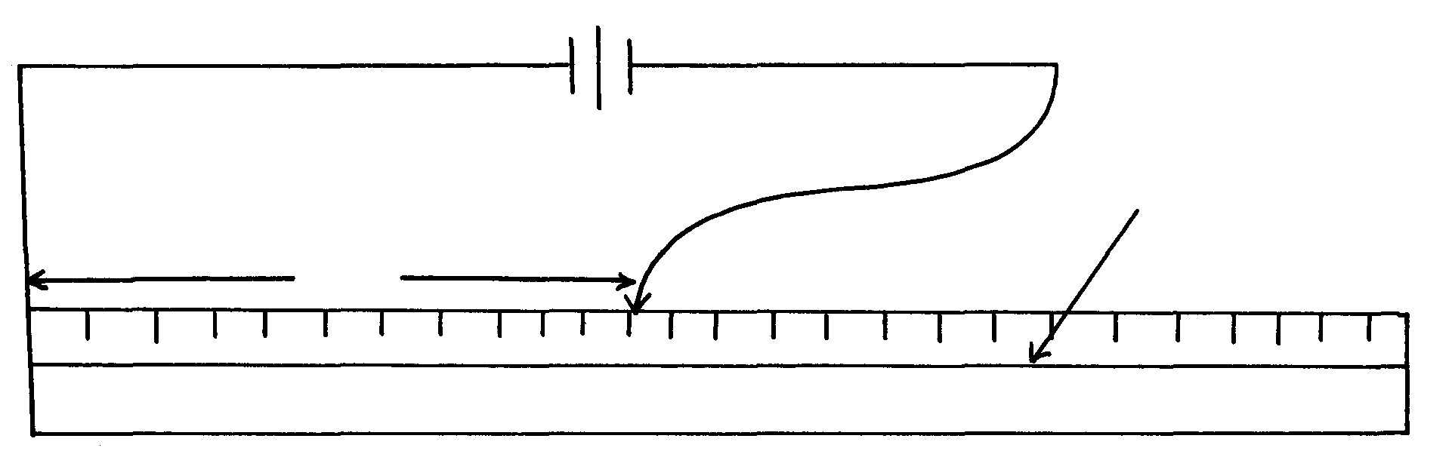

Resistance wire

(c) Repeat the procedure in (b) above for the following values of length L: 20cm, 30cm, 40cm, 50cm, and 60cm and complete the table below: 5 marks

|  |  |  |  |
| --- | --- | --- | --- |
| L(cm) | V(volts) | E-V(volts) | V  E- V |
| 10 |  |  |  |
| 20 |  |  |  |
| 30 |  |  |  |
| 40 |  |  |  |
| 50 |  |  |  |
| 60 |  |  |  |

(d) Plot a graph of against L(cm) on the grid provided. (5mks)





(e) Determine the slope of the graph. (2mks)

………………………………………………………………………………………………………………………………………………………………………………………………………………………………………………………………………………………………………………………………………………………………

(f) Given the equation



Determine the values of K1 and K2 (3mks)

………………………………………………………………………………………………………………………………………………………………………………………………………………………………………………………………………………………………………………………………………………………………

K1…………………………………… K2…………………………………………...

(g) Given that 4K2**r** = 10. Determine the value of **r.** And state its significance. (3 mks)

………………………………………………………………………………………………………………………………………………………………………………………………………………………………………………………………………………………………………………………………………………………………

2. (a) (i)You are provided with the following:

* A metre rule
* Solid labeled K
* A knife edge raised 20cm above the bench
* One 100g mass
* Some thread
* Some water in a beaker labelled W
* Some liquid in a beaker labeled L
* Tissue paper

Proceed as follows:

(ii) Balance the metre rule on the knife edge and record the reading at this point.

Balance point:…………………………………………………cm. 1 Mark

**(For the rest of the experiment the knife edge must be placed at this point)**

**(iii)**Set up the apparatus as shown in the figure below.

10cm

D

X

100g mass

K

water

Use the thread provided to hang the masses such that the position of the support can be adjusted.

The balance point is maintained by adjusting the position of the 100g mass.Note the distance X and D are measured from the knife edge.and the mass K is fully submerged in the water.

Measure mass K………………………………………..kg 1 mark

X=……………………………………………………….m 1 mark

D= ………………………………………………………m 1 mark

Apply the principles of moments to determine the weight W1of K mass in water and hence determine and hence determine the the uptrust Uw in water.

………………………………………………………………………………………………………………………………………………………………………………………………………………………………………………………………………………………

………………………………………………………………………………………………………………………………………………………………………………………………………………………………………………………………………………………………

W1 ……………………………………………………… 1 mark

Uw…………………………………………………………. 1 mark

Remove the K mass from the water and dry it using the tissue paper .

(iii) Replace the beaker W with the one with the one labeled L now keeping the metre rule at same equilibrium with the K mass fully submerged in liquid L maintain the distance D record the value of the distance X..As shown in the figure below.

100g mass

liquid

Solid K

X(m)……………………………………………………………….. 1 mark.

Apply the principle of moments to determine to determine W2 of the the 50g mass in the liquid L and hence determine the upthrust UL in the liquid.

………………………………………………………………………………………………………………………………………………………………………………………………………………………………………………………………………………………………

………………………………………………………………………………………………………………………………………………………………………………………………………………………………………………………………………………………………

W2……………………………………………………………….. 1 Mark

UL………………………………………………………………… 1 Mark

(iv) Determine the the value ……………………………………….1 mark



2. (b) ***You are provided with the following apparatus***:

* A candle
* A lens holder
* A convex lens
* A screen
* A metre rule
* An object

***Proceed as follows:***

Using an object infinity outside the room, focus its image on the screen provided. The image should be as sharp as possible and inverted. Measure the distance from the lens to the screen h cm. Repeat the same for three other values of h. Record your results and then calculate the average value of the three results, Hcm.

First reading of d1………………………………………………………….…

Second reading of d2 ……………………….……………………………….

Third reading of d3………………………………………………………….

The average value of (D) …………………………………………………...(1mk)

Arrange the candle flame, the lens, and the screen as shown in the diagram below:

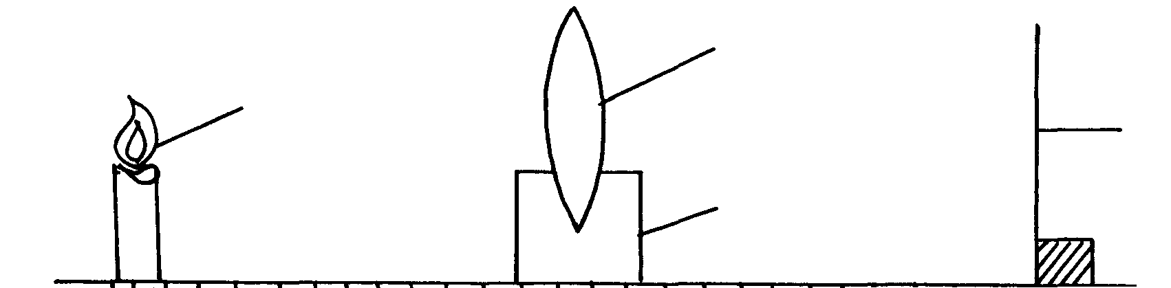

u

v

Candle flame

Screen

Lens holder

Lens

b) i) For particular value of u, adjust the position of the screen until a sharp image appears on the screen. Measure distance Vcm. Repeat the experiment for each of the other values of u, and enter the results in the table below: (3mks)

|  |  |  |  |
| --- | --- | --- | --- |
| **Distance u(cm)** | **Distance V(cm)** | **uv(cm2)** | **U + v (cm)** |
| 12 |  |  |  |
| 18 |  |  |  |
| 24 |  |  |  |
| 30 |  |  |  |

(ii) Plot a graph of **uv** against **u + v**  (4mks)



(iii) From your graph, calculate the slope S (2mks)

………………………………………………………………………………………………………………………………………………………………………………………………………………………………………………………………………………………………

(iv) Calculate the value of k given that *k*D = S (1mk)

………………………………………………………………………………………………………………………………………………………………………………………………………………………………………………………………………………………………

**Confidential.**

**Apart from a transparent 30cm ruler and a calculator each student should have the following.**

* 32G nichrome wire. Labeled A on one end and B on the other end.
* Two new dry cells
* Cell Holder
* 8 connecting wires with crocodile clips on both ends
* Voltmeter 0-5 V
* Metre rule
* Knife edge preferably 20cm height
* One 50g mass labeled K
* One 100g mass
* Two 25cm thread
* Two beakers 250ml one-half filled with water Labeled W and the other with kerosene labeled as liquid L.
* Tissue paper about 4 pieces.
* A candle about 10cm.
* A lens holder
* Convex lens of focal length 10cm
* White screen
* Students should be exposed to a nearby distant object like a window.
* Electronic balance to be shared.