511/3
MUSIC
Paper 3
July 2021
2 ½ hours.

KASSU JET EXAMINATION
Kenya Certificate of Secondary Education
MUSIC
Paper 3
2 ½ hours.

MARK SCHEME

SECTION A: BASIC SKILLS
- a) Continue the given opening to make a melody of 16 bars for voice. Modulate to the Sub-dominant before returning to the tonic. Incorporate a sequence. Add phrase marks. (9 marks)

16 Bars- 1 mark
Correct Modulation- 2 marks
Lyricism- 2 marks
Sequence - 2 marks
Phrasing- 1 mark
Cadences- 1 mark (Final and any other)
(b) Using staff notation, compose a tune to suit the following lyrics. Add phrase marks. (6 marks) Ewe mwana nisikiya nikupapo ushauri,
Mwendo wako na tabia lazima utafakari.
Syllabic division- 1 mark Accentuation- 1 mark
Lyricism- 2 marks Cadences – 1 mark (Final and any other)
Phrasing- 1 mark
Penalise if not indicated
Key signature- ½ mark
Time signature- ½ mark
- Copy and harmonize the given melody for Soprano, Alto, Tenor and Bass (SATB). Choose appropriate chords from the following; I, ii, IV, V and vi. Use a Cadential six four and a dominant seventh chord. Indicate the chords that you use. (15 marks)
Each correct chord (½ mark) – 5 ½ marks Dominant seventh chord – 1mark
Chord progression- 1 ½ marks Cadences – 2 marks
Voice leading- 1 ½ marks Voice range -1 ½ marks
Cadential six-four- 2 marks

SECTION B: HISTORY AND ANALYSIS (48 marks)
3. AFRICAN MUSIC

- Identify each of the following Kenyan dances: (4marks)

Kilumi - Kamba dance, married women, Condemning witchcraft.
Mukinyo - Embu dance, Women, for entertainment.
Ngelem - Nandi dance, Children, Singing game
Owalo - Samia dance, Women, for entertainment.
- Name any two parts of an adeudeu and state how each contributes to sound production.
(4 marks)
- The strings are plucked causing a vibration that produces sound.
- The resonator amplifies the sound produced.
- The tuning pegs tighten or loosen the strings to desired pitch.
- State three different ways in which the solo-choral response style is used in the performance of an African traditional folk song (3 marks)
- One person (soloist) leads then respondents / group answer after soloist has finished.
- Overlapping: Respondents join in before soloist completes his or her part
- A section of the singers lead as the rest respond
- An instrument takes the lead, answered by the singers
- List any three vocal techniques used to embellish a traditional folk performance. (3 marks)
- Ululation
- Whistling
- Heaving and Yodelling
- Shouts

4. WESTERN MUSIC

Answer any two of the questions (a), (b), (c) and (d).

(a) William Byrd
- State any four factors that influenced his music career. (4 marks)
- His association with Thomas Tallis/ Tavernier.
- Studies at musical establishment of chapel royal
- Appointment as organist
- He was made gentleman of royal chapel
- Licensed by queen to print and sell music
- His association with catholic and Anglican church
- Describe any three characteristics of his music (3 marks)
- Mainly vocal
- Polyphonic in texture
- Based in modes
- Free rhythms
- Melismatic
- Use of word painting
- Use of cantus firmus.
b) Haydn Franz Joseph
- Name the four standard classic movements of Haydn’s symphonies. (2 marks)
Allegro, Adagio, Minuet and trio, Fast finale.
- What is the Nelson mass by Haydn scored for? (1 mark)
SATB Soloists, Chorus, Organ and Orchestra.
iii) Outline any two of Haydn’s contributions to the development of the orchestra. (2 marks)
- He added the minuet and trio to his symphonies.
- He replaced the concerto grosso and orchestral suite of the late baroque period in his symphonies.
- He wrote numerous symphonies.
- Identify the following works by Haydn: (2 marks)
- Creation - Oratorio
- Coronation - Mass
- Military - Symphony
- Life on the moon - Opera
c) Franz Liszt
- Outline any three of Liszt’s contribution to music. (3 marks)
- Founded the Liszt’s school of music in Weimar.
- He was a piano teacher all over Paris.
- Created the symphonic poem genre.
- Wrote more than 1000 piano pieces.
- State any two characteristics of Liszt’s piano music. (2 marks)
- Reflect his advanced virtuosity.
- Uses thematic transformation (Variation technique & Leitmotif)
- Name any two of Liszt’s symphonic poems. (2 marks)
- Orpheus
- Prometheus
- Mazeppa
- Festklange
- Heroide funebre
- From the cradle

d) Bela Bartok
- In what musical period did Bela Bartok live? (1 mark)
- 20th Century
- Apart from Bela Bartok name any other four composers of the musical period named above. (4 marks)
- Charles Lives
- Aaron Copland
- Vaughan Williams
- Zoltan Kodaly
- Sibelius
- What was the importance of folk music to Bella Bartok. (2 marks)
- Folk music was an inspiration to Bella Bartok from the begging to the end.
- He imitated the strumming accompaniment‘s to fork tunes
- There is always an earthly feel to Bartok‘s folk songs output
- He applied the folk songs and dances in his most discordant phrases
- He used the established forms like Rondo & Sonata in his folk song arrangement
- His other compositions are saturated with folk music idioms like rhythms, modes
and melodic tunes

5. Prescribed Traditional African Music Chivoti by Diwani Nzaro from Youtube.
- State any two ways in which variety has been created in this work. (2 marks)
- Use of varying textures.
- Having different melodies played by the chivoti
- Write down the rhythm of the: (2 marks)
- Shaken idiophone.
- Struck idiophone.
- State any three roles of the percussive section in this recording. (3 marks)
- Accompany the performance
- Add tone colour
- Maintain the tempo
- Identify any three characteristics of African Music evident in this recording. (3 marks)
- Use of repetition
- Simple melodies
- Melody on chivoti is accompanied by idiophones
6. Prescribed Western: Too Much I Once Lamented: by Thomas Tallis
- By use of bar numbers, identify any two stylistic devices used in this work. (2 marks)
- Imitation - Soprano 2 bars 24 – 25 imitated by Soprano 1 bars 26 – 27.
- Tenor bars 28 – 29 imitates bass bars 26 – 27.
- Soprano 2 bars 28 – 29 imitated by soprano 1 bars 29 – 31.
- Sequence - Bass bar 26 – 27 is a sequence of bar 24 – 25.
- Soprano 1 bar 70 – 71 is a sequence of soprano 1 bar 66 – 67.
- Bass bar 71 – 72 is a sequence of bar 69 – 70.
- Repetition - Soprano 2 (bar 73 is repeated at bar 74)
- Soprano 1 (Bar 73 repeated at bar 74)

- Cite any three types of syncopations used in this work. (3 marks)
- Rest at the beginning of a bar (rest on a strong beat)
Soprano 1 – bars 5, 14, 22, 55, 64
Soprano 2 – bars 8, 13, 45, 54
Alto – bars 10, 19
Tenor – bars 18, 21
- Short note value followed by a long note value.
Alto – bar 24 and 32
Tenor – bar 33, 42
- Tie across a bar.
Sop 1 – bar 5 – 6
Sop 2 – bar 1 – 2
Alto – bars 4 – 5, 8 – 9, 10 – 11.
- By use of bar numbers, identify the texture of this work between bars 24 – 34. Give reasons for your answer. (2 marks)
- Homophonic texture
The melody shifts from bass to tenor to alto and back to bass being accompanied by chords from the other voices that are not doing the melody.
- What is the genre of this work? (1 mark)
Ballet
- What is the music scored for? (1 mark)
Choral SSATB
- What term is given to the entries at the beginning of the music? (1 mark)
Canonic

7. Unprepared Analysis
Study the music below and answer the questions that follow.
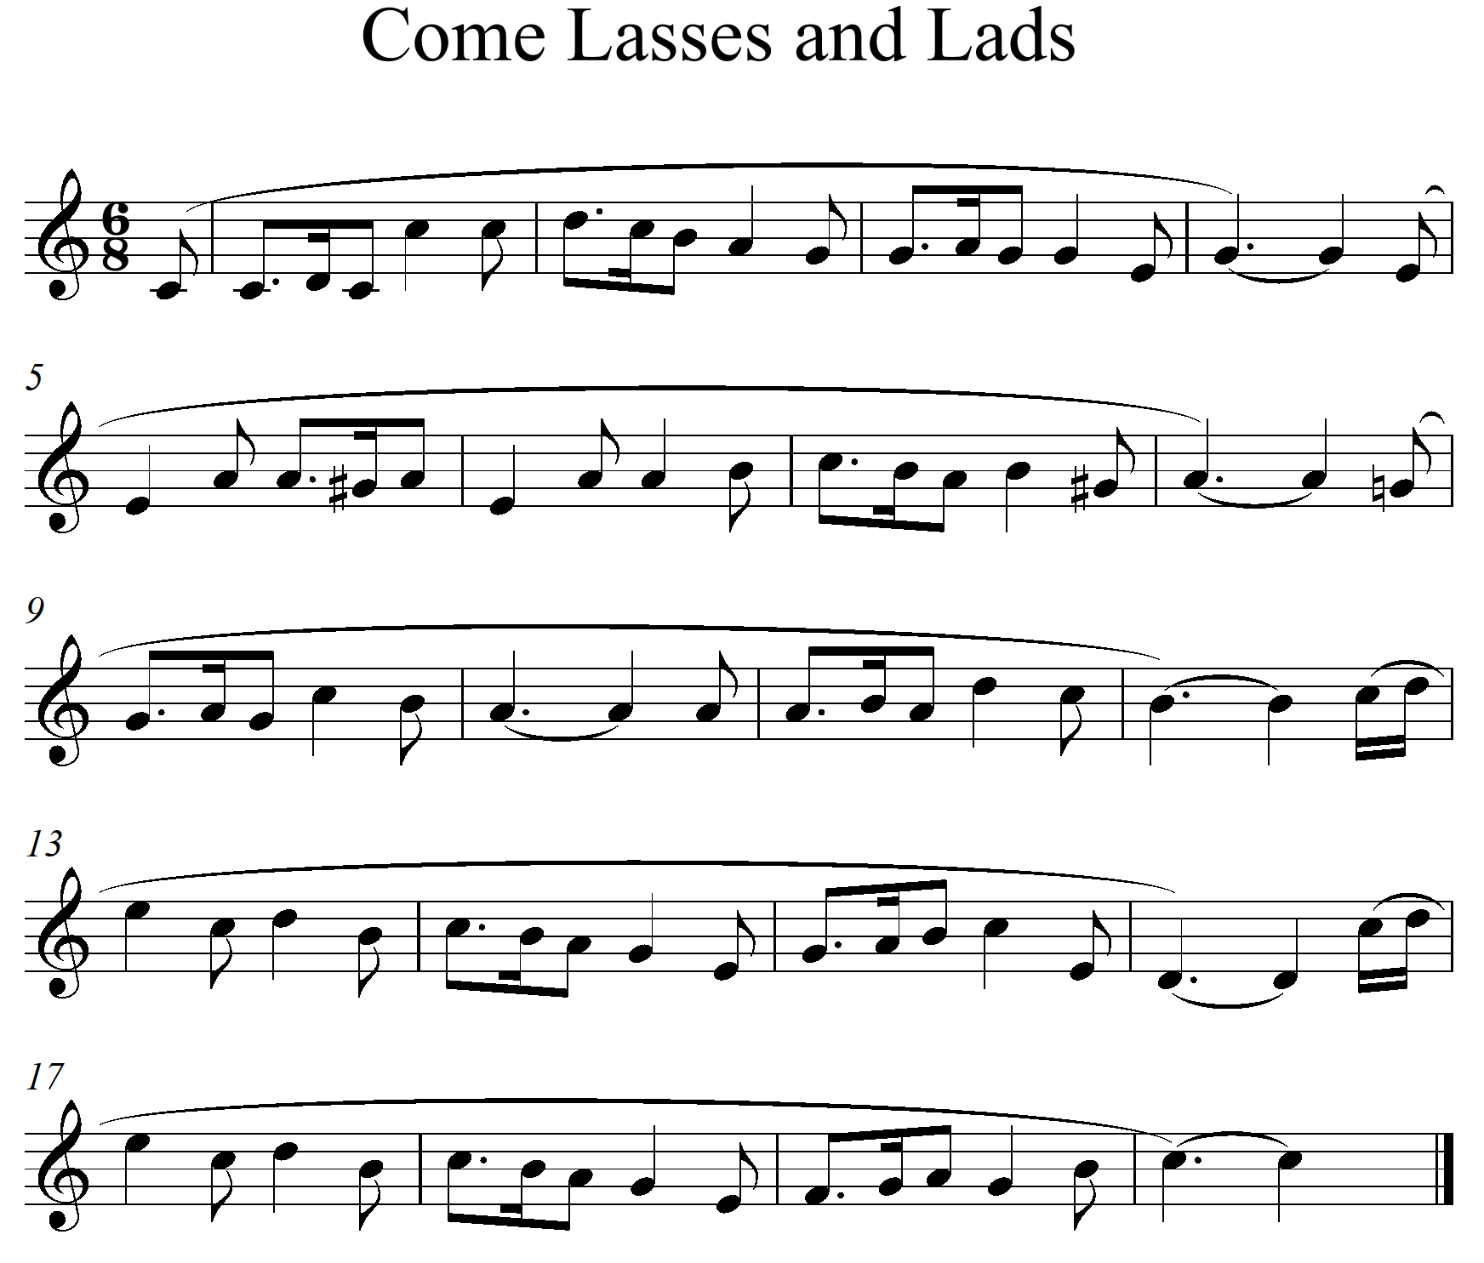
- Name the Tonic key and the key to which the music modulates at bars 7 to 8. (2 marks)
- C major
- Modulates to A minor at bars 7 – 8
- By use of bar numbers, identify the following; (2 marks)
- Exact repetition - bars 12b to 14 repeated at bars 16b to 18.
- Sequence - Bars 9 – 10 sequenced at bars 11 – 12.
- Name the cadence at bar 3 to 4. (1 mark)
- Imperfect cadence
- Write down the most commonly used rhythmic motif. (1 mark)

SECTION C: GENERAL MUSIC KNOWLEDGE (16 marks)
8. a) The following melody is written for a clarinet in B flat. Rewrite it for a violin. (5 marks)
ANSWER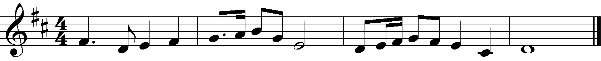
b) (i) Outline any three responsibilities of a Concert promoter. (3 marks)
- Organizes and presents live music events.
- Takes care of booking talent.
- Securing venues and performers
- Budgeting for the concert.
(ii) State any four ways in which musicians in Kenya earn their living. (2 marks)
- Selling their music through digital platforms
- Through live performances
- Getting royalties from music control bodies.
- Selling their music in recorded hard copies format directly.
- By selling sheet music online and on hard copies.
- Define any six of the following terms used in music. (6 marks)
- Arco - Use the bow
- Scherzando - In a playful manner
- Fiddle - A stringed instrument played with a bow.
- Auditions - An interview for a role or job as a singer, actor, dancer or musician
consisting of a practical demonstration of the candidate’s suitability and skill.
- Piracy - Unauthorized use or reproduction of another’s work.
- Drum major - The leader of a matching band who often twirls a baton.
- Andante - At a walking pace.
- Orchestra - A group of performers on various musical instruments playing music as
symphonies, operas, popular music or other compositions.

