PERFECT STEPS PUBLISHERS
END TERM EXAMS 2015
0721 745374/ 0721 707626 NAIROBI
PHYSICS
Form 2
- State with a reason which physics related course would you persue at the University or College (2mks)

- Explain the how temperature and impurities affect surface tension (2mks)

- An object weighs 8.0 N on Earth. What would its weight be on another planet of gravitational acceleration 6.25 N/kg given that acceleration due to gravity on earth is 9.8N/kg (2mks)

- Some cotton wool soaked in concentrated ammonia solution and hydrochloric acid were placed at the ends of a glass tube as shown.

Figure 3

Cotton wool soaked Cotton wool soaked in
in concentrated HCL Concentrated ammonia solution
a) After sometime a white deposit of ammonium chloride forms on the walls of the tube. Using a tick show where the deposit is formed (1mk)

b) Explain your observation. (1mk)

- An object of mass 120g half immersed in water displaced a volume of 20cm³. Calculate
the density of the object. (2mks)

- Explain why steel is normally preferred for constructing pillars or bridges (1mk)

- The mass of a density bottle of volume 60cm³ is 15g when empty. Aluminium tunings are poured into the bottle and the total mass is 70g. Water is added into the turnings till the bottle is full. If the total mass and its contents is 100g,calculate the density of the Aluminium turnings (4mks)

- (a) What is the SI unit of pressure (1mks)

(b) The figure below shows a manometer used to measure pressure. Determine the pressure of the gas(Atmospheric pressure=103000Pa) (4 mks) 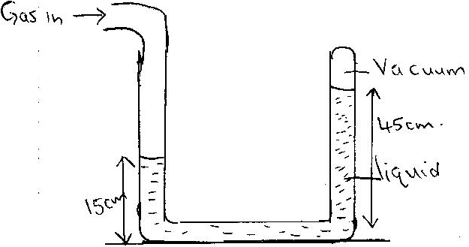

- In an experiment to determine to demonstrate the Brownian motion, bright specks were seen moving randomly. Account for this movement (2mks)

- (a)Briefly explain how a thermostat can be used to maintain the temperature of a room
(4mks)

(b) State two electrical equipments that works as a thermostat (2mks)

- Briefly explain any three factors that affect the conductivity of a solid (6mks)

- State one advantage and disadvantage of anomalous expansion of water (2mks)

- Why is mercury preferred over alcohol as a thermionic liquid (3mks)

- Name and explain how the two defects in a primary cell can be minimized (4mks)

- When a mercury thermometer is used to measure the temperature of hot water, it is observed that the level of mercury first drops before beginning to rise. Explain (2mks)

- Explain why fuel carrying tankers are painted white or silvery (1mk)

- How does a thermos flask minimize heat losses by convection and radiation (2mks)

- The distance of an object placed in front of a pinhole camera is 15cm. it forms an image of linear magnification 0.2. find the image distance (2mks)

- State THREE differences between light waves and sound waves. (3 mks)

- Name two types of progressive wave motion and distinguish between the two waves.
(4 mks)

