GATITU MIXED SECONDARY SCHOOL
PHYSICS FORM II
TUNE UP EXAM TERM III
ANSWER ALL THE QUESTIONS
- Define the following terms 4mks
- Mass

- Density

- Force

- pressure

- Water molecules wet the glass surface while mercury do not explain. 2mks

- Explain why a needle placed carefully on the surface of water does not sink. 2mks

- The air pressure at the base of a mountain is 75.0 cm of mercury while at the top it is 60.0cm of mercury. Given that the average density of air is 1.25kgm⁻³ and the density of mercury is 13,600kgm⁻³, calculate the height of the mountain. 3mks

- State the kinetic theory of matter. 2mks

- Enumerate four effects of anomalous behavior of water. 4mks

- While heating water in beaker wire gauze is placed below the beaker. Explain 2mks

- State the laws of reflection. 2mks

- Name three applications of reflection of light in everyday life. 1 ½ mks

- A pinhole camera of length 15 cm forms an image 3 cm high of a man standing 9 m in front of the camera. What is the height of the man? Give your answer to the nearest cm. 3mks

- The diagram below shows a lenclanche cell use it to answer the questions below.

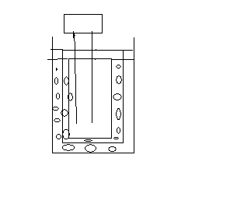
- A B
- What’s the function of manganese (iv) oxide. 2mks

- Explain why some water is observed on the surface of lenlanche cell after being used up? 2mks

**THE END**
Never trouble another for what you can do yourself.
MR KARANJA

