- The figure below shows a micrometer screw gauge used to measure the diameter of a metal rod. When the rod is removed and the jaws of the micrometer screw gauge are closed, the reading is 0.12mm. Determine the diameter of the rod. (2 marks)

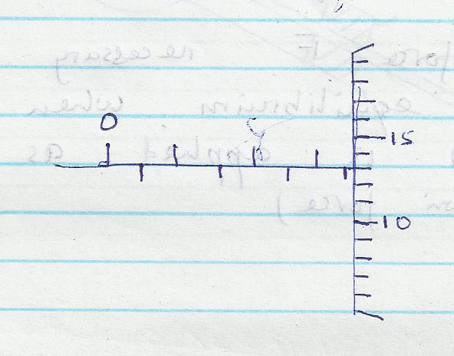

2. A metre rule is suspended by a thread such that it is in equilibrium balanced by a permanent magnet attached to the metre rule and some weight as shown in fig. bellow
If the soft iron is fixed to the bench, state and explain the effect on the metre rule when the switch is closed. (2 mks)

3. The figure below shows the object, formed in a concave mirror. Complete the ray diagram to show the position of the object. (2 mks)
I

- The figure below shows a flask air tightly fitted with a glass tube dipped into a beaker containing water at room temperature.
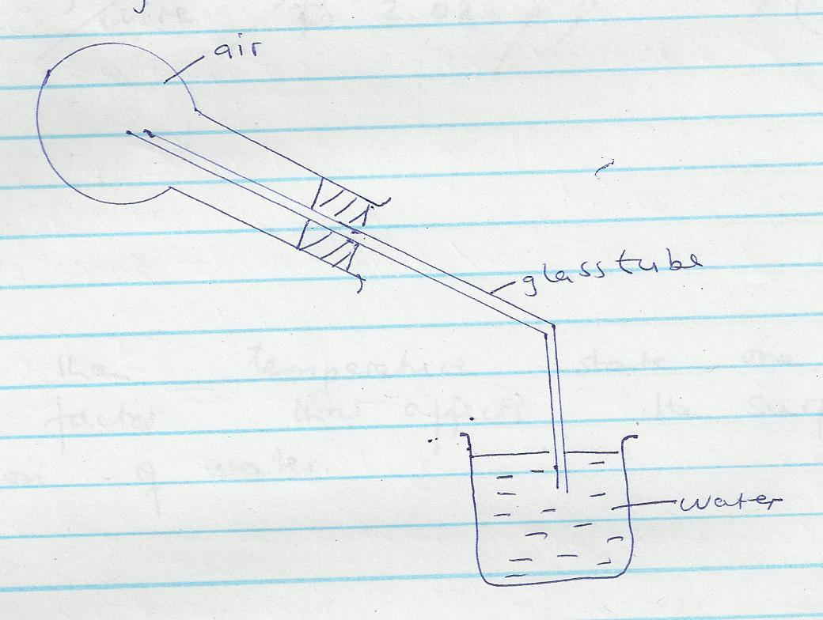

State giving a reason what is observed when ice-cold water is poured on the flask. (2 marks)

- The figure below shows an athlete lifting weights while standing with the feet apart.

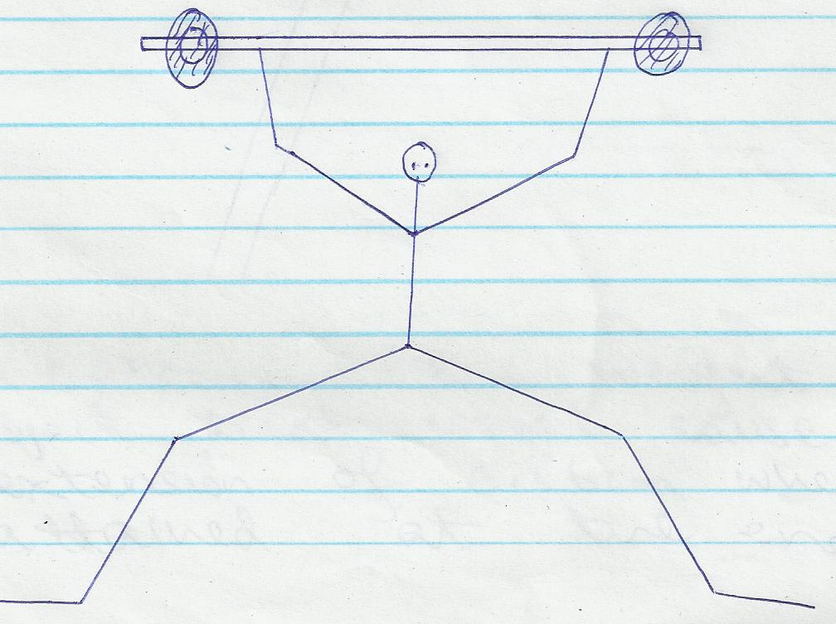

Explain why standing with the feet apart improves the athlete’s stability. (2marks)

- a) State Hooke’s law. (2mks)

b) Define the following terms (4mks)
i. Strength

ii. Stiffness

iii. Elasticity

iv. Ductility

c. An object of weight 20N attached at the end of a spring causes an extension of 0.5cm on the spring.
  - Determine the spring constant of the spring. (2 marks)

  - Determine the weight of an object that would cause an extension of 0.86cm when attached at the end of the same spring. (2 marks)

- The figure below shows a uniform triangular lamina.

Locate the centre of gravity of lamina. (2mks)

- State three reasons why a liquid and not a gas is used as a hydraulic brake fluid. (3mks)

- (a) Define the moment of a force. (2 mks)

3
- A uniform metre rule of mass 100g is balanced by suspending a 10g mass and a 20g mass
on its ends as shown below.

20g
10g

Determine the position of the pivot. (3 marks)

- (a) Define a wave. (2mks)

(b)State two types of waves and give an example in each case (2mks)

(c) Explain the meaning of the following terms as used in waves (6mks)
(i) Frequency

(ii) Period

(iii) Wavelength

- Differentiate between longitudinal and transverse waves (2mks)

- Explain why the smell of rotten eggs broken at one end of the room soon spreads throughout the room. (2marks)

- (a) State the law of magnetism (2mks)

(b) Describe magnetism using Domain theory (4mks)

IT IS NOT THE SIZE THAT MATTERS, BUT ABILITY AND CAPABILITY
MR KARANJA.
NAME:_____________________________________ADM:____________

GATITU MIXED SECONDARY SCHOOL
END OF TERM II EXAMS
PHYSICS FORM II

INSTRUCTIONS TO CANDIDATES

- Write your name and ADM number in the spaces provided above.
- Answer ALL questions in section A and section B in the spaces provided
- Take Acceleration due to gravity g = 10m/s²
- Mathematical tables and electronic calculators may be used.

FOR EXAMINERS’ USE ONLY

SECTION | QUESTION | MAXIMUM SCORE | CANDIDATE SCORE
 | 1-12 | 50

