PERFECT STEPS PUBLISHERS
0721745374/0721707626
Nairobi

END OF YEAR EXAMS 2015

FORM 3 PP1
INSTRUCTIONS TO CANDIDATES
- Write your name and index number in the spaces provided above.
- Sign and write the date of the examination in the spaces provided above
- This paper consists of TWO sections A and B.
- Answer all the questions in section A and B in the spaces provided in this booklet
- All working MUST be clearly shown.
- KNEC Mathematical tables and non-programmable silent electronic calculators may be used.
- Take: Acceleration due to gravity, g = 10m/s², Density of water 1g/cm³,
S.H.C. of water is 4200JKg⁻¹K⁻¹.
FOR EXAMINER’S USE ONLY
Section | Question (s) | Max. Score | Candidates Score
A | 1-13 | 25
B | 14 | 13
 | 15 | 07
 | 16 | 10
 | 17 | 12
 | 18 | 13
 | Total | 80

SECTION A (25 MKS)
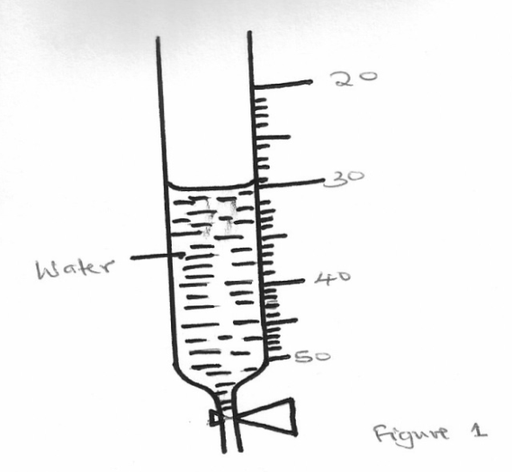
1. The figure below shows a section of a burette containing some water

20
30

40
Water
50

Determine the reading on burette if four (4) drops of water each of volume 0.5cm³ are added. (2mks)
………………………………………………………………………………………………………….…………………………………………………………………………………………………
2. A uniform wooden plank weighing 50N and 5m long is suspended by two ropes A and B, 1.5m apart. A is 2m from one end and B is 1.5m from the other end as shown in figure 2 below. A concrete block of weight 100N is suspended from the centre of the plank
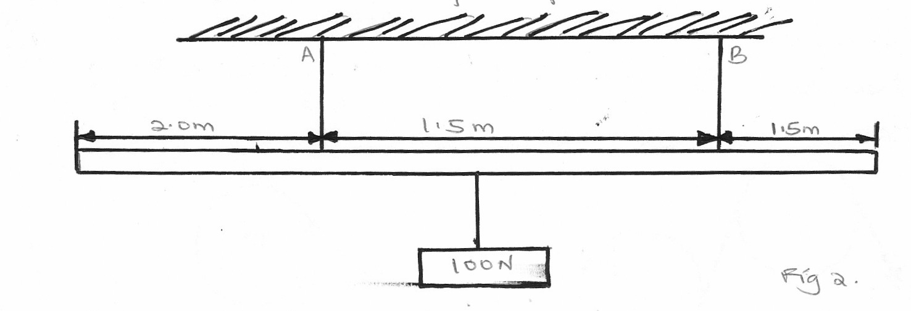Calculate the tension T_{A} in string A (3mks)

2.0m
1.5m
1.5m
100N

3. A steel sphere released in a tall transparent water jar attains a constant velocity after a while. The same sphere released in air falls at a constant acceleration. Explain with a reason the difference in its motion in water and in air (2mks)
………………………………………………………………………………………………………….………………………………………………………………………………………………………….
4. The stability of a body can be increased by increasing the base area and lowering its centre of gravity. Give one way of lowering its centre of gravity. (1mk)
………………………………………………………………………………………………………….………………………………………………………………………………………………………….
5. A body of mass 25kg moving with uniform accelaration has an initial momentum of 60kgm/s and after 10s the momentum is 90kgm/s. calculate the acceleration of the body (3mks)

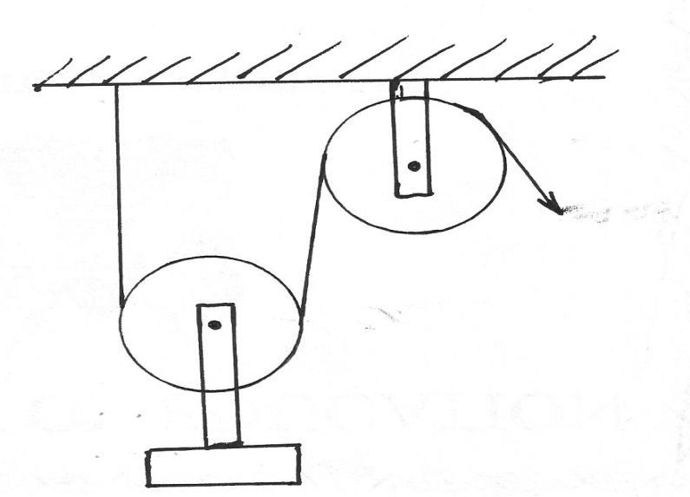
6. A load was raised using the system shown below. The system was then modified as in (b) and used to raise the same load
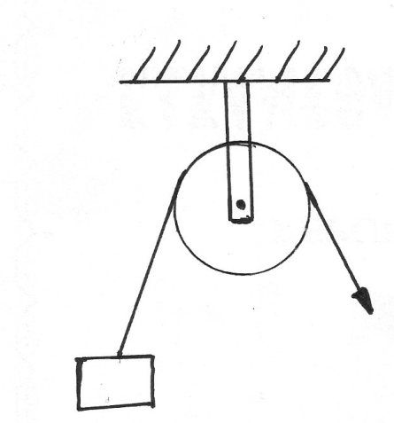
E
E
L
a
b
Figure 3

State and explain the change in efficiency (2mks)
………………………………………………………………………………………………………….………………………………………………………………………………………………………….
7. State two physical properties of a material medium which may be used to measure temperature (2mks)
………………………………………………………………………………………………………….………………………………………………………………………………………………………….
8. Give the reason why it is easier to separate water into drops than to separate a solid into small pieces (1mk)
…..…………………………………………………………………………………………………………..………………………………………………………………………………………………………
9. A drug manufacturer gives the mass of the active ingredient in a tablet as 5mg. express this quantity in Kilogram and in standard form (1mk)
…..…………………………………………………………………………………………………………..………………………………………………………………………………………………………
10. Some water in a tin can was boiled for some times, the tin was then sealed and cooled. After some time it collapsed. Explain this observation (2mks)
…..…………………………………………………………………………………………………………..………………………………………………………………………………………………………
11. The figure below shows a micrometer screw gauge being used to measure the diameter of a metal rod. The thimble scale has 50 divisions. The reading on the gauge when the jaws were fully closed without the rod was 0.012cm
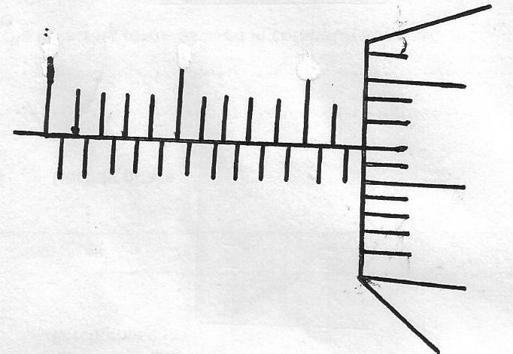
0
10
15
20
25

What is the actual diameter of the rod (2mks)

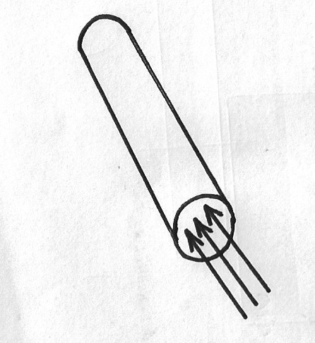
12. The figure shows a sheet of paper rolled into a tube

Paper tube

When a stream of air is blown into the tube as shown into the diagram, the paper tube collapses. Explain the observation (2mks)
…..…………………………………………………………………………………………………………..………………………………………………………………………………………………………
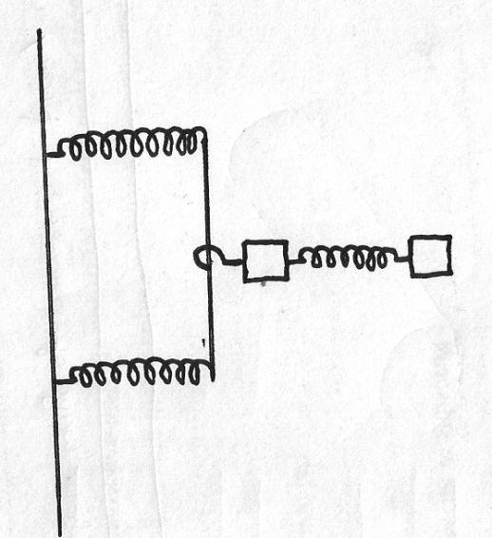
13. The three springs shown in the figure below are identical and have negligible weight. The extension produced on the system of the spring is 20cm

20N

20N

Determine the constant of each spring (2mks)
…..…………………………………………………………………………………………………………..………………………………………………………………………………………………………

SECTION B (55 MKS)
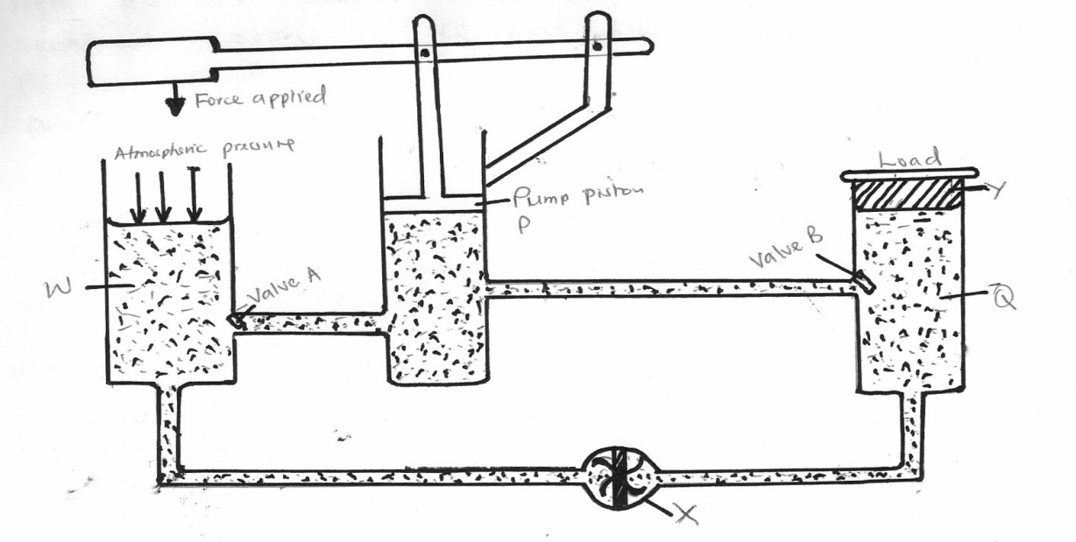
14. The figure below is a hydraulic jack system

Q
Y
Valve B
Pump piston P
Valve A
W
Atmospheric pressure
Forced applied

(a)Name the parts labeled W, X and Y (3mks)
……………………………………………………………………………………………
……………………………………………………………………………………………
(b) Briefly explain how the device may be used to raise a load at the position shown (3mks)
……………………………………………………………………………………………………….………………………………………………………………………………………………………….
(c) Part W is left open to the atmosphere as indicated. Explain (2mks)
………………………………………………………………………………………………………….………………………………………………………………………………………………………….
(d) State two ways by which the mechanical advantage of the device may be increased (2mks)
………………………………………………………………………………………………………….………………………………………………………………………………………………………….
(e) One such hydraulic brake system was used to lift a car whose mass was 1200kg. The cross sectional area of Q was 5000cm² and that of P was 5cm². Determine the force exerted on the pump piston (3mks)
………………………………………………………………………………………………………….………………………………………………………………………………………………………….
15. (a) A tape attached to a moving trolley is run through a ticker timer. The figure shows a section of the tape after running
1.5cm
B
C
3.2cm
D
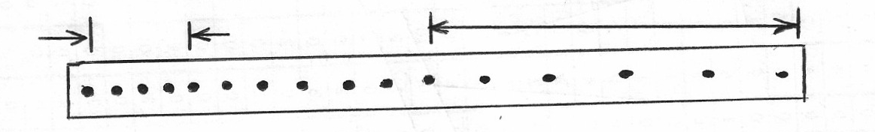

A
If the frequency of the ticker timer is 50Hz, calculate
(i) Average velocity at intervals AB and CD (2mks)
…..………………………………………………………………………………………………………
(ii) Average acceleration of the trolley (3mks)
…..………………………………………………………………………………………………………
…..………………………………………………………………………………………………………
(b) A stone is released from a height h, of the acceleration due to gravity is g, derive an expression of the velocity of the stone just before hitting the ground (2mks)
…..………………………………………………………………………………………………………
…..………………………………………………………………………………………………………

(c) The figure shows, velocity time graph of an object in motion
Velocity
Displacement
Time
Time

(i) (ii)
Sketch on the axes provided in c, the displacement time graph of the motion. (Motion upwards is taken as positive) (2 mk)

16. (a) Define the term velocity ratio of a machine (1mk)
…..…………………………………………………………………………………………………………..………………………………………………………………………………………………………
(b) The figure below shows part of hydraulic press. The plunger is the position where the effort is applied while the Ram piston is the position where load is applied. The plunger has cross section area am² while the Ram piston has cross section area Am²
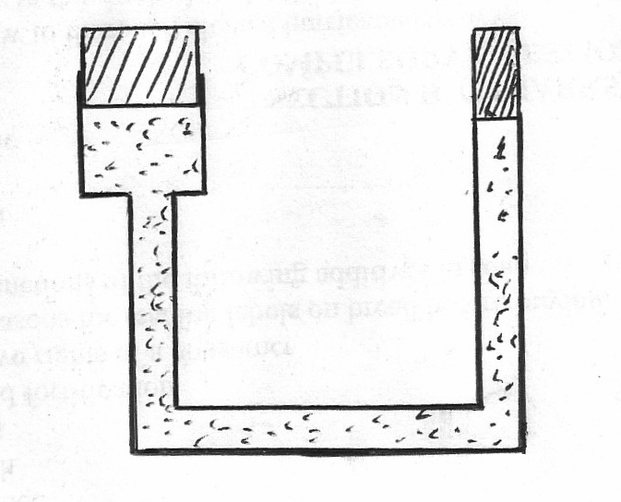
Plunger of cross sectional area=a
Ram piston cross sectional area =A

Oil

When the plunger moves down a distance d, the Ram piston moves up distance D
(i) State the property of liquid pressure on which the working of the hydraulic press operates(1mk)
…..…………………………………………………………………………………………………………..………………………………………………………………………………………………………
(ii) Derive an expression for the velocity ratio (V.R) in terms of A and a (3mks)

(c) A machine of velocity ratio 45, overcomes a load of 4.5x 103N when an effort of 135N is applied. Determine
(i) The mechanical advantage of the machine (2mks)

(ii) Efficiency of the machine (2mks)

(iii) The percentage of the work that goes to waste (2mk)

- (a) State the law of inertia (1mk)
…………………………………………………………………………………………………..……………………………………………………………………………………
- A ball of mass 50kg is thrown from the top of a cliff 20m high with a horizontal velocity of 20m/s. On reaching the ground it completely covered arm X of a hydraulic lift such that no water splashed out. The other arm Y has a weight of 25200N. Assuming the tap was opened when the ball struck the surface of water.

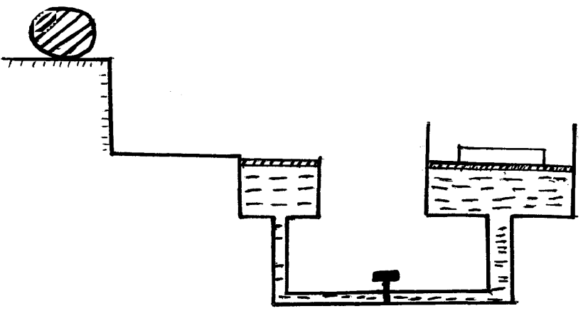
X
Ball

A = 50cm²

Determine

- The time taken by the ball to strike the surface of water at arm X (3mks)

- The distance from the foot of the cliff to where the ball strikes the surface of water. (2mks)

- The vertical with which it struck the surface of water at arm X (2mks)

- The force with which the ball struck the surface of water (2mks)

- The distance moved by the 25200N load arm Y if the level of water in arm X and arm Y was initially the same. (2mks)

- a) Define pressure and state its S.I Units. (2 marks)

b) State Pascal’s principal. (1 mark)

c) In construction of a mercury barometer care is taken to make sure it has no gas in the space above mercury.
i) How would you test whether there is gas above? (1 mark)

- State the problem caused by the presence of gas in the barometer. (1 mark)

d) Find the total pressure experienced by a diver 8 meters below the sea surface.
Take; Atmospheric pressure = 103 360N/m². Density of sea water 1030kg/m³(3 marks)

e) i)The air pressure at the base of a mountain is 75.0cm of mercury while at the top it is 60.0cm of mercury. Given that the average density of air is 1.25kgm⁻³ and the density of mercury is 13600 km⁻³, calculate the height of the mountain. (3 marks)

ii) State factors that affect pressure due to liquid column. (2 marks)

