COUNTY MULTILATERAL EXAMINATION
END TERM II EXAMINATION – YEAR 2016
PHYSICS 232 – FORM THREE
STUDENTS NAME:……………………….CLASS:…………….ADM. NO…………..
SCHOOL…………………………………..
Date…………………………
232
PHYSICS
2 Hours 30 minutes
Instructions
Write your name and admission number in the space provided.
Answer all questions in the space provided. A graph paper is attached.
All working must be clearly shown.
The paper is out of 100 marks.

Non programmable silent electronic calculators and KNEC mathematical tables may be used.
The paper has 11 printed pages. The student should check the question paper to ascertain that all the pages are printed as indicated and that no questions are missing.

Take
Earth gravitation strength, g = 10N/ Kg
Density of water as 1,000kg/m³
Density of mercy as 13,600kg/m³

For examiners’ use only
Section | Question | Maximum score | Candidates score
A | 1-16 | 40
B | 17 – 21 | 60

SECTION 1 (40 MKS)
1. Plane mirrors are not used as driving mirror. Explain. (1 mk)

2. An object initially moving at 50m/s decelerates uniformly to rest at 2m/s^{2.} What distance does it cover? ( 3mks)

3. State two factors on which friction in solids depends on. (2 mks)
i)
ii)

4. A block of mass 40kg rest on an inclined plane as shown in figure 1 below. On the same figure name and indicate the other forces acting on the block. (3 mks)
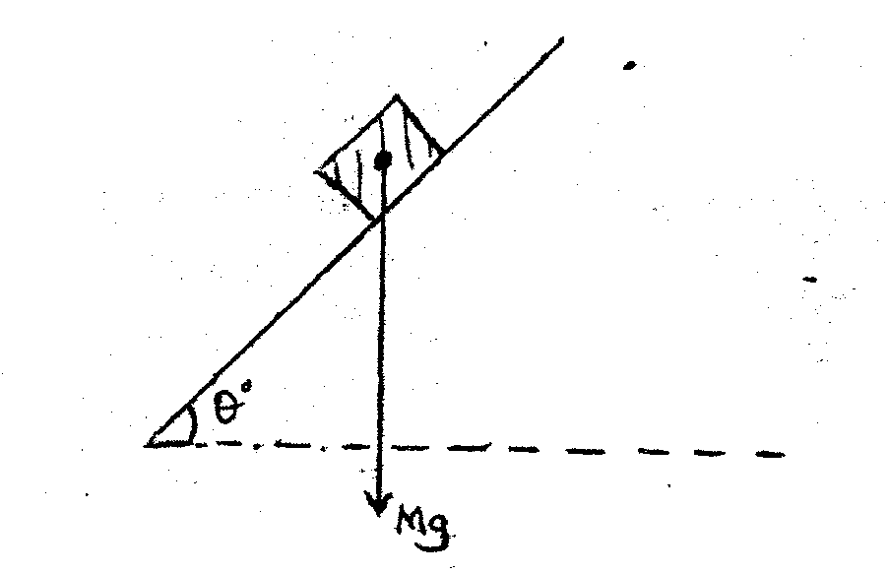
Figure 1
5. Sketch a well labeled diagram of a single pulley arrangement having a velocity ratio of 2. ( 2mks)

6. A girl standing 600m from a cliff bangs two pieces of wood and hears an echo after 3.5 seconds. Determine the speed of the sound in air at that place. (3 mks)

7. Water waves traveling in the deep section of a ripple tank at 34cm/s meet a shallow region at an angle of 60⁰. The speed of the waves change to 24cm/S. calculate.
i) The refractive index of the water. (2 mks)

ii) The angle refraction of the waves. (2 mks)

8. State two factors that would raise the boiling point of a liquid.
i)

ii)

9. An electric bulb is rated 752, 240V. Determine the resistance of the bulb. (3 mks)

10. Two trolleys of masses 2.5kg and 1.5kg are travelling towards each other at 0.25m/s and 0.40 m/s respectively. The two trolley collide and travel as one, calculate the velocity of the combined trolleys. (3 mks)

11.a) On the axes in figure 2 below, sketch a graph of pressure against Volume for a gas that obeys Boyle’s law. (1 mk)

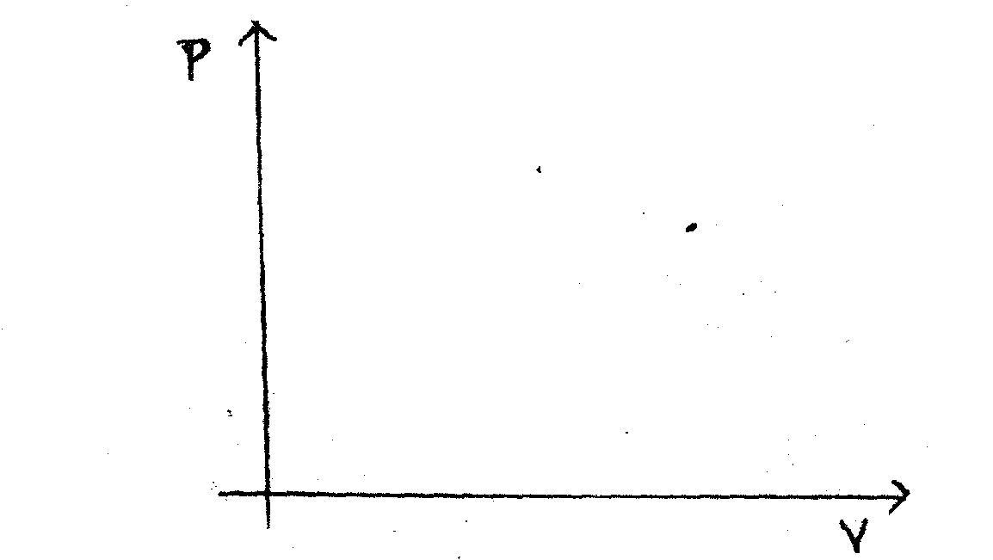
b) On the same axes, sketch the graph for the same mass of the gas when the temperature is lowered. (1 mk)

12. Explain why it is dangerous to stand close to a railway line when a fast moving train in passing. (2 mks)

13. Two identical each offspring constant 300N/ M supports a load of 30N as shown in figure 3 below.
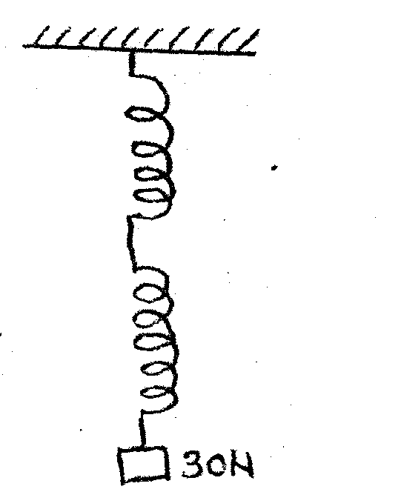

Figure 3
Determine the extension produced. (3 mks)

14. The diagram in figure 4 below shows a battery of 6v connected to two capacitors C1, and C2 of capacitance 4 and fin series.
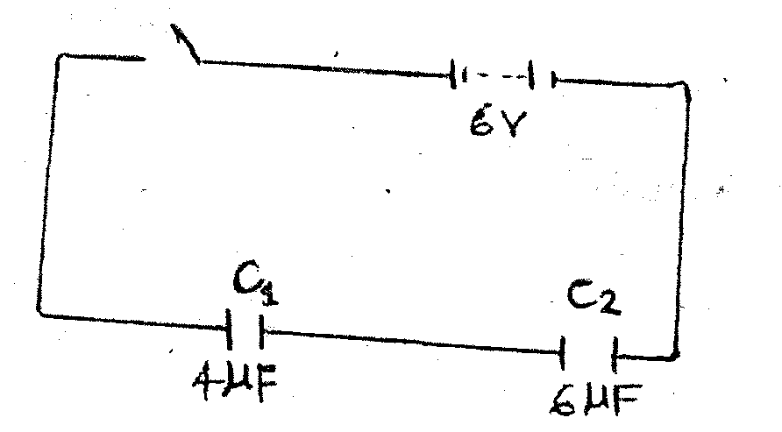
Figure 4
Determine the effective capacitance. (2 mks)

15. The diagram in figure 5 below shows a current carrying wire wound on a u- shaped piece of iron. Draw the magnetic field pattern between and Q. (2 mks)
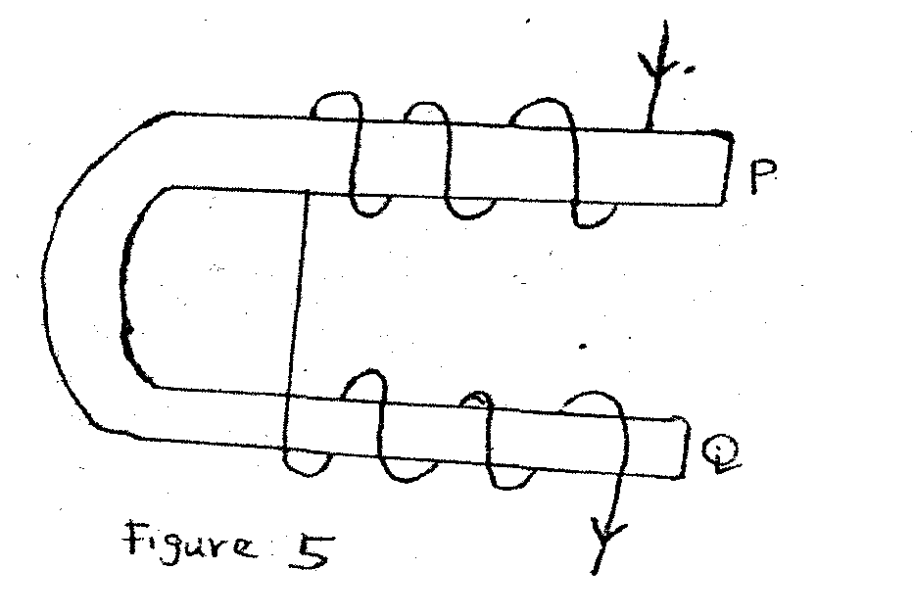
16. A uniform bar of length 140cm is balanced at 30cm when a load of 25N is placed at one end as shown in figure 6 below.
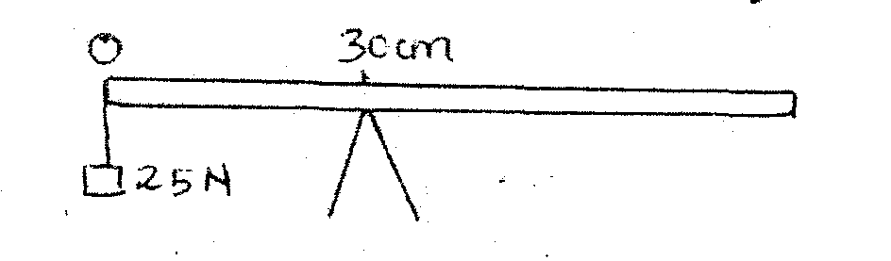
Figure 6
Determine the weight of the bar. (3 mks)

SECTION II (60 Mks)
17(a) State ohm’s law.

b) The diagram in figure 7 below shows a series – parallel circuit.
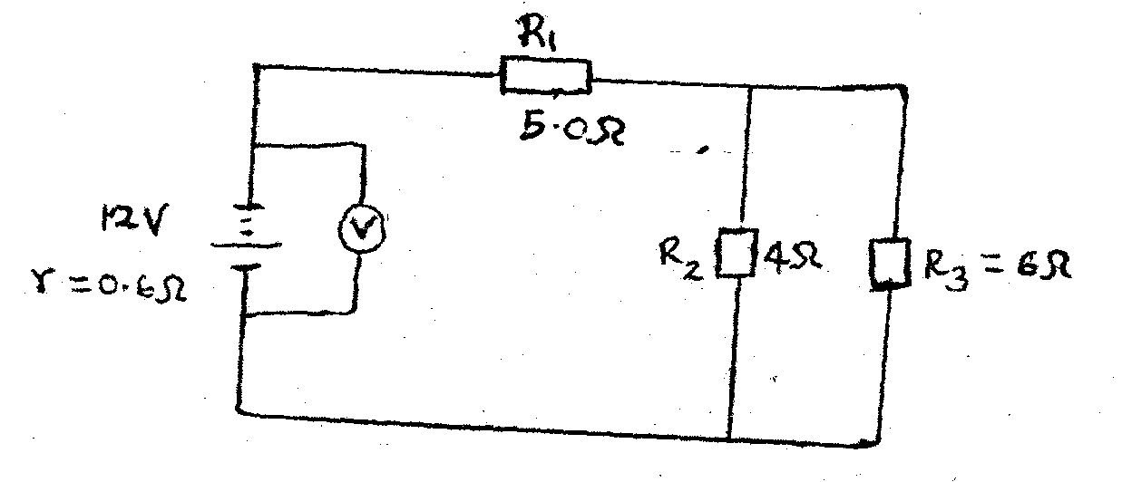Figure 7
Calculate:
i) The total resistance in the circuit. (3 mks)

ii) The total current in the circuit. (3 mks)

iii) The current through the 4 ohm resistor (3 mks)

iv) The voltmeter reading. (2 mks)

18.(a) The diagram in figure 8 below shows a wheel and axle being used to raise a load W by applying an effort, F; the radius of the wheel is R and that of the axle is r.
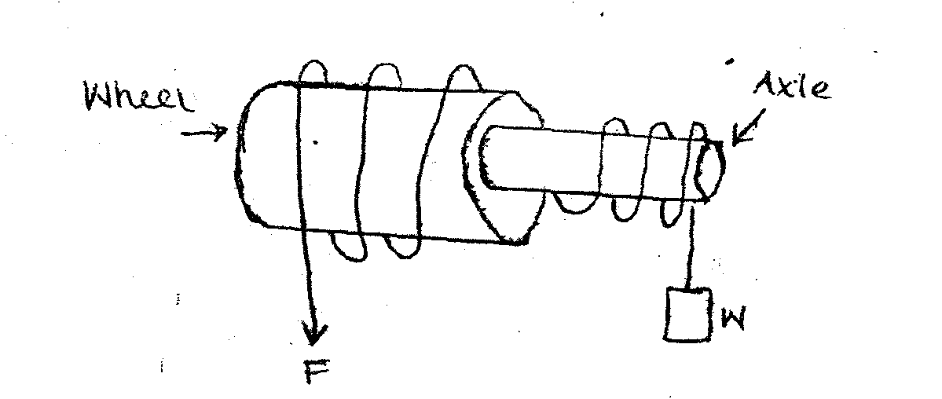
Figure 8

(i) Show that the velocity ratio of the machine is given by R/r. (2 mks)

(ii) Given that r=4cm and R = 10cm, determine the effort required to raise a load of 400N if the efficiency is 80%. (4 mks)

iii) Give a reason why the efficiency of the machine increases as the load increase.
(1 mk)

b) The pendulum bob of mass 100g oscillates between points A and B as shown in the figure 9 below.
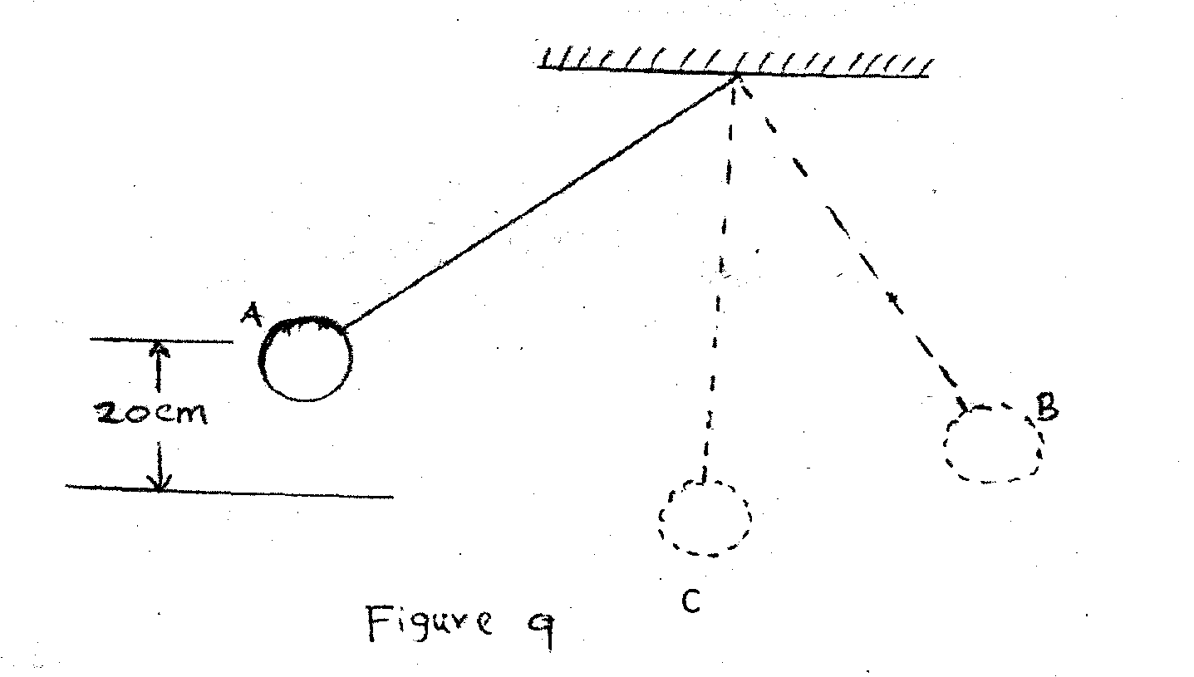

i) Indicate with an arrow the direction of the greatest velocity as the bob moves from A to B. (1 mk)

ii) State the forms of energy possessed by the bob at points A and C with being the lowest point. (2 mks)
A:_________________
B:_________________

iii) Calculate the velocity of the bob at point C. (3 mks)

19.(a) Define the term, specific heat capacity of a substance. (1mk)

b) 200g of a liquid was contained in a lagged copper calorimeter of mass 50g and specific heat capacity 400jKg-¹K⁻¹. A 25 W immersion heater was placed in the liquid and the temperature rose from 20⁰C to 100⁰C in 20 minutes.
Determine;
- The quantity of heat supplied by the heater. (2mks)

- The quantity of heat absorbed by the calorimeter. (2 mks)

- The absorbed by the liquid. (2 mks)

- The specific heat capacity of the liquid. (2 mks)

c) The diagram in figure 10 below shows the variation by temperature, T (⁰C)with time, t(sec) when frozen water at 0⁰C is heated for sometime.
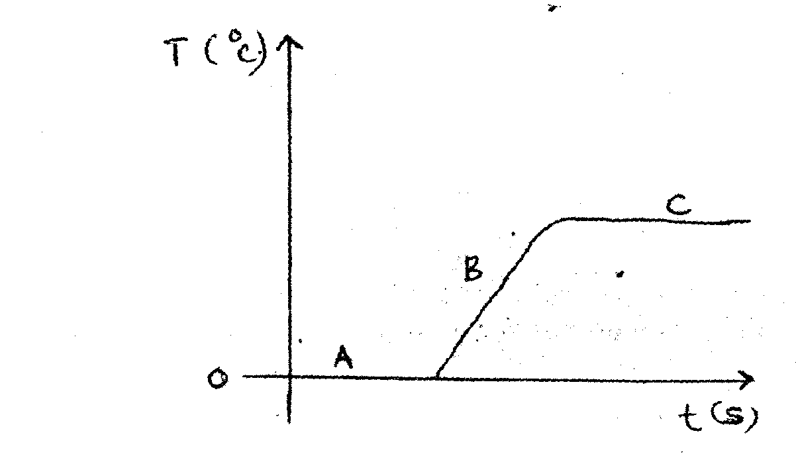
Figure 10
Explain the shape of the graph at the part labeled A, B and C. (3 mks)
A ______________________

B ______________________

C ______________________

20(a) State Charles law in gases. (3 mks)

b) The diagram in figure 11 below shows a set up used to verify Charles’ law.
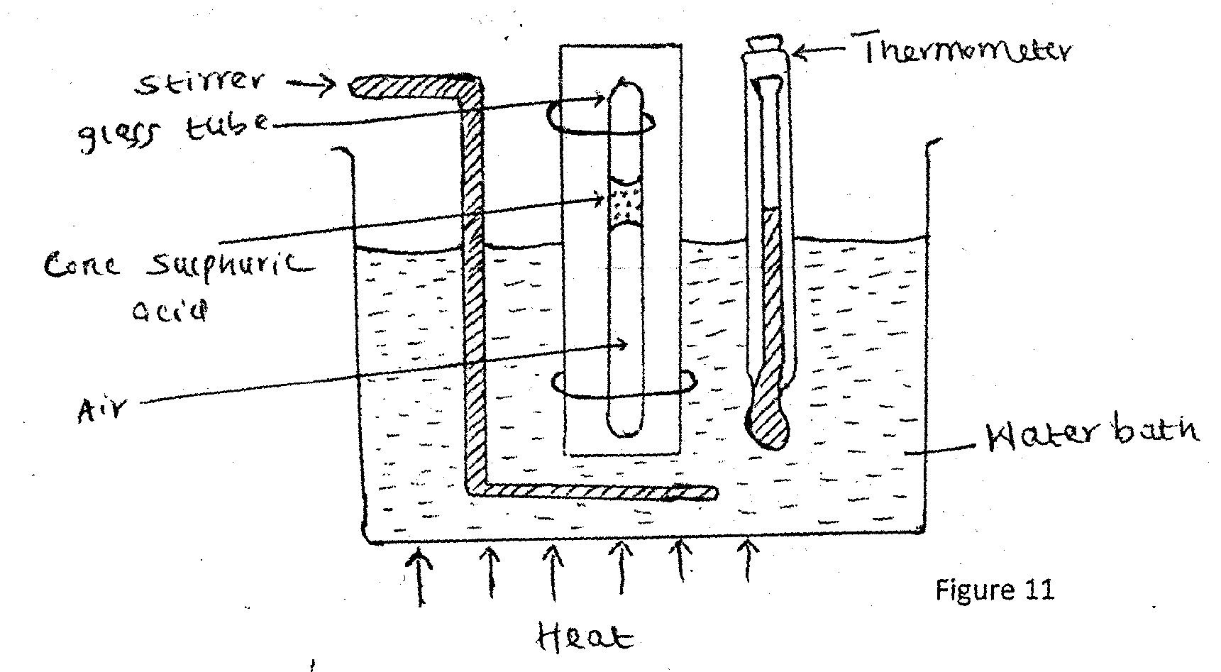
i. Give two reasons why a pellet of conc. Sulphuric acid was used. (2 mks)
i)

ii)

ii) What is the purpose of the water bath? (1mk)

(iii) What measurement is made to obtain the volume of the air? ( 1mk)

(iv) The following results were obtained from the above set up.
Temp. (⁰C) | 20 | 40 | 60 | 80 | 100
Volume (cm³) | 64.5 | 69.0 | 73.3 | 77.5 | 82.0

Plot a graph of the volume (Y-axis) against temperature.
c) A certain mass of a gas has a volume of 1200cm³ at a pressure of 500n.m2, and temperature 17⁰C. What is its volume at a pressure of 1500N/m² and temperature 317⁰c? (3 mks)

21.(a) The diagram in figure 12 below shows a displacement time graph as a wave passes a fixed point.

Determine
- The amplitude of the wave. (1mk)

- The frequency of the wave. (3 mks)

- The wavelength of the wave given that the velocity is 500m/s. (3mks)

b)(i) State one condition for an interference pattern to be observed in waves. ( 1mk)
ii) In an experiment to observe the interference pattern of light waves, a double slit, S₁, S₂ was placed close to the source as shown in figure 13 below.
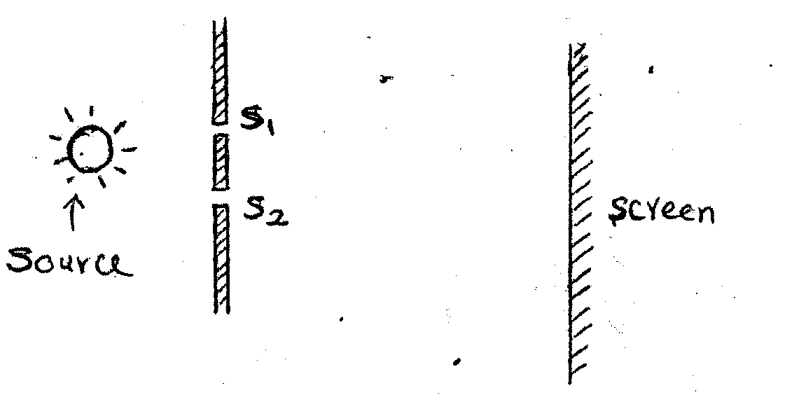
Figure 13
State what is observed on the screen when;
- The slit separation S₁, S₂ is increase

- The slit S₁ is covered.

