NAME……………………………………………………………………………….CLASS…………………………………

DATE……………………………………….. SIGNATURE…………………………

232/2
PHYSICS
FORM 3 (THREE)
3RD TERM 2013
2 HRS

INSTRUCTIONS
- ANSWER ALL QUESTIONS ION IN THIS PAPER
- ALL WORKING MUST BE SHOWN
- USE ONLY A CALCULATOR AND MATHEMATICAL SET
QUESTION | MAXIMUM SCORE | CANDIDATE SCORE
1-13 | 25
14-17 | 55

SECTION A(25MKS)
- State two difference between a virtual image formed by a plane mirror and that formed by a concave mirror 2mks
Plane mirror | Concave mirror
- Give two measurement that shows that an accumulator is due for recharging 2mks

- An echo sounder in a ship received the reflected wave from sea-bed after 0.4sec. what is the depth of the sea-bed if the velocity of sound in water is 1500m/s? 2mks

- A girl stands 5m away from a large plane mirror.how far should she walk to be 2m away from her image? 2mks

- When a magnet is placed in a solenoid carrying A.C current it demagnetizes.explain how demagnetization is achieved. 2mks

- The figure below shows displacement time graph for a wave.

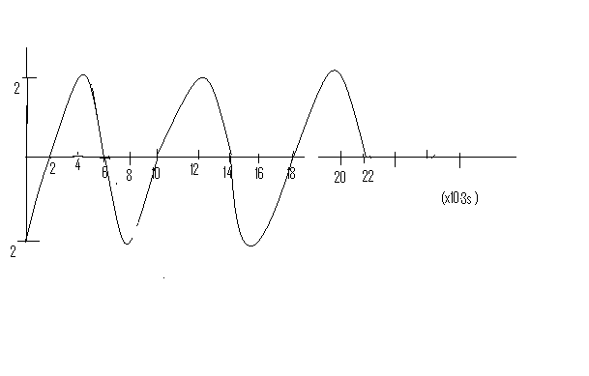
7.complete the diagram represented in the figure below to show the path of the refrected ray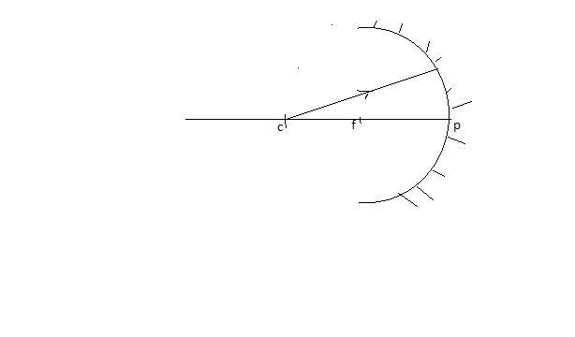
8. Name two devices which make use of the heating effect of an elecrict current 2mks

- When does a convex lens produce a virtual image 1mk

- State the basic law of electrostatics 1mk

- State two conditions necessary for production of interference of sound waves 2mks

- The effective resistance of two equal resistors in series is 20 ohms. what is effective resistance when connected in parallel. 3mks

- Two close conductors carry current as shown below

- Show the magnetic field pattern for the arrangement. 2Mks

- what physical observation is made between the two conductors. 1mk

- The figure below shows the path of a ray of light PQRS through a triangular prism AB and C of refractive index 1.5 .The merging ray RS is parallel to side AB.

- Determine the angle QRS 3mks

- Determine the angle of refraction on AB 2mks

- Determine the angle of incidence on AB. 3mks

- An object of height 5 cm is placed 30 cm from a convexlens of focal length 10 cm.
- Draw ray diagrams with your own scale to show the position of the image formed. 4mks
- Determine the height of the image formed 3mks

- Distinguish between tranverse and longitudinal waves. 2mks

- Give one example of each 2mks

- The figure below shows the displacement of a particle in a progressive wave incident on a boundary between deep and shallow regions.

- Complete the diagram to show the wave after the boundary .2mks

- Explain the observation in b(i) above 2mks

c) Water waves are observed as they pass a fixed point at a rate of 30 crests a minute. A particular crest takes 2 seconds to travel between two points 6m apart. Determine for the wave:
- The frequency 2mks

- The wavelength 2mks

d) The figure below shows two loud speakers L1,L2 connected to a signal generator

Explain giving reasons the observations made by a person moving along
AA¹ 2MKS
BB¹ 2mks
CA¹ 2mks

- State Ohm’s law. 1mk

- The figure shows the circuit diagram of an electric heater which has two heating elements p and d.

State the effect of
a. Closing switch S₁ only 1mk

b. Closing switch S₂ only 1mk

c. Choosing both switches 1mk

- Mrs. Njoroge uses domestic power supplied at 240v. she has the following gadgets in her house
- Electric cooker (2kw)
- Electric kettle ( 1.5 kw)
- Electric fan (0.5 kw)
a. Calculate the amount of current required to operate the devices 3mks

- The following are appliance used in a house. Five 100W lamps for 4 hours, two 60 W lamps for 4 hours, one 150 W refrigerator for 24 hrs on 100 W television set for 3 hours, one 750 W electric iron for 0.5 hrs and one 3kw electric cooker 2 hours. calculate
a. The electrical energy consumed in a day in kwh 4mks

b. the cost of electricity used for 30 days at cost of ksh 8.50 per unit. 2mks

- In an experiment to magnetize two substances P and Q using an electric current, two graphs of magnetizing current against .Using the information in the graph, Answer the following :

- What is the difference between P and Q in terms of the domain theory? 3mks

- From which metals are they likely to be made of 2mks

- Which one could you see to make a permanent magnet and why? 2mks

- Give two factors that affect the strength of an electromagnet. 2mks

