NAME ----------------------------------------------------- CLASS --------------ADM NO. ----------------------------------------
GATITU MIXED SECONDARY SCHOOL
PHYSIC PP1 FORM 3 2013 END TERM
SECTION A (25 MKS)
ANSWER ALL THE QUESTIONS IN THIS SECTION
- Draw a diagram of venier caliper showing a reading of 12.48cm. 2mks

- The diagram below shows two bodies hanging from the 30cm mark and the 80cm mark of a uniform meter rule pivoted at its center. One of the bodies of mass 1.5 kg is immersed in a fluid.
If the system is in equilibrium, calculate the up thrust of the liquid. 3mks

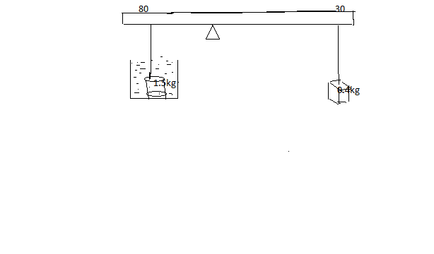

- A rectangular plate measures 3.0 m by 1.0m and is standing on its smallest side, calculate the smallest angle through which if tilted it will topple. 2mks

- Two students A and B who are equally strong push on the pistons of two syringes as sho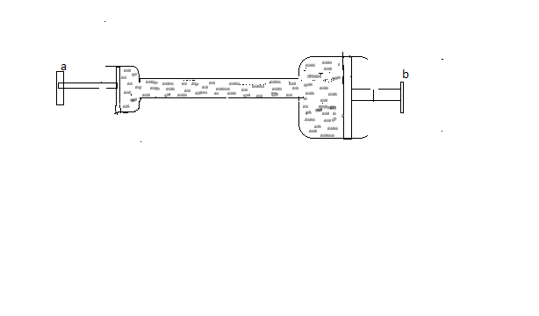State with reason which student will succeed in pushing his piston inwards. 3mks

- A graduated thermometer reads 8 cm in melting ice and 20 cm in steam at 100c. what is the temperature when the thermometer reads 6 cm? 3mks

- The figure below shows a test tube containing water ,an ice block is held at point B using a wire gauze as water heated at point A.

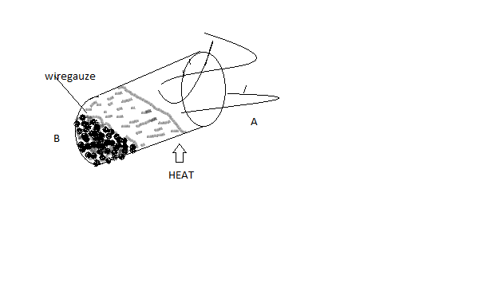
State with a reason what happens to ice at B as the water boils at A. 2mks

- A thin sheet of aluminium floats in water as hsown below, if a small piece of camphor is attached on one side of it, the plate moves in direction shown.

Explain why the sheet moves that way 2mks

- A boy throws a ball up in the air and it comes back to his hands at the same level. Sketch a velocity time graph to show the motion of the ball. 1mks

- A boy walks away from a plane mirror at a speed of 2m/s. with what speed does his image move away from him? 2mks

- In an experiment to determine the thickness of a molecule,the following results were obtained

- An air bubble was released at a depth of 45 m from a sea bed. The initial volume of the bubble at this depth was 3.0 ×10⁻⁵m³ and the temperature of the water was 13c. what was its volume on reaching the surface of the water where the temperature was 23c. (atmospheric pressure =101Kpa, density of water =1020kg/m³) 4mks

- The figure below shows a pulley system used to raise the load L below it. Complete the diagram to show how it works.

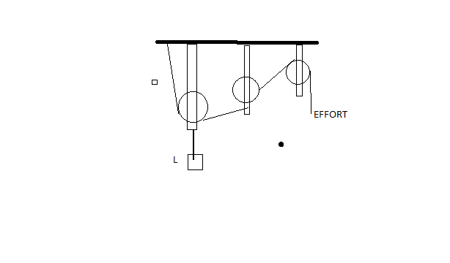

- State the velocity ratio of the system.

- A stone of mass 10kg is to be raised 10 metres from the from the ground using this pulley
- The work done in raising the stone. 3mks

- Each pulley above weigh 20N, calculate the total work done in raising the load through this height. 2mks

- The efficiency of this system of pulleys. 2mks

- Give two reasons why the efficiency of such a pulley cannot be 100%. 2mks

- Define density and state its S.I units. 2mks

- The figure below shows the set up to determine the density of a liquid.
- THe rod was submerged into the liquid to various lenghths L and corresponding readings of the spring balance F recorded. The metal rod has a uniform cross sectional area 5.0× 10 m2.The table below shows the result obtained
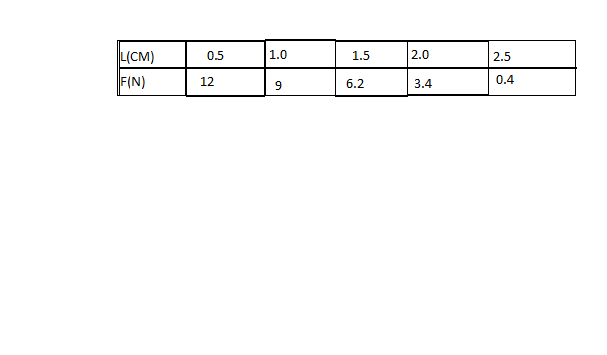
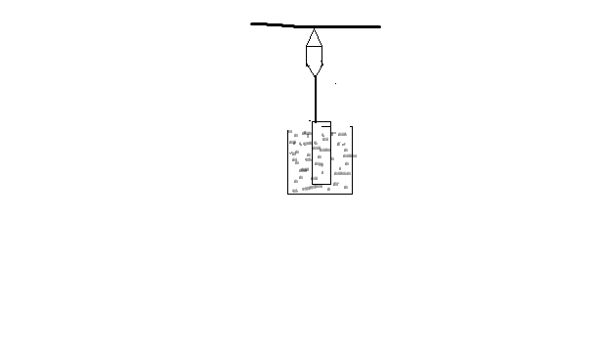

- The figure below shows an instrument for measuring atmospheric pressure

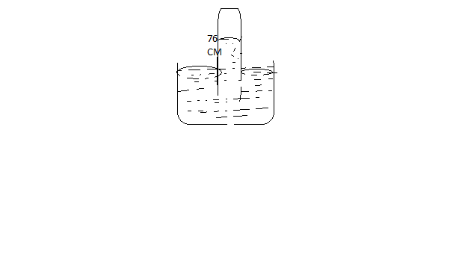

- Name the instrument . 1mk

- State two properties of the barometric liquid that make it suitable for use in the instrument. 2mks

- What is the effect of the following on the height of the liquid column
- Using a tube of a larger diameter 1mk

- Making a small hole at the topmost part of the uniform tube. 1mk

- State pascal’s principle of transmission of pressure. 1mk

- The figure below shows a simple hydraulic machine with an effort E, Load F

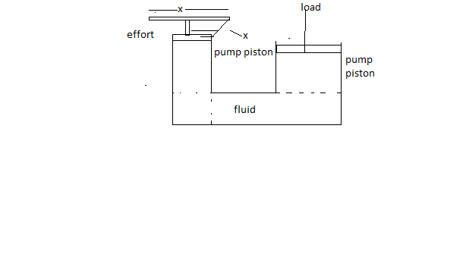

- Using the principle of levers,write down an expression connecting F,X,E and Y. 2mks

- Given that X =28 cm Y =7cm, effort =80n and that the area of a ram piston is four times that of the pump piston, determine the maximum load that can be lifted. 4mks

- Which of the following is more harmful to a figure? Steam or boiling water. Explain your answer. 2mks

- The figure below shows 50kg of molten being cooled , explain briefly what is happening to the liquid as its temperature reaches 1,000c. (not drawn to scale) 2mks

- The specific heat capacity of the molten metal is 800Jkg⁻¹k⁻¹ determine the amount of heat lost as it cools from point A and B. 3mks

- What is the power of the heater that will give out this amount of heat in the same time?

- State two factors that affect both the m.p and the B.p of a substance. 2mks

- Two ice cubes when pressed against each other are found to stick to each other. Explain 2mks

