MWAKICAN JOINT EXAMINATION 2016
PHYSICS PAPER 232/3
MARKING SCHEME
- (a) (i) d = 3.5 x 10⁻⁴m 1
(ii) E = 1.5± 0.1V1
(b) Table
L (cm) | 2.5 | 7.5 | 10 | 20 | 30 | 40
p.d (V) | 0.70 | 0.80 | 0.90 | 1.05 | 1.15 | 1.20
I | 0.55 | 0.46 | 0.40 | 0.31 | 0.25 | 0.22
VI (watts) | 0.3850 | 0.3680 | 0.3600 | 0.3255 | 0.2875 | 0.2640

(ii) A graph of VI against L.
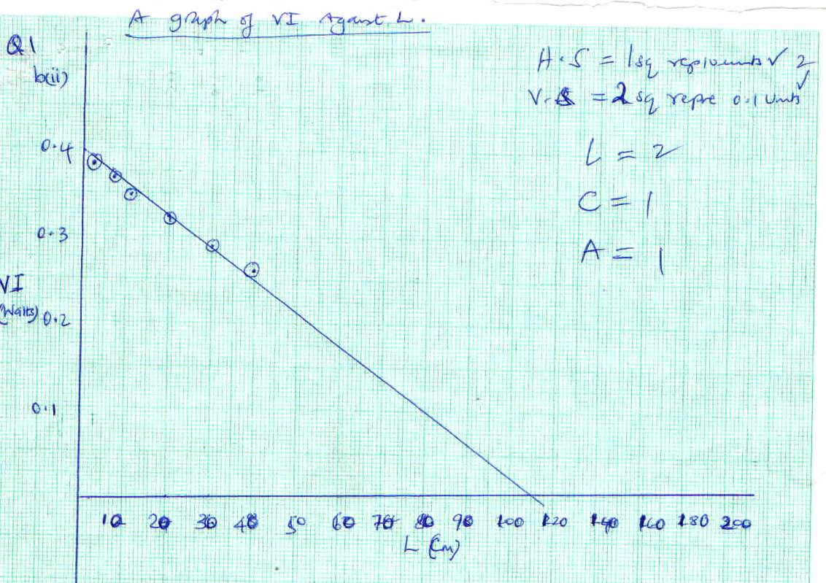
1
A graph of VI against L.

0.4

0.3

0.2

0.1

VI
(Watts)

10 20 30 40 50 60 70 80 90 100 120 140 160 180 200
L (CM)

(iii) From the graph
Lo = 110cm 1
(c) V = 1.30V
I = 0.17A 1
r = $\frac{E-V}{I}$ = $\frac{1.5-1.3}{0.17}$ 1= 1.17Ω 2
(d) e = $\frac{π{rd}^{2}}{2.52}$ = $\frac{3.142 x 1.176{ {(3.5 X 10}^{-4})}^{2}}{2.52}$ 1= 1.796x10⁻⁷Ωm ²
- (a) (i) L = 3.83cm 1 Diameter = 1.46cm 1
(b) t 5.85sec 1 T = 0.29sec 1

(iv)
Mass M(Kg) | Time of 2 oscillation | T | T²
0.1 | 5.85 | 0.29 | 0.09
0.2 | 9.35 | 0.47 | 0.22
0.3 | 11.40 | 0.57 | 0.32
0.4 | 13.16 | 0.66 | 0.43
0.5 | 14.78 | 0.74 | 0.55
0.6 | 16.16 | 0.81 | 0.65
2 2 2
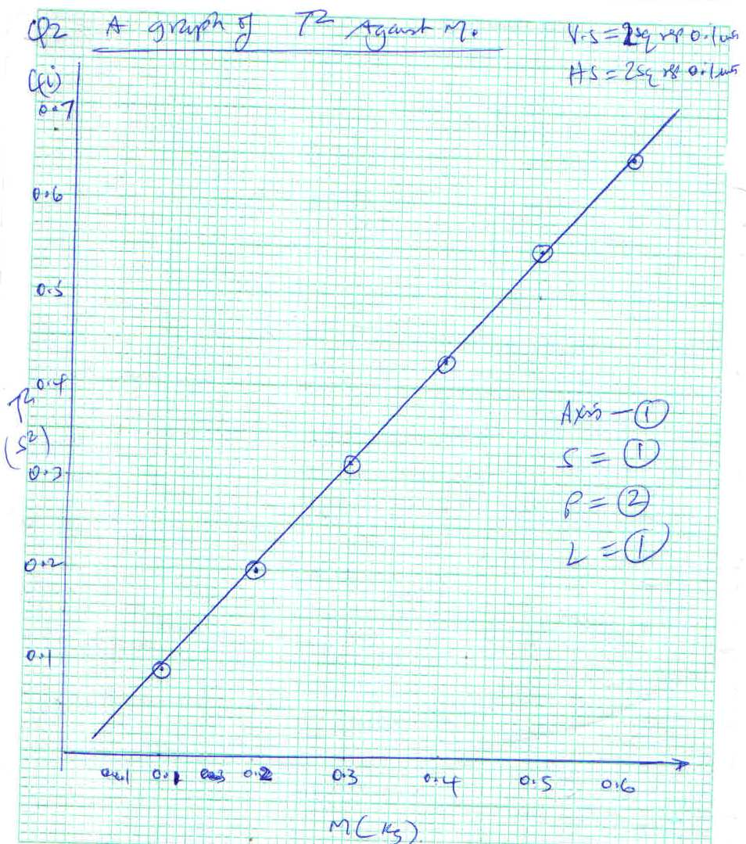
(i) A graph of T² against M.
A graph OF T² against M
0.1 0.2 0.3 0.4 0.5 0.6
M (kg)

(ii) slope = $\frac{∆T^{2}}{∆m}$ = $\frac{0.60-0.18}{0.55-0.17}$ = $\frac{0.42}{0.37}$
= ${1.11s}^{2}/m$

d) T² = 4ᴨ² mn
g
T² = 4ᴨ² n = n = 0.3m/kg
g

T² = 4ᴨ² n gradient =
m g

1.11 = 4 x (3.14) ² x 0.3m/kg1
g

g = 4 x (3.14) ² x 0.3 1
1.11
g = 10.669
g $≈$ 10N/kg1

