PHYSICS FORM 4 OPENER EXAM 2015
GATITU MIXED SEC SCHOOL
- State the effect of decreasing the distance between the plates of a parallel plate capacitor on the capacitance. 1mk

- State two uses of a charged gold leaf electroscope. 2mks

- The frequency of an electromagnetic wave is 4.0 ×10 ⁶HZ. Determine its wavelength( take speed of light as 3.0 ×10⁸ms⁻¹) 3mks

- In a smoke cell experiment, to demonstrate Brownian motion, smoke particles are seen making randomly. State the cause of the randomness. 1mk

- A light spiral spring extends by 4 mm when loaded with a weight W. The spring is connected in series with an identical spring. The combination is loaded with the weight W. Determine the extension of the combination. 2mks

- A student measured the length of a wire four times using a metre rule and obtained the following readings; 18.6 cm, 18.5 cm, 18.6 cm and 18.5 cm. determine the length the student should record. 2mks

- It is observed that when the cap of an uncharged electroscope is irradiated with light of high frequency, the leaf of the electroscope rises. Explain this observation. 3mks

- The figure below shows a uniform rod 4m long and of mass 2 kg. it is pivoted 1m from one end and balanced horizontally by a string attached near the other end.
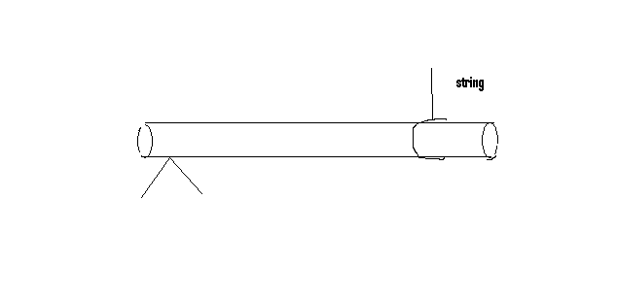

Determine the position where a mass of 5 kg should be placed on the rod so that the rod remains horizontal and the tension in the string is zero. 3mks

- Below is a graph of the variation of temperature with time for a pure substance heated at a constant rate.
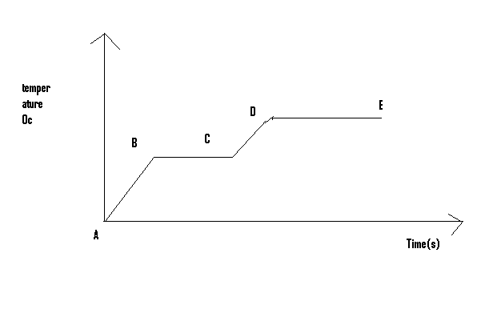
Assuming that heat transfer to the surroundings is negligible, state the changes observed on the substance in the region:
- BC 2MKS

- DE 2MKS

- The figure below shows resistors R1 and R2 connected to a battery of potential difference v volts.
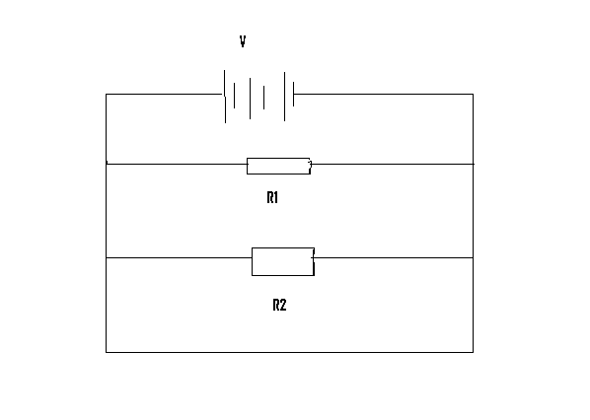

- In terms of V1, R1 and R2 write an expression for,
- Current I1, through R1 1mk

- Current I2 through R2 1mk

- Total current I in the circuit 1mk

- Show that the total resistance R1 is given by R1 = R1R2/R1 + R2 3mks

- A long horizontal capillary tube of uniform bore sealed atone end contains dry air trapped by a drop of mercury. The length of the air column is 142 mm at 17 c. determine the length of the air column at 25 c. 3mks

- The pressure of the air inside a car tyre increases if the car stands out in the sun for sometime on a hot day. Explain the pressure increase in terms of the kinetic theory of gases. 3mks.

- In an experiment the specific latent heat of vaporization of water, steam of mass 10g at 100c is passed into 100g of water initially at 20 c in container of negligible heat rises to 70 c. (take the specific heat capacity of water as 4.2 ×10³jkg⁻¹k⁻¹ and the boiling point of water as 100c)
- Determine the specific latent heat of vaporization of water. 4mks

- State two sources of error in this experiment. 2mks

- The figure below shows a test tube whose cross sectional area is 2 cm² partially filled with lead shot floating vertically in water.
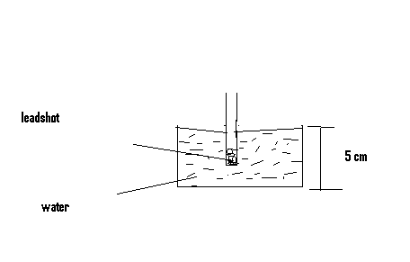
- Determine the;
- Volume of water displaced 2mks’

- Weight of water displaced. 3mks

- State the combined weight of the test tube and the lead shot. 1mk

- determine the length of the test tube that would be submerged in a liquid of density 0.8 g cm³ 4mks

- State how such a hydrometer would be improved to measure small difference in densities of liquids. 1mk

