NAME ……………………………………………………………………………. ADM NO. ……………………………………………….
GATITU MIXED SECONDARY SCHOOL
FORM 4 PHYSICS THEORY PAPER 2
SECTION A (25 MKS)
- Give a difference between a primary cell and a secondary cell. 1mk

- State two ways of increasing the image formed by a pinhole camera. 2mks

- With the help of a diagram, explain why convex mirrors are preferred for use as driving mirrors. 2mks

- Explain why bridges are made of concrete reinforced with steel. 1mk

- Distinguish between a transverse and a longitudinal wave. 2mks

- Give one similarity and one difference between elastic and inelastic collisions. 2mks

- An ammeter, a voltmeter, two dry cells and a bulb are connected in a circuit so as to measure the current flowing and the potential difference across both. Sketch a suitable circuit diagram for the arrangement. 3mks

- A current of 0.08 A passes in circuit for 2.5 minutes. How much charge passes through a point in the circuit. 2mks

- State and explain two factors affecting the resistance of a metal conductor. 3mks

- Show that the velocity ratio(V.R) for a wheel and axle is R/r 2mks

- Sketch a labeled diagram to show how an arrangement of a single pulley may be used to provide a mechanical advantage of 2. 2mks

- Show that the velocity ratio for an inclined plane is given by 1/sin$∅$. 3mks

SECTION B (45MKS)
- The cell in figure 10 has an emf of 2.1 v and negligible internal resistance.

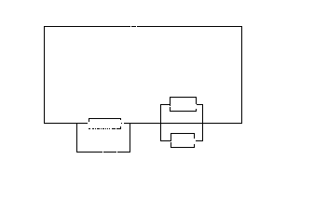
Determine the
- Total resistance in the circuit. 3mks

- Current in the circuit. 2mks

- Reading on the voltmeter. 2mks

- Fig 1 shows a displacement – time graph of a wave. The velocity of the wave is 50cm/s

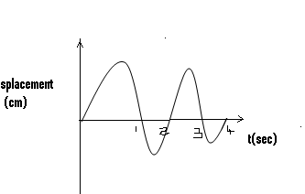

- Determine the,
- Amplitude 1mk

- Period 2mks

- Wavelength. 3mks

- Frequency 3mks

- Give the difference between constructive and destructive interference. 2mks

- The data below shows the results obtained when such an experiment was performed by form three students using various values of real depths, Y of a liquid

Real depth cm | 30 | 50 | 70 | 90 | 110 | 130
Apparent depth cm | 22 | 37 | 52 | 66 | 81 | 96
- Plot a graph of the real depth (y –axis) against apparent depth. 5mks

- From the graph, determine the refractive index of the liquid. 3mks

- State two uses of total internal reflection 2mks

- The real thickness of crown glass block of refractive index 1.58 is 10 cm. calculate the apparent thickness of the glass. 3mks

- A body of mass m initially at rest is acted on by a force F for a time t, as a result its velocity changes to a final value V. use this information to show that the grain is kinetic energy E= ½ MV². 3mks

- A bullet of mass 22g travelling at a velocity of 18/ms penetrates a sand bag and is brought to rest in 0.6 seconds. find:
- The depth of penetration in metres. 3mks

- The average retardeing force of the sand. 3mks

- A load of 100N is raised 20m in 50s. calculate ;
- The gain in potential energy . 2mks

- The power developed 2mks

