NAME………………………………………………ADM.NO……………CLASS:……….

MWAKICAN JOINT EXAMINATION (MJET) - 2019

FORM TWO PHYSICS TERM I 2019
TIME: 2 HRS.

INSTRUCTION TO CANDIDATE’S:
- Write your name, Admission number and class in the spaces provided above.
- This paper consists of TWO Sections; Section A and Section B.
- Answer ALL the questions in both Section A and B in the spaces provided.
- ALL working MUST be clearly shown.
- Candidates should check the question paper to ascertain that all the 10 pages are printed as indicated and that no questions are missing.
- Candidates should answer the questions in English.

Where necessary, take:
g = 10N/kg
Density of water = 1000kg/m³

For Examiners Use only

Section | Marks | Marks awarded
A | 25 Marks
B | 55 Marks
 | Total (80Marks)

SECTION A (25MARKS)

- The figure below shows a micrometer screw gauge being used to measure the diameter of a metal rod. The thimble scale has 50 divisions. What is the diameter of the rod? (1mark)

- A metal pin was observed to float on the surface of pure water. However the pin sank when a few drops of soap solution were carefully added to the water. Explain this observation. (2mks)

- State one advantage of fitting wide tyres on a vehicle that moves on earth roads (1mk)

- State two differences between mass and weight (2mks)

- What property of light is suggested by the formation of shadows? (1mk)

- Give a reason why attraction in magnetism is not regarded as a reliable method of testing for polarity. (1mark)

- In an experiment to determine the density of a liquid, a student filled a burette with a liquid to the 0cm³ mark. The figure shows a section of the burette showing the level of the liquid after 54.5g of the liquid had been run out.
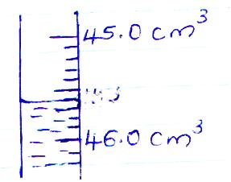

Determine the density of the liquid (3mks)

- State two advantages of an alkaline battery over a lead acid battery (2mks)

- In the set-up shown below, water near the top of the boiling tube boils while at the bottom it remains cold.
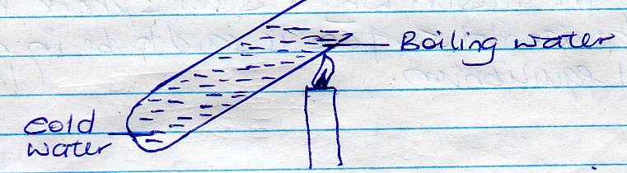

Give a reason for the observation. (1mk)

- The figure below shows a U – tube containing two liquids L₁ and L₂ of densities 0.8gcm⁻³ and 1.8gm⁻³ respectively in equilibrium.
Given that h₂ = 8cm, determine the value of h₁ (3mks)

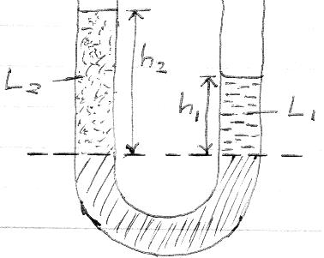

- A bag of sugar is found to have the same weight on planet earth as an identical bag of dry sawdust on planet Jupiter. Explain why the masses of the two bags must be different.
(2mks)

- State the reason why a steel sphere resting on a horizontal surface is said to be in neutral equilibrium (1mk)

- What is the reading on the vernier calipers shown in the figure below? (1mk)
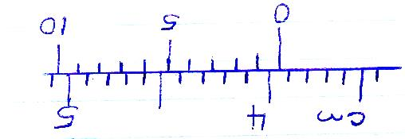

- The figure below shows water droplets on a waxed wooden surface and on a clean wooden surface.
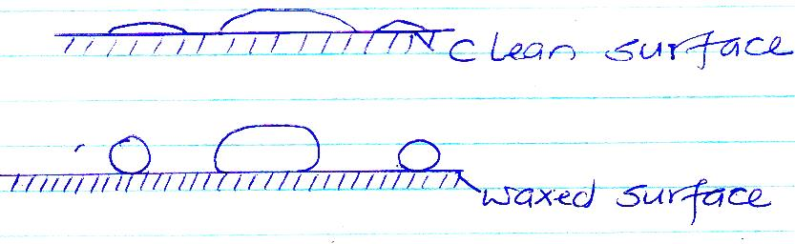

(a)

(b)

Explain the difference in the shapes of the droplets. (2mks)

- Distinguish between soft magnetic materials and hard magnetic materials. (2mks)

SECTION B (55MARKS)

- (a) State the law of electrostatic charges. (1mk)

(b) A highly negatively charged rod is gradually brought close to the cap of a positively charged electroscope. It is observed that the leaf collapses initially and then diverges. Explain the observation (3mks)

(c) State three uses of as leaf electroscope. (3mks)

- (a)What is meant by the centre of gravity of a body? (1mk)

(b) Using diagrams illustrate and explain the three states of equilibrium. (6mks)

(c) State and explain two factors that affect the stability of a body. (4mks)

- (a) Define the term heat. (1mk)

(b) State and explain three factors that affect the rate of heat transfer in solids. (3mks)

(c) The figure below shows a cross-section of a vacuum flask

- Name the parts labeled A and B (2mks)

- Explain how the heat losses are minimized when hot liquid is poured into the flask (3mks)

- (a) Distinguish between solid and liquid states of matter in terms of intermolecular forces. (1mk)

(b) Brownian motion of smoke particles can be studies by using the apparatus shown below. To observe the motion, some smoke is enclosed in the smoke cell and then observed through the microscope.
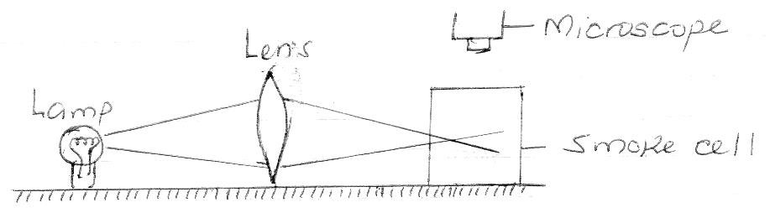

- Explain the role of the smoke particles, lens and microscope in the experiment. (3mks)

- State and explain the nature of the observed motion of the smoke particles. (3mks)

- State what will be observed about the motion of the smoke particles if the temperature surrounding the smoke cell is raised slightly. (1mk)

- (a) State the principle of moments. (1mk)

(b) The horizontal bar in the set-up shown in the figure below has a negligible weight.
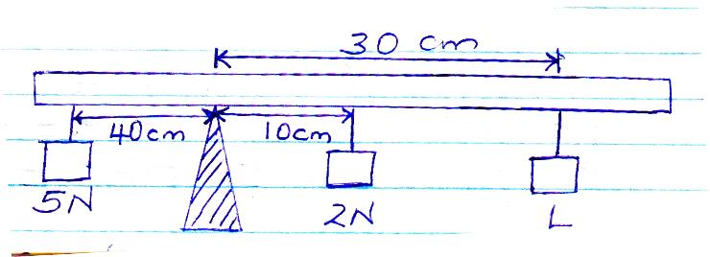

Determine the value of weight L. (3mks)

(c) Explain why it’s easier to use along hammer to remove a nail than to use a short one to remove the same nail. (2marks)

- (a) Define the term current. (1mark)

(b) A current of 0.5A passes through a bulb for 3 hours. Calculate the amount of charge passing through the circuit. (3marks)

(c) State two defects of a simple cell and how each can be corrected. (4marks)

- (a) State the basic law of magnetism. (1mark)

(b) The figure below shows a soft iron bar in a coil near a freely suspended magnet.
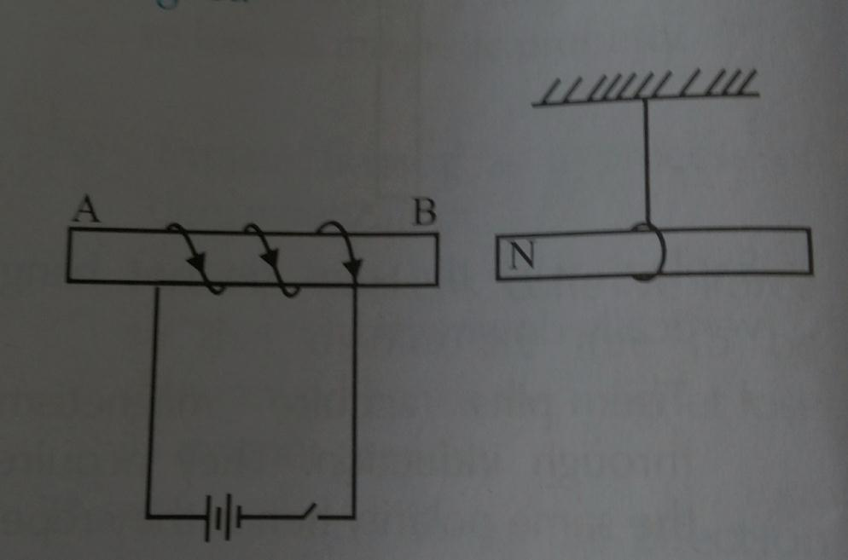
Explain the observation made when the switch is closed. (2marks)

(c) State three uses of magnets. (3marks)

