NAME: ADM No:
CLASS: SIGN:
232/3
PHYSICS FORM 4
PAPER 3
END TERM 2 YEAR 2019
JULY/AUGUST
TIME 2$\frac{1}{2}$ HRS

INSTRUCTIONS
i) Answer All questions in the spaces provided.
iii) All working must be clearly shown for numerical questions.
iv) Candidates should check to ascertain that all questions are printed as indicated in the table below.

- You are provided with the following;
- A stopwatch
- Cotton thread at least 120cm long
- Stand and a clamp
- Pendulum bob
- Metre rule
Arrange your apparatus as shown
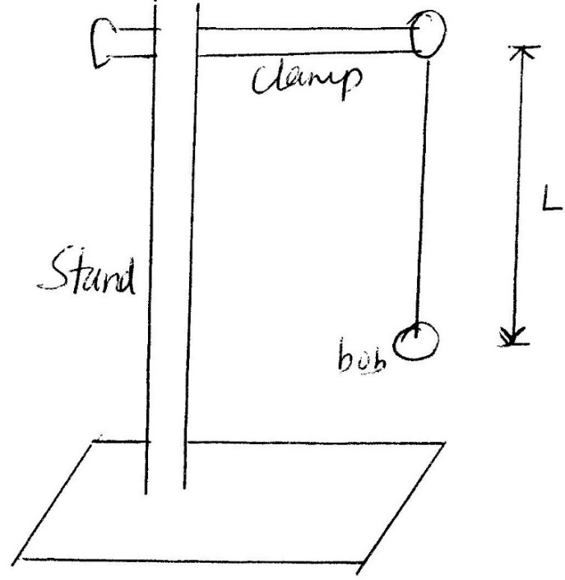
Proceed as follows;
- Adjust the length of the pendulum to 1meter.
- Displace the bob side ways to an angle of about 45º (estimate) and let the pendulum switching for 10 oscillations and record the time, t, take for the ten oscillations.
- Repeat the same for other values of L as shown in the table below and fill in the columns of the table as indicated. (8 Marks)
Length L(in m) | Time for 10 oscillations (in sec) | Periodic time (T) | (Periodic Time )²  T² (in 2 d.p.)
1.0
0.8
0.7
0.6
0.5
0.4
0.3

- Plot a graph of T² against L. (5 Marks)
- Determine the gradient (3 Marks)

- Given that period (T) of a pendulum and the length (L) are related by the equation
T = $\sqrt[2π]{\frac{l}{g}}$’
Where g is the gravitational pull, use your graph to determine the value of g. (4 Marks)

- PART A
You are provided with the following apparatus.
- A Convex lens
- A candle
- White screen
- Lens holder
- Metre rule
- Set up the apparatus as shown in the figure below.
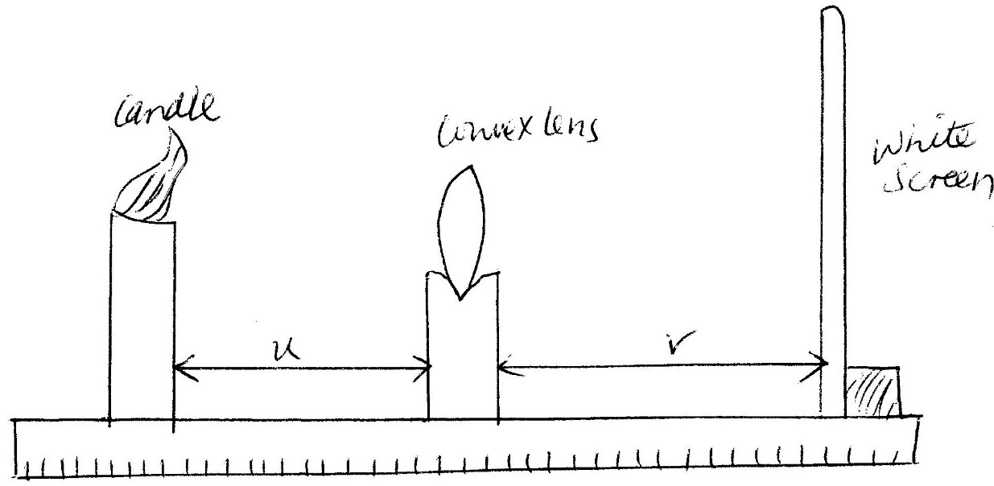
- Place a lighted candle at object distance, U = 20cm. Move the screen, towards or away the lens until a sharp image of the candle flame is obtained on the screen. Measure the distance V and record the results in the table below.
- Repeat the same for other values of U as shown in the table and fill their respective values of V. (5mks)
Object distance U (in cm) | Image distance V(in cm) | U + V (cm) | UV (cm²)
20
30
45
60
75
90

- Plot a graph of UV (cm²) against (U + V) (cm). (5 Marks)

- Determine the slope of the graph (2 Marks)

- Determine the power of the lens used in the experiment. (2 Marks)

PART B

You are provided with the following apparatus
- 2 New dry cells
- An ammeter
- A mounted wire labelled AB
- A cell holder
- A switch
- Connecting wires

- Draw a circuit that can be used to determine the resistance of the wire AB. (2 Marks)

- Set up the apparatus as in your circuit diagram and tabulate two set of values. (2 Marks)

- Calculate the resistance of the wire (2 Marks)

