‘

CASPA AMUKURA term 1 evaluation test 2021
232/2 – PHYSICS PAPER 2
MARKING SCHEME

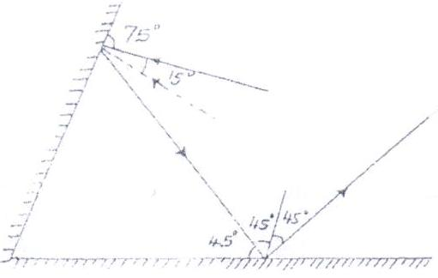

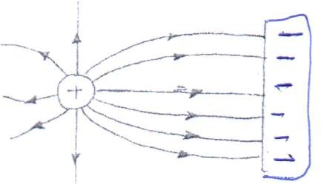

- They acquire North Poles at the ends thus they repel.
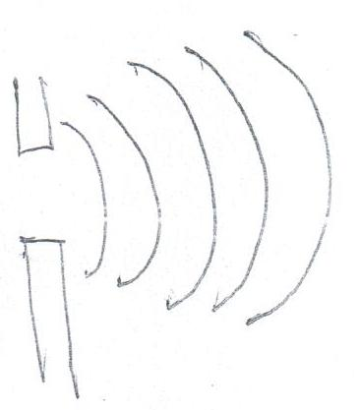
- (i) (ii)
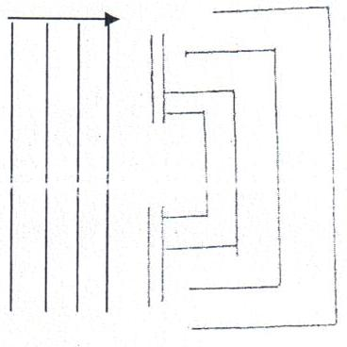

- (i) Microwaves, infrared, visible light, X-rays.
- Observing objects
- Taking pictures.

- I ) polarization -use potassium dichromate
ii) local action - use pure zinc metal

- V = 2S => S = Vt
t 2

S = 330 x 0.6 = 99m
2

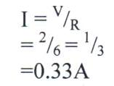
- .
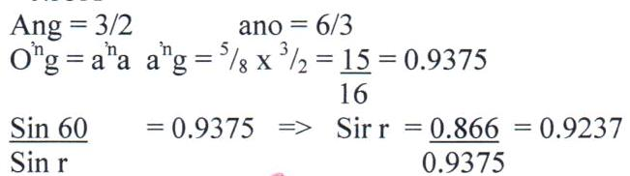
r = 67.47⁰

- Distance between the plates.
- Area of plates.
- Dielectric material used.

- Alkaline produces higher current
- Lasts longer
- It is portable
- Less maintenance and care.

12 p = v²/R

40 w = ( 240v ) ²/R

R =57600/40
= 1440Ω

SECTION TWO
13 (a) (i) Parallel 1 = 1 + 1 + 1
R 6 4 8

1 = 2 + 3 + 4
R 12

1 = 9
R 12

R = 4 = 1¹/₃Ω
R_{t} = 4 + 1¹/₃
= 5¹/₃Ω

(ii) V = IR

I = V = 4.5
R 5.33

= 0.844A
V = 4 x 0.844
= 3.377V

(b) E = 3.2r + 2.8 (3.2) E = 5r + 5 (1.6)
E = 3.2r + 8.96 E = 5r + 8 = …
Solve 1 & 2 simultaneously
r = 0.533Ω E = 10.67V

Complete the diagram below indicating the rays that will lead to the formation of the image

- A compound microscope with an objective lens L_{o} of focal length 1.2cm and an eye piece lens L_{e} of focal length 2.8cm. An object is placed 1.8cm from the objective lens. The system of lenses produces a final image a distance of 12.0cm from L_{e}. Determine the distance of separation of lens L_{o} and L_{e}. (4 MARKS)
$$\frac{1}{v}=\frac{1}{f}-\frac{1}{u}=\frac{1}{1.2}-\frac{1}{1.8}, \frac{1}{v}=0.2778,v=3.6cm$$
$$u_{e}=d-v$$
$$\frac{1}{d-3.6}=\frac{1}{2.8}-\frac{1}{10}$$
$$d-3.6=3.8889$$
$$d=7.489cm$$
- An object is placed 12cm from a convex lens and it forms a virtual image 36cm from the lens. Calculate the focal length of the lens. (3 MARKS)
$$u=12cm$$
$$v=-36cm f=\frac{uv}{u+v}$$
$\frac{12 x-36}{12-36}=\frac{432}{24}=+8cm$

- The graph below shows the variation of potential difference V with current I for a certain cell.
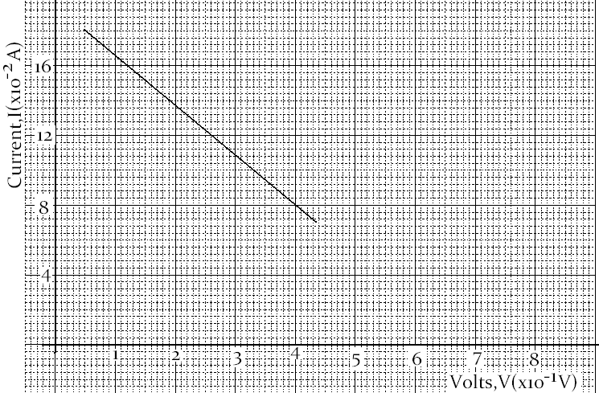
From the graph determine
- The internal resistance of the cell (3 marks)
$$internal resistance,r=\frac{1}{gradient}=\frac{12-8}{2.6-4}={2.857}^{-1}, 0.35±0.01$$
- The e.m.f of the cell (1 mark)
$$e.m.f when I=0 e.m.f=6.8V$$

14(a) (i) State one cause of energy losses in a transformer and explain
how it can be minimized. (2mks)
Causes Method of minimising
Eddy currents Laminations
Hysterises loss/Magnetic reversals Use of soft iron
Heating effect (T²R) Use of thick copper wires
Magnetic flux leakage Winding secondary on primary/use of soft iron core
Any one, with correct method (2mks)
(ii) Describe briefly the energy changes involved in the generation of electrical energy at a hydropower station (2mks)
Potential energy kinetic energy electrical energy;;
(iii)What are the advantages of transmitting power at?

- Very high voltages (1mk)
To minimize power loss;
- Alternating voltage (1mk)
Can be stepped up or stepped down;
(b)(i) Explain how electrons are produced in a cathode ray oscilloscope (CRO) (2mk)
The cathode is heated by filament and electrons are released from cathode ray by thermionic emission
- State two functions of the anodes in a CRO (2mks)
-to accelerate the electrons
-to focus the electrons towards the screen

- At what part of the cathode ray oscilloscope would the time be connected (1mk)
Across x-plate
- State why the tube is highly evacuated (1mk)
To reduce collision/interaction/interferance of electrons, (hence ionization) with air molecules in the tube
Or
To maintain K.E or minimise loss of K.E
15 a) (i) speed of sound
2.5 s x c = 400 m x 2 ( c is the speed of sound in air )
C =( 400 m x 2 ) /2.5 s
= 320 m/s
( ii ) 2 ( X – 400 ) m /320 = ( 2.5 + 2 ) s
( 2X -800 )/320 =4.5 s
2x =2240
X = 1120m

16 a) an eclipse of the moon occurs when the earth comes between the moon and the sun.
b) umbra is a type shadow that occurs when no light reaches the screen while penumbra is a
type of shadow that occurs when some light reaches the screen
c) 20 x 2
= 40 degrees
d) h_{o} =25 m, u = 50 m, v = 30 m
( h_{o} / h_{i} )= 50 m/ 30 m
h_{i} = 750/50
= 15 m

