MARKING SCHEME PAPER ONE PHYSICS
- =(1000 x 0.5) (0.10 x 2)
= 500 + 0.2
= 500.2 mm
- pressure at P= pressure at Q
= 0.16 X 1000X10
=1600 PASCALS
- h= 5 x 10⁻⁸ x 0.1 (1mk)
= 5 x 10^{-9m}
- i)The patch is circular
ii)The patch is monolayer
- When temperatures are high the pipe expands and loop curve move. When temperatures drop the pipe contracts and stretch up the loop preventing breaths. (1mk)
- 5. The wire gauze is a good conductor . It conducted the heat but after sometime the ignition point was reached.
- M.S = 11.5
S.S = 0.32
11.82 mm
Error 0.14
Actual diameter = 11.68 mm
- a) The moment of force would be very small because it depends on the perpendicular distance from the pivot.

Clockwise moments = 0.9 x 0.1 + 0.2 x0.3
= 0.09 + 0.06
=0.15Nm
Anticlockwise moments = 0.72 x 0.2 = 0.142NM
Rule tilts inside of 20g mass since clockwise moments are greater than anticlockwise moments.
- Number of curve
Diameters of the turn
- The velocity of air inside is high hence lowers the pressure inside. The greater pressure outside makes the paper to collapse.
- Y= 1cm = 100cm/s
0.01sec
V= 0.5cm = 50cm/s
  - sec
a = v – u
t
= (50 – 100)
10 x 0.01
= -50cm/s
0.15
=-500cm/s²
= -5ms⁻²
- F= ke
K=f=3 x 1000
0.06 x 1000
=3000
6
= 500 N/M
Work done = 1/2ke²
= ½ x 500 x (0.04)²
= 0.4J
- a) Temperature of the gas
Mass of the gas
b i) 4.0 x 10 m
- -275º c to -285⁰ c
- They are at rest/they have zero K.E
- Before reaching this temperature the gas
–liquifies
-solidifies
c) V1 = V2 = 300cm³ volume is constant P1V1 = P2V2
T1 T2
9.5 X 10⁴ X 300 = P2 X 300
298 283
p2 = 9.022X 10⁴pa
- a) Time
Mass of water collected
b) Power = MLf
Time
c)) energy lost is not accounted for eg energy absorbed by heater, container and variation
d) liquid boiling at constant temperature
14.

b) h=1/2gf2
S=1/2x10xt
t = 1
ii) t =1
V=30
Range = 30 x 1
=30m
V = U + 2ag
V=2 x 10 x s
V=10
15 a)

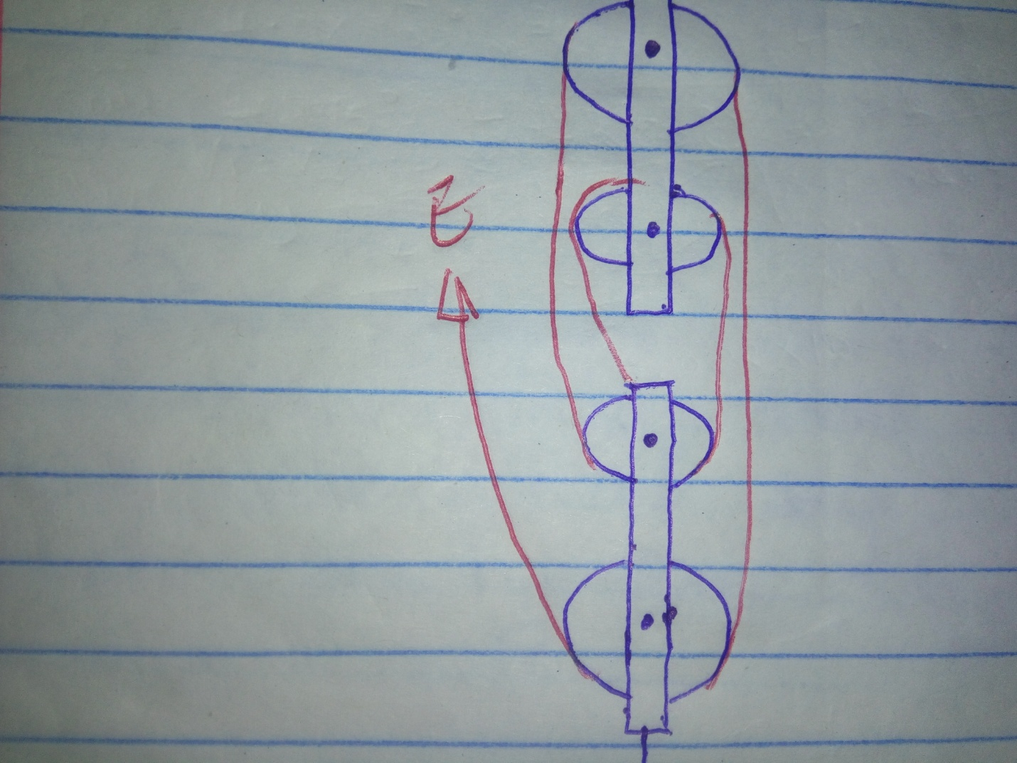

b) n=MA x 100
V.R
m.a = 80 x 5
100
MA = 4
II) M.A. = load
Effort
4= 2800
E
e= 700N
c) –Heat loss due to friction
Weight of lower block
16. a) A body displaces its own weight in the fluid in which it floats (1mk)
b)ii) Volume of displaced water = 3 x 2 x 0.6= 3.6m³
Mass of displaced water = 3.6 x 1030 = 3708kg
Weight = mg = 3708 x 10 = 37080N
ii) upward force exerted on the body by the water = mg
= 3708 x 10
=37080 N
iii) Tension in the wire = 37080 – 100 = 36980 N
17.

velocity

time

b) Body accelerates uniformly from rest as it falls
i) momentum = MV
= 0.5 x 10
5kgms⁻¹
ii) M1V1 = m2v2
s= 2v2
v2 = 2.5ms⁻¹
iii) P.E =K.E
mgh = 1/2mv²
2x 10xh = ½ 2 x 6.25
h=0.3125m.

