3KNT FRATERNITY EXAM 2017
TERM II FORM 4
PHYSICS PAPER III MARKING SCHEME
1. V = 14ml ± 0.1ml –r 14cm3 ± 0.1cm³ 1mk
- pour some water in the measuring cylinder and record the volume V₁
- Lower the 100g mass into the measuring cylinder using a string and record the new volume. V₂. ½ mk
Therefore the volume of 100g mass = V₂ – V₁. ½ mk

b)i) Centre of gravity – 50cm ± 0.5 1mk

ii) X = 10cm

Y = 9.3cm or 930mm 1mk

c)
Xmm | 100 | 150 | 200 | 250 | 300 | 350
Ymm | 93 | 133 | 178 | 221 | 263 | 306
½ mk per reading

e) N = DY = 15 – 8.5 1mk
DX 17.5 – 10

= 6.5
7.5 1mk

= 0.8667 1mk

f) Given N = F where F – apparent weight of mass in salt solution
W W – actual weight of mass in air
N – is the gradient

i) F = WN but W = 0.1kg x 10N/kg = 1N
= 0.8667 x 1
= 0.8667 0.87N 1mk

ii) U = W – F
= (1 – 0.8667) 1mk
= 0.133
0.13N 1mk

h) Upthrust = Pvg
= P x 14 x 10⁻⁶ x 10

0.13 = p x 14 x 10⁻⁶ x10

P = 0.13 1mk
14 x 10⁻⁶ x10

= 928.57kg/m³ 1mk

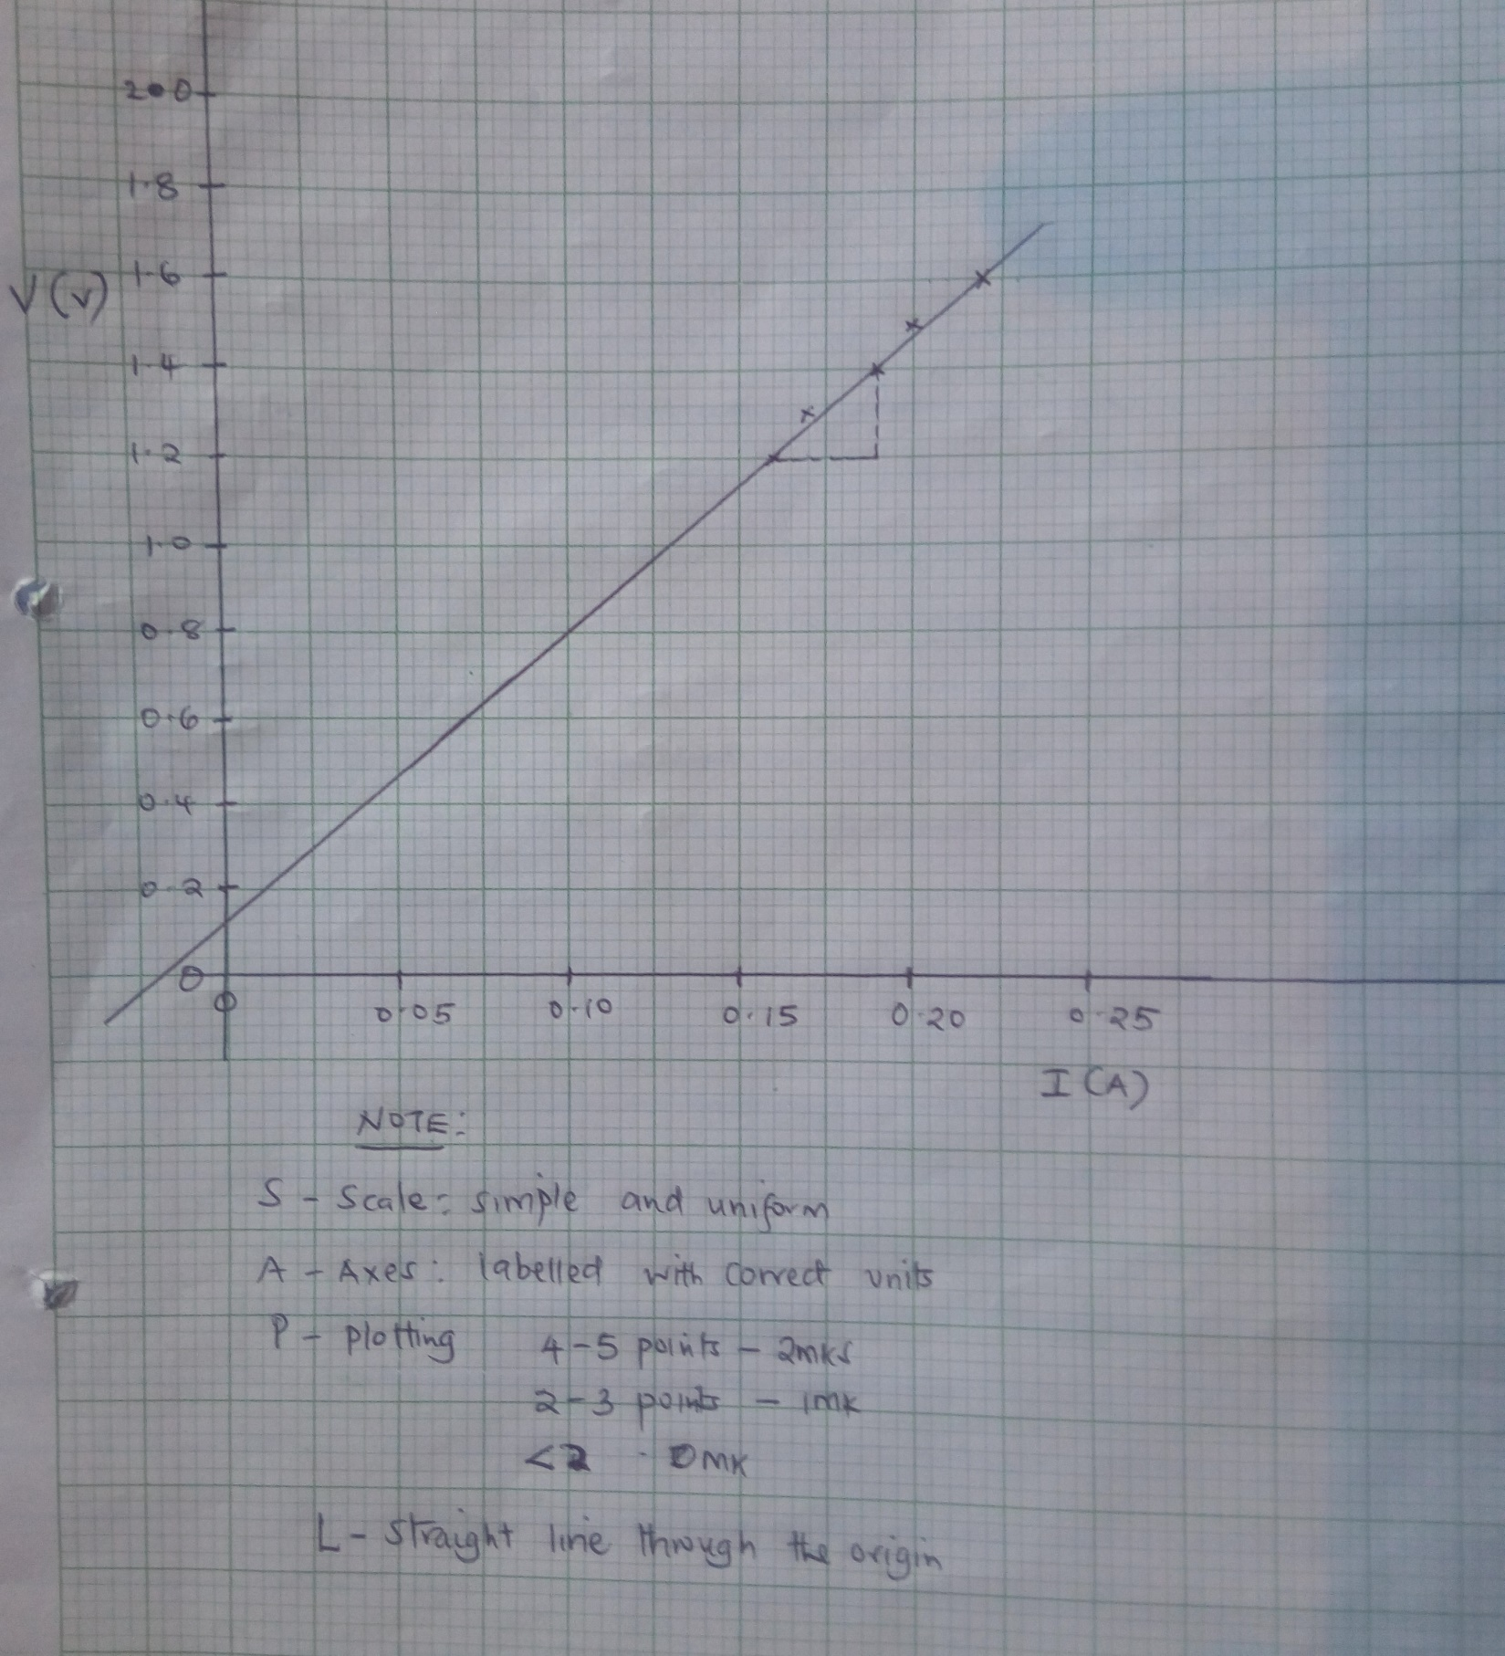

2.(iii)
Length, L (m) | 0.2 | 0.4 | 0.6 | 0.8 | 1.0
Current, I (A) | 0.22 | 0.20 | 0.19 | 0.17 | 0.16
Voltage, V (v) | 1.60 | 1.50 | 1.40 | 1.30 | 1.20

5 values - 4mks
4 values - 3mks
3 values - 2mks
2 values - 1mk

v) Gradient = points on the line 1mk
substitution

Dy = 1.4 - 1.2
Dx 0.19 – 0.16

= 0.2
0.03

= 6.6667 ± 2µ 1mk

vi) d = 0.21 0.01mm = 2.1 x 10⁻⁴m 1mk

vii) K = 6.6667 x ( 2.1 x 10⁻⁴)2 x π substitution 1mk
2 answer 1mk

4.6187630 x 10⁻⁷ Ωm

Part B
i) f₁ = 20.0 ± 2.0cm

iv) Distance, x of lens from crosswire(cm) Distance, y (cm) Distance, d (cm) y – d (cm)
±1cm ±1cm
35 19.0 52.5 33.5
45 11.0 43.0 32

(½ mk each, 1mk both)

v) (33.5 + 32) = 32.75cm 1mk
2

vii) f₂ = 32.75 = 16.75cm 1mk
