GATITU MIXED SECONDARY SCHOOL
FORM 4 JUNE MIDTERM EXAM 2014
PHYSICS
INSTRUCTIONS
Answer all questions provided.
- A lens forms an image that is four times the size of the object on a screen. The distance between the object and the screen is a 100cmwhen the image is sharply focused.
- State with reasons what type of lens was used 2mks
- Calculate the focal length of the lens 4mks
- Give the similarities between a lens and a camera 4mks
- (i) List three factors affecting the centripetal force 3mks
(ii) A body having a mass of 0.5kg is tied to a string and whirled in a horizontal circle of radius 2m with a speed of 3.16ms-1. Calculate the centripetal acceleration 2mks
- State the law of floatation 1mk
- The figure below shows a cathode ray tube in which a beam of electrons is cast on the screen. 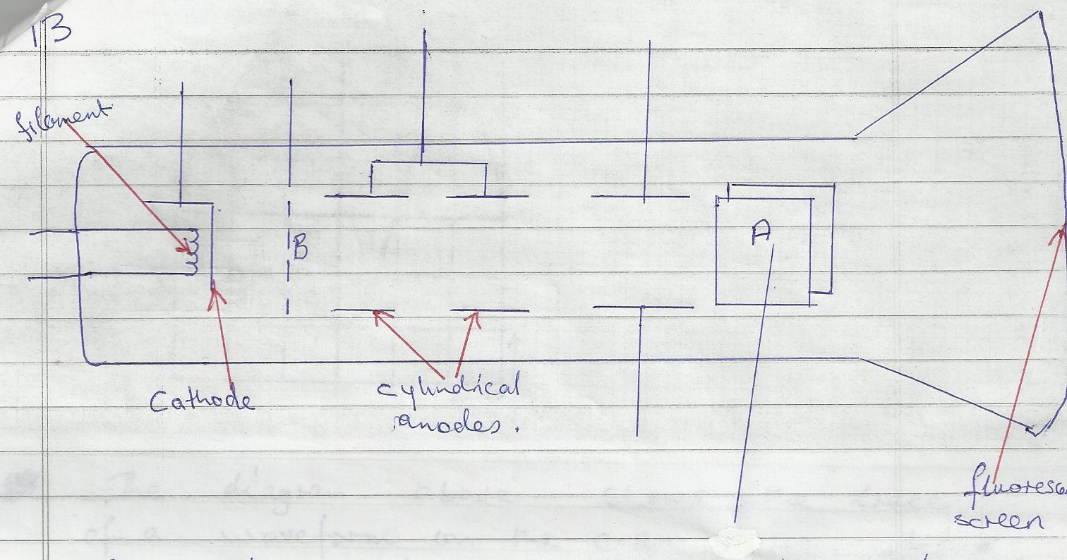
- State how electrons are produced in the tube 2mks
- State how the electron beam is detected 2mks
- The figure below shows the waveform of a signal applied at the Y-plates of an oscilloscope which time base is switched at a scale of 2ms/div. determine the;
0 |  | 1 |  | 2 |  | 3

(i) Period of the signal 2mks
(ii) Frequency of the signal 3mks
- Give the reason why barium oxide and strontium is used in the fluorescent screen of a cathode ray oscilloscope. 1mks
- (a) State the Flemings left hand rule 2mks
(b) Suggest three ways in which an electric motor could be made to move faster 3mks
(c) Explain how the motor works 3mks
(d) Mention any other two applications of electromagnetic induction apart from the motor (2mks)
- In an experiment to determine the height of a tree by estimation method, a student obtained the following results
Length of the shadow of the tree =2.0m
Length of the shadow of the rod =80cm
Length of the rod =100cm
Use the information above to work out the height of the tree 3mks
- Distinguish between the soft x-rays and hard x-rays 4mks
- A small wind pump develops an average of 50W. It raises water from the borehole to a point 12m above the water level. Determine the mass of water delivered in one hour 4mks
- Arrange the following electromagnetic waves in order increasing wavelength; infrared, radio waves, ultra violet, microwaves and gamma rays (3mks)

