NAME …………………………….. INDEX NO. ……..…
DATE ……………………………. CLASS ……………..
MWAKICAN FORM 3 JOINT EXAMINATION – 2016 TERM I
232/1
PHYSICS
PAPER 1
TIME: 2 HRS

INSTRUCTION TO CANDIDATES:
- Write your name and Admission number in the spaces provided.
- Answer all the questions in the spaces provided.
- Mathematical tables and electronic calculators may be used.
- All workings must be clearly shown where necessary.

FOR EXAMINERS USE ONLY:

SECTION | QUESTIONS | MAXIMUM SCORE | CANDIDATES SCORE
A | 1 – 13 | 25
B
TOTAL

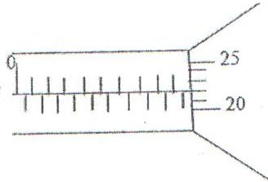
- The micrometer screw gauge represented by figure 1 below has a thimble scale of 50 divisions. What is the reading shown? (1 mk)

- Figure 2 shows a uniform bar of length 1.0m pivoted near one end. The bar is kept in equilibrium by a spring balance.

Given that the reading of the spring balance 0.6N, determine the reaction on the pivot. (3 mks)

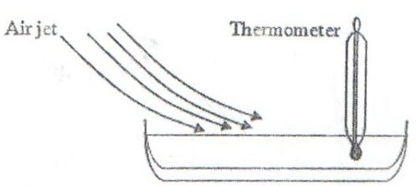
- Figure 3 shows a shallow dish containing a volatile liquid. The bulb of a thermometer is held inside the liquid. A jet of air is blown over the surface of the liquid, so that the liquid evaporates rapidly.

State and explain what happens to the reading shown on the thermometer. (3 mks)

- Figure 4(a) shows a glass ornament standing on a shelf. Figure 4(b) shows an identical ornament filled with colored glass beads.

State which ornament is more stable and why. (2 mks)

- 100g of water of density 1g/cm³ is mixed with 60g of a liquid of relative density 1.2. Assuming no change in volume, find the density of the mixture. (2 mks)

- An object of mass ‘m’ has a weight ‘w₁’ in air and ‘w₂’ in water. Suggest a reason why w₁ is greater than w₂. (1 mk)

- State the significance of the closeness of streamlines in fluids. (1 mk)

- A thin metal disc has a hole passing through its center. What would happen to the size of the hole if the disc were heated? (1 mk)

- State two factors, which can cause the temperature at which water boils to rise. (2 mks)

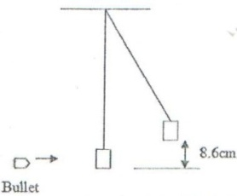
- A bullet of mass 2.0g is fired horizontally into a block of wood of mass 600g. The block is suspended from strings so that it is free to move in a vertical plane. The bullet and the block rise together through a vertical distance of 8.6cm as shown in figure 5.

Determine the speed of the bullet before the impact with the block. (3 mks)

- The figure below shows a uniform plank of wood of length 1.2m pivoted near one end. The plank is kept in equilibrium by a string as shown S.
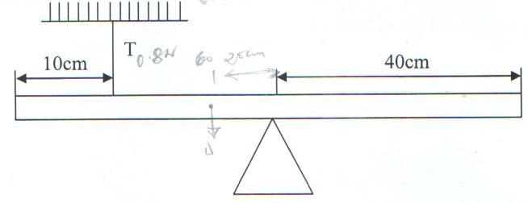

Given that the tension T in the string is 0.8N, determine the reaction force at the pivot. (3 mks)

- Give a reason why heat transfer by radiation is faster than heat transfer by conduction. (1 mk)

- In the diagram in figure 6, water flows through a section of a pipe whose diameter changes.
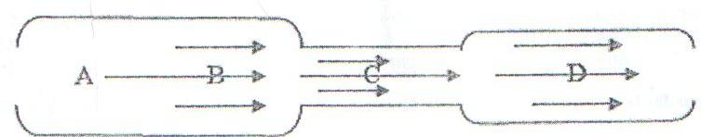

Sketch a graph of the variation of pressure along the line ABCD. (2 mks)

SECTION B:
- (a) The figure below shows a section of a ticker tape. The dots were made at a frequency of 50Hz.

Determine the acceleration of the trolley pulling the tape. (3 mks)

(b) A body starts from rest and accelerates at 2 m/s² for a time of 5 seconds, calculate:
- Its final velocity. (2 mks)

- The distance travelled. (2 mks)

(c) State Newton’s 2nd Law of motion. (1 mk)

(d) A hammer of mass 2 kg strikes a nail with a velocity of 9m/s and is stopped by the force of reaction in 0.025s. find the force of the acting on the nail. (2 mks)

(e) A body is released from a height, h. if the acceleration due to gravity is g, derive an expression of the velocity of the stone just before hitting the ground. (3 mks)

(f) The figure below shows a velocity – time graph of a body in motion – sketch on space provided a displacement – time graph of the motion. (2 mks)
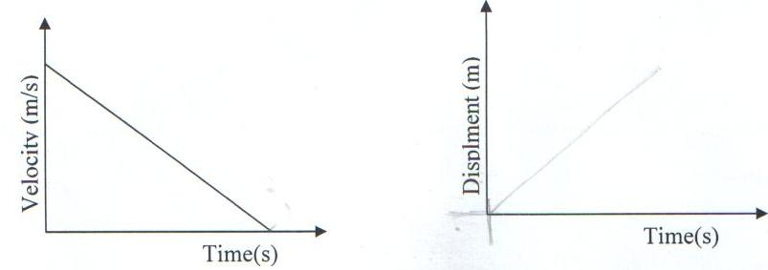

- A burette is filled with oleic acid drop upto the 15.5cm³ ark. After 50 drops of the oil were let out of the burette the level of the oil dropped to 22.5cm³.
- Determine the volume of one drop of the oleic oil. (3 mks)

- One drop of the oleic oil is carefully introduced onto a clean surface of a trough. It spread to a patch. Determine the thickness of each oleic oil molecules in metres. (Assuming the radius of drop = radius of patch). (5 mks)

- State two assumptions made in part (b) above. (2 mks)

- The table below shows the values of extensions of a spiral spring when various forces are applied to it.
Force F, (N) | 0 | 1.2 | 2.0 | 3.0 | 4.0 | 5.0 | 6.0
Extension R, (cm) | 0 | 0.8 | 1.5 | 2.3 | 3.1 | 3.8 | 4.6
- On the grid provided, plot a graph against the extension. (5 mks)

- From the graph, determine the work done in stretching the spring by 4cm. (3 mks)

- Differentiate between mechanical advantage and velocity ratio. (2 mks)

- An effort of 125N is used to lift a load of 500N through a vertical height of 2.5 m using a pulley system. If the distance moved by the effort is 1.5 m, calculate the;
- Work done on the load. (2 mks)

- Work done by the effort. (2 mks)

- Efficiency of the system. (2 mks)

- Draw a well labeled diagram of the pulley used in (b) above. (3 mks)

- Suggest one method of improving the efficiency of the system. (1 mk)

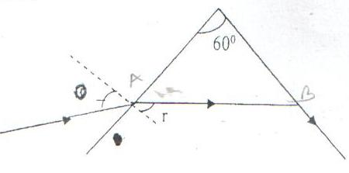
- The figure below shows path of ray of yellow light through a glass prism. The speed of yellow light in the prism is 1.88x10⁸m/s.

- Determine the refractive index of the prism material for the light (speed of light in vacuum=3.0 x 10⁸m/s). (3 mks)

- (i) Show on the diagram the critical angle. (1 mk)

- Given that r=21.20, determine angle Ɵ. (3 mks)

- On the same diagram sketch the path of the light after striking the prism if the prism was replaced by another of similar shape but lower refractive index (use dotted line for your answer). (2 mks)

- State 2 conditions that must be satisfied at B for total internal reflection to occur. (2 mks)

