Name: …………………………………………………………… Index No. …………………………
School: …………………………………………………………. Candidate’s Sign. …………............
Date: ………………………………............................................

232/1
PHYSICS THEORY
PAPER 1
TIME: 2 HOURS

Kenya Certificate of Secondary Education (K.C.S.E.)
JOINT EXAMINATION-2021

232/1
Physics
Paper 1

INSTRUCTIONS TO THE CANDIDATES:
- Write your name and index number in the spaces provided above.
- Answer all the questions both in section A and B in the spaces provided below each question
- All workings must be clearly shown; marks may be awarded for correct steps even if the answers are wrong.
- Mathematical tables and silent electronic calculators may be used.
FOR EXAMINERS’ USE ONLY
SECTION | QUESTION | MAXIMUM SCORE | CANDIDATE’S SCORE
SECTION A | 1-13 | 25
SECTION B | 14 | 11
 | 15 | 15
 | 16 | 08
 | 17 | 07
 | 18 | 14
 | TOTAL | 80

This paper consists of 15 printed pages. Candidates should check to ascertain that all pages are printed as indicated and that no questions is missing

SECTION A (25 MARKS)
ANSWER ALL QUESTIONS IN THIS SECTION IN THE SPACES PROVIDED
- Figure 1 shows an object held between two straight edges. Determine the radius of the object using the meter rule shown in figure 1 below. (2 marks)
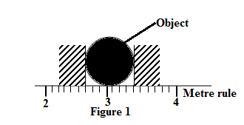
$$Diameter=3.4cm-2.2=1.2cm$$
$$radius=\frac{1.2}{2}$$
$$=0.6cm$$
- Apart from the size of an object state the other factor to be considered when choosing an instrument for measuring length of a given object (1 mark)
The accuracy required
- The figure shows the level of mercury in a barometer. Study the diagram and answer the questions that follow
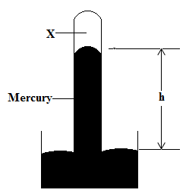
State and explain the effect on the height h when the atmospheric pressure increases (2 marks)
The height increases. Increase in atmospheric pressure will push the level of the mercury column to rise in the tube

- Give a reason why it easier to use a hammer with a long handle to remove a nail from wood that to use another one with a short handle to remove the same nail (1 mark)

A hammer with a longer handle has a higher Velocity ratio/less effort will be required/has higher efficiency

- When a steel ball is allowed to fall freely in a viscous fluid, it is observed to attain terminal velocity after some time. State the reason why the ball attains terminal velocity (1 mark)
The ball attains terminal velocity because the total upward force acting on the ball equals to the total downward force
- The tape in the figure (not to scale) was obtained from an experiment using a timer of frequency 50Hz

State whether the body is decelerating or not the acceleration of the body whose motion is represented in the tape. (1mark)
The body is accelerating

- The figure shows two identical measuring cylinder containing different liquids X and Y placed on a weightless simple balance. The system is equilibrium.
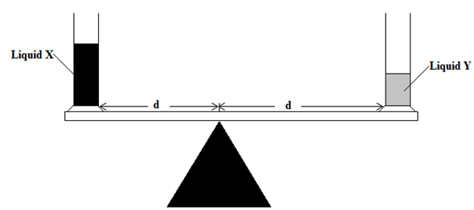
Compare the density of liquid X and that of Y (2 marks)
Liquid Y has a higher density than liquid. Less volume of Y exerts same moment as that of X hence greater density

- The figures below show an arrangement of two pulleys used to lift same load of 100N
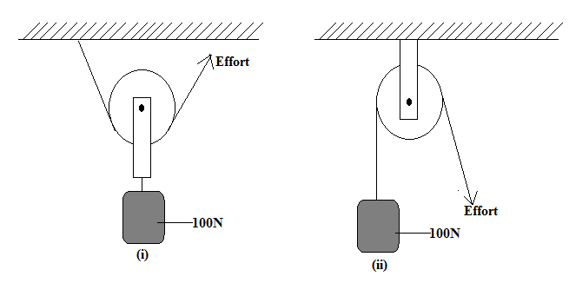
State with a reason the system that is more efficient (2 marks)
System (ii) is more efficient, less energy is lost in lifting parts of the pulley like in the case of system in (i)

- The figure shows a water tank that is used to heat water and supply through taps.
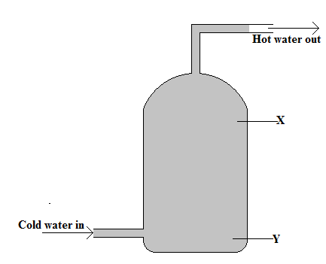
State with a reason whether the appropriate position for a heater is X or Y (2 marks)
Position Y. To ensure heat is transferred upwardly in the water through convection

- The figure shows a uniform metre of mass 200g balance by a spring balance placed 70cm form one. The pivot is placed 30cm away from the same end. Study the diagram and answer the questions that follow

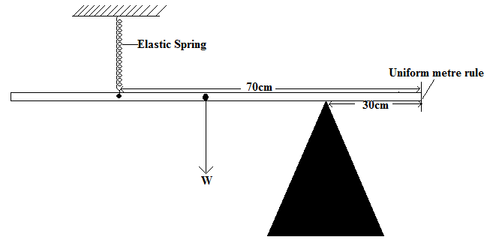

Determine tension T on the spring (2 marks)
$$F_{1}d_{1}=F_{2}d_{2}$$
$$T×0.4=2N×0.2$$
$$T=1N$$

- State the cause of random motion of smoke particles as observed in Brownian motion experiment using a smoke cell. (1 mark)
It is caused by the bombardment of smoke particles by the air particles that are moving randomly

- The figure shows the level of mercury and water in identical glass beakers
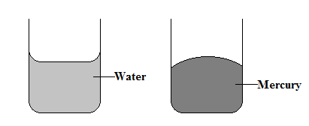

Explain the difference in the shapes of the meniscus (2 marks)
In the water, the meniscus curves downwardly because water molecules experience greater adhesive forces than cohesive forces while in mercury the mercury molecules experience greater cohesive forces than adhesive forces with glass
- A wooden block of mass 2kgs is placed on a horizontal surface. A horizontal force of 12N is exerted on it makes it to accelerate at 5ms⁻². Determine the frictional force acting between the surfaces. (2 marks Resultant force = mass x Acceleration= 2 x 5
Friction = 12 – resultant force
= 12 – 10 = 2N

SECTION B (55 MARKS)
ANSWER ALL QUESTIONS IN THIS SECTION IN THE SPACES PROVIDED

- State the two conditions necessary for a system of forces acting on a body to be in equilibrium (2 marks)
- Sum of clockwise moments must equal to sum of anticlockwise moment at a point
- Total upward force must equal to total downward force
- The figure shows a loaded wheelbarrow held in equilibrium by a gardener. The wheel of the wheelbarrow is in contact with the ground at point C

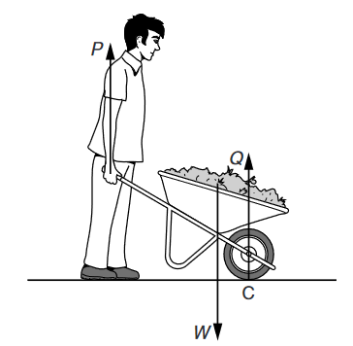
There are three vertical forces acting on the wheelbarrow P is the upward force applied by the gardener. Q is the upward force of the ground on the wheel at point C.W is the weight of the wheelbarrow and its contents. Explain why the force P is less than the force W
- By considering the forces P, Q and W, ( 2 marks)
The sum of the forces P and Q are the ones equaling to W since the system is at equilibrium
$$P+Q=W$$
- By considering the moments of the forces P and W about point C. (2 marks)
P is less than W since it acting at a longer distance from the pivot C and since the system is at equilibrium P must be smaller

- The figure shows a tanker lorry full of liquid. Study the diagram and answer the questions that follow
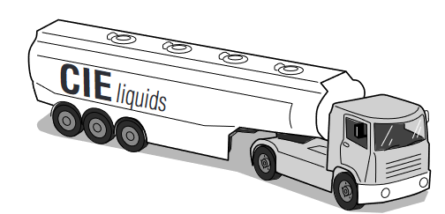
- The tanker delivers the liquid and drives away empty. Compare the acceleration of the empty tanker with the acceleration of the full tanker for the same resultant force (2 marks)
The full tanker will travel at a higher acceleration that the empty tanker for the same resultant force. This is because acceleration is inversely proportional to the mass of the object or the body

- Given that empty tanker has a weight of 50 000 N. The forward force is 6000 N and the total resistive force is 2000N. Determine the acceleration of the tanker (3 marks)
$$Net force=6000-2000=4000N$$
$$mass of the tanker=5000kg$$
$$F=ma 4000N=5000×a$$
$$a=\frac{4000}{5000}$$
$$=0.8{ms}^{-2}$$

- A warm bottle of soda placed in ice at 0°C cools faster than when the same soda is placed in water at the same temperature. Explain this observation (2 marks)
Ice will absorb more heat from the warm soda than water at the same temperature
Since ice will absorb latent heat of fusion from the warm soda

- The figure shows an incomplete circuit set up that can be sued in an experiment to determine the specific heat capacity of a solid block by electric method. Study the diagram and answer the questions that follow
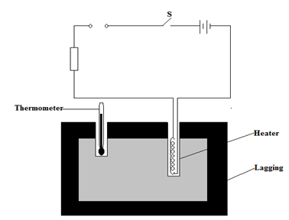

- State the purpose of the rheostat in the experiment (1 mark)
To keep constant the amount of current flowing through the heater /to vary the amount of current flowing through the heater
- Complete the diagram by inserting the missing components for the experiment to work (2 marks)
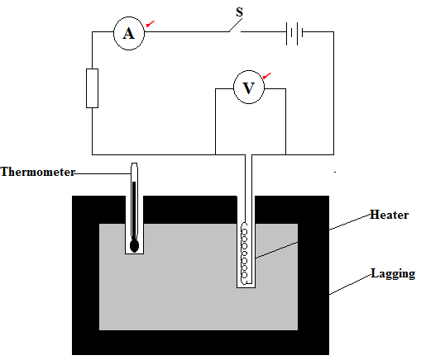

- Other than temperature, state three measurements that should be taken (3 marks)
Voltmeter reading
Ammeter reading
Time taken

- The figure shows a set-up of apparatus used in an experiment to determine the specific latent heat of fusion of ice. Study the diagram and answer the questions that follow
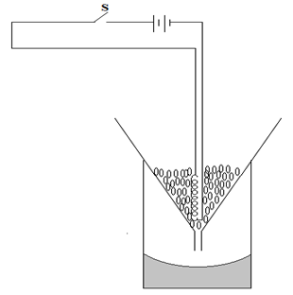
The following readings were noted after the heater was switched on for 10 minutes
- Mass of the beaker=260g
- Mass of the beaker +melted ice =280g
Determine
- The energy supplied by the 120W heater in the 10 minutes (3 marks)
$$E=Pt$$
$120W×10×60$
$$=72000J$$
- The specific latent heat of fusion of the ice (3 marks)
$$Heat lost by the heater=heat gained by the ice$$
$$72000=\frac{20}{1000}L_{f}$$
$$L_{f}=3.6×{10}^{6}J/kg$$
- The experiment value for the specific latent heat of fusion of ice obtained is less than the theoretical value. Give one reason for this observation (1 mark)
There is heat energy lost to the surrounding
Error in the measurement of time and temperature

- The figure shows a conveyor belt transporting a package to a raised platform. The belt is driven by a
motor.
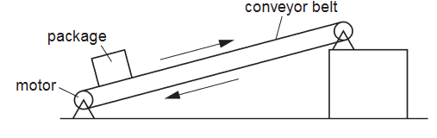
The mass of the package is 36 kg.
Determine
- The increase in the gravitational potential energy (g.p.e.) of the package when it is raised through a vertical height of 2.4 m. (2 marks)
$$G.P.E=mgh$$
$$=36×10×2.4m$$
$$=864J$$
- The power needed to raise the package through the vertical height of 2.4 m in 4 s (2 marks)
$$Power=\frac{Workdone }{time }$$
$$=\frac{864}{4}$$
$$=216W$$
- The electrical power supplied to the motor is much greater than the answer to (b).
Explain how the principle of conservation of energy applies to this system. (2 marks)
The energy is still conserved bit not all energy is used in lifting the load. Some of the energy is used in overcoming friction and also lifting the parts of the conveyor

- Assume that the power available to raise packages is constant. A package of mass greater
than 36 kg is raised through the same height. Suggest and explain the effect of this increase in mass on the operation of the conveyer belt. (2 marks)
The time taken to lift the package through the same height will be longer. This is because the power supplied is constant and work done is directly proportional to the time taken

- An athlete of mass 64 kg is bouncing up and down on a trampoline.
At one moment, the athlete is stationary on the stretched surface of the trampoline as shown in the figure below.
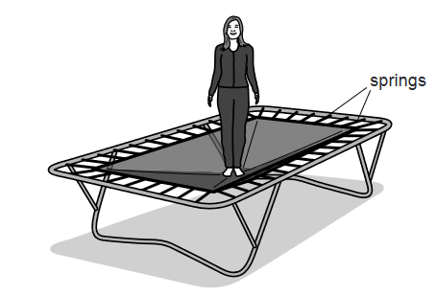
- State the form of energy stored due to the stretching of the surface of the trampoline. (1 mark)
Elastic potential energy

- The stretched surface of the trampoline begins to contract. The athlete is pushed vertically
upwards and she accelerates. At time t, when her upwards velocity is 6.0 m / s, she loses
contact with the surface. Determine

- Her kinetic energy at time t. (2 marks)
$$K.E=\frac{1}{2}mv^{2}$$
$$K.E=\frac{64×6^{2}}{2}$$
$$=1152J$$
- The height at which the kinetic energy will be zero (2 marks)
$$K.E=mgh$$
$$1152=64×10×h$$
$$h=1.8m$$

- In practice, she travels upwards through a slightly smaller distance than the distance
calculated in (ii).Suggest why this is so. (1 mark)
This is due to the effect of air resistance

- The trampoline springs are tested. An extension-load graph is plotted for one spring. Fig. 3.2
is the graph.
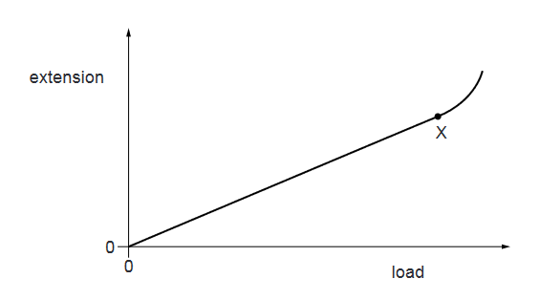
- On the same axes sketch a graph of another spring whose spring constant is higher than the trampoline springs (1 mark)
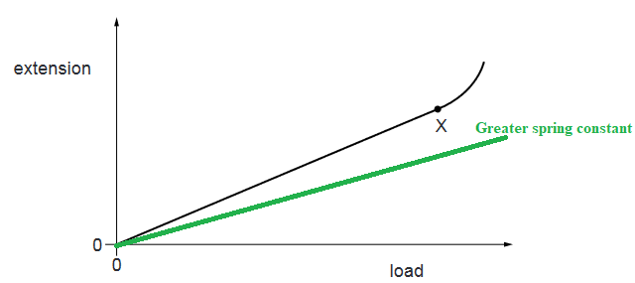

- The diagram below shows a set-up used to investigate a particular gas law. Study the diagram and answer the questions that follow
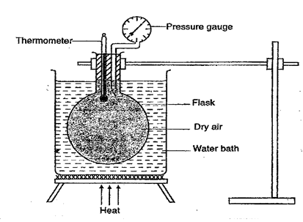
- State with a reason which gas law is being experimented by the set-up (2 marks)
Pressure law since it can measure pressure and temperature
- Name the two factors that are held constant in the experimented (2 marks)
Mass of the gas
Volume of the gas
- Give the reason why heating is done through a water bath (1 mark)
To ensure uniform distribution of heat
- Figure (a) shows 52cm of air trapped by a mercury column of 10cm while figure (b) shows the column of air when the glass tube is inverted
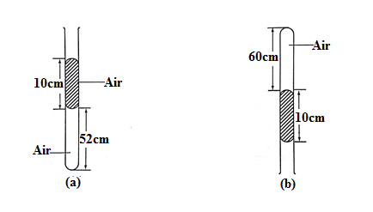
Determine the atmospheric pressure in mmHg (3 marks)

$$Before the tube is invereted , pressure of the gas=Atm. pressure+pressure due to mercury column$$
$$After inversion , Gas pressure+presure due mercury column=Atm. pressure let atm. presure=X$$
$$From Boyle^{'}s$$
$$P_{1}V_{1}=P_{2}V_{2}$$
$$\left(x+10mmHg\right)×52=60\left(x-10mmHg\right)$$
$$52x+520=60x-600$$
$$8x=80$$

- The graph below shows the relationship between the pressure and temperature of a gas of volume V₁

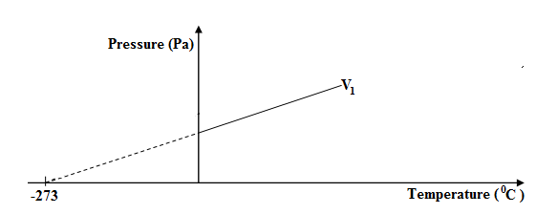

On the same axis sketch another graph for a gas of a larger volume. (1 mark)

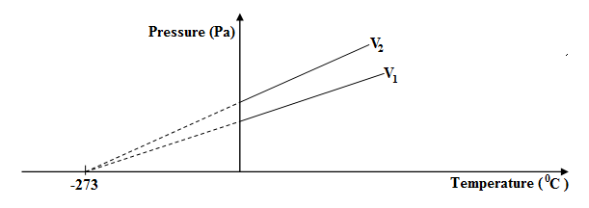

- The figure below shows a ball spinning in anticlockwise direction through still air
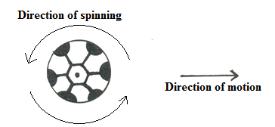
The horizontal distance covered by the ball is observed to be longer than when the ball is not spinned. Explain how the spinning increases the range of the ball (3marks)
The velocity of air above the ball becomes higher than the velocity below the ball. The pressure below the ball becomes greater than the pressure above the ball. Greater pressure below the ball lifts it higher increasing its range.

- The figure below shows gas flowing along a pipe of non-uniform cross-sectional area. Two pipes A and B are dipped into liquids as shown below.

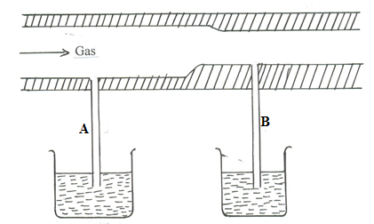

Indicate the levels of the liquids in A and B giving a reason for your answer (2marks)

