Name………………………………………………………………….. Index Number……………..…………..……………
SCHOOL:……………………………………………………………… Date…………….………………………………..………
232/3 Candidate’s Signature.............……………….
PHYSICS
Paper 3
2018
2 ½ hours
JULY/AUGUST
FORM FOUR EVALUATION TEST
PHYSICS PAPER 3
2 ½ hours

Instructions to candidates
(a) Write your name and index number in the spaces provided above.
(b) Write the name of your school in the space provided above.
(c) Sign and write the date of examination in the spaces provided above.
(d) Answer all the questions in the spaces provided in this booklet.
(e) You are supposed to spend the first 15 minutes of the 2½ hours allowed for this paper reading the whole paper carefully before commencing your work.
(f) Marks are given for a clear record of the observations actually made, their suitability, accuracy and the use made of them.
(g) Candidates are advised to record their observations as soon as they are made.
(h) Non-programmable silent electronic calculators may be used.
(i) Mathematical tables must not be used.
(j) This paper consists of 8 printed pages.
(k) Candidates should check the question paper to ascertain that all the pages are printed as indicated and that no questions are missing.
(l) Candidates should answer the questions in English.

For Examiner’s Use Only
Question 1 | a | b | c | d | e | f  TOTAL
Maximum Score | 0 | 0 | 8 | 5 | 6 | 1
Candidate’s Score | 0 | 0
Question 1 | a | b | c | d | e | f | g | h | i | j | k | l
Maximum Score | 1 | 0 | 0 | 0 | 0 | 0 | 5 | 5 | 4 | 0 | 3 | 2
Candidate’s Score |  | 0 | 0 | 0 | 0 | 0 |  |  |  | 0

1. You are provided with the following:
Grand Total
(i) Two dry cells in a cell holder
(ii) One ammeter
(iii) A switch
(iv) A voltmeter
(v) Connecting wires
(vi) A resistance wire mounted on a mm scale labelled PQ.
Proceed as follows:
(a) Set up the apparatus as shown in Figure 1
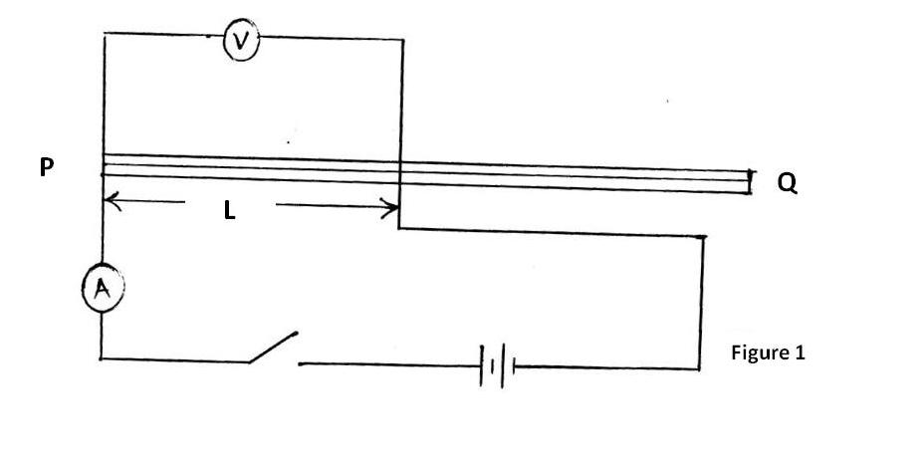

(b) Starting with length, L = 0.2m, close the switch. Record the value of I, the current flowing through the wire and V, the p.d. across it. Enter the results in the Table 1.
Table 1
L(m) | 0.2 | 0.4 | 0.5 | 0.6 | 0.7 | 0.8
I (A)
p.d. (V)
R = $\frac{V}{I}$ (Ω)
$\frac{1}{I}$(A⁻¹)

(c) Repeat the procedure in (b) for other values of length, L in Table 1 and complete Table 1. (8 marks)
(d) Plot a graph of R (y axis) against $\frac{1}{I}$. (5 marks)

(e) (i) Determine the slope S of the graph. (3 marks)
…………………………………………………………………………………...
…………………………………………………………………………………...
…………………………………………………………………………………...
(ii) Given the equation R = $\frac{E}{I}$ – r determine the values of:
(I) E (1 mark)
……………………………………………………………………………
(II) r (2 marks)
……………………………………………………………………………
……………………………………………………………………………
……………………………………………………………………………
(f) Draw a simple circuit you can use to determine the e.m.f. of a single cell. (1 mark)

2. You are provided with the following:
(i) Four optical pins
(ii) A soft board
(iii) A rectangular glass block
(iv) Some cellotape
(v) A plain sheet of paper (provided by school)
(vi) A plane mirror
(vii) A source of water
(viii) A stopwatch
(ix) A boiling tube
(x) A cylindrical container that can accommodate a boiling tube
(xi) A metre rule or half-metre rule
(xii) some sand
(xiii) A rubber band

Every candidate should have a ruler and protractor
Proceed as follows:
PART A
(a) Measure and record the breadth (b) of the glass block. (1 mark)
b = ……………………………………………………………
(b) Fix the plain sheet of paper on the soft board using some cello tape. Using cello tape, fix the mirror on one side (length) of the glass block and trace its outline on the plain paper as shown in Figure 2.
NB: The plain sheet of paper must be submitted together with the question paper.
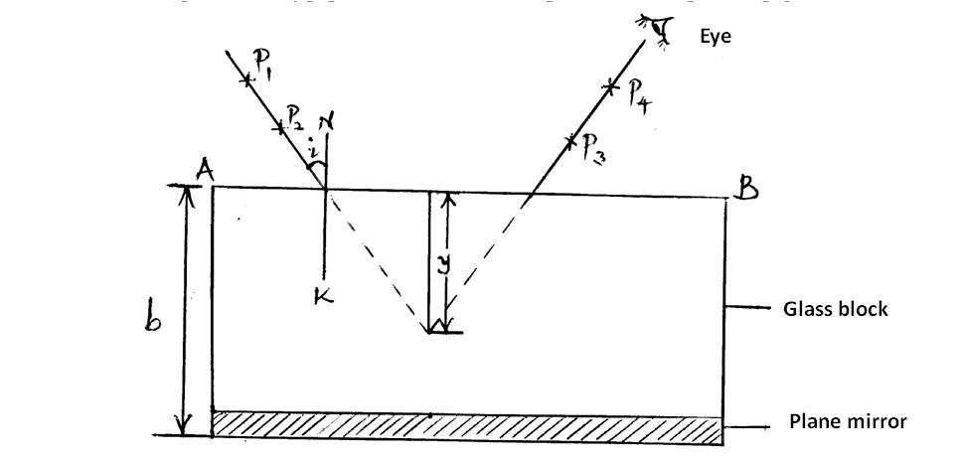

Figure 2
(c) Draw the normal NK to the side AB and measure angle i = 10° from the normal.
(d) Draw the line representing the incident ray and fix pins P₁ and P₂ as shown in Figure 2.
(e) By observing the images of the pins P₁ and P₂ locate the positions P₃ and P₄ such that they appear in a line (non-parallax) using other pins.
(f) Join the points P₃ and P₄ and extend them to intersect line P₁ and P₂ produced. Measure and record the perpendicular distance y.
(g) For different values of i in Table 2 repeat steps (c) to (f). Complete Table 2. (5 marks)
Table 2
i (°) | 10 | 15 | 20 | 25 | 30 | 35 | 40
y (cm)
(h) Plot a graph of y (y axis) against i. (5 marks)

(i) From the graph
(i) determine the y-intercept y₀. (1 mark)
y₀……………………………………………………………………………
(ii) Given the equation n = $\frac{b}{y_{o}}$ determine the value of n. (2 marks)

……………………………………………………………………………
……………………………………………………………………………
(iii) State the physical meaning of n. (1 mark)
……………………………………………………………………………

PART B
(j) Tie the rubber band around the boiling tube so that it is at a distance L = 12cm from the bottom of the tube as shown in Figure 3(a). Pour water into the cylindrical container until the level is about 2.0cm from the top of the container. Float the boiling tube in the water in the container. Add sand gradually into the boiling tube until the tube sinks to the 12cm mark as shown in Figure 3(b).
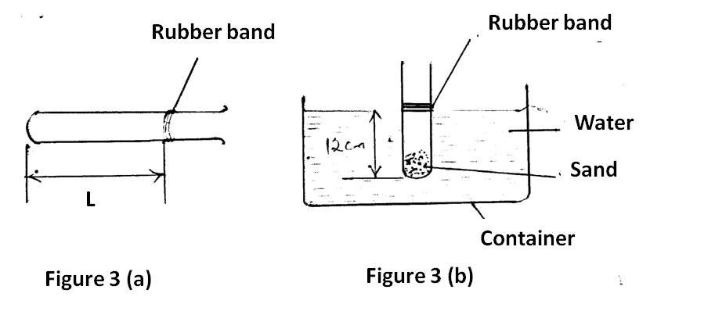

(k) Depress the boiling tube slightly and release so that it oscillates vertically without touching the sides of the container. Measure and record in Table 3 the time t₁, for five oscillations of the boiling tube. Repeat the procedure two more times to obtain t₂ and t₃ and record the values in Table 3. Complete Table 3. (3 marks)
Table 3
t₁(s) | t₂(s) | t₃(s) | Average t(s)  t = $\frac{t1 + t2 + t3}{3}$ | T = $\frac{t}{5}$ (s)

(l) Evaluate P given the equation P = $\frac{40L}{T^{2}}$ where L is the length of the tube up to the rubber band in (j) and T is the value obtained in (k) above. (2 marks)
P =
……………………………………………………………………………
……………………………………………………………………………
……………………………………………………………………………

THIS IS THE LAST PRINTED PAGE

JULY/AUGUST EXAM
FORM FOUR JOINT EVALUATION TEST - 2018
232/3 PHYSICS PP 3 CONFIDENTIAL

Each candidate will require the following:
Question 1
(i) Two new size D dry cells
(ii) A cell holder to hold two cells in series.
(iii) One ammeter (range 0 to 1A at full scale deflection)
(iv) A switch
(v) A voltmeter (range 0 to 2.5V)
(vi) 6 connecting wires, at least four with crocodile clips at one end.
(vii) A nichrome wire (SWG 32) 1m long mounted on a mm scale labelled PQ.
Question 2
(i) A source of water
(ii) A stopwatch
(iii) A boiling tube
(iv) A cylindrical container that can accommodate a boiling tube
(v) A metre rule or half-metre rule
(vi) some sand
(vii) A rubber band
(viii) Four optical pins
(ix) A soft board at least 30cm X 20cm
(x) A rectangular glass block of breadth 6.0cm
(xi) Some cellotape
(xii) A plain sheet of white paper (to be provided by the school)
(xiii) A plane mirror
Every candidate should have a ruler and protractor

JULY/AUGUST EXAM - 2018
PHYSICS PAPER 3 MARKING SCHEME
- (c)
L(m) | 0.2 | 0.4 | 0.5 | 0.6 | 0.7 | 0.8
I (A) | 0.40 | 0.31 | 0.25 | 0.22 | 0.20 | 0.19 | ±0.05
p.d. (V) | 1.6 | 1.9 | 2.0 | 2.1 | 2.2 | 2.4 | ±0.1
R= $\frac{V}{I}(Ω$) | 4.0 | 6.13 | 8.0 | 9.55 | 11.0 | 12.63
$\frac{1}{I}$ (A⁻¹) | 2.50 | 3.23 | 4.00 | 4.55 | 5.00 | 5.26

I – Values : ½ mk for 1 correct value. Max 2 marks
pd – values: ½ mk for 1 correct value. Max 2 marks

R – values - All correct (2 marks)
At least 4 correct (1 mark)
1/I – values - All correct (2 marks)
- At least 4 correct (1 mark)

(d) A1
S1
P2
L1

(e)(i) = $\frac{11.0-4.0}{5.00-2.50}$ 1 correct extraction of intervals
= $\frac{7.0}{2.50}$

= 2.8V± 0.2 1 evaluation
½ For accuracy
½ For units
(ii) (I) E = slope = 2.8V 1
(II) –r = y –intercept 1
= -3
r = 3Ω ½ mk for accuracy
½ for units
V
(f)

- 1

- (a) b = 6.0cm ±0.2cm 1
(g)
iº | 10 | 15 | 20 | 25 | 30 | 35 | 40
Y(cm) | 4.0 | 3.8 | 3.6 | 3.5 | 3.4 | 3.3 | 3.2 | +0.2

1 mark for 1 correct value Max 5 marks

- (i) $y_{0}$= 4.1 cm $±$ 0.1 1

- N = $\frac{6.0}{4.1}$ 1 substitution allow transfer of error

= 1.46 ± 0.1 1 accuracy

- Refractive index 1

(k)
t1(s) | t2(s) | t3(s) | Average t(s) | T(s)
3.20 – 3.70 | 3.20 – 3.70 | 3.20 – 3.70 | 3.20 – 3.70 | 0.64 – 0.74
½ mk | ½ mk | ½ mk | ½ mk | 1 mk

(l) P = $\frac{40 x 12}{0.64^{2}}to\frac{40 x 12}{0.74^{2}}$ 1 substitution
= 1,171.9cms⁻² = 876.6cms⁻² ½ mk Accuracy ½ mk Unit
876.6 to 1,171.9 cms⁻²
Allow
P = 40x 0.12/0.64² to 40x0.12/0.74²
= 11.719ms⁻² 8.766ms⁻²
8.766ms⁻² to 11.719ms⁻²

2 (h)
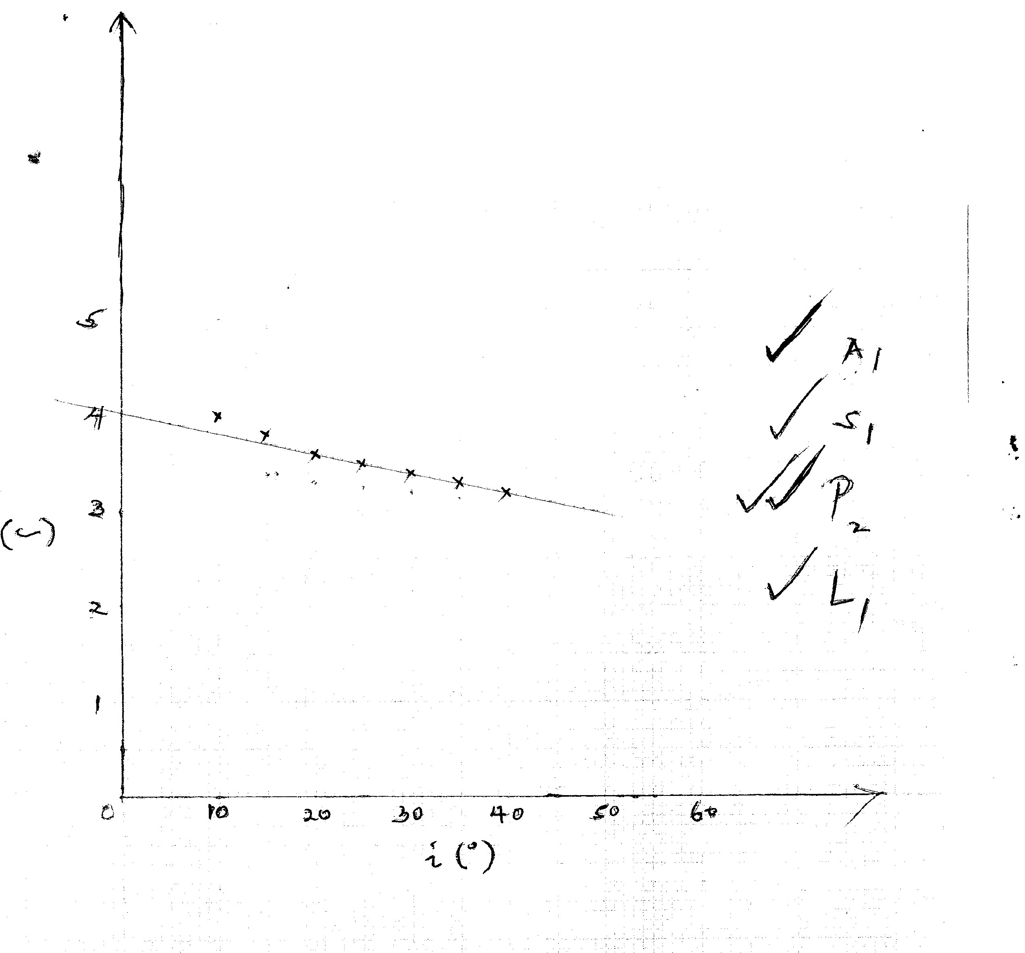
y (cm)

