**MARKING SCHEME**

**232/2 MARKING SCHEME**

**PHYSICS**

**PAPER 2**

**JULY / AUGUST- 2019**

**TIME : 2 HRS**

**SECTION A (25 MARKS)**

1. - increasing the size of the object (1 mk)

- Reducing the distance of the object from the pin-hole. (I mk)

2. - Large currents can be drawn from them

- They can be kept in a discharged condition for a long time.

- They are lighter than lead-acid accumulators (2 marks)

3. Magnet move away from the solenoid. (1 mk) End Y acquires a N-pole which repels the N-pole of the permanent magnet (1 mk)

4.

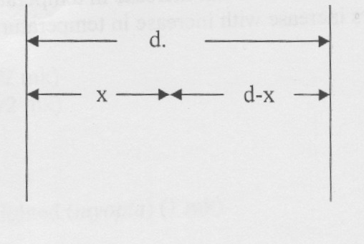

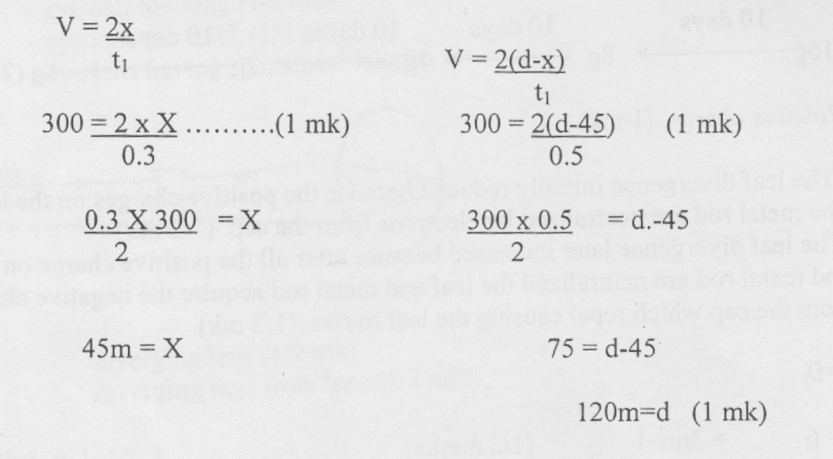

5. holes (1mk)

6.

|  |  |  |  |  |  |  |
| --- | --- | --- | --- | --- | --- | --- |
| Gamma rays | x-rays | Ultra – Violet  Radiation | Visible  Light | Intra –red radiation | Micro waves | Radio waves |

7. R1 = + 6

= 7.5 Ω (1mk)

I1 = = (1mk)

= 0.6A (1mk)

8. The resistance of semi-conductors decreases with increase in temperature while the resistance of metallic conductors increases with increase in temperature. (1 mk)

9. N = N ( ½ )  T/t ½

= 16 ( ½) 40/10

= 16 ( ½ )4

= 1g (2mks)

OR

**10 days**

**10 days**

**10 days**

**10 days**

16g 8g 4g 2g 1g (2mks)

10 (i) Positive charge (1 mk)

(ii) The leaf divergence initially reduced because the positive charges on the leaf and the metal rod are neutralized by electrons from the cap. (1/2 mk)

The leaf divergence later increased because after all the positive charge on the leaf and metal rod are neutralized the leaf and metal rod acquire the negative charge from the cap which repel causing the leaf to rise. (1/2 mk)

11. V = f

V = = 3ms -1 ( ½ mks)

f = $\frac{30}{60}$ = 0.5 HZ ( ½ mk)

V = f

3 = 0.5 x 

6m =  (1mk)

12.

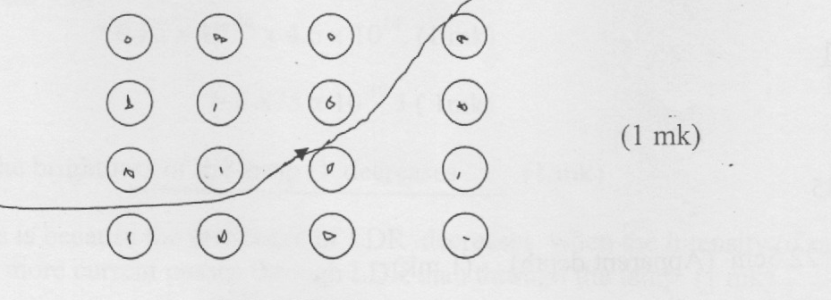

13.

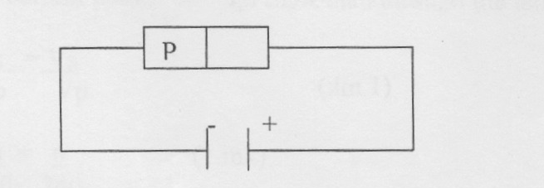

14. a = 140 ( ½ mk)

b = 36 ( ½ mk)

ball too long (1)2 mk)

lens too thick (112 ink)

lens having short focal length

**SECTION B**

13.a) To avoid collisions between air particles and the electrons in motion since collisions would reduce the energy of the electrons.

b) i) Can be deflected by both magnetic and electric fields

ii) Cause fluorescence in fluorescent materials.

iii) Travels in straight lines.

iv) They ionize the gas through which they travel

c) i). 10v/cm x2cm=20v

ii) T=2.5ms



d) i) 

=6.6x10-34x 5.6x1019

=3.696 x 10-19J

ii) hf=wo+ k.e

k.e= hf-wo

=(6.6x10-34 x8.6 x1014)- 3.696 x 10-19

= 5.676 x10-19 - 3.696 x 10-19

=1.98 x 10-19J

14(a) Angle of incidence in optically dense medium for which the angle

of refraction in optically less dense medium is 90º. 🗸¹ (1mk)

1. 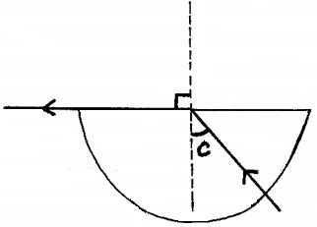(i)

Labeling 🗸¹ (1mk)

(ii)  🗸¹

🗸¹

 🗸¹ (3mks)

1. Move the cardboard with crosswire along the metre rule until a sharp image

of the cross-wires is formed alongside the object cross-wires. 🗸¹

Measure the distance between the lens and the cardboard, 🗸¹ this is equal

to the focal length, f, of the lens.

Repeat the procedure 🗸¹ and find the average value of f. 🗸¹ (4mks)

15.a) The current transmitted is lower thus energy lost due to heating effect in transmission is reduced. 1×1=1mk

(b) (i) 80% of 180,000W

$\frac{80}{100}×180,000$ = 120,000W

I= $\frac{P}{V}$ = $\frac{120,000}{60,000}$

I= 2A 1×3=3mks

(ii) Power cost= I2R

= 22×15

=4×15=60W

(c) (i) A- filament. B- Copper anode 1×2=2mks

(ii) Increase in p.d across the PQ leads to higher current flow which increases the heating effect of electric current. 1×1=1mk

(iii) The kinetic energy of electrons on heating the target is transformed into heat. 1×1=1mk

(iv)

(d) hf = ev

f= $\frac{ev}{h}$

f= $\frac{1.6×10×12000}{6.62×10}$

f=2.9003×10Hz

16.The figure below shows an electromagnetic relay being used to switch an electric motor on and off. The electromagnet consists of a coil of wire wrapped around a core. The motor in figure is switched off.

Motor

Springy metal strips

Contacts

Soft iron armature

Core

S

A

B

Pivot

Insulator

1. Suggest suitable material for the core. (1mark)

* *Soft iron*

1. What happens to the core when switch S is closed? (2marks)

* *The current flows through the solenoid; it is magnetized and attracts the soft iron armature.;*

1. Why do the contacts A and B close when the switch S is closed. (2marks)

* *The magnetized core attracts the soft iron armature. The pivot armature pushes the springy metal strip which joins contact B and A.;;*

1. When the switch S is opened, what will happen to;
2. The core (1mark)

* *It loses its magnetism;*

1. Soft iron armature. (1mark)

* *Soft iron goes back to its original position thus switching off the current in the circuit.;*

1. Give **one** other application of an electromagnet. (1mark)

* *Electric bell, telephone receiver, moving coil loudspeaker and circuit breaker.;*

1. State two ways in which an electromagnet could be made more powerful. (2marks)

* *Using a soft iron core, increasing the current and*

*Increasing the number of turns;;*

17.(a) (i) Explain why carbon-14 ( ${}_{6}^{14}C)$ is radioactive while carbon ${}_{6}^{12}C$ is not. (1 mark)

**In $\left({}_{6}^{12}C\right)$, the Newton to proton ratio is one thus stable, while in $\left({}_{6}^{14}C\right)$ N/P >1**

**thus unstable.**

(b) The figure below shows features of a diffusion cloud chamber used for detecting

radiations from a radioactive source.

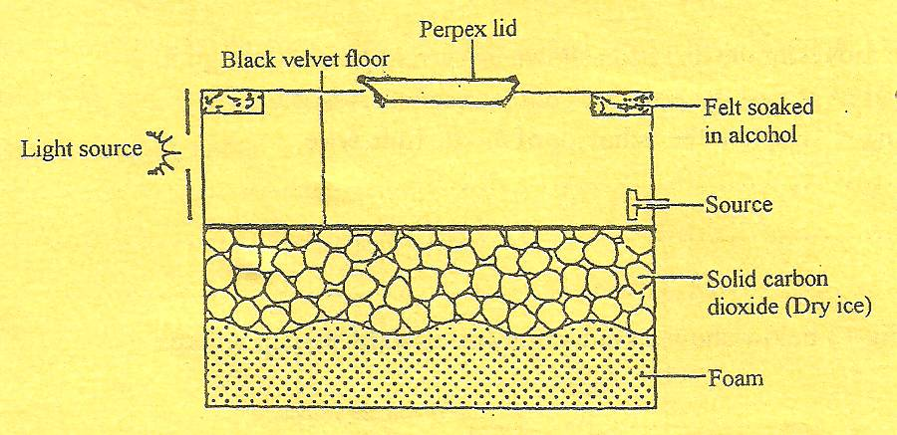

Explain how the chamber works when a radioactive particle is introduced at the source. (2 marks)

**The radiations ionize argon gas ✓1 – along their path. The alcohol vapour condense on the ions formed creating tracks. ✓1**

(c) (i) What is the purpose of solid carbon (iv) oxide. (1 mark)

**Lower the temperature in the chamber thus making it possible for the alcohol vapour to condense. ✓1**

1. (i) Using a diagram explain how doping produces a p-type semi-conductor. (3 marks)

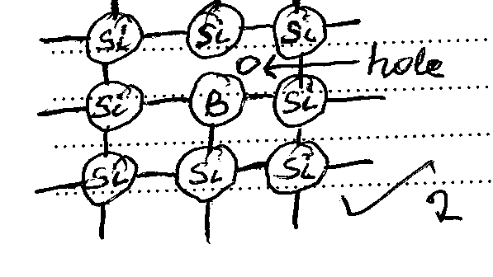

**The impurity atom forms only 3 bonds crating a hole that acts as a +ve charge carrier. ✓1**

(ii) What is biasing? (1 mk)

**Causing current to flow through adiode. ✓1**

(iii) The diagram below shows a circuit with a p-n junction and a very low power

bulb.

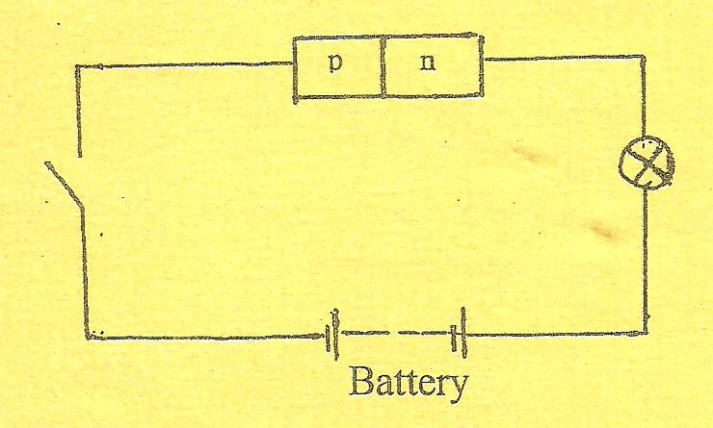

State with reason the observations made on the bulb when the switch is closed.

(2 marks)

**Bulb does not light because diode is reverse biased.**