**NAME ……………………………………………………… adm no………………..………..…..…… class ………………..……**

**231/3**

**PHYSICS**

**PAPER 3(PRACTICAL)**

**TIME: 2½ HOURS**

**x x x x x x x xx x the school Name x x x x x x x x x**

**Instructions to candidates:**

*1. Write your* ***name*** *and* ***index number*** *in spaces provided* ***above****.*

*2.* ***Sign*** *and write the date of examination in spaces provided* ***above****.*

*3. Answer* ***all*** *the questions in spaces provided in the question paper.*

*4. You are* ***NOT*** *allowed to spend the first 15 minutes of 2½ hours allowed for this paper*

*reading the whole paper carefully before commencing the work.*

*5. Marks are given for clear record of the observations actually made, their suitability,*

*accuracy and the use made of them.*

*6. Candidates are advised to record their observations as soon as they are made.*

*7. Non-programmable silent electronic calculators and KNEC Mathematical table may be used.*

**FOR EXAMINER’S USE ONLY**

|  |  |
| --- | --- |
| Question 1 | **Total 15** |
| Candidate’s Score |  |

|  |  |
| --- | --- |
| Question 2 | **Total 25** |
| Candidate’s Score |  |

|  |  |
| --- | --- |
| **Grand Total 40** |  |

1. You are provided with the following

* Two dry cells
* One ammeter**(0-2.5A)**
* One voltmeter**(0-5v)**
* A variable resistor**(0-50Ω)**
* A switch
* 6 connecting wires

Proceed as follows

1. Set up the apparatus provided as in the diagram below.



1. Close the switch and adjust the variable resistor until the voltmeter reads 2.9V. Record this value of voltage V and the corresponding value of current I in the table below.

|  |  |  |  |  |  |  |  |
| --- | --- | --- | --- | --- | --- | --- | --- |
| Voltage (V) | 2.9 | 2.8 | 2.7 | 2.6 | 2.5 | 2.4 | 2.2 |
| Current (A) |  |  |  |  |  |  |  |

1. Repeat procedure (b) above for the other values of V and complete the table. (5mks)
2. Plot a graph of Voltage (V) against Current (A). (5mks)
3. From the graph, determine the emf, E and internal resistance of the battery given that E=V+rI
4. E (2mk)
5. r (3mks)
6. You are provided with the following apparatus:-

* A meter rule
* One stop watch, one stand, clamp and boss
* One spring
* Two pieces of wood
* A beam balance or electronic balance (to be shared)

One mass labeled M

**Proceed as follows**

1. 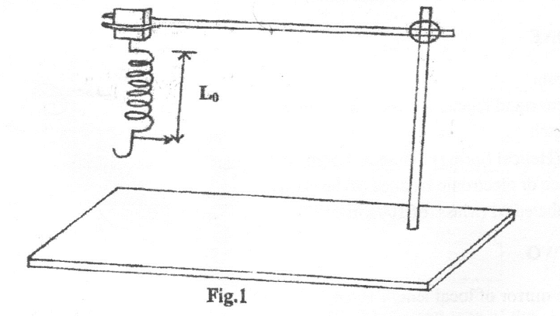Hang the spring vertically by clamping one end as shown in fig 1 (the small pieces of wood to clamp the spring)
2. Measure the length Lo, of the unloaded spring and record below.

L0=__________________________________mm (1mk)

1. Hang the mass M given from the lower end of the spring. Measure the length, L1 of the loaded spring

L1=__________________________________mm (1mk)

1. Find the value of L1-L0______________________________cm (1mk)
2. Using the balance given find the mass of the object M

Mass of M=_________________________________g (1mk)

1. Hang the mass M from the lower end of the spring. Displace it by small vertical distance and release so that the spring makes vertical oscillations.

|  |  |  |  |  |  |  |  |
| --- | --- | --- | --- | --- | --- | --- | --- |
| Oscillations N | 5 | 7 | 10 | 13 | 15 | 18 | 20 |
| Time in seconds |  |  |  |  |  |  |  |
|  |  |  |  |  |  |  |  |

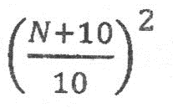

1. On the grid provided, Plot a graph of against (5mks)
2. i. determine the Slope S, on the graph at N=16 (2mks)

ii. find the constant k, given that: (2mks)

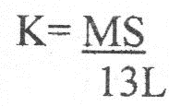

L1=__________________________________mm (1mks)

2.b You are provided with the following apparatus

* lens
* lens holder
* cardboard with cross wire
* white screen S
* candle
* Match box

**Proceed as follows**

1. Set up the apparatus as shown below

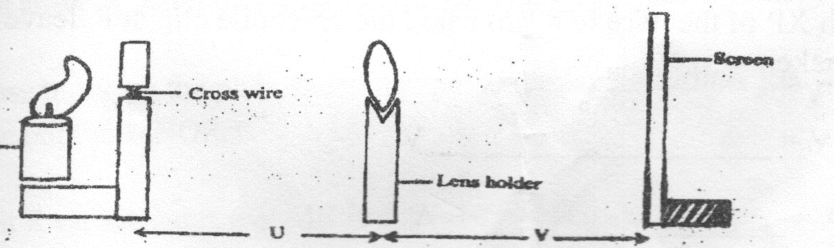

candle

1. Let the distance U be 15 cm, by adjusting the distance of the screen from the lens, determine the distance V that will give the sharpest image of the cross wire on the screen. Record the value for V

V=_______________________________cm(1mks)

1. Repeat the experiment for U=20cm, 25cm and enter them in the table. Complete the table. (3mks)

|  |  |  |  |  |  |
| --- | --- | --- | --- | --- | --- |
| U (cm) | V (cm) | (cm-1) | (cm-1) | += cm-1 | F cm |
| 15 |  |  |  |  |  |
| 20 |  |  |  |  |  |
| 25 |  |  |  |  |  |

1. Determine

i. mean value of $\frac{1}{f}$ (1mks)

ii. mean value of f (1mks)