Name ………………………………………………………………..………….…… Adm.No. ……..……….… Class …….……….
231/3
BIOLOGY
Paper 3
(Practical)
July 2011
1 ¾ hours

KAHUHO UHURU HIGH SCHOOL
KCSE Mock Examination 2011 Form Four

INSTRUCTIONS TO CANDIDATES
This paper has ONE section ONLY
Answer ALL the questions in this paper
All answers should be written in the spaces provided on the question paper.

For Official Use Only

SECTION | QUESTION | SCORE
 | 1
 | 2
 | 3
 | TOTAL

This paper consists of 5 printed pages
Candidates should check the question paper to ensure that all the printed pages are printed as indicated and no questions are missing
- Below are photographs labeled A,B,C,D,E,F,G and H.
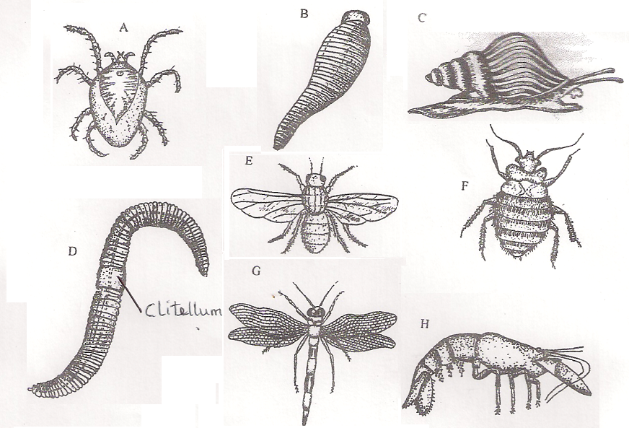

- Using observable features in the photographs, complete the dichotomous key given below (2 marks)
1(a) Jointed legs present…………………………………………….. Go to 2
(b) Jointed Legs absent…………………………………..………. Go to 6
2(a) Three pairs of legs ……………………………………………….. Go to 3
(b) …………………………………………….………………………………… Go to 5
3 (a) Wings Present………………………………………………………. Go to 4
(b) Wings absent……………………………………………………….. Bedbug
4(a)………………………………………………………………………………… Dragon fly
(b) One pair of wings ………………………………………………… House fly
5(a) Antennae Present………………………………………………….. Crayfish
(b) Antennae absent………………………………………………….. Mite
6. (a) Shell present……………………………………………………….. Snail
(b) Shell absent………………………………………………………….. Go to 7
7 (a) Prominent clitellum visible …………………………………… Earthworm
(b) No clitellum visible…………………………………………………….. Leech
b) Use the completed dichotomous key to identify the names of each of the organisms. In each case show the steps you followed to arrive at the identity (12 marks)
Identity Steps followed
A ……………………………………………….. ………………………………………………………
B ……………………………………………….. ………………………………………………………
C ……………………………………………….. ………………………………………………………
D ……………………………………………….. ………………………………………………………
E ……………………………………………….. ………………………………………………………
F ……………………………………………….. ………………………………………………………
G ……………………………………………….. ………………………………………………………
H ……………………………………………….. ………………………………………………………

2.You are provided with substances labeled S,T,U,X and Y. S,T and U are food substances, while X is 10% sodium
hydroxide solution and Y is 1% copper sulphate solution.
a) Carry out tests to determine the food substance(s) in S, T and U (9 marks)
Substance | Food Substance  Being tested for | Procedure | Observations | Conclusion
S

T
U

b) Name TWO diseases caused by deficiency of the food substance S. (2 marks)
……………………………………………………………………………………
…………………………………………………………………………………..

3. Below is a photograph obtained from a plants tissue. Examine it and answer the questions that follow.

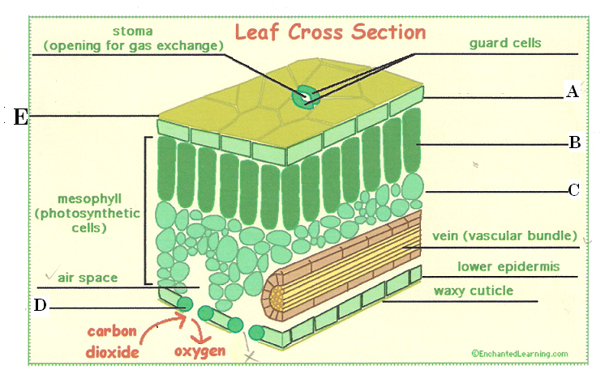
A

B

- Name the parts labeled A,B,C, and D (4 marks)
A………………………………………………………….
B………………………………………………………….
C………………………………………………………….
D………………………………………………………….
- How is structure labeled B and E adapted to their functions (4 marks)

B………………………………………………………………………………………………………………………………………

E ………………………………………………………………………………………………………………………………………

- (i) What is the major pigment found in the structure labeled B (1 mark)
……………………………………………………………………………………………….
(ii) What is the role of the pigment you have named in (c) (i) above (2 marks)

…………………………………………………………………………………………………………………………………………………….

…………………………………………………………………………………………………………………………………………………….

- Name the space labeled X and give its functions (2marks)
………………………………………………………………………………………………………………………………………………….
………………………………………………………………………………………………………………………………………………….

