**Name………………………………………..………….…… Adm.No. ……..……….… Class …….……….**

|  |
| --- |
|  |

**231/3**

**BIOLOGY supplementary**

**Paper 3**

**(Practical)**

**June 2015**

**1 ½ hours**

**KAHUHO UHURU HIGH SCHOOL**

**Mid Term Examination 2015 Form Three**

**INSTRUCTIONS**

This paper has ONE section ONLY

Answer **ALL** the questions in this paper

All answers should be written in the spaces provided on the question paper.

**Questions (50 marks)**

1. You are provided with two visking tubes, a thread and solutions L and P. Tie one end of the visking tubes and put solution L in it.Place this tubing in Beaker containing sol P.The the tube, tie it at the base, insert solution P , tie at the top and place it in a beaker containing solution L. Leave to settle for 30 min and answer the questions that follow.
2. Remove thevisking tubes from the solutions after 30 minutes feel with your index finger and thumb,draw and label the appearance of the visking tubes in the two solutions (6marks)

Visking tube in L

Before After

Visking tube in P

Before After

1. i) Which physiological process is under investigation (1mark)

...………………………………………………….………………………………………..

……………………………………………………………………………………………..

1. What observations were made in the strip placed in solution L (2marks)

...………………………………………………….………………………………………..

……………………………………………………………………………………………..

1. Account for the above observation (2marks)

……………………………………………………………………………………...……………..……..

………………………………………………………………………………….…………..……………

…………………………………………………………………………………………………….……..

1. What observations were made in the strip placed in solution P (2marks)

...………………………………………………….………………………………………..

……………………………………………………………………………………………..

1. Account for the above observation (2marks)

……………………………………………………………………………………...……………..……..

………………………………………………………………………………….…………..……………

…………………………………………………………………………………………………….……..

1. i) The photomicrograph below was taken from the internal structure of a leaf

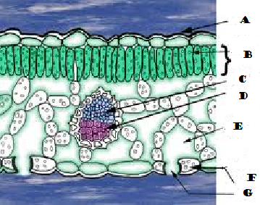

1. Identify the parts labelled A-G (7marks)

A…………………………………

B…………………………………

C…………………………………

D…………………………………

E………………………………….

F………………………………….

G………………………………….

1. State two adaptations that make structure F well suited to its functions (2marks)

……………………………………………………………………………………………………………………………………………………………………………………………………………………

1. State the functions of the parts labelled C and D (2marks)

C………………………………………………………………………………………………….

D………………………………………………………………………………………………….

ii) The photographs below were taken from plants in different habitats

X Y

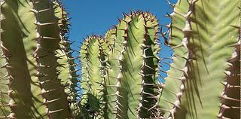

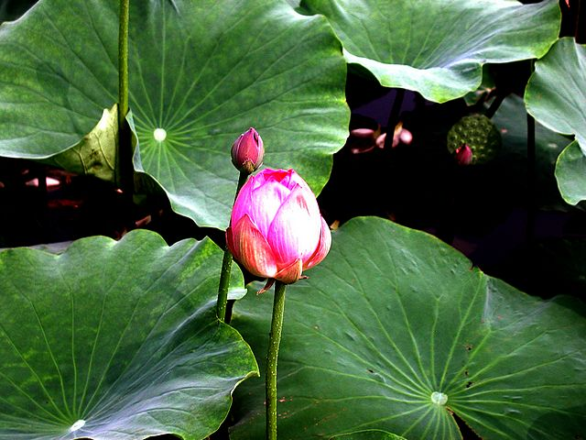

* 1. State the habitats that the two plants were taken from (2marks)

X……………………………………………..

Y……………………………………………..

* 1. Using observable features only, state one modification in each that enables the plants to reduce rates of transpiration (2marks)

………………………………………………………………………………………………………………………………………………………………………………………………………………………………………………………………………………………………………………………………………………

………………………………………………………………………………………………………………

* 1. Giving a reason, Name the sub division to which plant X belongs (2marks)

………………………………………………………………………………………………………………………………………………………………………………………………………………………………………………………………………………………………………………………………………………………

1. You are provided with a photograph of an organ system of a mammal.

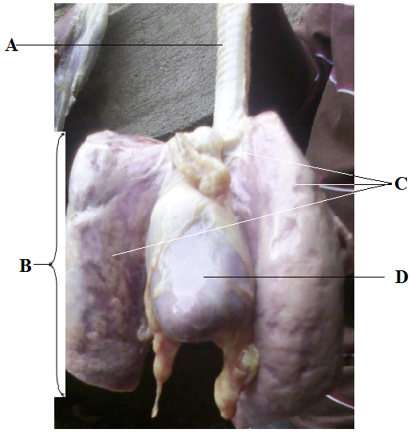

(a) (i) Name the organ system represented by the photograph. (1 mark)

……………………………………………………………………………………………………

(ii) State the function of the organ system named in 3(a) above. (1 mark)

………………………………………………………………………………………………………………………………………………………………………………………………………………

(b) Name the parts labeled A, B and C (3 marks)

A ……………………………………………………………………………….

B ……………………………………………………………………………….

C ……………………………………………………………………………….

(c) (i) What is the function of part labeled A. (1 mark)

………………………………………………………………………………………………………………………………………………………………………………………………………………

(ii) State 4 ways in which structure labeled D is adapted to its function. (4 marks)

………………………………………………………………………………………………………………………………………………………………………………………………………………………………………………………………………………………………………………………………………………………………………………………………………………………………

(d) (i) State **two** features that adapt structure B to its function. ( 2marks)

………………………………………………………………………………………………………………………………………………………………………………………………………………………………………………………………………………………………………………………………………………………………………………………………………………………………

(ii) Describe how air moves from the atmosphere until it gets into structure B and finally into

the blood. (6 marks)

………………………………………………………………………………………………………………………………………………………………………………………………………………………………………………………………………………………………………………………………………………………………………

………………………………………………………………………………………………………………………………………………………………………………………………………………………………………………

The end