Name………………………………………..………….…… Adm.No. ……..……….… Class …….……….

231/3
BIOLOGY
Paper 3
(Practical)
July 2016
1 ½ hours
KAHUHO UHURU HIGH SCHOOL
Mid Term Examination 2016 Form Three

INSTRUCTIONS
This paper has ONE section ONLY
Answer ALL the questions in this paper
All answers should be written in the spaces provided on the question paper.

Questions (50 marks)
- You are provided with specimen labeled S, a scapel and solutions L and P. Make a longitudinal section of specimen S using a scapel to obtain TWO equal pieces. Emerse one piece in solution labelled L and the other piece in solution labelled P. Leave to settle for 30 min and answer the questions that follow.

- Remove the pieces from the solutions after 30 minutes draw and label the appearance of the pieces in the two solutions (6marks)
Piece in L

Piece in P

- i) Which physiological process is under investigation (1mark)
...………………………………………………….………………………………………..
……………………………………………………………………………………………..
- What observations were made in the strip placed in solution L (2marks)

...………………………………………………….………………………………………..
……………………………………………………………………………………………..
- Account for the above observation (3marks)
……………………………………………………………………………………...……………..……..
………………………………………………………………………………….…………..……………
…………………………………………………………………………………………………….……..
- What observations were made in the strip placed in solution P (2marks)

...………………………………………………….………………………………………..
……………………………………………………………………………………………..

- Account for the above observation (3marks)
……………………………………………………………………………………...……………..……..
………………………………………………………………………………….…………..……………
…………………………………………………………………………………………………….……..
- Study the photographs below and answer the questions that follow.

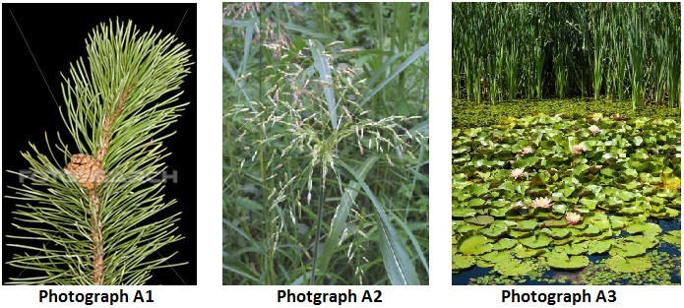

I: Observe the branch in photograph A1.
(a) (i). State the order to which the plant from which the branch in photograph A1 was obtained. (1mark)
………………………………………………………………………………………………………………………………………………………………………………………………………………………………………………
(ii) Give a reason from your answer. (2marks)
………………………………………………………………………………………………………………………………………………………………………………………………………………………………………………
(b) (i). State whether this branch is male or female. (1mark)
………………………………………………………………………………………………………………………………………………………………………………………………………………………………………………
(ii) Give a reason for your answer. (1mark)
………………………………………………………………………………………………………………………………………………………………………………………………………………………………………………
II . (a) (i). State the class to which the plant in photograph A2 belongs. (1mark)
………………………………………………………………………………………………………………………
(ii). Give a reason for your answer. (2marks)
………………………………………………………………………………………………………………………………………………………………………………………………………………………………………………
(b) (i). State the agent of pollination of the flowers of this plant. (1mark)
………………………………………………………………………………………………………………………
(ii). Give a reason for your answer. (1mark)
………………………………………………………………………………………………………………………………………………………………………………………………………………………………………………
III. Explain how the plant in the foreground in photograph A3 is suited to its habitat. (3 marks)
………………………………………………………………………………………………………………………………………………………………………………………………………………………………………………………………………………………………………………………………………………………………………………………………………………………………………………………………
- The photographs below were as samples from the Kenya wildlife service. Use them to answer the questions that follow.
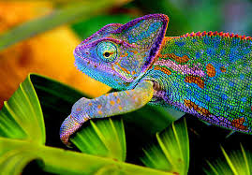
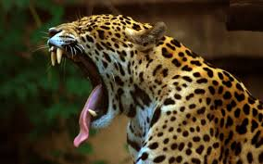
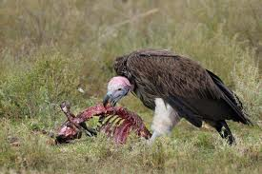

U V W
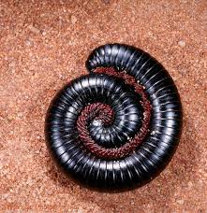
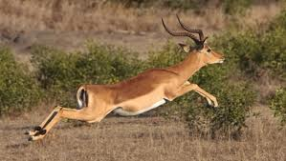
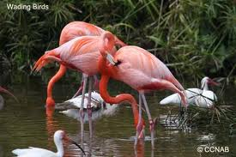

X Y Z

a) Name the classes to which photographs labeled U,V, X and Z belong (3 marks)
U…………………..…………………
V………………….………………….
X……………………………………..
Z……………………………………..
- Among the photographs, Identify; ( 3 marks)

Predator……………………………………
Prey………………………………………..
Scavenger………………………………….
- From observable features only, state one adaptation each that enables the following organisms to survive in their habitats ( 4marks)
U………………………………………………………………………………………………………
V………………………………………………………………………………………………………
Y………………………………………………………………………………………………………
Z……………………………………………………………………….……………………………...
- State two effects that water pollution will have to the animal labeled X (2marks)
…………………………………………………………………………………………………………..……………………………………………………………………………………….……………………….…………………………………………………………………………………………………………..………………………..
- Starting with grass, construct a food chain that involves organisms V,W and Y (Use letters only) (4 marks)

- What would be the effect of the following to the food chain you constructed? (2 marks)
- prolonged drought
…………………………………………………………………………………………………………………….…………………………………………………………….……………………….…
- Removal of Y
…………………………………………………………………………………………………………………….…………………………………………………………….……………………….…
- i) Photograph Z indicates a type of a defensive behaviour, Name the type of behaviour (1 mark)
…………………………………………………………………………………………………………………….…………………………………………………………….……………………….………………………………...…
- How does the behaviour help in defence of the animal (1 mark)

The end

