KAHUHO UHURU HIGH SCHOOL
231/3
BIOLOGY
PAPER 3
(PRACTICAL)
MAY 2016
TIME:1 ½ HOURS
CONFIDENTIAL:

Each candidate will require the following:
- 15ml of 5% Bromothymol Blue.
- Lime water (calcium hydroxide) labeled solution X.
- A drinking straw.
- 2 test tubes.
- 10ml measuring cylinder.
- Boiling tube.
- Large bean seed soaked overnight labeled R1.
- Large maize grain soaked overnight labeled R2.
- Scalpel or razor blade.
- Iodine solution provided with a dropper.
- Dilute hydrochloric acid.
- Dilute sodium hydroxide.
- Hand lens.
- Distilled water provided in a wash bottle.
- 2 droppers.

NB: Bromothymol blue stock solution is 0.04g in 6 – 4ml N/100 NaOH, 73.6ml distilled water and 20ml absolute ethanol 5% Bromothymol blue is made by adding 95ml of distilled water to 5ml of stock solution.

NAME……………………………………………………………..ADM NO……………LASS………

KAHUHO UHURU HIGH SCHOOL
Kenya Certificate of Secondary Education
BIOLOGY
PAPER 3
(PRACTICAL)
TIME: 1¾ HOURS

1. You are provided with the following:
- 25ml Bromothymol blue.
- Solution X.
- A drinking straw.
- 2 test tubes.
- 10ml measuring cylinder.
- A boiling tube.
- Dilute hydrochloric acid.
- Dilute sodium hydroxide.
- Place 2ml of Bromothymol Blue (B.T.B) in a clean test tube. Add dilute hydrochloric acid drop by drop and shake after each drop till there is a permanent colour change.
(i) State the resulting colour. (1 mark)
…………………………………………………………………………………………………………………

…………………………………………………………………………………………………………………

- To the mixture obtained above, now add sodium hydroxide solution drop by drop until there is a colour change. Record your observation. (1 mark)
…………………………………………………………………………………………………………………

…………………………………………………………………………………………………………………
- From your observations in (a)(i) and (a)(ii) above what is the nature of Bromothymol blue.(1 mark)
…………………………………………………………………………………………………………………

…………………………………………………………………………………………………………………
- Place 10ml of fresh Bromothymol blue in a boiling tube. Using the drinking straw, bubble air through the bromothymol blue until there occur colour change.
(i) Record your observation. (1 mark)
…………………………………………………………………………………………………………………

…………………………………………………………………………………………………………………
- What does the colour obtained in (b)(i) above suggest about the nature of the gas breathed out? (1 mark)
…………………………………………………………………………………………………………………

…………………………………………………………………………………………………………………
- Rinse the measuring cylinder and use it to place 2ml of solution X in a clean test tube. Rinse the drinking straw used in (b) above and use it to bubble air through solution X.
(i) Record your observation. (1 mark)

…………………………………………………………………………………………………………………

(ii) Suggest the identity of solution X. (1 mark)
…………………………………………………………………………………………………………………

…………………………………………………………………………………………………………………
- Suggest the identity of the gas that gave rise to the observation above. (1 mark)
…………………………………………………………………………………………………………………

…………………………………………………………………………………………………………………
(d) (i) Name the physiological process in cells that leads to formation of the gas named in c(iii) above. (1 mark)
…………………………………………………………………………………………………………………

…………………………………………………………………………………………………………………
- Write down a word equation for the process named in d(i) above. (2 marks)
…………………………………………………………………………………………………………………

…………………………………………………………………………………………………………………

…………………………………………………………………………………………………………………
- What is the importance of the identified process in cells of living organisms? (1 mark)
…………………………………………………………………………………………………………………

…………………………………………………………………………………………………………………
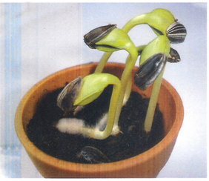
2. Study the photographs and answer the following questions.

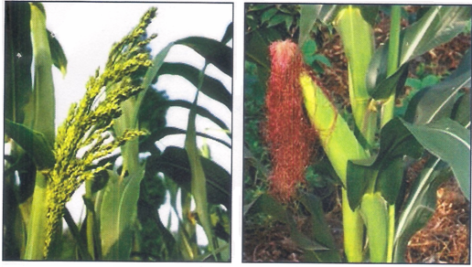
PLATE 5

PLATE 6 PLATES 7

(I) The photograph in Plate 5 shows the germination process in a species of legume.
(a) (i) Name the type of germination shown in the photograph. (1 mark)

…………………………………………………………………………………………………………………

…………………………………………………………………………………………………………………

(ii) Give a reason for your answer. (1 mark)
…………………………………………………………………………………………………………………

…………………………………………………………………………………………………………………
(b) Other than germination the seedling have shown some responses.
(i) Name two responses shown in the photograph. (2 marks)
…………………………………………………………………………………………………………………

…………………………………………………………………………………………………………………

…………………………………………………………………………………………………………………

…………………………………………………………………………………………………………………
(ii) State one survival value of each of the response named above. (1 mark)
…………………………………………………………………………………………………………………

…………………………………………………………………………………………………………………
(II) Examine the photograph in Plate 6 and Plate 7 which show different essential parts of a flower of a species on two different plants.
(a) Name the flower parts shown in Plate 6 and Plate 7. (2 marks)
…………………………………………………………………………………………………………………

…………………………………………………………………………………………………………………

…………………………………………………………………………………………………………………

…………………………………………………………………………………………………………………
(b) (i) Name the phenomenon described in the statement above. (1 mark)

…………………………………………………………………………………………………………………

…………………………………………………………………………………………………………………

- Explain the significance of the phenomena stated in (a)(i) above. (1 mark)
…………………………………………………………………………………………………………………

…………………………………………………………………………………………………………………
(c) (i) State the mode of pollination of the flower shown in the photograph. (1 mark)

…………………………………………………………………………………………………………………

…………………………………………………………………………………………………………………
(ii) Give a reason for your answer. (1 mark)
…………………………………………………………………………………………………………………

…………………………………………………………………………………………………………………
(d) (i) State the type of pollination of the flower shown in the photograph. (1 mark)

…………………………………………………………………………………………………………………

…………………………………………………………………………………………………………………

(ii) Give two reasons for your answer. (2 marks)
…………………………………………………………………………………………………………………

…………………………………………………………………………………………………………………

…………………………………………………………………………………………………………………
3. The photographs in Plate J, K and L shows the anterior part of two different animals,
Plate L shows the longitudinal dissection of Plate K. Examine the photographs and answer the questions below.
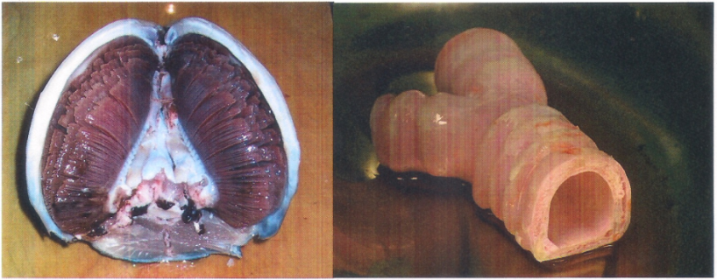

PLATE J PLATE K
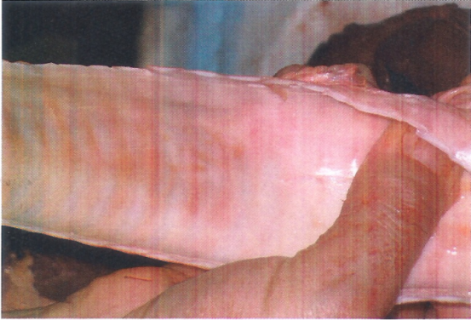

PLATE L
(a) (i) State the class to which the animal organ in Plate J belongs. (1 mark)

…………………………………………………………………………………………………………………

…………………………………………………………………………………………………………………

(ii) State the habitat of the animal. (1 mark)
…………………………………………………………………………………………………………………

…………………………………………………………………………………………………………………

(iii) Give a reason for your answer in (ii) above. (1 mark)
…………………………………………………………………………………………………………………

…………………………………………………………………………………………………………………
(b) (i) Name the organ shown in the photograph in Plate J. (1 mark)
…………………………………………………………………………………………………………………

…………………………………………………………………………………………………………………
(ii) State the function of the organ named above (i). (1 mark)
…………………………………………………………………………………………………………………

…………………………………………………………………………………………………………………
(iii) Name the structure that protects the organ named in (b(i) above from mechanical damage . (1 mark)
…………………………………………………………………………………………………………………

…………………………………………………………………………………………………………………
(iv) From observable features only explain three adaptation of the organ to its function.(3 marks)

…………………………………………………………………………………………………………………

…………………………………………………………………………………………………………………

…………………………………………………………………………………………………………………

…………………………………………………………………………………………………………………
(c) (i) Identify the structure in the photograph Plate K and L. (1 mark)

…………………………………………………………………………………………………………………

…………………………………………………………………………………………………………………

(ii) Give a reason for your answer. (1 mark)
…………………………………………………………………………………………………………………

…………………………………………………………………………………………………………………
(iii) Using observable features only state three adaptations of the structure to its functions. (3 marks)
…………………………………………………………………………………………………………………

…………………………………………………………………………………………………………………

…………………………………………………………………………………………………………………

…………………………………………………………………………………………………………………

…………………………………………………………………………………………………………………

