**KAHUHO UHURU HIGH SCHOOL**

**END OF TERM 1 2014 EXAMINATION**

**BIOLOGY**

**231 / 3 Name…….………………………………………………………….**

**PAPER 3 PRACTICAL Class…………………………….Adm No……………….Roll……**

**TIME 1 ½ HRS**

**INTRUCTIONS:**

* ***Answer ALL the questions in the spaces provided.***
* ***You are required to spend the first 10 minutes of the* 1 ½  *hours allowed for this paper . Candidates may be penalized for recording irrelevant information and incorrect spelling of technical terms.***

1. You are provided with the following:

* Specimen K
* Dilute hydrochloric acid
* Iodine solution
* Benedicts solution
* 1% copper sulphate solution
* 0.1% sodium hydroxide
* sodium hydrogen carbonate
* Distilled water,
* 4 Test tubes
* A means of heating.
  1. Using the apparatus provided extract a solution from K. test the extract using the reagents provided and tabulate your results as follows: - (12 marks)

|  |  |  |  |
| --- | --- | --- | --- |
| TEST | **PROCEDURE** | **OBSERVATION** | **DEDUCTION** |
| Starch |  |  |  |
| Reducing sugar test |  |  |  |
| Non-reducing sugar |  |  |  |
| Proteins |  |  |  |

* 1. Name any other food substance NOT tested above but of great value in nutrition (1mk)

……………………………………………………

* 1. Which nutritional value does the food mentioned in (b) above provide (1mk)

……………………………………………………….........................................................

* 1. Of the food substrates tested above, which one produces the greatest kilo joules per gramme

(1mk)

…………………………………………………….

1. The following are photographs of a particular phylum in kingdom animalia.Use them to answer the questions that follow.

A B C

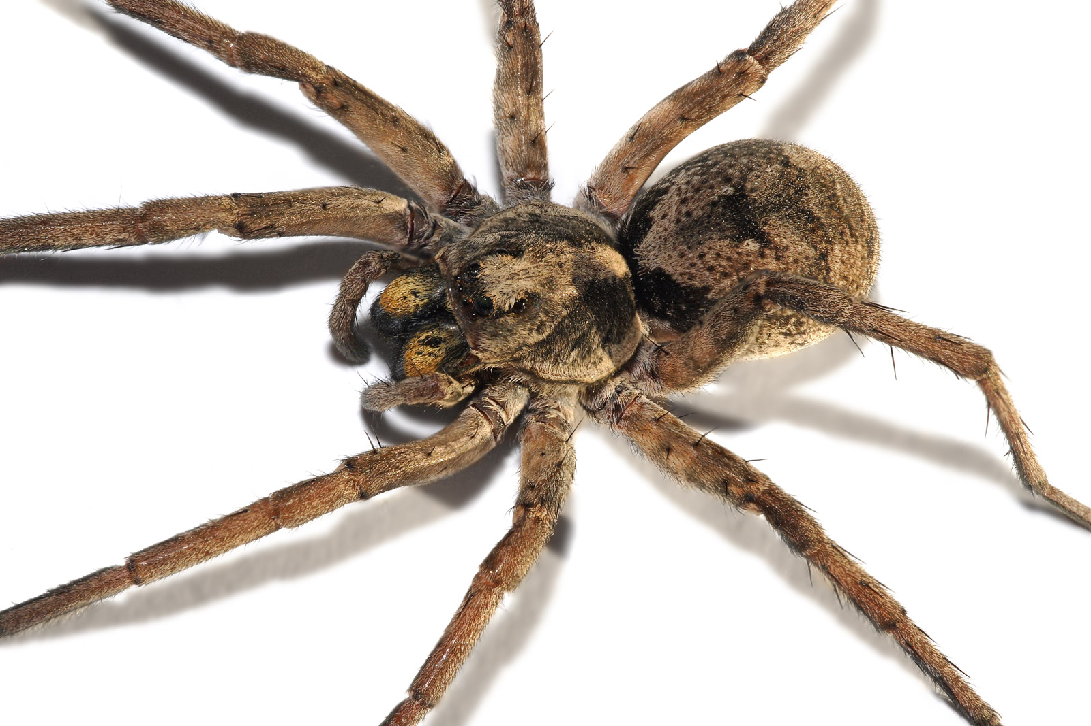

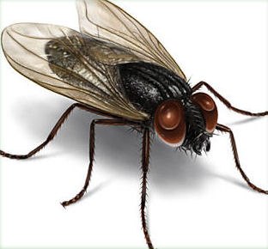

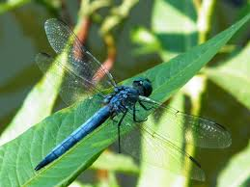

***D E F***

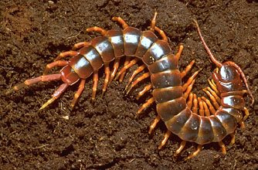

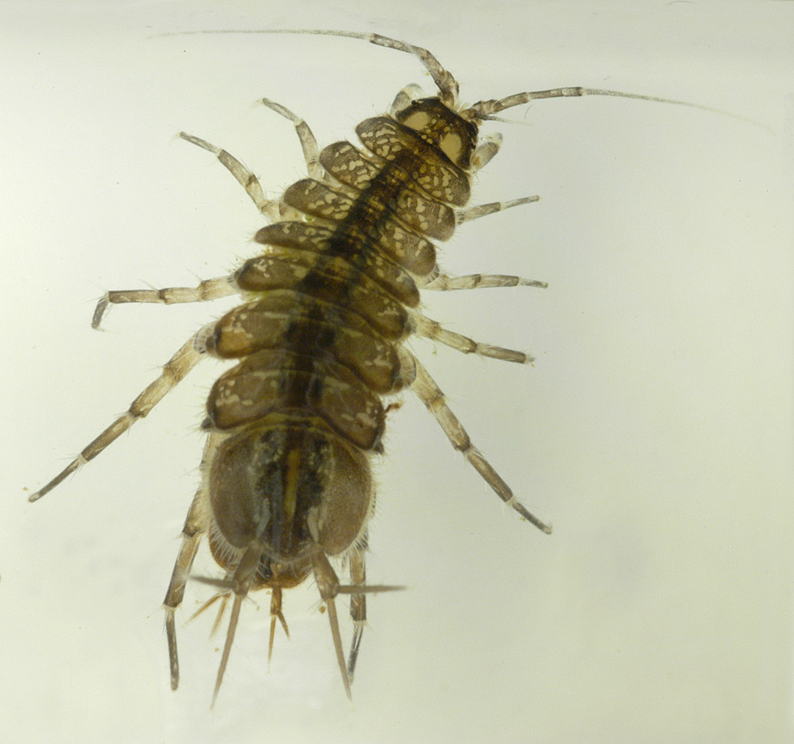

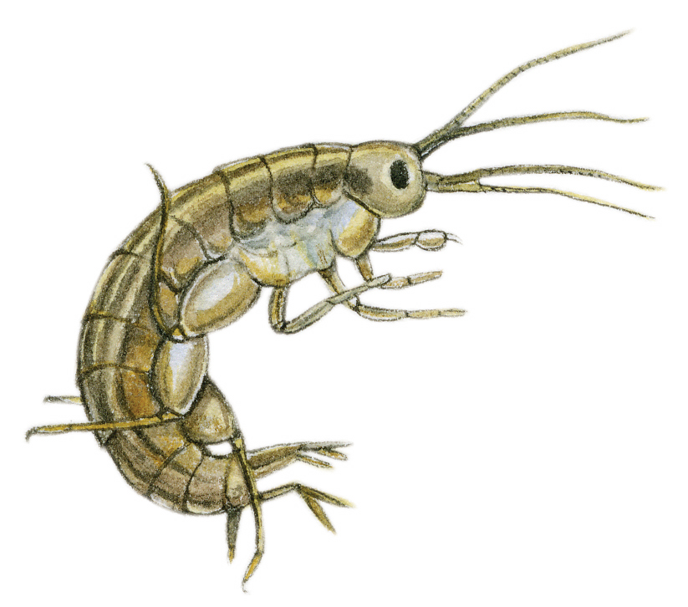

***G H***

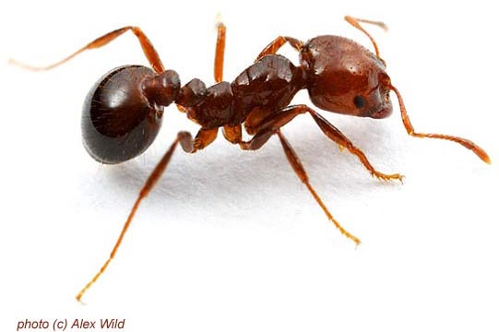

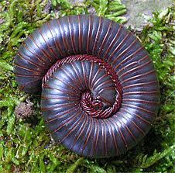

* 1. Identify the phylum from which the organisms were obtained (1mark)

…………………………………………..

* 1. State the main difference between organism F and G (1mark)

………………………………………………………………………………………………..

* 1. Using the photographs, a 7 key dichotomous key has been constructed. Fill in the blanks the appropriate organisms (use letters) (8marks)

**Key**

1.a Animal with wings……………………………………………….go to 2

b. Animal without wings……………………………………………go to 3

2.a With one pair of wings……………………………………………______________

b. With two pairs of wings…………………………………………______________

3.a. With three pairs of legs………………………………….………._______________

b. With more than three pairs of legs……………...………………..go to 4

4.a. With four pairs of legs………………….……………………….._______________

b. With more than four pairs of legs….…………………………….go to 5

5.a. With two pairs of antennae……….………………………………go to 6

b. With one pair of antennae…………...……………………………go to 7

6. a. With six pairs of legs……………..………………………………_______________

b. With ten pairs of legs…………………………………………….._______________

7. a. With cylindrical body……………..………………………………_______________

b. With a dorsal-ventrally flattened body………..…………………._______________

In the table below, indicate the steps followed and the identity of the organisms (8marks)

|  |  |  |
| --- | --- | --- |
| **Specimen** | **Steps** | **Identity(Common names)** |
| **A** |  |  |
| **B** |  |  |
| **C** |  |  |
| **D** |  |  |
| **E** |  |  |
| **F** |  |  |
| **G** |  |  |
| **H** |  |  |

1. i) The photomicrograph below was taken from the internal structure of a leaf

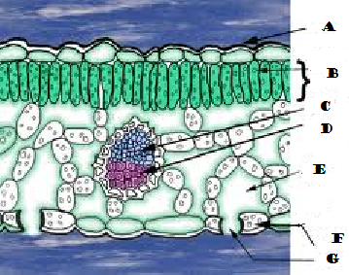

1. Identify the parts labelled A-G (7marks)

A…………………………………

B…………………………………

C…………………………………

D…………………………………

E………………………………….

F………………………………….

G………………………………….

1. State two adaptations that make structure F well suited to its functions (2marks)

……………………………………………………………………………………………………………………………………………………………………………………………………………………

1. State the functions of the parts labelled C and D (2marks)

C………………………………………………………………………………………………….

D………………………………………………………………………………………………….

ii) The photographs below were taken from plants in different habitats

X Y

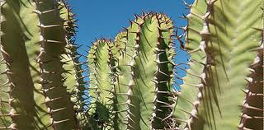

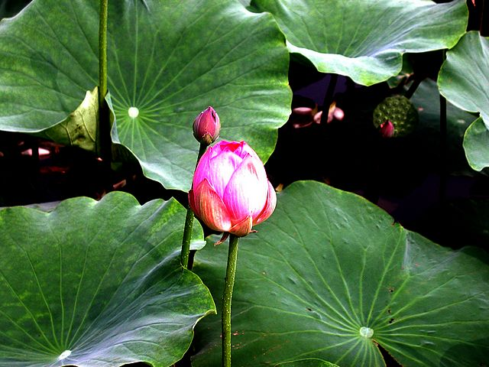

* 1. State the habitats that the two plants were taken from (2marks)

X……………………………………………..

Y……………………………………………..

* 1. Using observable features only, state one modification in each that enables the plants to reduce rates of transpiration (2marks)

………………………………………………………………………………………………………………………………………………………………………………………………………………………………………………………………………………………………………………………………………………

………………………………………………………………………………………………………………

* 1. Giving a reason, Name the sub division to which plant X belongs (2marks)

………………………………………………………………………………………………………………………………………………………………………………………………………………………………………………………………………………………………………………………………………………………

***Best wishes***