Name:………………..……………………………………………… Adm No: ..………………….….….
Class: ………………………………………………………………. Date: ………....................................

231/3
BIOLOGY
PRACTICAL
PAPER 3
1½ HOURS
END TERM 3 EXAMINATION

KAHUHO UHURU HIGH SCHOOL

INSTRUCTIONS TO CANDIDATES
- Write your name and admission number in the spaces provided at the top of this page.
- Answer all questions.
- You are required to spend the first 15 minutes of the 1½ hours allowed for this paper reading the whole paper carefully before commencing your work.
- Answers must be written in the spaces provided in the question paper. Additional pages must not be inserted.
- Candidate may be penalized for recording irrelevant information and for incorrect spelling especially of technical terms.

For Examiners Use Only
Question | Total Score | Candidate’s Score
1 | 12
2 | 10
3 | 08
Total | 30

- You are provided with a specimen labeled H, which is a piece of mammalian intestine. Squeeze the contents in the lumen into a test tube. Add about 6ml of water and shake the contents. Reserve the piece of intestine for question (b). Divide the solution into three separate test tubes.

(a) (i) Use the reagents provided to test for the presence of starch, proteins and reducing sugars in the contents.
Record the procedures, observations and conclusions in the table below. (6 marks)
Food substance | Procedure | Observations | Conclusion

(ii) Account for the results obtained in (a)(i) above. (2 marks)
………………………………………………………………………………………………………………………………………………………………………………………………………………………………………………………………………………………………………………………………………………………………………………………………………………………………………………………………………………………………
(b) Cut specimen H along its length to expose the inner surface.
(i) Feel the inner and outer surfaces of the specimen. Record your observations. (2 marks)
Inner surface ………………………………………………………………………………………
Outer surface ………………………………………………………………………………………
(ii) Account for your observations of the inner surface. (2marks)
………………………………………………………………………………………………………………………………………………………………………………………………………………………………………………………………………………………………………………………………………………………………………

- Study the photographs below and answer the questions that follow.

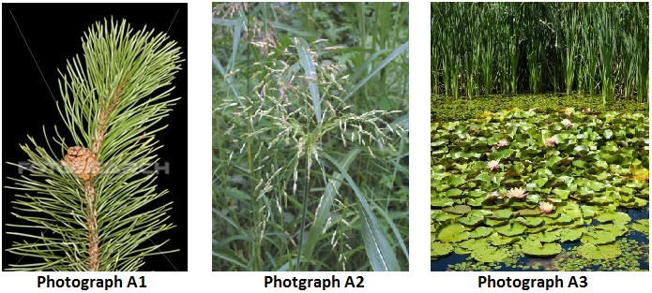

I: Observe the branch in photograph A1.
(a) (i). State the order to which the plant from which the branch in photograph A1 was obtained. (1mark)
………………………………………………………………………………………………………………………………………………………………………………………………………………………………………………
(ii) Give a reason from your answer. (1mark)
………………………………………………………………………………………………………………………………………………………………………………………………………………………………………………
(b) (i). State whether this branch is male or female. (1mark)
………………………………………………………………………………………………………………………………………………………………………………………………………………………………………………
(ii) Give a reason for your answer. (1mark)
………………………………………………………………………………………………………………………………………………………………………………………………………………………………………………
II . (a) (i). State the class to which the plant in photograph A2 belongs. (1mark)
………………………………………………………………………………………………………………………
(ii). Give a reason for your answer. (1mark)
………………………………………………………………………………………………………………………………………………………………………………………………………………………………………………
(b) (i). State the agent of pollination of the flowers of this plant. (1mark)
………………………………………………………………………………………………………………………
(ii). Give a reason for your answer. (1mark)
………………………………………………………………………………………………………………………………………………………………………………………………………………………………………………
III. Explain how the plant in the foreground in photograph A3 is suited to its habitat. (2 marks)
………………………………………………………………………………………………………………………………………………………………………………………………………………………………………………………………………………………………………………………………………………………………………………………………………………………………………………………………………………………………
3. The photographs below are blood vessels taken from the body of a healthy human being. Use it to answer the questions that follow.
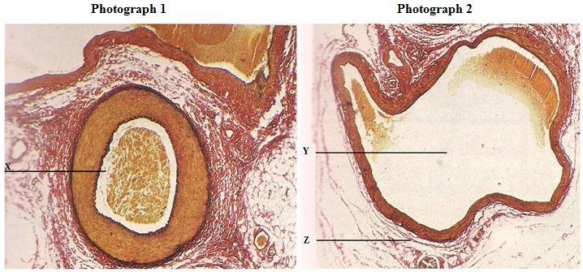
- Identify vessels in photographs 1 and 2. (2 marks)
1………………………………………………………………….……………
2…………………………………………………………….…………………
- Identify the parts labeled. (3 marks)
X…………………………………………………………………………………………………………..
Y……………………………………………………………………………………………….………….
Z………………………………………………………………………………………………………….
- State two structural differences between vessel 1 and 2. (2 marks)
………………………………………………………………………………………..………………………………………………………………………………………..……………………………………………………(d) Which defect is characterized by vessel 2 becoming swollen and flabby due to failure of the valves to function properly? (1 mark)
………………………………………………………………………………………..…………………………

This is the last printed page.

