Name………………………………………..…………………………………….…… Adm.No. ………..……….… Class …….……….
KAHUHO UHURU HIGH SCHOOL
231 BIOLOGY
Form 4 Revision Series
Gaseous exchange quiz
40 min

Questions
- State three factors that affect the rates of breathing (3 marks)
……………………………………………………………………………………………………………………………………………………………………………………………………………………………………………………………………………………………………………………………………
……………………………………………………………………………………………………………………………………………………………………………………………………………………………………………………………………………………………………………………………………
……………………………………………………………………………………………………………………………………………………………………………………………………………………………………………………………………………………………………………………………………
- What are the causes of the following diseases (3marks)
- Tuberculosis
………………………………………………………………………………………………………………………………………………………………………………………………………………………………………………………………………………………………
………………………………………………………………………………………………………………………………………………………………………………………………………………………………………………………………………………………………
- Lung cancer
………………………………………………………………………………………………………………………………………………………………………………………………………………………………………………………………………………………………
………………………………………………………………………………………………………………………………………………………………………………………………………………………………………………………………………………………………
- Pneumonia
………………………………………………………………………………………………………………………………………………………………………………………………………………………………………………………………………………………………
………………………………………………………………………………………………………………………………………………………………………………………………………………………………………………………………………………………………
- State three control/Treatment of each of the above diseases (3marks)
………………………………………………………………………………………………………………………………………………………………………………………………………………………………………………………………………………………………………………………………………………………………………………………………………………………………………………………………………………………………………
- Name two Forms of cancer (2 marks)
………………………………………………………………………………………………………………………………………………………………………………………………………………………………………………………………………………………………………………………………………………………………………………………………………………………………………………………………………………………………………
- Explain the importance of a counter current flow system in gaseous exchange in fish (3 marks)
…………………………………………………………………………………………………………………………………………………………………………………………………………………………………………………………………………………………………………………………………………………………………………………………………………………………………………………………..…………………………………………
- What would be the easiest way of preventing the spread of the disease from one person to the other or from country to country? (1 mark)
………………………………………………………………………………………………………………………………………………………………………………………………………………………………………………………………………………………………………………………………………………………………………………………………………………………………………………………………………………………………………
- Identify one disease whose vaccination is the use of BCG (Bacille Calmette Guerin) (1 mark)
……………………………………………………………………………………………………………………………………………………………………………………………………………………………………………………………………………………………………………………………………
- How does smoking cause lung cancer (2 marks)
……………………………………………………………………………………………………………………………………………………………………………………………………………………………………………………………………………………………………………………………………
……………………………………………………………………………………………………………………………………………………………………………………………………………………………………………………………………………………………………………………………………
- Suggest how too much dust particles affect respiratory system (2 marks)
……………………………………………………………………………………………………………………………………………………………………………………………………………………………………………………………………………………………………………………………………
……………………………………………………………………………………………………………………………………………………………………………………………………………………………………………………………………………………………………………………………………
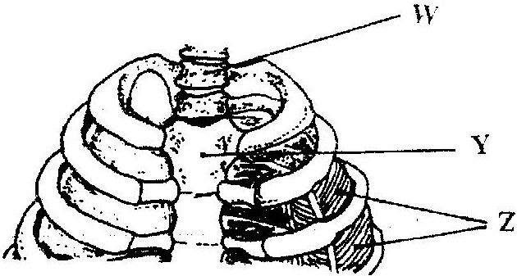
- The diagram below represents a part of the rib cage.

a) Name the parts labeled W, Y and Z. (3marks)
W ……………………………………………………
Y …………………………………………………….
Z ……………………………………………………..
b) How does the part labeled Z facilitates breathing in? (3marks)
……………………………………………………………………………………………………………………………………………………………………………………………………………………………………………………………………………………………………………………………………
……………………………………………………………………………………………………………………………………………………………………………………………………………………………………………………………………………………………………………………………………
10. What characteristics do mammalian lungs and the gills of a bony fish have in common that enables them to exchange gases effectively (4 marks)

- List three structures used for gaseous exchange in land plants (3marks)

- Explain why a fish has to pass large amounts of water continuously over its gills during gaseous exchange (2 marks)

- State two ways in which the tracheole system is adapted to its function. (2 marks)
………………………………………………………………………………………………………………………………………………………………………………………………………………………………………………………………………………………………………………………………………………………………………………………………………………………………………………………………………………………………………
- Explain the photosynthentic theory of opening of the stomata (3 marks)
…………………………………………………………………………………………………………………………………………………………………………………………………………………………………………………………………………………………………………………………………………………………………………………………………………………………………………………………..…………………………………………
- Describe Inhalation and exhalation in human beings (10marks)
…………………………………………………………………………………………………………………………………………………………………………………………………………………………………………………………………………………………………………………………………………………………………………………………………………………………………………………………..…………………………………………
…………………………………………………………………………………………………………………………………………………………………………………………………………………………………………………………………………………………………………………………………………………………………………………………………………………………………………………………..…………………………………………
…………………………………………………………………………………………………………………………………………………………………………………………………………………………………………………………………………………………………………………………………………………………………………………………………………………………………………………………..…………………………………………
…………………………………………………………………………………………………………………………………………………………………………………………………………………………………………………………………………………………………………………………………………………………………………………………………………………………………………………………..…………………………………………
…………………………………………………………………………………………………………………………………………………………………………………………………………………………………………………………………………………………………………………………………………………………………………………………………………………………………………………………..…………………………………………
…………………………………………………………………………………………………………………………………………………………………………………………………………………………………………………………………………………………………………………………………………………………………………………………………………………………………………………………..…………………………………………

