Name………………………………………..…………………………………….…… Adm.No. ………..……….… Class …….……….
KAHUHO UHURU HIGH SCHOOL
231 BIOLOGY
Form 4 Revision Series
Respiration quiz
40 min

Questions
- Below is a diagram of an organelle that is involved in respiration

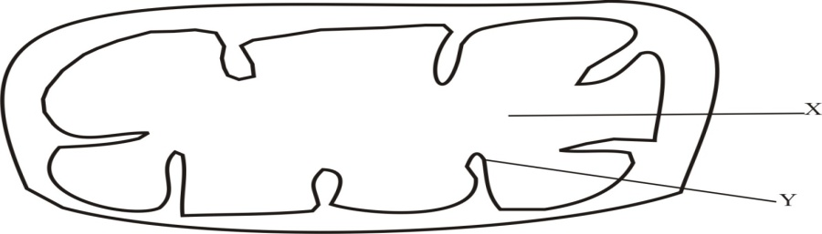

- Name t he organelle …………………………………………………………… ( 1mark)

- Name the part labeled X………………………………………………………… (1 mark)

- What is the purpose of the part labeled Y (1 mark)

………………………………………………………………………………………………………

………………………………………………………………………………………………………

………………………………………………………………………………………………………
- (a) Define the term oxygen debt (2 marks)
………………………………………………………………………………………………………

……………………………………………………………………………………………………..

……………………………………………………………………………………………………
- State what happens to the lactic acid produced by active muscles during anaerobic
respiration (2 marks)
………………………………………………………………………………………………………

………………………………………………………………………………………………………

………………………………………………………………………………………………………

- State four differences between aerobic and anaerobic respiration (4marks)
………………………………………………………………………………………………………

……………………………………………………………………………………………………..

- The diagram below shows a set – up that was used to demonstrate fermentation
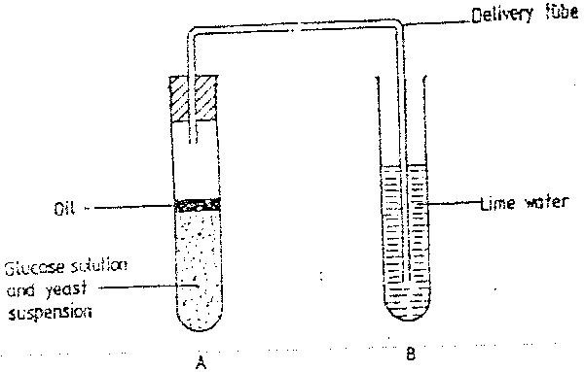

Glucose solution was boiled and oil added on top of it. The glucose solution was then allowed to cool before suspension.
  - Why was the glucose solution boiled before adding the yeast Suspension? ( 1 mk)
………………………………………………………………………………………………………
……………………………………………………………………………………………………..
  - What was the importance of cooling the glucose solution before adding the yeast suspension? ( 1 mk)
………………………………………………………………………………………………………
……………………………………………………………………………………………………..
  - What was the use of oil in the experiment? ( 1 mk)
………………………………………………………………………………………………………
……………………………………………………………………………………………………..
  - What observation would be made in test tube B at the end of the experiment? ( 1 mk)
………………………………………………………………………………………………………
……………………………………………………………………………………………………..
  - Suggest a control for this experiment ( 1mk)
………………………………………………………………………………………………………
……………………………………………………………………………………………………..
- Name the substance which accumulates in muscles when respiration occurs with insufficient oxygen. (1mks)
………………………………………………………………………………………………………
……………………………………………………………………………………………………..
- Identify the products of anaerobic respiration in;- (6 marks)
- Animals
………………………………………………………………………………………………………
………………………………………………………………………………………………………
- Plants
……………………………………………………………………………………………………………………………………………………………………………………………………………..

- What is meant by the following terms as used in repiration (3 marks)
- Respiratory quotient
………………………………………………………………………………………………………
……………………………………………………………………………………………………..
- Aerobic respiration
………………………………………………………………………………………………………
……………………………………………………………………………………………………..

- Glycolysis
………………………………………………………………………………………………………
……………………………………………………………………………………………………..
- What is the significance of Respiration (4 marks)
……………………………………………………………………………………………………..
………………………………………………………………………………………………………
……………………………………………………………………………………………………..
………………………………………………………………………………………………………
……………………………………………………………………………………………………..
- Distinguish between aerobic and anaerobic respiration (4 marks)
……………………………………………………………………………………………………..
………………………………………………………………………………………………………
……………………………………………………………………………………………………..
………………………………………………………………………………………………………
……………………………………………………………………………………………………..
………………………………………………………………………………………………………
……………………………………………………………………………………………………..
- Discuss the applications of anaerobic Respiration to man (14 marks)
………………………………………………………………………………………………………
……………………………………………………………………………………………………..
………………………………………………………………………………………………………
……………………………………………………………………………………………………..
………………………………………………………………………………………………………
……………………………………………………………………………………………………..………………………………………………………………………………………………………
……………………………………………………………………………………………………..
………………………………………………………………………………………………………
……………………………………………………………………………………………………..
………………………………………………………………………………………………………
……………………………………………………………………………………………………..
………………………………………………………………………………………………………
……………………………………………………………………………………………………..

