GEOGRAPHY FORM FOUR
GATITU MIXED SECONDARY
MID TERM EXAM
TERM TWO 2014
Kenya certificate of secondary education
INSTRUCTIONS TO STUDENTS
- This paper contains two sections
- Answer all the questions in section a
- Answer question six and any other two questions

SECTION A
Answer all the questions in this section
1. (a)What is the solar system (1mk)
(b) Give three reasons why the interior of the earth is very hot (3mks)
2. Statethree effects of the revolution of the earth (3mks)
3. Explain four effects of folding to human activities (4mks)
4. (a) Distinguish between weather and climate(2mks)
(b) The map below shows the climatic regions of Kenya
(a) Use it to answer the question a and b
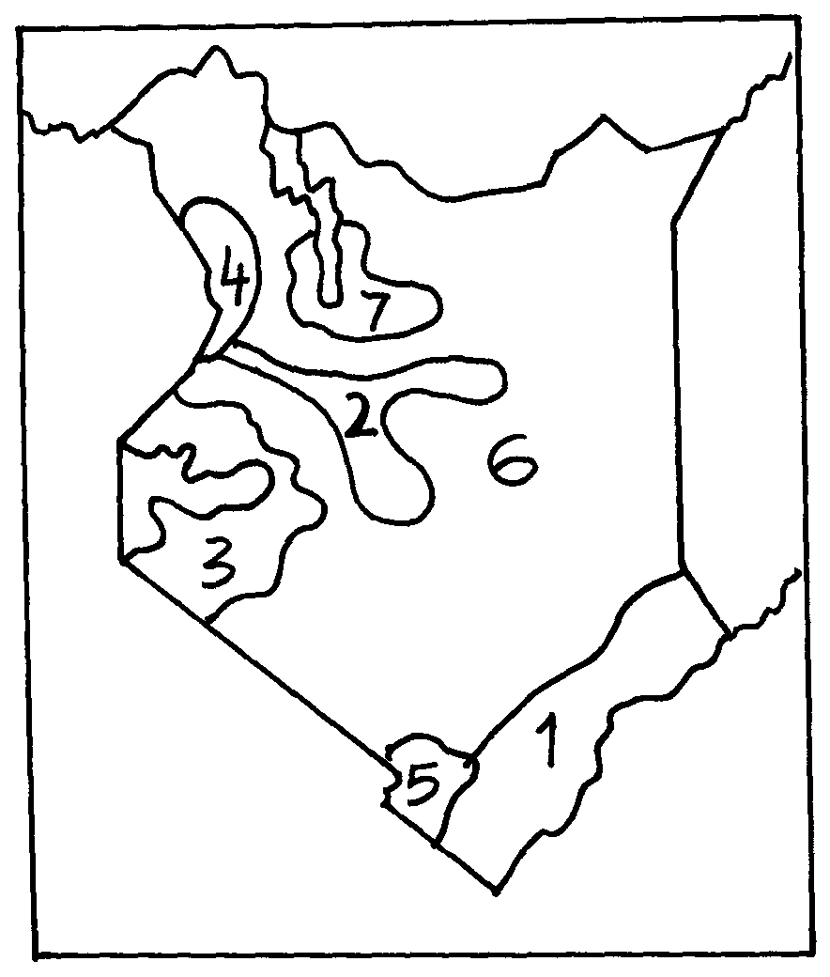

. (a) Name the climatic region name 2 and 3 (2mks)
(b) State three characteristics of climatic region marked 1 (3mks)
b) Four classes intend to visit a weather station near your school to study the instruments for measuring weather element:-
- Describe how you would use a rain gauge to measure rainfall(2mks)
- Name two instruments you would find inside a Stevenson screen(2mks)
5. Explain three problems caused by a large aging population (3mks)

SECTION B
Answer question 6 and any other two questions
6. The table below shows leading import crops by value (Kshs. Million). Use is to answer questions a – c

 | CROP
Year | Un milled wheat | Maize | Rice | Wheat flour
2000 | 6,989 | 4,664 | 1,968 | 180
2001 | 7,515 | 3,342 | 2,619 | 639
2002 | 5,577 | 229 | 2,104 | 237
2003 | 6,099 | 1,417 | 2,981 | 168
2004 | 6,754 | 4,647 | 3,659 | 200
(a) (i) Using a scale of 1cm represents 100,000 , draw a comparative bar graph to represent the data in the table above (7mks)
(ii) Give three advantages of suing comparative bar graphs (3mks)
(b) Explain three reasons why Kenya is a producer of the commodities shown in the table above yet she imports the same (3mks)
(c) Name two districts in Rift valley where maize is grown in plantations. (2mks)

(d) Outline the significance of maize growing in Kenya.(4mks)
(e) Explain three problems facing maize farmers in Kenya(3mks)
(f). Explain three physical conditions which favors wheat growing in Kenya (3mks)

7. (a) Apart from Mwea, name three other large irrigation schemes in Kenya (3mks)
(b) (i) Explain four conditions that made Mwea-Tebere a suitable location for an irrigation scheme (4mks)
(ii) Explain four problems facing farmers in Mwea irrigation scheme (4mks)
(c) State six benefits which Kenya derives from irrigation farming (6mks)
(d)Distinguish between land reclamation and land rehabilitation (2mks)
(e) Explain four methods of land reclamation in Kenya (4mks)
(f) Explain any two methods used in land reclamation and rehabilitation in Netherlands (2mks)

8. a) State three reasons why wind erosion is predominant in desert areas.(3mks)
(b) Describe three processes by which wind erodes.(3mks)
(c) With aid of well labeled diagrams, describe the formation of the following desert features;
(i) Rock pedestal. (5mks)
(ii) Zeugen. (5mks)
(d) State four ways in which desert land forms influence man’s activities.(4mks)
(e) Differentiate between oceans and seas. (2mks)
(f) Explain three sources of salinity in the oceans (3mks).

9. (a) (i) Name three traditional methods of fishing used in Kenya (3mks)
(ii) Identify the two main fishing grounds of the Atlantic Ocean (2mks)
(b) Explain any four problems facing fishing in East Africa (8mks)
(c) Explain any four ways in which fishing is significant to Kenya (4mks)
(d) Explain three factors that favor fishing in Japan.(3mk

(e) Name commercial methods of fishing shown in the diagrams below: (2mks)
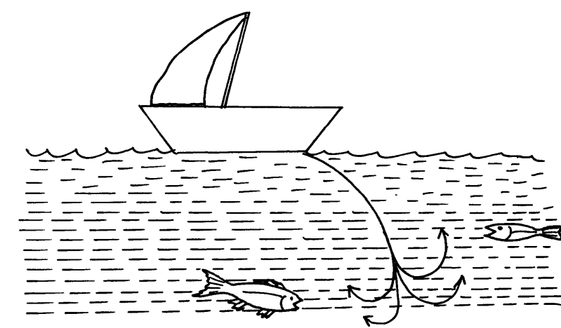

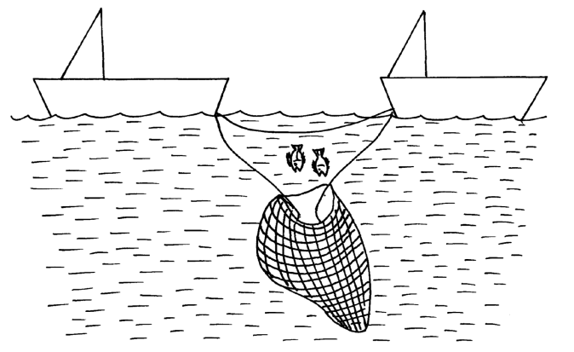

(f) State three reasons why marine fisheries in Kenya are underdeveloped (3mks)

10.(a) name three types of map (3mks)
(b) State four ways of representing relief on topographical maps (4mks)
Students from your school have conducted a field study on a Lake in Kenya
(i) In their study they identified some of the problems affecting the lake to have beencaused by nearby industriesand deforestation in the surrounding areas. Explain how each of the two could have affected the lake.( 4mks)
(ii) Name any two methods they might have used to collect the data. (2mks)
(iii) State any two reasons why it would be important to do follow-up after the study (2mks)
(d) You are required to carry out a field study on soil erosion around your school (2mks)
(i) State two methods you would use t record data (2mks)
(ii) Give three problems you may encounter during the field study (3mks)

ALL THE BEST
MR. MUHINDI SIR.

