1 | $$\frac{25}{12}$$  − $\frac{3}{4}$  -2$\frac{7}{9}$ | M₁  M₁  A₁  3 | Numerator  Denominator
2 | - M=-2  - tan⁻¹ (2)  =63.43º | B₁  M₁  A₁  3
3 | EB=x cm  5=$\frac{12-x}{x}$  X=2  EC=10cm | M₁  A₁  B₁  3
4 | 12c+8t=940  8c+10t=860  T=sh 50  C=sh 45  6(45)+12 (50)  =sh 870 | M₁  A₁  B₁  3 | For both equation  For both
5 | 3^{-3m}x 3⁻⁴= 3¹⁰  -3m-4=10  $$M=-4\frac{2}{3}$$ | M₁  M₁  A₁  3 | Expressing all to base 3
6 | $$\frac{500,000x84}{100}=ksh 420,000$$  $$\frac{95}{100}×420,000=399,000$$  ¼$×399,000=99,750$  $$\frac{99,750}{88.7}$$  =1124.58 dollars  =1125 dollars | M₁  M₁  M₁  A₁  4
7 | - Sin⁻¹$\left(\frac{365×2}{25×32}\right)$  = 65.85º  180-65.85  =114.15º  - a²=25²+32²-2x25x32x cos114.15º  =625+1024-(1600(-0.4.91)  a=$\sqrt{2303.56}$  =47.995  =48cm | M₁  A₁  M₁  A₁  4 | Application of cosine rule
8 | LCM=12  2+1=13 staircases | B₁  B₁  2
9 | $$\frac{8+x^{2}-6x}{2x}$$  $$\frac{x^{2}-2x-8}{6x}$$  $$\frac{3(x^{2}-6x+8)}{x^{2}-2x-8}$$  $$\frac{3\left(x-2\right)\left(x-4\right)}{\left(x-2\right)\left(x-4\right)}$$  $$=\frac{3(x-2)}{x+2}$$ | M₁  M₁  M₁  A₁  4 | Simplified numerator and denominator (both)  Factorization of both
10 | (2, -3) 4 B(-10, 9) p  A  $$\frac{5}{4}\left(\begin{aligned}-10 \\ 9\end{aligned}\right)+\frac{-1}{4}\left(\begin{aligned}2 \\ -3\end{aligned}\right)$$  $\left(\begin{aligned}\frac{-50}{4} \\ \frac{45}{4}\end{aligned}\right)$+$\left(\begin{aligned}\frac{-2}{4} \\ \frac{3}{4}\end{aligned}\right)$=$\left(\begin{aligned}-13 \\ 12\end{aligned}\right)$  $$\vec{OP}=(-13, 12)$$ | M₁  M₁  A₁  3
11 | $$\frac{\left[4\left(3\right)\left(-3\right)\left(-1\right)\right]-\left[2\left(3\right)+{1)}^{2}\right]-5\left(-3\right)}{\begin{aligned}3({-3)}^{3}\left(-1\right)+[3(3)({-1)}^{3}+4\left(-3\right)] \\ \frac{\begin{aligned}24-6+10\end{aligned}}{\begin{aligned}81-9-12 \\ \frac{45}{60}=\frac{3}{4}\end{aligned}}\end{aligned}}$$ | M₁  M₁  A₁  3 | - substitution
12 | (7-2)180º=900º  40+2x+x+2x+25+155+140=900º  360+5x=900  5x=540  X=108º | B₁  M₁  A₁  3
13 | $$\frac{22}{7}×{35}^{2}h=10,000$$  h=2.597cm  $$\frac{20}{2.597}$$  =7.701 hrs | M₁  M₁  A₁  3 | $\frac{22}{7}×\frac{35×35×20}{1000}$=77 litres  $$=7^{\frac{7}{10}hrs=7 hrs 42 mins}$$
14 | 1 h= 60km  Relative speed=x-60km/h  $$\frac{60}{x-60}=3hrs$$  x-60=20  x=80km/h | B₁  M₁  A₁  3
15 | A: J: M=2:6:9  $$\frac{6}{17}×32,640$$  =sh. 11,520  A  5  B  5  D  5  A  6  V  C  5  6  B  6  A  5 | B₁  M₁  A₁  3 | - Ratio of the three
16 |  | B₁  B₁  B₁  3 | - Net drawn accurately  - Labeling  - Path shown
17 | marks 30-34 50-59 60-79 80-89  F 2 10 40 5  b) x=32 42 54.5 69.5 84.5  fx=64 126 545 2780 422.5  $$\overline{x}=\frac{3937.5}{60}$$  =65.625  - CF =2 5 15 55 60  59.5+$\frac{30-15}{40}×20$  =67 | B₁  B₂  M₁  M₁  M₁  A₁  B₁  M₁  A₁  10 | - Classes  - All frequencies  - B₁ at least 3 frequencies  - Mid points  - fx  Cumulative frequencies  Or equivalent
18 | - $\frac{5}{x}$  - $\frac{7}{x+24}$  - $\frac{5}{x}-\frac{3}{5}=\frac{7}{x+24}$  3x²+82x-600=0  (x-6)(3x+100)=0  X=6  - Time to walk  =$\frac{5}{6}×60=50 minutes$  - $\frac{5}{60}×30=2\frac{1}{2} km$  $$7-2^{\frac{1}{2}}=4^{\frac{1}{2}}$$  $$\frac{9}{2}×\frac{1}{6}=\frac{3}{4}hrs$$ | B₁  B₁  M₁  M₁  M₁  A₁  B₁  M₁  M₁  A₁  10
19 | - V=$\frac{KH}{R^{2}}$  18.5=$\frac{kx8}{16}$  K=37  V=$\frac{37H}{R^{2}}$  - $\frac{37X12}{25}$  =17.76  - R₁=1.15R  H₁=0.88H  V₁=$\frac{k 0.88H}{{(1.15R)}^{2}}$  V₁=0.665v x 100%  =66.5%  Decreased by 33.5% | M₁  A₁  B₁  M₁  A₁  B₁  M₁  M₁  M₁  A₁  10 | For both R₁ and H₁  Difference
20 | - Quadrilateral drawn  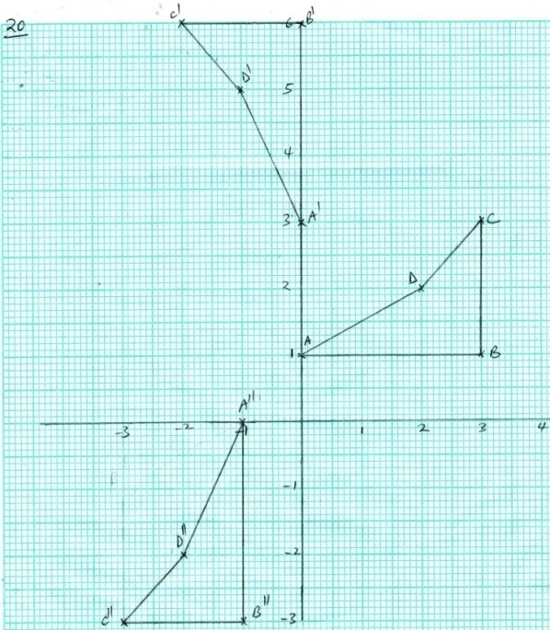  - Centre (-1, 2)  Angle +90º  - B`(0,6)  C`(-2,6)  - B``(-1, -3)  C``(-3,-3) | B₁  B₁  B₁  B₁  B₁  B₁  B₁  B₁  B₁  B₁  10 | - ABCD  - Bisector  - Centre  - Angle  - Point B`  - Point C`  - Quadrilateral A`B`C`D` drawn  - Reflection in line y=-x  - B`` coordinates  - C`` coordinates
21 | - $\sqrt{{10}^{2}+{10}^{2}}$  $$=14.14cm$$  - Sin 36º=$\frac{7.07}{r}$  R=$\frac{7.07}{sin36}$  =12Cm  - ($\frac{72}{360}×\frac{22}{7}×{12}^{2}-\frac{1}{2}×{12}^{2}\sin{72}$)+($\frac{90}{360}×\frac{22}{7}×{10}^{2}-\frac{1}{2}×{10}^{2}sin{90}^{o}$)  (90.51-68.48)+(78.57-50)  22.08+28.57  =50.6cm² | M₁  A₁  M₁  A₁  M₁  M₁  M₁  M₁  M₁  A₁  10
22 | - V=$\frac{4}{3}×\frac{22}{7}×5^{3}=523.81{cm}^{3}$  M=523.81 x 2.4  =1257.144g  =1.257kg  - $\frac{22}{7}×8×8×h=523.81$  h=$\frac{523.81×7}{22×64}$  =2.604  - $\frac{22}{7}×5×5×h=523.81$  $$h=\frac{523.81×7}{22×25}$$  =6.667cm | M₁A₁  M₁  A₁  M₁  M₁  A₁  M₁  M₁  A₁  10
23 | A  N  D  N  B  4cm  N  6cm  C  N  5cm  b)i 7.6 x 10=76$±1$  325º  ii) 4.6 x 10=46$±1$  200º  iii) 9.8 x 10= 98$±1$  296º | B₁  B₁  B₁  B₁  B₁  B₁  B₁  B₁  B₁  B₁  10 | - Location of A  - Location of C  - Location of D  - Diagram
24 | - 75x + 60y=70(x+y)  5x=10y  X:y=2:1  - i) $\frac{1}{5}+\frac{1}{10}=\frac{3}{10}$  Time till=$\frac{10}{3}=3\frac{1}{3}hrs$  ii) 1 hr $=\frac{1}{5}+\frac{1}{10}$ - $\frac{1}{6}$= $\frac{2}{15}$ full  $$\frac{1}{5}-\frac{1}{6}=\frac{1}{30}$$  rem= $\frac{13}{15}$  $$\frac{13}{15}×30=26hrs$$  iii) empty =$\frac{3}{4}$  $$\frac{3}{4}×\frac{15}{2}=5\frac{5}{8}hrs$$ | M₁  M₁  A₁  M₁  A₁  M₁  M₁A₁  M₁  A₁  10 | Or equivalent

