**Name……………………………………………………............ Index no……......…………………….. Candidate’s signature…………………**

**Date………………………………**

**121/1**

**Mathematics alt A**

**Paper 1**

**First term examination 2017**

**TIME: 2½ hours**

**Kenya Certificate of Secondary Education 2017**

**Form four evaluation examination**

**Mathematics alt A**

**Paper 1**

**First term examination 2017**

**TIME: 2½ hours**

**INSTRUCTIONS TO CANDIDATES:**

1. *Write your name, admission and class in the spaces provided at the top of this page.*
2. *Sign and Write the date of examination in the spaces provided above.*
3. *This paper consists of* ***TWO*** *Sections;* ***Section I*** *and* ***Section II.***
4. *Answer* ***ALL*** *the questions in* ***Section I*** *and only* ***five*** *questions from* ***Section II.***
5. ***Show all the steps in your calculation, giving your answer at each stage in the spaces provided***

***below each question.***

1. *Marks may be given for correct working even if the answer is wrong.*
2. ***Non-programmable*** *silent electronic calculators* ***and*** *KNEC Mathematical tables may be used except*

*where stated otherwise.*

1. ***This paper consist of 14 printed pages****.*
2. ***Candidates should check the question paper to ascertain that all the pages are printed as indicated and that no questions are missing***
3. ***Candidates should answer the questions in English.***

**

**FOR EXAMINER’S USE ONLY:**

**SECTION I**

|  |  |  |  |  |  |  |  |  |  |  |  |  |  |  |  |  |
| --- | --- | --- | --- | --- | --- | --- | --- | --- | --- | --- | --- | --- | --- | --- | --- | --- |
| 1 | 2 | 3 | 4 | 5 | 6 | 7 | 8 | 9 | 10 | 11 | 12 | 13 | 14 | 15 | 16 | TOTAL |
|  |  |  |  |  |  |  |  |  |  |  |  |  |  |  |  |  |

**SECTION II GRAND TOTAL**

|  |  |  |  |  |  |  |  |  |
| --- | --- | --- | --- | --- | --- | --- | --- | --- |
| 17 | 18 | 19 | 20 | 21 | 22 | 23 | 24 | TOTAL |
|  |  |  |  |  |  |  |  |  |

SECTION 1 (50 marks)

Answer all the questions in this section in the spaces provided.

1. Evaluate the following (3mks)
$$\frac{1\left(\frac{1}{4}-\frac{3}{8}\right)÷3\frac{1}{2}+1\frac{5}{6}}{\frac{3}{7} of 3\frac{2}{3}-3\frac{4}{7}-(\frac{-5}{4})}$$

2. The line $y-mx-4=0$ passes through (1, 2), Find:-
3. The value of $m$ (1mk)
4. The angle the line makes with x-axis (2mks)
5. In the figure below AB is parallel to CD, BC and AD intersect at E. Given that DE:EA = 5:1 and BC=12cm. calculate the length of EC (3mks)

E

D

C

A

B

1. In order to be healed, Jane can take a combination of either 12 capsules and 8 tablets which cost Sh. 940 daily or 8 capsules and 10 tablets which cost Sh. 860 daily. How much would a combination of 6 capsules and 12 tablets cost? (3mks)
2. Evaluate (3mks)
$${\left(\frac{1}{27}\right)}^{m}×{81}^{-1}=59049$$

3. A commercial bank buys and sells foreign currencies at the rate shown below

**Buying Selling**

100 Japanese yen 84.0 84.2

1 US dollar 88.6 88.7

A tourist went to Kenya with 500,000 yen. He changed the money to Ksh in a bank which charged a commission of 5%. He spent $\frac{3}{4}$ of the money and converted the rest to US dollars when leaving the country. How much money to the nearest dollars did he go back with? (4mks)

1. Two sides of a triangle are 25cm and 32 cm and their included angle is obtuse. Given that the area of the triangle is 365 cm2
2. The included angle. (2mks)
3. The length of the third side. (2mks)
4. Find the least number of steps in a staircases if when I go up 2 steps at a time, 3 steps at a time or 4 steps at a time there is always one odd step at the top (2mks)
5. Simplify completely (4mks)
$$\frac{\frac{4}{x}+\frac{x}{2}-3}{\frac{x}{6}-\frac{1}{3}-\frac{4}{3x}}$$

6. A point A is at (2, -3) and B is at (-10, 9). Point P lies on AB produced such that BP= $\frac{1}{4}AB$. Determine the coordinates of P. (3mks)
7. Given that x=3, y=-3 and z=-1. Find the value of: (3mks)
$$\frac{4xyz-{2xz}^{2}-5y}{{xy}^{3}z+{3xz}^{3}+4y}$$

8. The diagram below shows an irregular polygon ABCDEFG. Calculate the value of x if <FED=25o, <EDC=2xo, <DCB=xo, <ABC2xo and <AGH=40o  (3mks)

x0

250

C

D

2xo

2xo

B

A

G

E

F

40o

H

1. A cylindrical water tank is 70cm in diameter. To begin with it is full of water. A leak starts at the bottom so that it loses 10 litres of water in one hour. How long will it take for the water level to fall by 20 cm? (3mks)
2. At 8.00Am, a truck travelling at 60km/h leaves a certain town. At 9.00 Am, a car leaves the town and overtakes the truck at 12.00 noon the same day. Find the average speed of the car. (3mks)
3. Amos, Jeni and Mwai shares Sh. 32,640 so that for every Sh.1that Amos gets, Jeni gets sh. 3 and for every Sh. 2 that Jeni gets, Mwai gets Sh.3.

Find Jenis share (3mks)

1. The figure below represents a right pyramid. A string is fixed at A, then passes through mid-points of edges DC, VC, VB and finally at A. Given that the dimension of the base is a square of side 5cm and VA=VB=VC=VD=6cm

B

A

C

D

V

B

5 cm

5 cm

1. Draw and label the net of the solid (2mks)
2. On the net show the straight string (1mk)

**SECTION 11 (50 marks)**

**Answer only five questions from this section in the spaces provided.**

1. The histogram below represents the distribution of marks obtained in a test. The frequency of the second class is 3

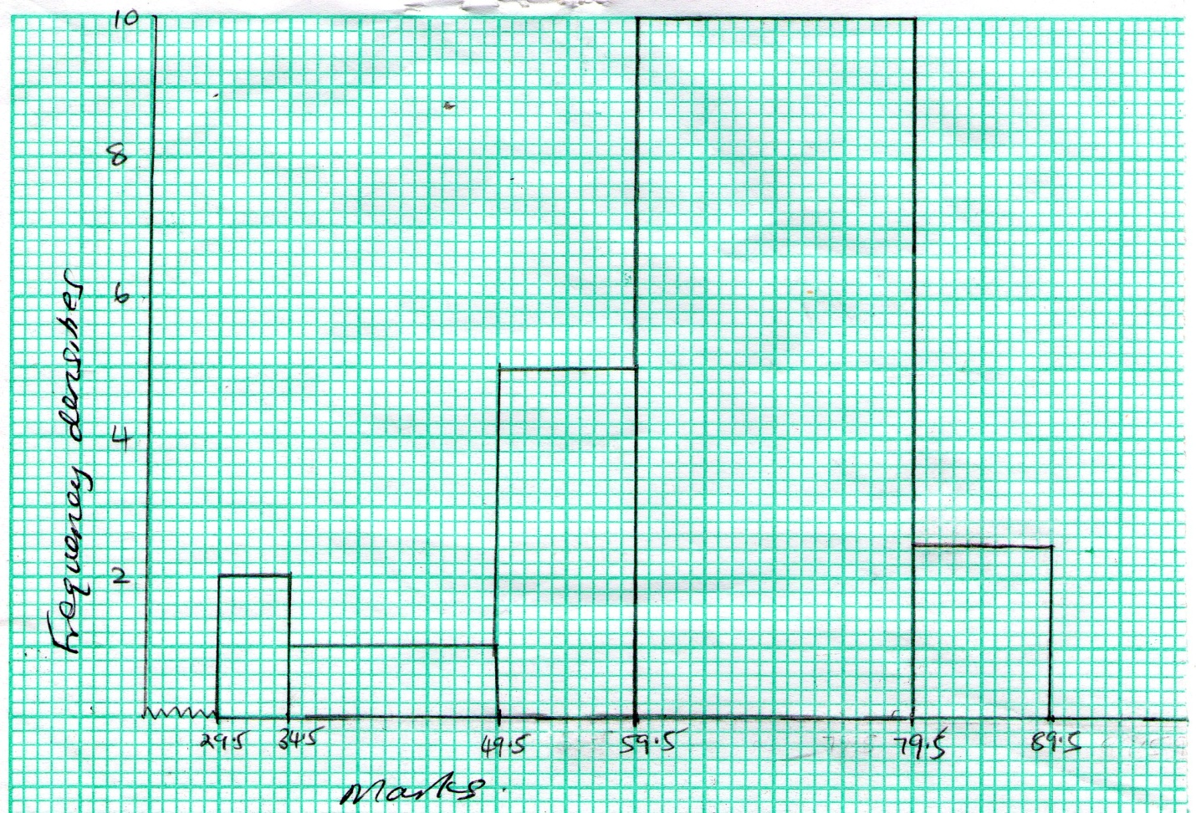

1. Complete the table below. (3mks)

|  |  |  |  |  |  |
| --- | --- | --- | --- | --- | --- |
| Marks |  | 35-49 |  |  |  |
| Frequency |  | 3 |  |  |  |

1. Use the table in (a) above to find
2. The mean mark. (4mks)
3. Median mark. (3mks)
4. A man normally walks to work a long a route of 5 km at an average speed of x km/h
5. Write down an expression for the time of his journey by foot (1mk)
6. Sometimes he takes a bus journey of 7 km. The average speed of his bus journey is 24 km/h faster than the man’s average walking speed. Write down an expression for the time taken when using the bus (1mk)
7. If the bus journey takes 36 minutes less than the journey on foot, form an equation in x and solve it (4mks)
8. Hence find the time in minutes he takes to walk. (1mk)
9. On a certain day he decided to use the bus journey. After travelling for 5 minutes, the bus broke down and he decided to walk the rest of the journey. Calculate the time he took to walk. (3mks)
10. Three quantities V, H and R are such that V varies directly as H and inversely as the square of R.
11. Given that V is 18.5 when H=8 and R=4. Write an equation connecting V, H an R. (3mks)
12. Find the value of V when H = 12 and R=5. (2mks)
13. Given that R is increased by 15% and H is decreased by 12%. Find the percentage change in V to the nearest

1 decimal place. (5mks)

1. The vertices of a quadrilateral are A(0, 1), B(3,1), C(3,3) and D(2,2). Under a rotation, the image of A and D are A`(0,3) and D`(-1, 5)
2. Draw the quadrilateral ABCD on the grid provided (1mk)

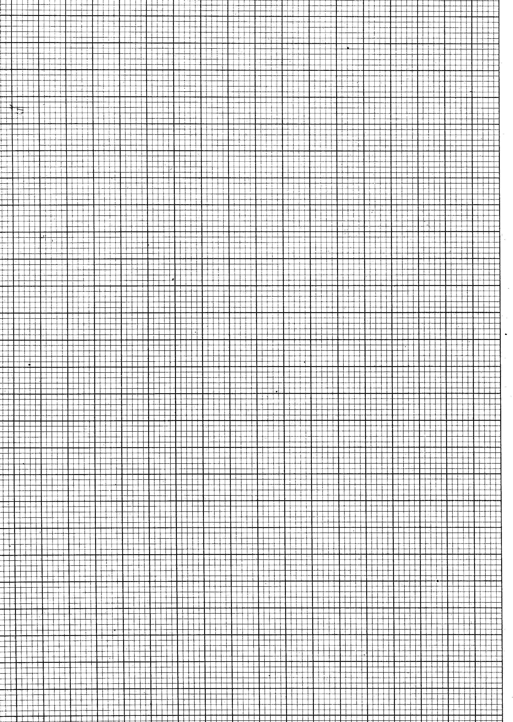

1. If ABCD is mapped into A`B`C`D` by a rotation, find the coordinates of the centre and the angle of rotation (3mks)
2. Give the coordinates of B` and C` and draw the quadrilateral A`B`C`D` on the same set of axes (3mks)
3. Under another transformation the images of A and D are A``(-1, 0) and D``(-2,-2)

Describe this transformation fully and hence write the coordinates of B`` and C`` under this transformation (3mks)

1. The figure below shows two intersecting circles with centre A and B. <CBD=90o and BC=BD=10cm, <CAD=720 and line CD is a common chord.

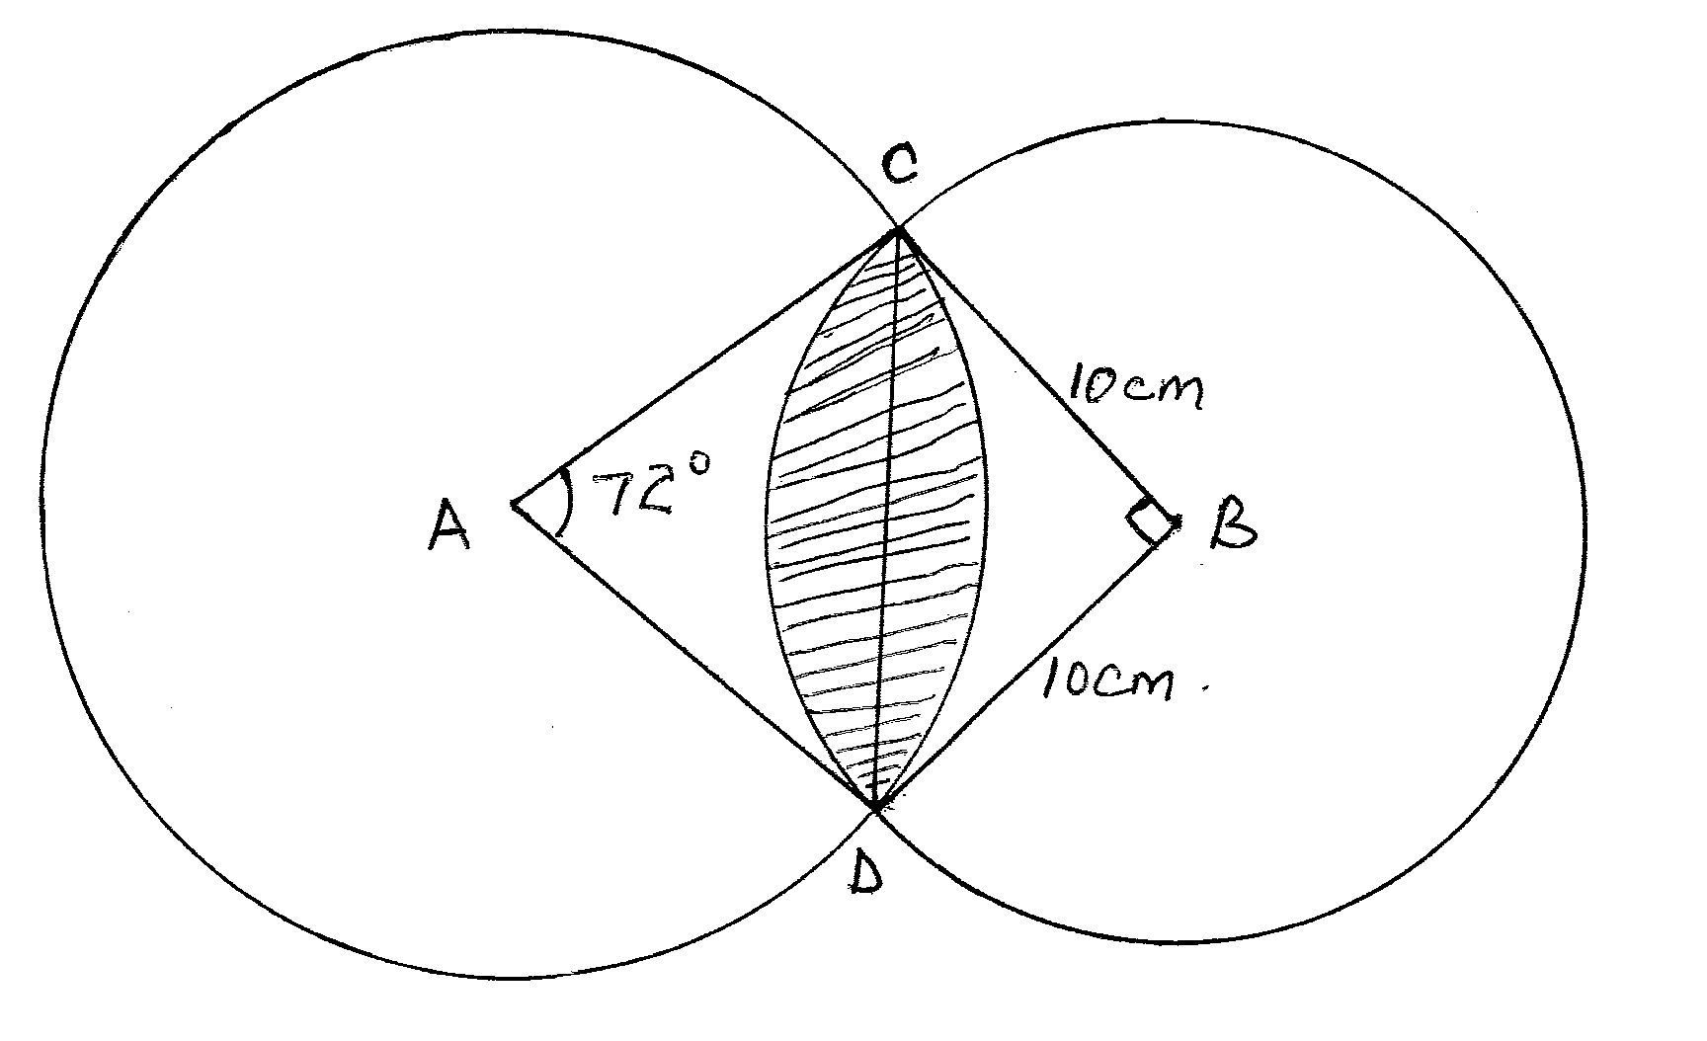

Calculate

1. The length of common chord CD. (2mks)
2. The radius AC to the nearest whole number. (3mks)
3. The area of intersection of the two circles that is shaded. (5mks)
4. A metal sphere has a radius of 5cm and density 2.4g/cm3
5. Calculate the mass of the ball in kg. (4mks)
6. The ball is dropped into a cylindrical container which is partly filled with water. The ball is fully submerged and the cylinder has a radius base of 8cm. calculate the change in water level. (3mks)
7. The sphere is melted down to form a metal cylinder of base radius of 5cm. Calculate the height of the cylinder formed. (3mks)
8. Four towns A, B, C and D are situated such that town A is 40km from B on a bearing of 310o. C is 60km from B on a bearing of S70o E. Another town D is 50km from A on a bearing of N70oE
9. Using a scale of 1 cm to represent 10 km, show the relative position of the towns (4mks)
10. From your scale drawing determine: -
11. Bearing and distance of D from C (2mks)
12. Bearing and distance of B from D (2mks)
13. Bearing and distance of A from C (2mks)
14. a) Two grades of tea are sold such that grade A cost Sh. 75 per kg and grade B cost sh. 60 per kg. In what ratio must the two be mixed such that the mixture cost sh. 70 per Kg? (3mks)
15. Tap A can fill an empty tank in 5hrs, tap B in 10 hrs while tap C can drain the same tank in 6hrs
16. If tap A and B are opened at the same time, how long will they take to fill an empty tank? (2mks)
17. Starting with an empty tank and all taps opened at the same time for one hour, then tap B is closed. How long will it take to fill the tank? (3mks)
18. On a certain day the tank was quarter full, the three taps are opened at the same time. How long will they take to fill the tank? (2mks)