Name...................................................................................................... Index No...............................

443/1
AGRICULTURE
PAPER 1
JULY/AUGUST 2016

PRE KCSE EXAMINATION 2016
TRIAL 2

AGRICULTURE
PAPER 1
2 HOURS

INSTRUCTIONS TO CANDIDATES

a) Write your name and Index number in the spaces provided above
b) This paper consists of three sections A, B and C.
c) Answer all the questions in section A and B
d) Answer any two questions in section C.

For Examiners Use only
Section | Questions | Maximum score | Candidates score
A | 1-19 | 30
B | 20-24 | 20
C |  | 20
 |  | 20
TOTAL

SECTION A (30 MARKS)
Answer ALL the questions in this section in the spaces provided.

- Give two factors which characterise small scale farming (1mark)
............................................................................................................................................................

............................................................................................................................................................

- State two limitations of mixed farming (1mark)

............................................................................................................................................................

............................................................................................................................................................

- State four effects of HIV/AID and ill-health on Agricultural production (2marks)
.
...........................................................................................................................................................

............................................................................................................................................................

............................................................................................................................................................

............................................................................................................................................................
- State reasons for carrying out soil conservations in a farm. (2marks)
............................................................................................................................................................

............................................................................................................................................................

............................................................................................................................................................

..........................................................................................................................................................

- State four methods of treating water for domestic use (2marks)
............................................................................................................................................................

............................................................................................................................................................

............................................................................................................................................................

............................................................................................................................................................
- State TWO ways in which inorganic mulch helps to conserve water in the soil (1mark)

............................................................................................................................................................

............................................................................................................................................................

- State TWO factors that would determine the amount of fertilizer to be top dressed to a crop in the field (1mark)

............................................................................................................................................................

............................................................................................................................................................

- In what ionic form is the element N absorbed by plants (1mark)

............................................................................................................................................................

............................................................................................................................................................

- Give FOUR factors that would determine the number of tillage operations when preparing a seedbed (2marks)
............................................................................................................................................................

............................................................................................................................................................

............................................................................................................................................................

............................................................................................................................................................

- Name four factors would influence the choice of tools and implement used for primary tillage
(2marks

............................................................................................................................................................

............................................................................................................................................................

……………………………………………………………………………………………………….

- Give TWO ways by which pesticides kill crop pests. (1mark)

............................................................................................................................................................

............................................................................................................................................................

(b) State FOUR disadvantages of chemical pests control in crop production. (2marks)
............................................................................................................................................................

............................................................................................................................................................

............................................................................................................................................................

............................................................................................................................................................

- What causes late blight in tomatoes (1mark)

............................................................................................................................................................

............................................................................................................................................................

(b) List TWO symptoms of late blight in tomatoes (1mark)

............................................................................................................................................................

............................................................................................................................................................

- Name the vegetative part of each of the following crops which is propagated (2marks)

Sweet potatoes ...................................................

Cassava................................................................

Bananas..............................................................

Oranges..........................................................

- Give TWO factors that determine the depth at which seeds should be planted (1mark)
............................................................................................................................................................

............................................................................................................................................................

...........................................................................................................................................................

............................................................................................................................................................

- Give TWO factors that would influence the time of planting beans (1mark)

............................................................................................................................................................

............................................................................................................................................................

- Name TWO basic economic concepts (1mark)

............................................................................................................................................................

............................................................................................................................................................

- Name TWO methods of weed control in pasture. (1mark)

............................................................................................................................................................

............................................................................................................................................................

- State the importance of agroforestry (1mark)
............................................................................................................................................................

............................................................................................................................................................

- State FOUR advantages of undersowing in pasture e production (2marks)

............................................................................................................................................................

............................................................................................................................................................

...........................................................................................................................................................

SECTION B (20 MARKS)
Answer ALL the questions in this section in the spaces provided.

- (a) Below is a diagram of a grain store
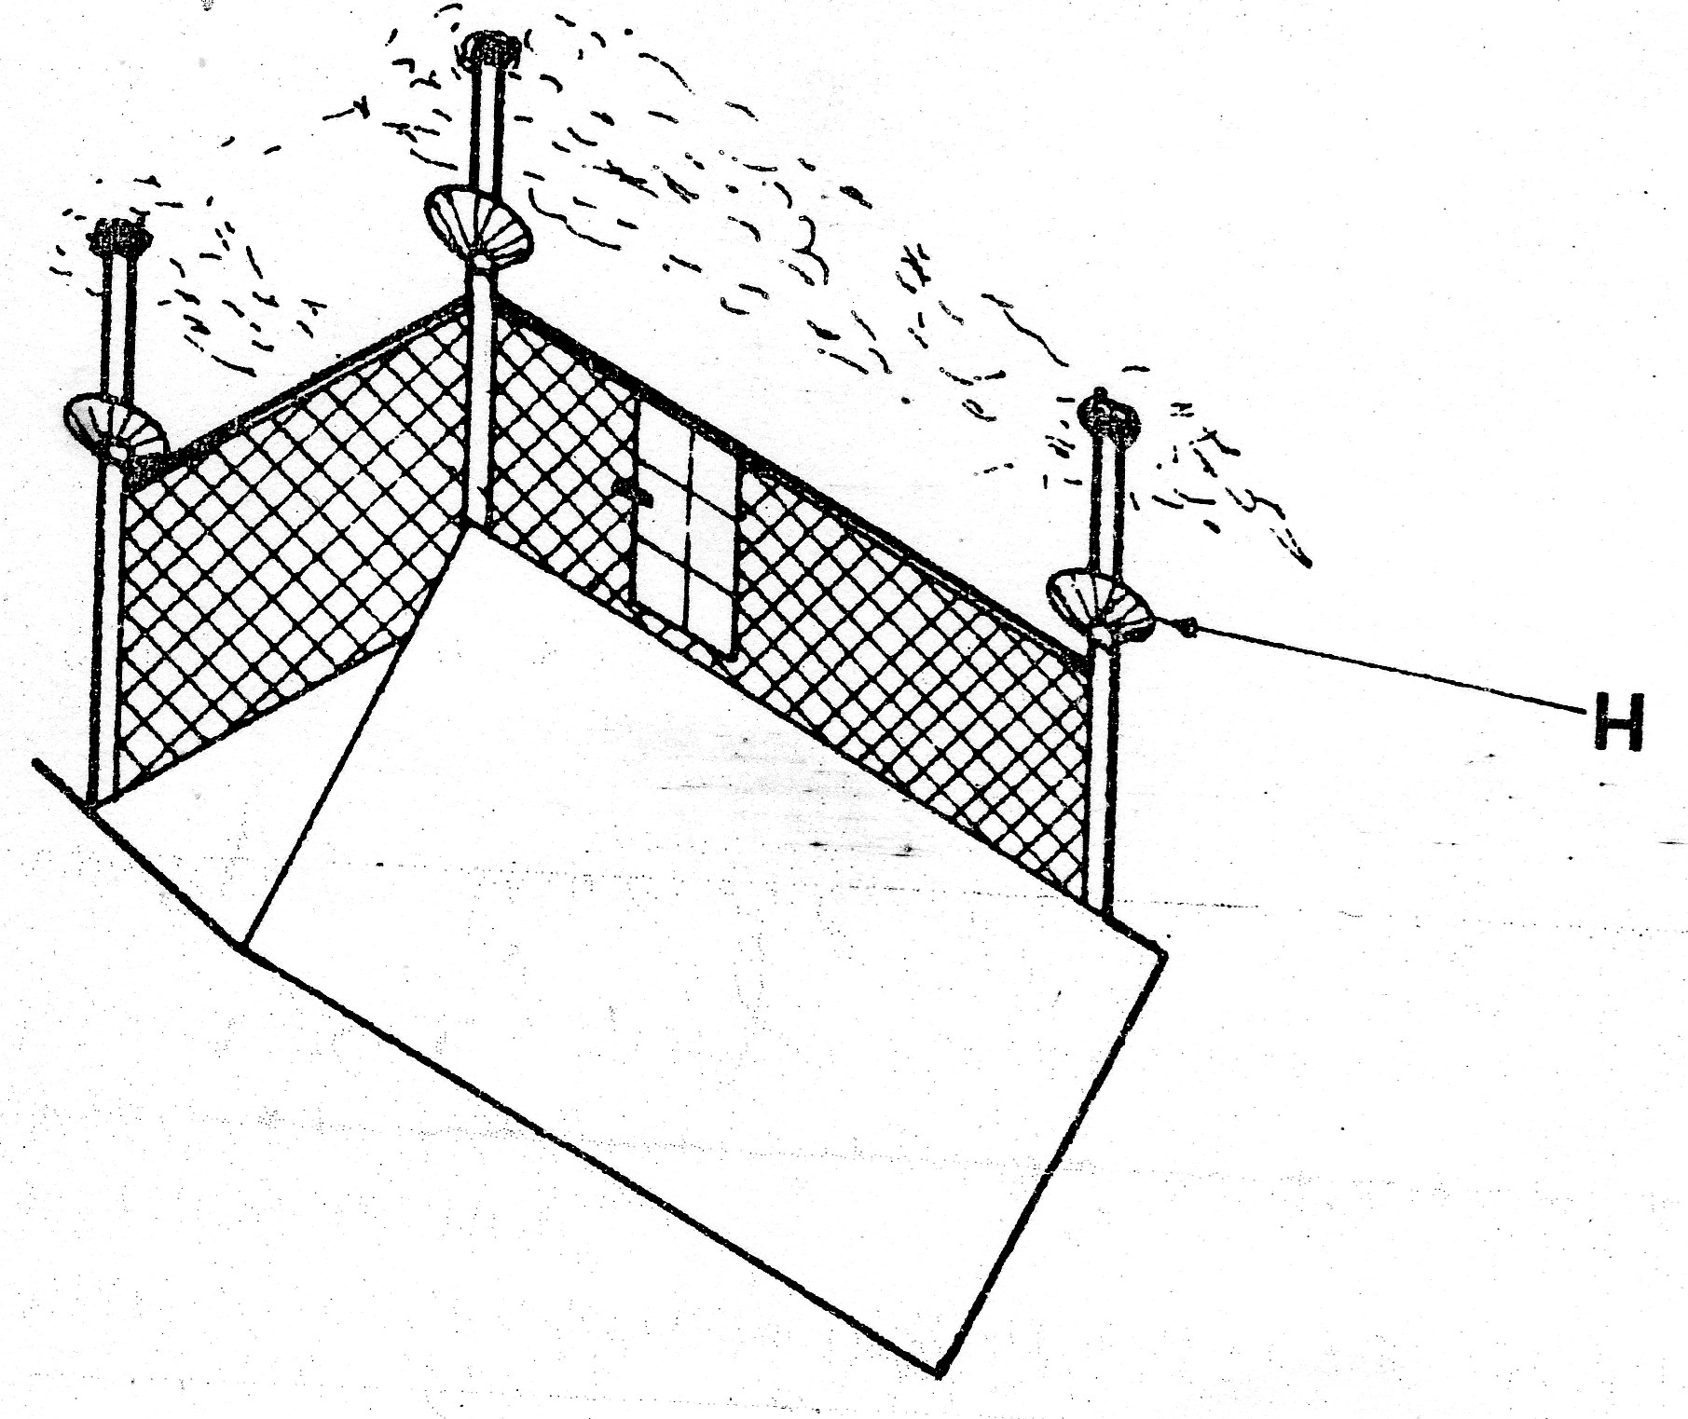

(i) Name the part labeled H................................................................................ (1mark)

(ii) State TWO maintenance practices that should be carried out on the store before storing a crop (2marks)
...........................................................................................................................................................

...........................................................................................................................................................

...........................................................................................................................................................

(iii) Why is it important to have some open spaces on the walls of the store? (1mark)

...........................................................................................................................................................

...........................................................................................................................................................

- A diagram of a nursery for raising tomato seedling is shown below. Study the diagram and
answer the questions that follow.

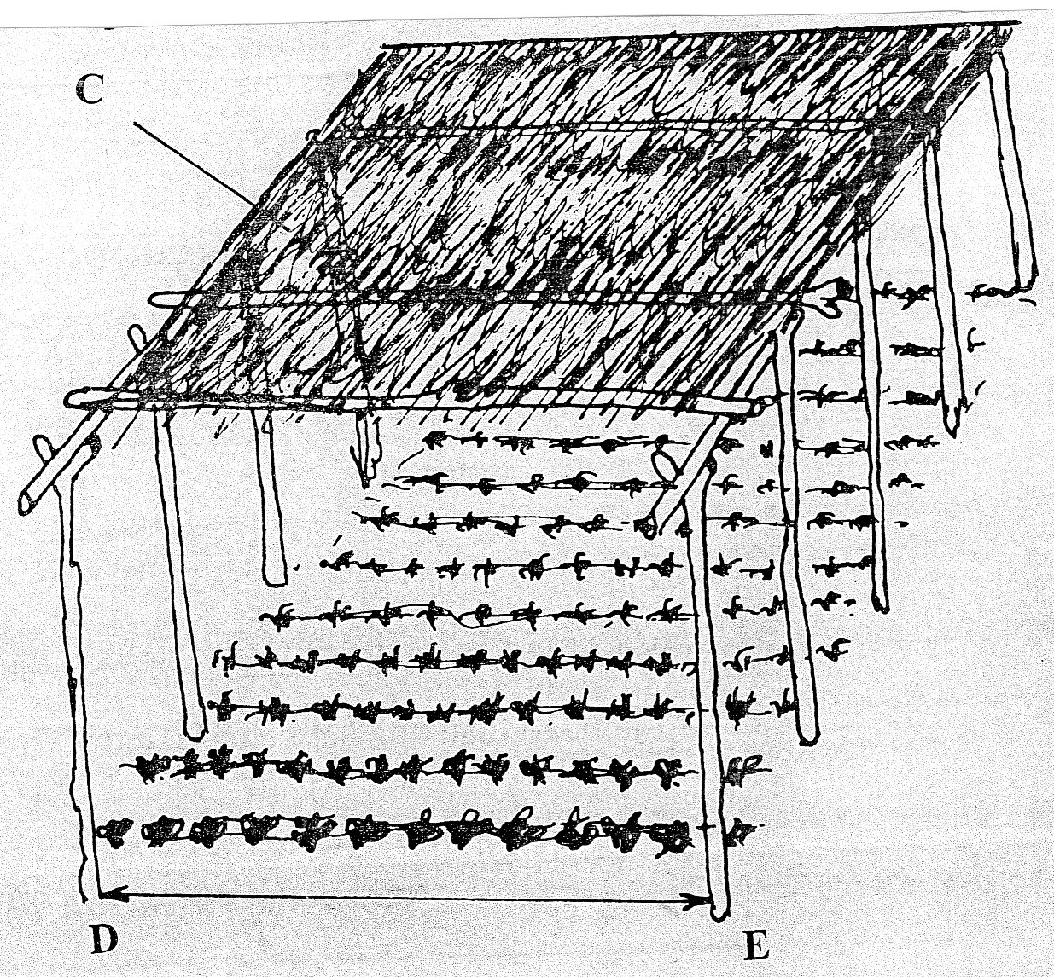

- State TWO advantages of having the part labelled C (1mark)

...........................................................................................................................................................

...........................................................................................................................................................

(ii)State any three management practices that should be carried out on the nursery from the time
seedlings emerge to the stage of transplanting (1 ½ marks)

...........................................................................................................................................................

...........................................................................................................................................................

(iii) At what stage of growth should tomato seedlings be transplanted? ( ½ mark)

...........................................................................................................................................................

...........................................................................................................................................................

(iv) How would damage to the seedlings be minimized when uprooting them for transplanting?
(1mark)
...........................................................................................................................................................

...........................................................................................................................................................

(v) What is the recommended distance between D and E in the diagram above? (1mark)

...........................................................................................................................................................

...........................................................................................................................................................

- The diagram below represents a weed

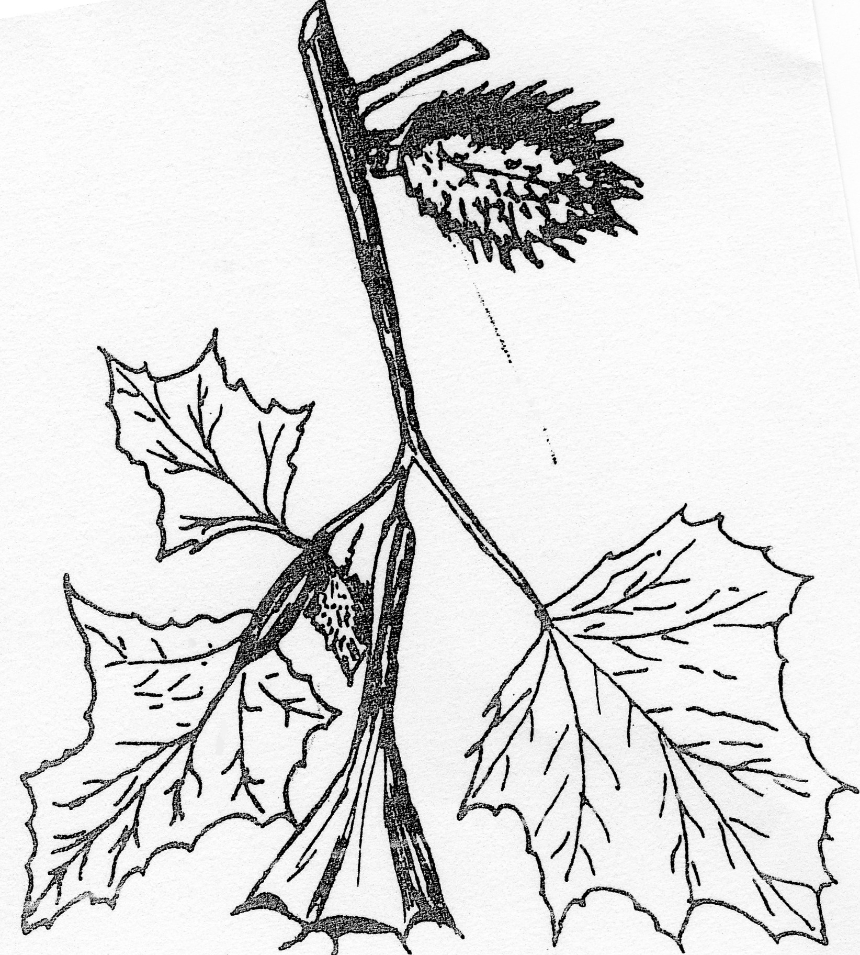

(a) Identify the weed......................................................................................................... .(1mark)

(b) Classify the weed according to its life span (1mark)

...........................................................................................................................................................

...........................................................................................................................................................

(c) State ONE harmful effect of this weed to livestock (1mark)

............................................................................................................................................................

- A farmer is to apply a compound fertilizer 20:30:10 on a vegetable plot measuring 5 meters long
by 4 metres wide, at the rate of 200kg per hectare.

(a) Calculate the amount of the fertilizer the farmer would require for the plot (show your
working) (2marks)

...........................................................................................................................................................

...........................................................................................................................................................

...........................................................................................................................................................

...........................................................................................................................................................

(b) What do the figures 30 and 10 in the fertilizer stand for? (1mark)

..........................................................................................................................................................

...........................................................................................................................................................

...........................................................................................................................................................

...........................................................................................................................................................

- Diagram E below shows a method of crop propagation

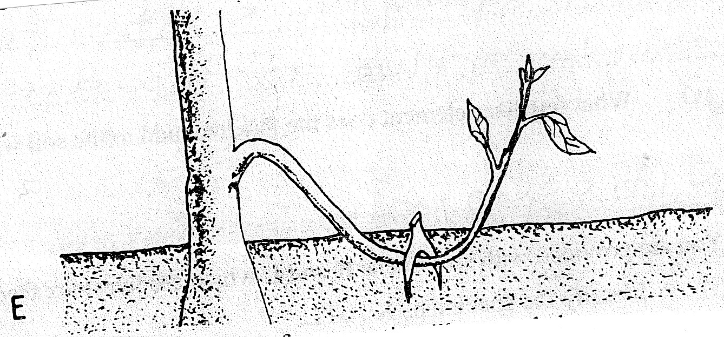

(a) Name the method of propagation illustrated above ( 1 mark)

...........................................................................................................................................................

(b) Give two ways of initiating faster root development in the propagation method shown above
(1mark)
...........................................................................................................................................................

...........................................................................................................................................................

- What would make it necessary for a farmer to choose the above method of propagation instead
of using cuttings? (1 mark)
...........................................................................................................................................................

...........................................................................................................................................................

- Identify the crop pest illustrated below
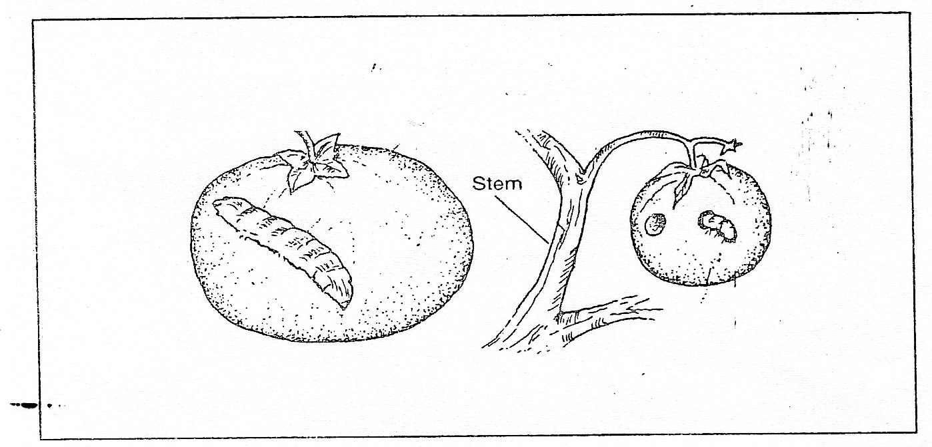

(a) Identity...................................................................................................................... (½ mark)

(b) Give two damages caused by the pest (1mark)

...........................................................................................................................................................

...........................................................................................................................................................

(c) How can this pest be controlled? ( ½ mark)

...........................................................................................................................................................

...........................................................................................................................................................

SECTION C: 40 MARKS
Answer any two questions from this section.

- (a) The inventory for Kangaroo farm as at 01-06-2012
 | Shs.
Cash at hand | 5,000
Layers | 30,000
Beans in store | 7,000
Calves | 15,000
Dairy cattle | 120,000
Buildings | 75,000
Machinery | 95,000
Land | 200,000

On the same day, the following information was obtained from the farmers records

 | Kshs.
Interest payable | 2,000
Cash in the bank | 20,000
Taxes payable | 750
Wages payable | 5,600
Bank loan | 213,000
Eggs sales on credit | 10,000
Milk sales on credit | 13,000
Farm inputs purchased on credit | 19,800
Vegetables sales on credit | 5,000

Prepare a balance sheet for the farm (13 marks)

25 (b) Give seven natural factors that encourage soil erosion (7marks)

26 (a) Describe production of onions (bulb) under the following subheadings.
(i) Varieties (2marks)
(ii) Land preparation (3marks)
(iii) Field management practices (5marks)

- State four cultural methods of controlling pests in an established field of sorghum (4marks)

- State six factors that affect the effectiveness of a pesticide (6marks)

27 (a) Explain the factors that influence spacing in crops (10 marks)

- Describe the practices that a farmer should carryout to ensure uniform germination of seeds
(10marks)

