312/2
GEOGRAPHY
PAPER 2
MARKING SCHEME
1. (a) Disadvantages of plantation in agriculture (2 marks)
- It is capital intensive ,causing unemployment/require high capital
- Huge losses are experienced in the world market prices fall/in the event of a disease outbreak
- Monoculture encourages soil exhaustion / erosion
- The period between harvesting of the crop and the next planting season leaves land idle
- Concentration on cash crops may result to food shortages due to neglect of food crops
- Use of extensive land for crop farming leaves families landless (Any 2×1=2 marks)
(b) Reasons why greenhouses are preferred in Agriculture (3 marks)
- The amount of rainfall /water and temperature is controlled for fast growth
- The confining of the crops control spread of pests/ diseases in the green house
- Crops are grown throughout the year since the growing conditions are regulated.
- Easy to control weds since it is a small area and herbicides are used (Any 3×1=3 marks)
2. (a) raw materials in the Ruhr region of Germany (3 marks)
- Limestone
- Iron ore
- Coal (3×1=3 marks)
(b) rivers that are source s of water in the Ruhr industrial zone. (2 marks)
- River Lippe
- River Ruhr (2×1=2 marks)
3. (a) Canals in Africa. (2 marks)
- Suez canal
- Jonglei canal (2 marks)
(b) Transport Problems experienced along St. Lawrence river (3 marks)
- Presence of rapids e.g. Lachine
- Shallow depth of water /several islands near lake Ontario
- Waterfalls- Niagara falls
- Deposition of silt between lakes Erie and Huron
- Difference in lake levels (Any 3×1= 3 marks)
4. (a) Types of ground photographs. (2 marks)
- Close-ups
- Ground general views
- Ground oblique (any 2×1= 2marks)
(b) Uses of photographs (3 marks)
- Help in study of human and economic activities e.g. types of settlement, farming etc
- They provide useful information on physical features, vegetation types and drainage system.
- Help to deduce the climate of an area
- Useful in resource documentation / map making
- Used to depict actual objects just as they appear. (any 3×1=3 marks)
5. (a) Cultural factors that have led to large families in Africa. (2 marks)
- Polygamy
- Sex preference
- Early marriages
- Africans required large families for security
- High mortality rate hence to produce more (Any 2×1=2 marks)
(b) Problems created by the decline in population in Sweden. (3 marks)
- Reduction of population leads to shortage of manpower or labour in some profession
- A large population of old people compared to young people which lead to increased dependency ratio
- There is under utilization of already set up social facilities for young people
- Provision of pension health care to the aged causes the government financial strain
- Some farms are abandoned as the rural areas are depopulated. (Any 3×1=3 marks)

SECTION B:
6. (a) (i)
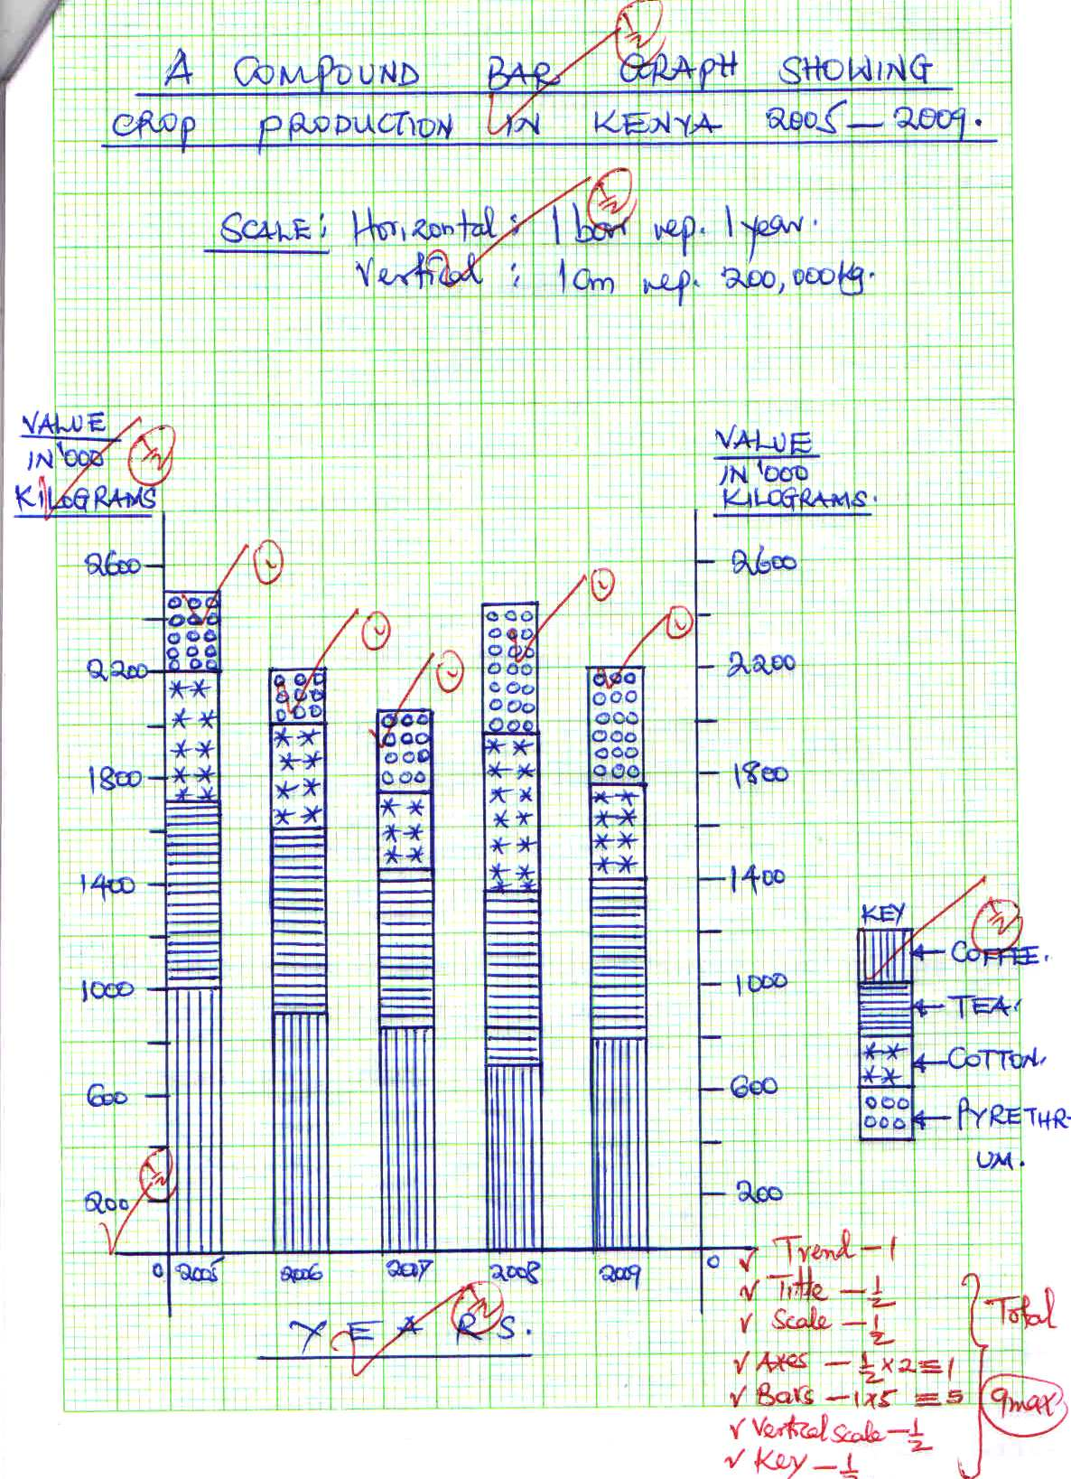

(ii) Advantages of using a compound bar graph to represent statical data. (2 marks)
- Facilitates comparison of data
- A number of variables can be represented in one bar
- Changes /trend is easy to trace
- Good visual impression (any 2×1=2 marks)
(b). (i) Other than Ghana, name two countries in West Africa where cocoa is grown. (2 Marks)
- Nigeria
- Cote -de -vore
- Cameroon (Any 2×1=2 marks)
(ii) Physical conditions that favor the growth of cocoa in Ghana. (3 marks)
- High/ well distributed rainfall, exceeding 1200mm p.a.
- High temperatures /between 24⁰c-30⁰c
- High relative humidity throughout the year
- Deep ,fertile well drained soils
- Low altitude/below 700m a.s.l. (any 3×1=3 marks)
(c) How cocoa is processed in Ghana (6 marks)
- Beans are fermented for 5-6 days and dried
- The fermented beans are washed / cleaned
- The beans are roasted
- The roasted beans are then crushed to extract cocoa butter
- Cocoa is blended and mixed with sugar (1 mark×6= 6 marks)
(d) Importance of cocoa production to the economy of Ghana. (3 marks)
- Has contributed to development of industries which use cocoa as raw materials
- Earn the country foreign exchange since most of it exported
- Provide employment opportunities to people working in the cocoa farms and distributing it.
- Has contributed to development of infrastructure in the country
- Has attracted foreign investments into the country (Any 4×1=4 marks)
7 (a) Name two types of trade (2 marks)
- Internal trade/local trade
- External /foreign/international trade (2×1=2 marks)
(b) (i) Explain how the following factors influence trade (2 marks)
Availability of capital
- Capital refers to the finances and machinery necessary for trade /production activities/resources for production
- The type and size of trade is determined by how much resourc4es the trader /country has infrastructure (2 marks)
Infrastructure
- Goods means of transport /communication facilitate delivery of raw material and finished goods into and out of the industries .it also enhances transfer of people 9traders)hence facilitating trade (2 marks)
(ii) Name three major Kenya foreign exchange earners. (3 marks)
- Tea
- Horticultural products
- Coffee (3×1=3 marks)
c. (i) Distinguish between balance of trade and balance of payments (2 marks)
- Balance trade is the difference between value of visible exports and visible imports while Balance of payments is the difference in value between exports and imports. (2 marks)
(ii) Benefits of the Common Market for Eastern and Southern Africa (COMESA) to the member states.
- Has created a large market for each country
- Help promote regional peace
- A country’s citizens enjoy a higher living standard
- The expansion of industries and agriculture to cater for the widened market create employment opportunities
- Reduction of tariffs makes the goods cheaper
- The expanded market for goods promote industrial development as the demand for goods increases
- Avails goods to the citizens from nearby countries (any 4×1=4 marks)
(iii) Trading blocks in Africa. Other than COMESA (2 marks)
- The Economic Community of West African states (ECOWAS)
- The Southern African Development Community (SADC) (2×1=2 marks)
(d) Problems facing trade in Kenya, (8 marks)
- Inadequate capital –makes traders engage in small scale trading activities with minimal ret6urns and lack of funds to expand
- High charges /taxes –traders are charged high fees to acquire trading licenses ,particularly for large scale businessmen which makes traders engage in retail trade and earn little profits
- Poor infrastructurev –most parts of the country are not easily acce3ssible because of poor transport network the traders result to who vehicles /motor cycles which is expensive
- Scarcity of goods-in the remote areas ,some goods needed by people are unavailable in the markets
poverty among people-high levels of poverty among majority of Kenyans makes it difficult for them to afford goods or pick very few items .This limits trade volume.
- Insecurity –thugs /terrorists attack or kill traders to rob them off their money, etc. The traders henceforth open their premises late and close early install expensive security gadgets or shift their businesses.
Smuggling –some traders sneak in goods or export them through the black market .They hurt genuine traders since their goods haven’t been taxed. (Any of well explained points × 2=8 marks)
8 (a (i) Benefits of irrigation over natural water supply (2mks)
- Ensures a steady and reliable water supply
- Irrigation makes cultivation possible in arid areas
- River water when used for irrigation brings silt which is good for crops
- Cultivation can also be done throughout the year and this maximizes the use of land resources
- When dams are created they become multi-purpose (any 2×1 =2 marks)
(ii) Ways of reclaiming land, apart from irrigation)
- Drainage of swamps
- Pests and disease control
- Afforestation
- Planting drought resistant crops
- Building dams / gabions
- Use of manure /fertilizers (Any 4×1= 4 marks)
(b) (i) Polders created under the Zuyder Zee project in the Netherlands
- Markerwaad
- Eastern Flevoland
- North Eastern polder
- South Flevoland
- Wierigermeer (any 4×1=4 marks)
(ii) Stages followed in reclamation of land from the sea in Netherlands
- Constructing protective dykes/sea walls enclosing part ofm sea to be reclaimed
- Ring canals are constructed
- Installation of pumping stations to jump out water from the enclosed dyke /pumping out water.
- Reeds are sawn to help dry out the soil
- Drainage ditches/pipes are laid
- The area is divided into rectangular portions using inner dykes / ring canals
- Soil is treated with chemicals to lower salinity
- Drained land was flushed with fresh water
- People are settled
Sequence for awarding of marks (Any 6×1=6 marks)
(iii) Give three benefits of the Zuyder Zee project? (3mks)
- Connected North Holland and Friesland by road
- Has improved drainage system in the area /reduced risk of flooding
- Created a fresh water lake Ijassel which supplies surrounding areas with fresh water
- The reclaimed land has increased arable land (any 3×1=3 marks)
(c) (i) objectives for the study
- To find out crops grown in the irrigation project
- To investigate problems facing the project
- To establish management practices in the project
*accept any other relevant /correct answer (Any 2×1=2 marks)
(ii) Problems facing irrigation projects in Kenya did they come up with
- Attack of crops by pests and diseases which is expensive
- Siltation in the canals requiring regular desiltation.
- Mismanagement of the projects leading to their closure or operating below capacity
- Aquatic weeds grow fast due to flooding of the canals
- Soil exhaustion due to continued use
- Stagnant water causes bilharzia and malaria to people. (any 4×1= 4 marks)
9 a) (i) what is wildlife? (2mks)
- Wildlife refers to the animals and plants existing in a natural habitat
(ii) Factors that influence distribution of wildlife in East Africa? (6mks)
- Climate-where there is abundant rainfall a variety of plant species grow .Most animals are found in the hot and warm parts. Areas with low temperatures have few species of animal plants.
- Relief –different vegetation species grow in different altitudes and intensity.
- Soil type-Different plant types grow in different soils
- Vegetation-different types of vegetation are habitants for different animals
- Human activities-people greatly influence survival and distribution of wildlife. (any 3×2=6 marks)
b) (i) National Park (3mks)
Kenya | Uganda | Tanzania
Tsavo | Kipendo valley | Serengeti
Amboseli | Murchison falls | Kilimanjaro
Aberdare | Semliki | Mikumu
Chyulu | Ruwenzori | Ruaha
Nairobi | Queen Elizabeth | Tarangire
(NB: Accept any other correct answer .Mark only one from each country)
(3×1=3 marks)
(ii) Reasons why game reserves and national parks are located in marginal areas
- It is the best economic use of land since agriculture is not viable in these areas
- Population is low in there areas –reduces human –animal conflicts /resettling people who have been misplaced
- Requires extensive land that is available only in these areas
- There is less threat of animals interfering with human life and crop production. (Any 3×1=3 marks)
c) Apart from windstorms, name other three environmental hazards experienced in Kenya?
- Land slides
- Thunderstorms /lightning
- Desertification /deforestation
- Pollution
- Floods (Any 3×1=3 marks)
(ii) Three reasons why windstorms are considered as natural hazards? (3mks)
- They are agents of soil erosion
- They transport prevailing temperatures e.g. heat waves
- They transport sand and dust that may cause problems in breathing and visibility
- They destroy vegetation/property and human life. (any 3×1=3 marks)
d) (i) Distinguish between management of environment and conservation of the environment (3 mks)
- Management of the environment refers to the effective planning and control of the process and activities that could cause deterioration of the environment while conservation of the environment refers to the protection, preservation and proper utilization of the resources in the environment to avoid destruction, wastage or loss.
(ii) State three reasons why it is necessary to manage and conserve the environment (3 marks)
- For future generation
- To sustain human life
- To protect endangered species
- To sustain utilisation of resources
- For economic value
- For aesthetic value
- To curb global warming (any 3×3=3 marks)
10(a) Common physical characteristics of the major world fishing regions (6 marks)
- Convergence of ocean currents _the major fishing areas have a warm ocean current converging with a cold ocean current causing upwelling of water/modifying water temperature e.g. Kurosiyo and oyashio currents: Labrador currents and gulf stream current etc.
- Temperate regions-temperatures are cool and so support the survival of plankton ,food for fish
- Indented coastlines _the coastlines are irregular sheltering fish from strong winds and ocean currents ;and encouraging development of ports
- Rugged hinterland the immediate surrounding areas do not support arable agriculture because of uneven landscape ;hence people turn to fishing
- Shallow and extensive continental shelf ideal for plankton growth of fish breeding
(any well explained point 3×2=6 marks)
(b) Giving an example for each, differentiate between pelagic fish and domersal fish.
Pelagic fish are fish communities that mainly live near the surface /at shallow depths of lakes /seas e.g. mackerel/sardines and tuna while demersal fish live at or close to the bottom of water bodies e.g. cat fish
(c) (i)Describe four environmental problems affecting fishing in Kenya.
- Warm ocean waters Kenya lies in the equator and therefore the warm currents discourages the survival of planktons and so few species of fish are available in low concentration/influence of Somali current
- Regular coastline-sea currents and winds are strong hence negatively affecting fish breeding and fishing activity
- Less extensive continental shelf which limits the amount of plankton that may grow.
- Most of the inland waters are affected greatly by the seasonal variation of rainfall .prolonged drought results in a reduction of water in the rivers and lakes affecting fish habitats (any 4×2=8 marks)
(ii) Reasons why government of Kenya encourages fishing (4 marks)
- Fishing diversifies the economy
- It is a source of food to people
- The industry creates employment opportunities
- It is a source of foreign income when it is exported
- Leads to development of subsidiary industries e.g. chemical and fertilizer manufacturing
- Contribute to development of infrastructure (any 4×1=4 marks)
(d) Name three methods of preserving fish (3 marks)
- Smoking
- Drying in the sun
- Canning
- Refrigeration (3×1)=3 max

