GATITU MIXED SECONDARY SCHOOL
AGRICULTURE FORM 3 END OF TERM 2 EXAM 2015

- List three materials that may be used for constructing a gabion 3mks

- Explain five ways by which grass helps to conserve soil 5mks

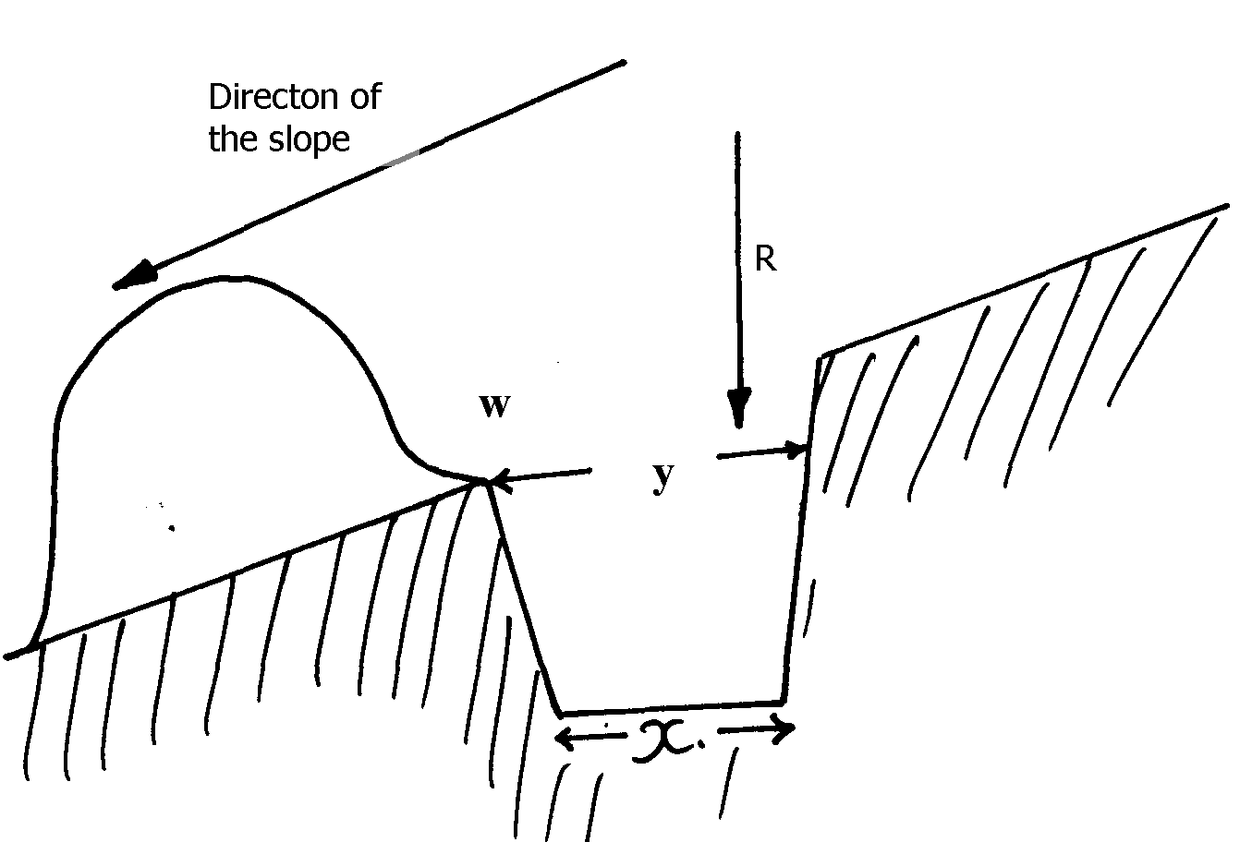
- The figure below represents a physical soil and water conservation measure used on various slopes

- Identify the measure represented above 1mk

- Describe the construction of the identified measure above 3mks

- Explain factors which influence soil erosion 3mks

4. Study the diagram below and answer the questions that follow:

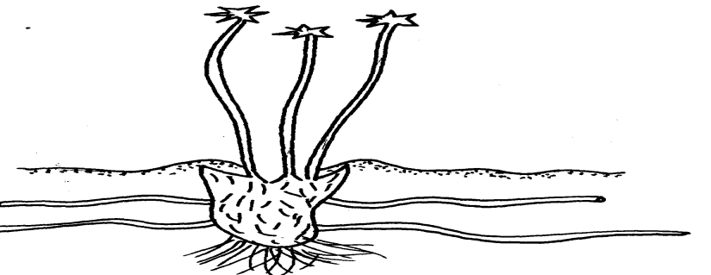

(a) Identify the weed 1mk

(b) Why is it difficult to control the weed? 1mk

(c) State the economic importance of the weed shown above 1mk

- Below is a diagram of some common weeds. Study then and answer the questions that follow:-

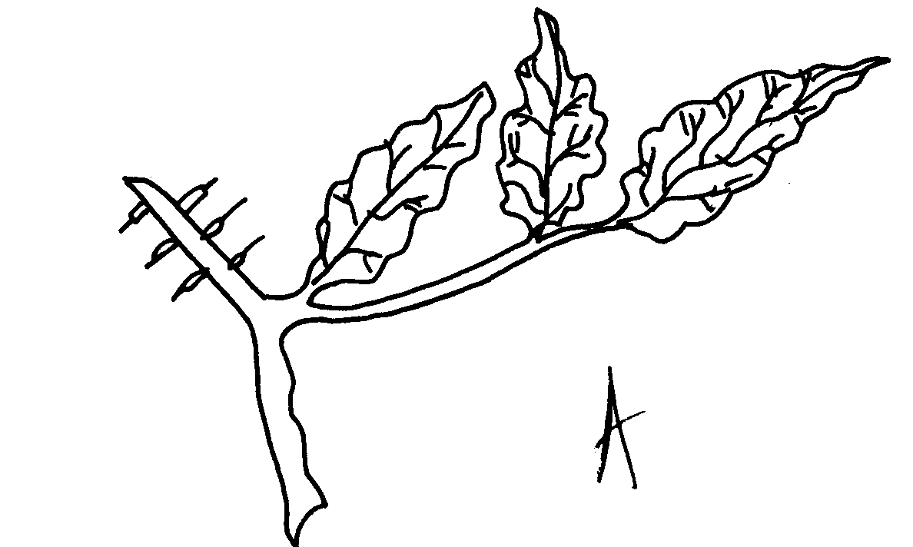
A
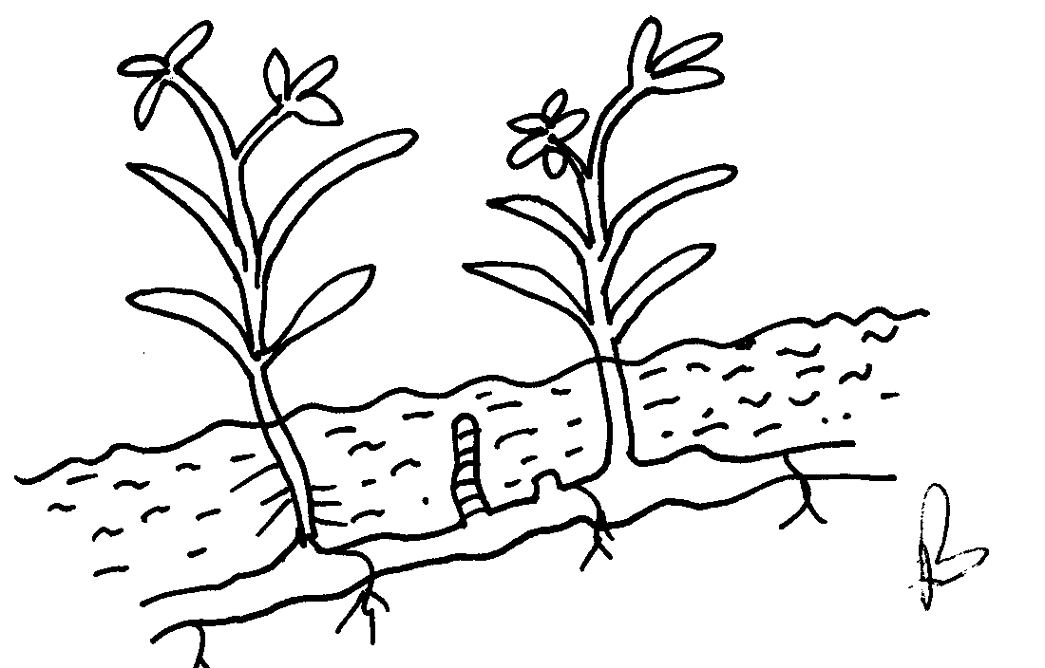

(i) Identify weed A and B 2mks

(ii) State two effects of weed B on crop production 2mks

(iii) Give a reason why weed B is difficult to control 1mk

(iv) State the effective method of controlling weed B 1mk

- Give four methods of propagation which make weeds have a high competitive ability
over crops 4mks

7. List any four types of weeds known to be poisonous to livestock 4mks

8. State two disadvantages of using herbicides 2mks

9. a) Name four herbicides that can be used to control weeds in a field of maize 2mks

b) Mention two factors that affect selectivity of herbicides 2mks

10. Mention four disadvantages of using steel materials for construction of farm structures 4mks

11. State two uses of a footbath in cattle dip 2mks

11. What is “calf crop” in beef production? 1mk

12. The diagram below illustrates a cross-section of a fish pond. Study it carefully and answer the questions that follow:-

X
Z
Y
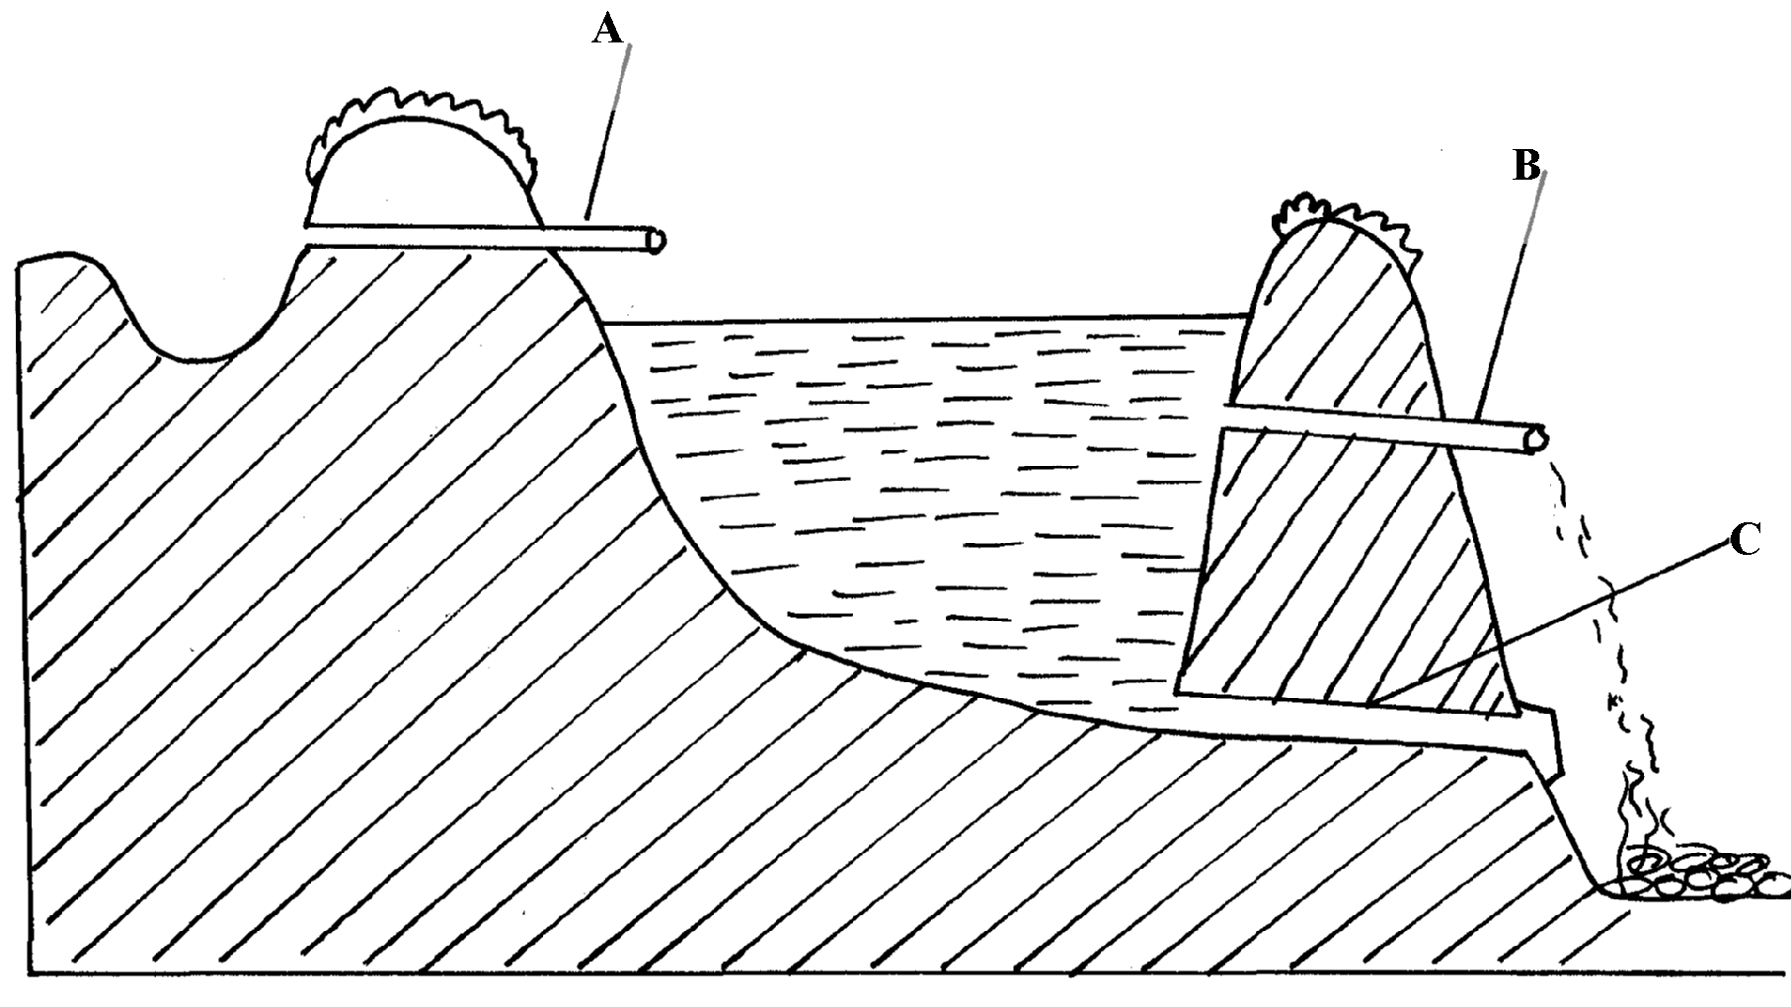

(a) Identify the parts marked A, B, C and C 3mks

(b) On the diagram the points marked X, Y and Z are possible sites where fish feeding
can be done. Which is the most appropriate point for feeding? 1mk

(c) Give two reasons why the floor of the pond should be covered with lime 14days before filling it with water 1mk

(d) Why should part marked B be screened? 1mk

