NAME: ……………………………………..…… DATE: ………………………………………..............

SCHOOL……………………………………………………………………………………………………………………….
ADM NO: .…………….……….……..…..…….. CANDIDATE’S SIGNATURE: …………..………..

443 / 1
AGRICULTURE PAPER ONE
FORM THREE
TIME: 2 HOURS
TERM TWO

FORM THREE

INSTRUCTIONS TO CANDIDATES
- Write your name and admission number in the spaces provided above.
- This paper has THREE sections: A , B and C.
- Answer ALL the questions in section A and B and any TWO questions in section C.
- ALL answers MUST be written in the spaces provided.

FOR EXAMINERS USE ONLY
SECTION | QUESTIONS | MAXIMUM SCORE | CANDIDATES SCORE
A | 1 – 17 | 30
B | 18 – 21 | 20
C |  | 20
 |  | 20
TOTAL |  | 90

SECTION A (30 MARKS)
Answer all questions in this section in the spaces provided.
- State two advantages of intensive farming system. (1 mk)
……………………………………………………………………………………………………………..
……………………………………………………………………………………………………………..

- Outline four effects of application of nitrogenous fertilizers on tomatoes. (2 mks)
……………………………………………………………………………………………………………..
……………………………………………………………………………………………………………..
……………………………………………………………………………………………………………..
……………………………………………………………………………………………………………..

- List four ways which are used to control stalk borers in maize. (2 mks)
……………………………………………………………………………………………………………..
……………………………………………………………………………………………………………..
……………………………………………………………………………………………………………..
……………………………………………………………………………………………………………..

- Give four factors that influence the quantity of water used in the farm. (2 mks)
……………………………………………………………………………………………………………..
……………………………………………………………………………………………………………..
……………………………………………………………………………………………………………..
……………………………………………………………………………………………………………..

- List four factor considered when siting a nursery bed (2 mks)
……………………………………………………………………………………………………………..
……………………………………………………………………………………………………………..
……………………………………………………………………………………………………………..
……………………………………………………………………………………………………………..

- List three causes of land subdivision and land fragmentation (1½ mk)
……………………………………………………………………………………………………………..
……………………………………………………………………………………………………………..
……………………………………………………………………………………………………………..
……………………………………………………………………………………………………………..

- Give four methods of layering in crop production. (2 mks)
……………………………………………………………………………………………………………..
……………………………………………………………………………………………………………..
……………………………………………………………………………………………………………..
……………………………………………………………………………………………………………..

- Outline four adaptive features of a weed to establishment (2 mks)
……………………………………………………………………………………………………………..
……………………………………………………………………………………………………………..
……………………………………………………………………………………………………………..
……………………………………………………………………………………………………………..

- Give four disadvantages of landlordism tenancy system of land tenure. (2 mks)
……………………………………………………………………………………………………………..
……………………………………………………………………………………………………………..
……………………………………………………………………………………………………………..
……………………………………………………………………………………………………………..

- List two types of labour record kept on the farm. (1 mk)
……………………………………………………………………………………………………………..
……………………………………………………………………………………………………………..

- Give reason as to why the following practices are carried out in preparation of planting materials.
- Seed dressing. (½ mk)
…………………………………………………………………………………………………………

- Seed innoculation. (½ mk)
…………………………………………………………………………………………………………

- Chitting. (½ mk)
…………………………………………………………………………………………………………

- Identify four ways of achieving plant population in an agricultural farm (2 mks)
……………………………………………………………………………………………………………..
……………………………………………………………………………………………………………..
……………………………………………………………………………………………………………..
……………………………………………………………………………………………………………..

- State four ways in which biological agents influence soil formation. (2 mks)
……………………………………………………………………………………………………………..
……………………………………………………………………………………………………………..
……………………………………………………………………………………………………………..
……………………………………………………………………………………………………………..

- Besides providing water to the plants. State two other uses of flood water to rice field. (1 mk)
……………………………………………………………………………………………………………..
……………………………………………………………………………………………………………..

- Outline four reasons for pruning fruits crops. (2 mks)
……………………………………………………………………………………………………………..
……………………………………………………………………………………………………………..
……………………………………………………………………………………………………………..
……………………………………………………………………………………………………………..

- State four importance of breaking hard pan in land preparation. (2 mks)
……………………………………………………………………………………………………………..
……………………………………………………………………………………………………………..
……………………………………………………………………………………………………………..
……………………………………………………………………………………………………………..

- How are the following conditions prevented in carrot production (2 mks)
- Forking.
…………………………………………………………………………………………………………

- Greening of root tuber.
…………………………………………………………………………………………………………

SECTION B: (20 MARKS)

Answer all questions in this section in the spaces provided.
- The illustration below shows a layout of a method of making compost manure. Study it correctly and answer the questions that follow.

Field

- Identify the method above. (1 mk)
…………………………………………………………………………………………………………

- Using letters X, Y and Z and arrows complete the diagram above. (4 mks)

- The diagrams below A and B illustrates some field pests study them carefully and answer the questions that follow.

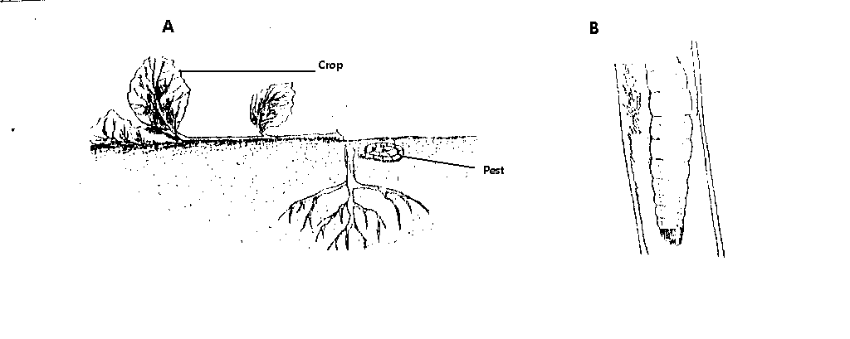

- Identify pests A and B. (1 mk)
…………………………………………………………………………………………………………
…………………………………………………………………………………………………………

- State two damages caused by pest B to a crop of maize. (2 mks)
…………………………………………………………………………………………………………
…………………………………………………………………………………………………………

- Give two cultural practices carried out to control the pest in A. (2 mks)
…………………………………………………………………………………………………………
…………………………………………………………………………………………………………

- Below are diagrams of weed study them and answer the questions that follow.

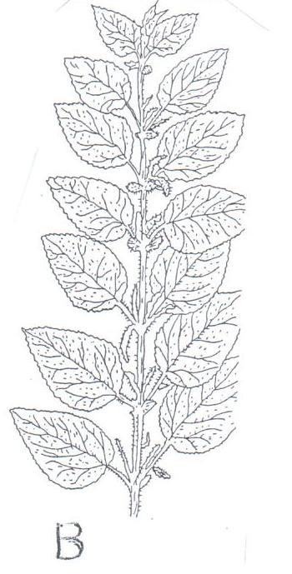
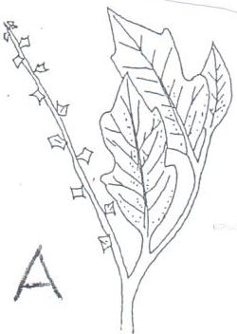

- Identify weeds (2 mks)
…………………………………………………………………………………………………………
…………………………………………………………………………………………………………

- Explain why it’s difficult to control the above weeds. (1 mk)
…………………………………………………………………………………………………………

- Mention two benefits of weed B to the farm. (2 mks)
…………………………………………………………………………………………………………
…………………………………………………………………………………………………………

- Study the following diagram and answer questions that follow.
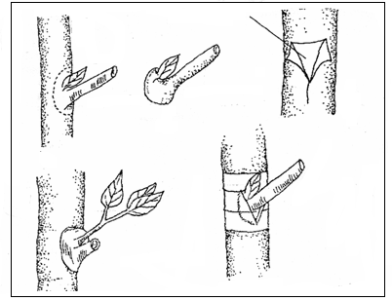
T-shaped cut
A
B

- Name the practice shown in the above diagram. (1 mk)
…………………………………………………………………………………………………………

- Identify parts A and B. (2 mks)
…………………………………………………………………………………………………………
…………………………………………………………………………………………………………

- Give two advantages of the above operation shown on the diagram in crop production. (2 mks)
…………………………………………………………………………………………………………
…………………………………………………………………………………………………………
…………………………………………………………………………………………………………
…………………………………………………………………………………………………………

SECTION C (40 MARKS)

Answer any two questions in this section in the spaces provided.

- Discuss five factors considered when choosing a type of irrigation. (10 mks)
- Explain five structural methods of soil erosion control. (10 mks)

- Describe ten management practices carried out on a nursery to ensure proper seedling development. (10 mks)
- Discuss five benefits from practicing minimum tillage. (10 mks)

- Explain five methods of drainage (5 mks)
- Explain five factors to consider when choosing maize varieties for different ecological zones in Kenya. (5 mks)
- Outline ten effects of wind on agricultural production. (10 mks)
END OF PRINTED PAGE

