TOP EVALUATION EXAMINATION - 2016

Agriculture Paper 2
FORM 3
JULY/AUGUST

MARKING SCHEME
- Mention four factors affecting livestock industry in Kenya. (2 marks)
Tradition and belief
Product/ input prices
Management
Capital
Selling prices marketing
Climatic conditions
Communication/ transport
Diseases and parasites
2. give four reasons for keeping camel by Kenyan farmers. (2 marks)
To provide milk.
To provide meat.
To provide leather, wool
To help in transport of people/load.

3. Name the four pig breeds kept in Kenya. (2 marks)
-Large white
-Saddleback
-Landrace
-Hampshire
4. mention four characteristics of exotic cattle breeds. (2 marks)
.
-No humps
-Produce more milk
-Easily attacked by tropical diseases
-Susceptible to tropical heat
-Cannot tolerate hardy areas
-Early maturing
5. Why is it important to keep livestock healthy? (2 marks)
Healthy animals give high income due to low treatment costs.
The productive life span of a healthy animal is longer
High production
Healthy animals can multiply regularly
Healthy animals give high quality products.
Safety of consumers of livestock products.
6. Identify four ways in which livestock diseases are categorized. (2 marks)
Notifiable diseases
borne diseases
Breeding diseases
Nutritional
Parasitic diseases
7. list four examples of ecto-parasites. (2 marks)
- ticks
- tsetse flies
- lice
- mites
- fleas
- keds
8. Mention four factors that determine the requirements of water by livestock. (2 marks)
- Livestock Production level
- Amount of dry matter eaten
- Temperature of the surrounding area.
- Type of animal
- Type offood eaten
.
9.Give four roles of proteins in the body of livestock. (2 marks)
- Growth of new tissues
- Repair of worn out tissues (body building).
- Synthesis of antibodies
- Synthesis of hormones and enzymes
- Production of energy during starvation.
10. Identify four sources of minerals needed by livestock. (2 marks)
- Salt licks
- bone meal
- legumes
- cereals.
11. state four characteristics of roughages. (2 marks)
- Low level of available nutrients
- Have high level of calcium especially legumes.
- Good source of vitamin A
- Have high fibre content
.
12. Identify four factors to consider when selecting a goat for breeding. (2 marks)
- Fertility
- Mothering ability.
- Growth rate
- Twining rate
- Carcass quality/dressing percentage
- Growth rate.
- Suitability to the enterprise -milk or mutton
- Health of the animal
- Age.
13. Mention four signs of heat in pigs. (2 marks)
- Restlessness
- Frequent urination
- Swelling and reddening of the vulva
- Clear or slimy discharge from the vulva.
- Frequent mounting on others
- It responds very well to the 'riding test'.
14. Define the following terms. (2 marks)
(a) Castration
It is the rendering unserviceable the testicles of a male animal.
(b) Caponisation
It is the practice of making male birds lose their male characteristics by use of hormones.
15. List four types of farm fences. (2 marks)
Dead fences
Barbed wire fences
Electric fence.
Concrete fence
Chicken wire fence (mesh wire fence)
Woven wire fence (chain link)
Wooden fence

SECTION B: (20 MARKS)

Answer all the questions in this section in the spaces provided.

16. (a) The diagram below represents roof of a building.

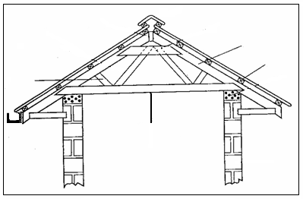
A
D
C
B

(i) Identify the parts labeled A, B, C and D. (4 marks)

A : Strut

B : Purlin

C : Rafter

D: Crosstie board

(ii) Give four factors considered when sitting farm buildings and structures. (2 marks)
  - Accessibility.
  - Nearness to social amenities.
  - Direction of prevailing wind.
  - Topography of the area.
  - The soil type.
  - Government policy.
  - Future expansion.
  - Farmer preferences / paranomic view.
  - Gradient / drainage.
  - Sewage disposal.
  - Aspect.
  - Security

(b) Give four advantages of using synthetic materials in construction of farm structure. (2 marks)
- light
- cheap
- can be moulded into any shape
- are durable
- cannot be destroyed by insects and fungus
- are water-proof.

17. Below is reproductive system in a bull. Use it to answer questions that follow.
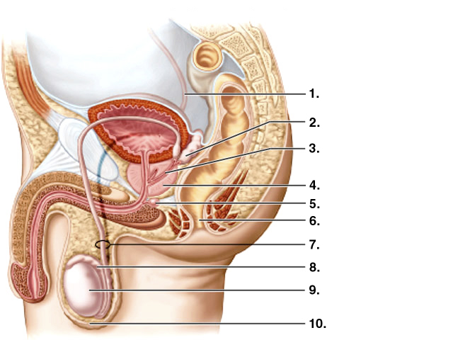

- Name the parts labeled: (2 marks)
- Anus
- Vas deferens

- Give the function of the parts labeled: (5 marks)
1 – conveys sperm
2 – produce semen.
8 – Storage of sperms(spermatozoa)
9 – produce spermatozoa/sperms
10 – regulate temperature of testis.
18. The pictures below show dairy breeds of cattle. Use it to answer questions that follow.
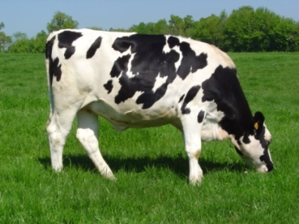
Breed A 1
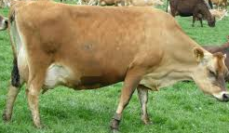
Breed A 2

- Identify: (2 marks)
- Breed A1
Friesian
- Breed A2
Jersey
- Give three advantages of keeping breed A2 over bread A1. (3 marks)
- Can tolerate high temperatures
- High butter fat content
- Small size hence less food required
- Can utilize poor pasture well.

SECTION C (40 MARKS)
Answer any two questions from this section in the spaces provided.
19. Using appropriate illustration, describe the process of egg formation in a layer. (20 marks)

Ovary
- Produces ova
Infindibulum
- Site of fertilization and storage of sperm calls
- Yolk takes 15 minutes here
Magnum
- Albumenis added
- Egg takes 3 hours here
Isthmus
- Secretes the shell membrane
- Water, minerals and vitamins
- Process takes 1 ¼ hours
Uterus/ shell gland
- Has calcium deposits
- Shell added round eggs
- Completes the addition of albumen
- Process takes 18 –22 hours
Vagina
- Pigmentation of egg takes place here
- Socrates mucus which reduces friction and facilitates expulsion of the egg
- Takes 1. 10 minutes
Cloaca
- -Delivers the egg out gently
1 x15=15 marks
Diagram well labeled – 5 marks
19. (a) State five advantages Artificial insemination. (5 marks)
Cheap / can be afforded by many farmers
Controls breeding diseases /
One male can serve many females
Makes use of good bulls/ quick way of improvement
Young/ small females not injured
Used to prevent inbreeding
Semen can be used in distant places

b) Describe how a gilt is reared from the time of weaning to the time it farrows. (15 marks)
- Feed gilt on atleast 3 kg of sow and weaner meal daily
- Provide clean drinking water
- Vaccinate the gilt to control common diseases
- Control external parasites by dusting with pesticides
- Treat gilt of sick
- House the gilt next to a boar at age of 12 months
- Ready to be served/ serve it at right age and weight
- Keep the pen clean by maintaining clean litter
- Flush gilt 3-4 weeks before service by feed on high quality diet
- Take gilt to the boars pen for service and let it stay for at least 12 hours.
- Observe the return to heat, if any, after three weeks, and repeat the service if necessary.
- Steaming up should start 1 ½ months before farrowing by giving 3-4 kg of feed
- 7-10 days before farrowing, the gilt should be washed and moved into a clean and disinfected farrowing pen.
- Sow and weaner meal should be reduced three days before farrowing
- Observe the signs of farrowing, and supervise the farrowing process.
- Deworm the gilt 7-10 days before farrowing.

20. (a) Describe the life-cycle of a tapeworm. ( 8 marks )
- Man is the main host of tapeworm / primary host.
- Intermediate host are cattle and pigs.
- Man drops the tapeworm segments in the faeces.
- Eggs released from proglottids to the pasture.
- Eggs picked up by the intermediate host.
- Eggs hatch to embryos penetrate intestinal wall and enter blood stream.
- Embryos go to the liver and distribute to muscles where they develop into cyst / blander worm.
- Inside the host eggs develop in cysts / blander worms.
- Cyst are found in the muscles of the animal.
- If man eats meat with cysts, become infected.
- Cyst wall dissolve in the intestine and parasites attach themselves on the intestine wall to develop
into adult tapeworms.
b) Describe the digestion of grass in the rumen of a ruminant. (6 marks)

- Cow picks up material very fast, chews mixing with saliva and swallows.
- Later it chews cud, mixing the feed with more saliva.
- There is no enzymatic digestion in the mouth as cattle do not have ptyalin enzyme in their saliva.
- After the food is mechanically broken in the mouth, it is passed onto the rumen.
- The rumen stores the food temporally and during this time it churned mixed and soften with water.
- Micro-organisms break down the carbohydrates cellulose, starch and simple sugars.
- The results of micro-organism digestion are volatile fatty acids, microbial proteins, gases such as methane and vitamin B2 and K.
- Most of the volatile fatty acids are absorbed through the rumen wall and what remains goes into the reticulum.

c) Give six ways of controlling ticks. (6 marks)
- Use of chemicals/ acaricides
- Ploughing the pastures or crop
- Burning infested pasture
- Hand picking and killing
- Rotational grazing
- Fencing the farm

