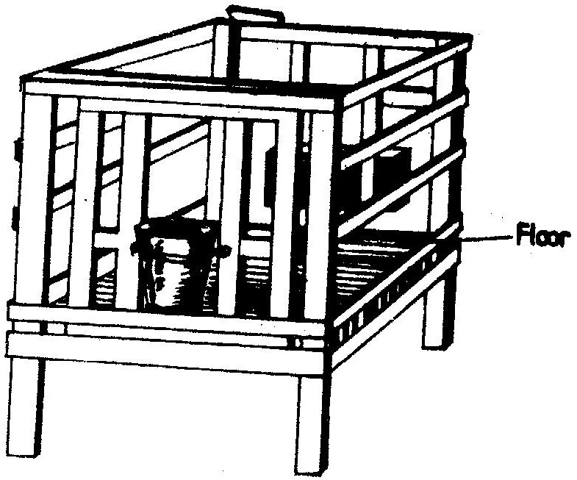
18. The diagram below represents a calf pen. Study the diagram and answer the questions that follow.

(a) (i) Identify the type of floor.(1/2 mks)

(ii) How high should the floor be raised above the ground level? (1mk)

(b) (i) Give one reason for having the floor of the calf pen raised. (1mk)

(ii) State three factors that should be considered in sitting the calf pen. (3mks)

19. The diagrams labeled A and B below show the teeth arrangements in hand workshop tools.
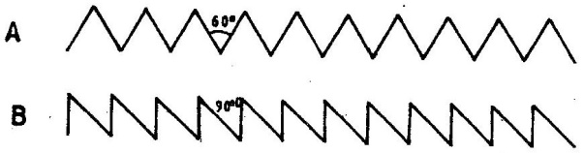

a) Identify the tools represented with by the teeth arrangements
A and B.(1mk)
A ……………………………………………..

B ……………………………………………..

b) State one functional difference between tools represented by the teeth arrangements A and
B. (2mks)
A ………………………………………………

B ………………………………………………

20. The diagram below illustrates a hoof of a sheep. Study it carefully and answer the questions
That follow.

(a) Name the routine management practice that should be carried out on the hoof illustrated above(1mk)

(b) State two reasons for carrying out the management practice in (a) above (2mks)

- Below is an illustration of livestock management equipment. Study the diagram and answer the questions that follow.

(a) Identify the equipment ( 1 mk)

(b) State the use of the equipment ( 1 mk)

22. A dairy farmer is required to prepare 100 kg of dairy meal containing 20% Digestible Crude
Protein (D.C.P.). Using the Pearson's Square Method, calculate the quantity of soya bean (40% D.C.P.) and rice (16% D.C.P.) the farmer requires for the dairy meal. (4 marks

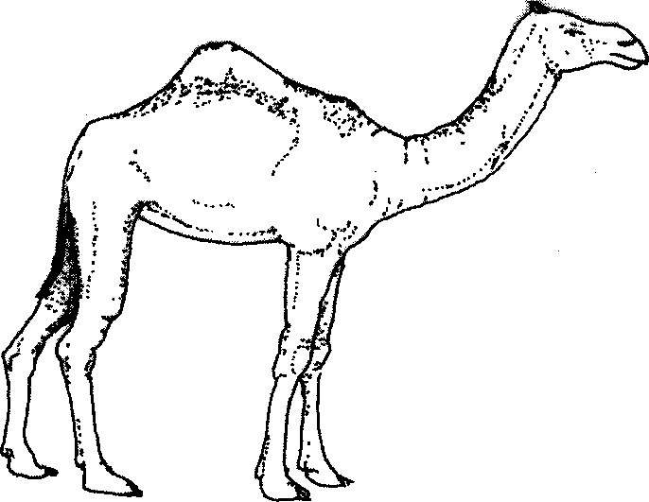
23. Below is an illustration of a camel. Study it and answer the questions that follow.

(a) Identify the camel species illustrated above. ( 1 mark)
(b) Name two products that farmers obtain from the camel species illustrated above.(1mks)

(c) Give one reasons why the camel species illustrated above is able to survive in its
natural habitat. (1/2 marks)

24. a) Describe the management practices that a farmer should carry out to
improve milk production in a low yielding herd of dairy cattle.(15mks)
b) Describe the management practices that would ensure maximum yield of fish in a fish pond. (5mks)

25. a) Describe the advantages of the battery system of rearing layers. (10mks)
b) Outline the factors to consider when selection livestock for breeding.(10 mks)

26. (a) Describe the life cycle of a named tapeworm ( Taenia spp) (10 mks)
(b) Describe the process of egg formation in the reproduction system of hen (10 mks)

