NAME: …………………………………………. INDEX NO: ……………………………….
CANDIDATE’S SIGNATURE: …………………………………

DATE : ……………………………………………………………

443/2
AGRICULTURE
PAPER 2
JULY / AUGUST 2014
FORM 3
TIME: 2 HOURS

INSTRUCTIONS TO CANDIDATES:

- Write your name and Index number in the spaces provided above.
- Sign and write the date of examination in the spaces provided above.
- This paper consists of THREE sections A, B and C.
- Answer ALL questions in Section A , B and C

SECTION A (30 MARKS)
Answer ALL Questions in the Spaces Provided

- (a) What is a notifiable disease? (1mk) ………………………………………………………………………………………………………………………………………………………………………………………………
(b) Name two notifiable diseases of cattle. (1mk)
………………………………………………………………………………………………
- List any four farm tools and equipment that are complementary in use.(2mks)
………………………………………………………………………………………………………………………………………………………………………………………………………………………………………………………………………………………………………………………………………………………………………………………………
- Give two characteristics that make indigenous cattle better suited to marginal areas than exotic cattle. (2mks)
………………………………………………………………………………………………………………………………………………………………………………………………
- Give four similarities between the importance of good creep feed and colostrum. (4mks)
…………………………………………………………………………………………………………………………………………………………………………………………………………………………………………….…………………………………………………………………………………………………………………………………………………
- Give two examples of light breeds of poultry. (1mk)
………………………………………………………………………………………………………………………………………………………………………………………………
- A farmer intends to prepare 600kg of feed containing 20% DCP for chicks using feedstuffs which contains 18% DCP and N which contains 40% DCP, using a pearson’s square method, calculate how much of Q and N will be needed.(5mks)
……………………………………………………………………………………………………………………………………………………………………………………………………………………………………………………………………………………………………………………………………………………………………………………………………………………………………………………………………………………………………………………………………………………………………………………………………………………………………………………………………………………………….
- Differentiate between pen mating and flock mating in poultry. (2mks)
………………………………………………………………………………………………………………………………………………………………………………………………
- State four signs of heat in pigs. (2mks)
…………………………………………………………………………………………………….…………………………………………………………………………………………………………………………………………………………………………………………………………………………………………………………………………………………
- Give two reasons why teaser rams are introduced to a flock of Ewes some weeks before tupping. (2mks)
………………………………………………………………………………………………………………………………………………………………………………………………
- Name two livestock diseases controlled through artificial inseminatiton. (1mk)
………………………………………………………………………………………………………………………………………………………………………………………………
- What characteristics of gizzard of a cock enable it to digest food? (1mk)
………………………………………………………………………………………………………………………………………………………………………………………………
- Give two reasons for seasoning timber before its used for construction.(2mks)
………………………………………………………………………………………………………………………………………………………………………………………………
- Give two uses of droppers in a barbed wire fence. (1mk)
………………………………………………………………………………………………………………………………………………………………………………………………
- State two factors which determine the amount of feeds given to an animal. (1mk)
………………………………………………………………………………………………………………………………………………………………………………………………
- State two factors that lower quality of concrete. (1mk)
………………………………………………………………………………………………………………………………………………………………………………………………
- Give two maintenance practices of a tractor battery. (1mk)
………………………………………………………………………………………………………………………………………………………………………………………………
SECTION B :( 20MARKS)
Answer all questions from this section

- Study the illustration of a farm structure below and answer the questions that follow:
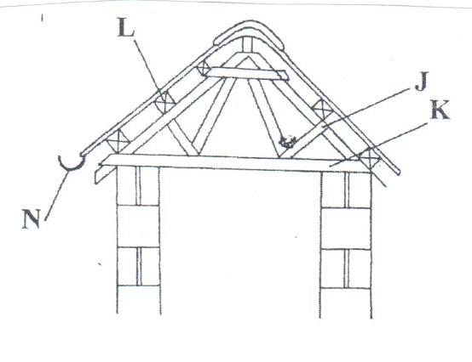
  - Identify the parts labeled: (2mks)
J…………………………………………………………………………………………
K…………………………………………………………………………………………
L…………………………………………………………………………………………
N…………………………………………………………………………………………
  - State two uses of part labeled L. (1mk)
…………………………………………………………………………………………
………………………………………………………………………………………….
- Below is an illustration of a bee keeping structure.
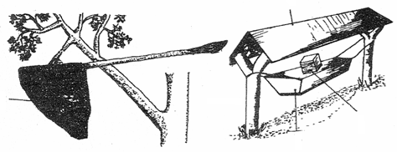
P
Q
R
S

- Name the parts labeled P, Q, R and S. (2mks)
P: ……………………………………………………………………
Q: …………………………………………………………………………………
R: ……………………………………………………………
S: …………………………………………………………………………………………..
- Give two methods used in stocking hives. (2mks)
………………………………………………………………………………………………………………………………………………………………………………………………
- Name four materials used for feeding bees. (2mks)
………………………………………………………………………………………………………………………………………………………………………………………………………………………………………………………………………………………………………………………………………………………………………………………………
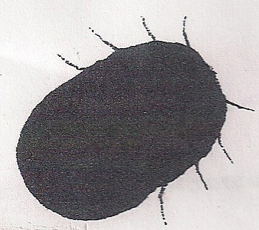
- Study the diagram of the tick below and answer the questions that follow.

  - (i) Identify the tick. (1mk)
……………………………………………………………………………………………….
(ii) Name one cattle disease transmitted by the above species of tick. (1mk)
……………………………………………………………………………………………….
  - Name three mechanical methods of controlling ticks. (3mks)
………………………………………………………………………………………………………………………………………………………………………………………………………………………………………………………………………………………………
- The diagram below shows a rearing practice in livestock production.
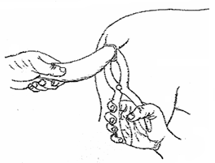

- Name the method of routine practice shown in the diagram above. (1mk)
……………………………………………………………………………………………….
- Describe the procedure used to carry out the routine practice identified in (a) above. (3mks)
………………………………………………………………………………………………
……………………………………………………………………………………………………………………………………………………………………………………………
21. Study the diagram of the digestive system of a farm animal illustrated below and answer the Questions that follow.

(a) Name the parts labeled P, Q, R and S (2mks)

(b) State the function of the part labeled R (1mk)

(c) Give one reasons why livestock with the above parts are able to digest cellulose food
material (1 mk)

(d) In which of parts labeled P, Q, R and S would a nylon paper be found if fed on by an
animal with the above digestive system? ( 1 mk)

22. Diagrams A and B below illustrates garden tools
(a) (i) Identify the tools labeled A and B (2mks)

(ii) Name the category of field crops where each tool labeled A and B is the most appropriate (1mk)
(b) State one disadvantage of B over A. (1mk)

SECTION C ( 40 MARKS )
Answer ALL THE questions in this section.
23. (a) Discuss bee management under the following sub-headings.
(i) Location of bee hive. ( 5 marks )
(ii) Diseases of bees. ( 2 marks )
(iii) Factors that determine the quality of honey. ( 3 marks )
b. Explain five signs of ill-health in livestock. (10 marks
24. (a) Describe the biotic factors that affect livestock production. (8 marks )
(b ) Discuss four advantages of farm mechanization. ( 8 marks
(c ) State four factors that influence milk let-down in cows. (4 marks)
25. Describe the management practices in fish farming. 20mks

