GATITU DAY MIXED SECONDARY SCHOOL
AGRICULTURE FORM 3 PP1
END OF TERM EXAM 2012 TIME: 1 ½ HRS 90MKS

INSTRUCTIONS
The paper consists of three sections: A, B AND C.
SECTION A ---------Answer all the questions in this section.
1 a) Define the term agro forestry (2mks)

b) Give 4 importance of agro forestry (2mks)

2. a) Give 4 characteristics of shifting cultivation (2mks)

b) Give 4 advantages of shifting cultivation (2mks)

3. a) Give 5 ways in which low level of education affects agriculture (2.5 mks)

b) Give 5 aspects of rainfall (2.5mks)

4 a) Give 4 factors influencing soil formation (2mks)

b) Give 4 characteristics of top soil layer (2mks)

5. a) Differentiate between macro nutrients and micro nutrients (2mks)

b) Give 4 characteristics of nitrogenous fertilizer (2mks)

6. a) Give 3 vegetative materials of pineapples (1 1/2mks)

b) Factors consider when selecting a stem cuttings (2.5mks)

7. a) Define the term layering (2mks)

b) Give 3 methods of layering (3mks)

8………SECTION B answer all questions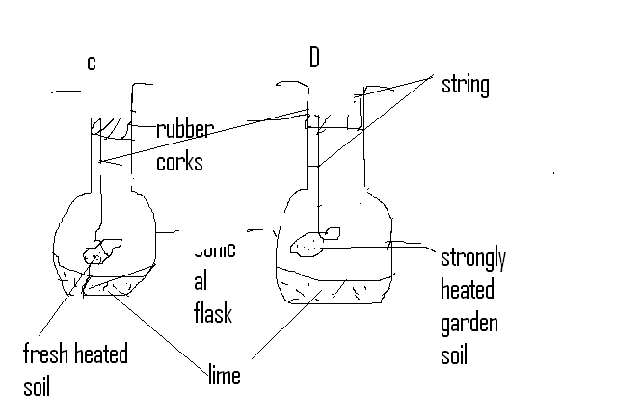

a) What was the aim of the experiment? (1mk)

b) State one observation that was made in each of the flasks labeled (1mk)
C
D

C) Give a reason for each of your answer in ( b) above
C (2mks)

D (2mks)

9.
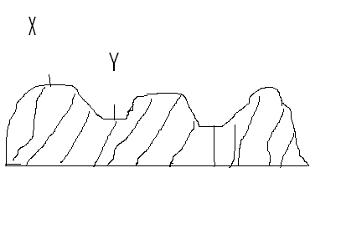
a) Name the tertiary operation drawn above (1mk)

b) Name the parts labeled
i) X (1mk)

ii)Y (1mk)

c) Give 2 importance of the above (a) operation (2mks)

d) Give 4 crops which are appropriate for the above (a) operation (4mks)

10. 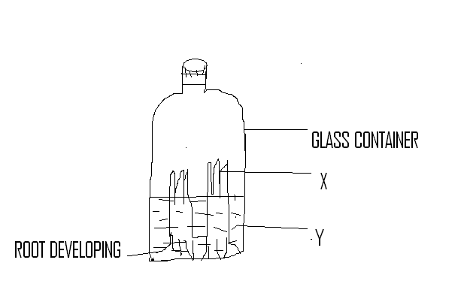

a) Name the above method of crop propagation (1mk)

b) Name the parts labeled
X (1mk)

Y (1mk)

SECTION C: choose any 2 question to answer
11. a) Explain 5 roles of agriculture to Kenya’s economy (10mks)
b) Explain 5 human factors that affect agriculture (10mks)

12. a) Give the procedure for transplanting tree seedling (10mks)
b) Explain the importance of budding and grafting (10mks)

13. a) Define the term crop rotation (2mks)
b) Explain 5 importance of crop rotation (10mks)
c) Explain 4 factors influencing crop rotation (8mks)

